**Your First Love**

Revelation 2:1-7 (Letter to Ephesus)

There is nothing like ***a paper letter***. I realize the kids here have no idea what that is. In this world of instant communication, mainly in the form of emojis and gifs and 5-second TikToks or whatever they’re called.

But back in our day, called the mid to late ‘90s, communication was called landline phone calls and LETTERS. Email was starting up but wasn’t common yet. I met Kristin in the fall of 1996, so the summer of ‘97 was our first summer apart. We talked as much as we could on the phone, and we exchanged these things called LETTERS.

***We took a piece of paper and wrote on it*** with a pen that was filled with black or blue ink that marked the paper with intelligible words and symbols. We sealed up this coded paper in a nifty container called an envelope, labelled it with an address where it would be taken and attached a stamp that made sure the delivery guy got paid. I looked it up; stamps back then cost 32 cents.

It’s really hard to describe **the feeling of opening a letter** from your girlfriend. Yes, I could hear her voice over the phone, but video calls were still years in the future as were text messages and social media. So opening this letter combined all of those feelings. I suppose it WAS the social media of the olden days. But it wasn’t a public post shared with 1,000 people, it was a private message written just to you.

And it contained ***the personal thoughts and feelings of the person you love most.*** What was she doing? What was she thinking? How was she feeling? What did she think of your last letter? Had you sent enough letters? Had you said enough nice things? Had you explained enough of what you were doing?

Those letters were so special, we kept them. And that’s what we have here in Revelation 2 and 3. Letters that were so special to the early believers that they kept them and have shared them with us. Look back in chapter one.

“John to the seven churches that are in Asia: Grace to you and peace from him who is and who was and who is to come, and from the seven spirits who are before his throne, and from Jesus Christ the faithful witness, the firstborn of the dead, and the ruler of kings on earth. To him who loves us and has freed us from our sins by his blood…” John 1:4-5

This book of Revelation is a prophecy from the Lord to encourage and challenge His people. But mainly it is ***a love letter from our beloved Savior***.

“Behold, he is coming with the clouds, and every eye will see him, even those who pierced him, and all tribes of the earth will wail on account of him. Even so. Amen.” Revelation 1:7

And look at that message: ***the One who loves us is COMING***. Amen! Come quickly, Lord Jesus!

Now as we turn to Revelation 2, we see there is not one letter, but seven. **This book is full of SEVENS**. Seven is the number of perfection, of completion. 7 stars, 7 spirits, 7 lampstands, 7 seals, trumpets and bowls. The bad guy, the antichrist has a number, 666. A mockery of God’s perfect 7. Close, but not the same. Just a little distorted, a twisting of truth. The world’s number is 6. But God’s number is 7.

And ***we are a part of that completion*** when it comes to the church. 7 lampstands among which Jesus walks represented the 7 churches of the region of Asia Minor, or modern day Turkey. But those 7 lampstands stand for all churches throughout history, including ours right here in Carrollwood. And so our letter for today begins:

“To the angel of the church in Ephesus write: ‘The words of him who holds the seven stars in his right hand, who walks among the seven golden lampstands.’” Revelation 2:1

The word for angel means messenger, so it could refer to an angelic being or just to the average believer bringing a word of encouragement. ***Imagine Timothy or Titus coming to Ephesus with a new letter from the Apostle Paul, like Philippians.*** Imagine when that letter first arrived. How precious Philippians is to us, now, as we’ve had access to it for our whole lives. But for them, when it was right from Paul’s pen…

When a believer brought a letter like that, they were fulfilling this directive, they were **bringing the word of God to the people of God**. Now we are bringing these words to each other, not only in our worship services, but also in our small groups as we discuss these letters and seek to apply them to our lives. Remember, the blessing for this book is for those who read it, who hear it and who KEEP IT. If you want the ***full triple blessing***, you have to do all three! Read it. Hear it and obey it.

So as we go through this letter and the other six, let’s receive this as it is - a love letter from our Lord and Savior Jesus Christ, the Lamb who was slain for us and who reigns forever over His eternal kingdom! ***He holds the seven stars*** in the palm of his hand. The angels that serve every church on this planet, all of them, are in the hand of King Jesus. Millions upon millions of faithful servants. Billions of faithful believers. All in the hand of Jesus. YOU are in the hand of Jesus, who walks among the lampstands. ***He is with us.*** All-powerful and always present.

We will see that these letters have a common structure, though some make important deviations from that structure.

**The Structure of the 7 Letters**

* Introduction
* Affirmation
* Confrontation
* Exhortation

They all begin with a description of Jesus, some aspect of His glory. They all include some affirmation, although some churches have more to affirm than others. They all go on to confront some specific problem, usually sin but also persecution. And they all include both direct warnings and calls to repent plus promises to motivate obedience and endurance.

You can remember it like this:

**The Structure of the 7 Letters**

* **I** ntroduction
* **A** ffirmation
* **C** onfrontation
* **E** xhortation

I ACE the test. If you remember this format, you will ace the test on the 7 letters. There is an important lesson just in this structure. Jesus is showing us HOW to confront sin in a loved one. It’s a **“compliment sandwich.”** There are some difficult, direct calls to repent here. But they are surrounded by loving affection and affirmation. Jesus always speaks the TRUTH, but He does so in a loving way.

If you have someone in your life who is straying into sin or danger, ***it is your job to call that out, but in a loving way***. Too much truth and not enough love and you could damage the relationship. Too much love and not enough truth and you could leave the person unaffected and unchanged; still straying into trouble.

Jesus won’t do that with us. He always strikes the balance perfectly. So let’s first be encouraged by the Lord Jesus, and then be open to His words of exhortation!

**Be Encouraged:**

* Jesus is **With us**

“The words of him who holds the seven stars in his right hand, who walks among the seven golden lampstands. ‘I know your works…’” Revelation 2:1-2

Jesus holds us and walks with us. He is not a distant deity, watching from afar. He is right here with us all the time, through the person of the Holy Spirit. There is a beautiful blending of Trinitarian roles just in these first two chapters of Revelation. Look again at that opening greeting of the book.

**Be Encouraged:**

* Jesus is **With us**

“Grace to you and peace from him who is and who was and who is to come, and from the seven spirits who are before his throne, and from Jesus Christ the faithful witness.” Revelation 1:4-5

***Where do grace and peace come from?*** God in all of His fullness. God in all of His Trinitarian glory and love. The One who is and was and always will be, the God of all being; with 7 spirits or the seven-fold Spirit before His throne and Jesus Christ the faithful one, the Word of God, the firstborn from the dead, the ruler of kings, the Lamb that was slain for us yet lives.

**This is the God who is with us**. To believe in Jesus is to be united with God and filled with all of His fullness. So our first encouragement is that this Jesus is the One who is with us, who walks with us.

* Are you discouraged today? Jesus is with you in that sadness.
* Are you worried today? Jesus is walking with you through all of your fears.
* Are you in pain? Jesus knows your pain and is with you in the midst of it.
* Are you excited? Jesus is too. He is with you.

***Jesus is our Good Shepherd.*** We need never fear any evil because HE is with us, His rod and staff comfort us with the simple reminder of His presence. But it’s not just that Jesus is with us:

**Be Encouraged:**

* Jesus **Sees us** and protects us

“The words of him who holds the seven stars in his right hand, who walks among the seven golden lampstands. ‘I know your works…’” Revelation 2:1-2

After the description of Jesus, the first words He writes are “I know.” To all 7 churches, this is a consistent feature. **Jesus KNOWS**. There is not a single thing that Jesus misses. He sees everything. He knows the hairs on your head. He knows the sparrows in the park. The God who clothes the flowers of the field knows exactly what you need. He sees. He knows.

And Jesus uses that knowledge ***to protect us and bless us***. He is our loving Shepherd. He leads us to still waters. He makes us lie down in green pastures. He does not lead you into traps or danger. That’s the other guy.

Jesus holds us in the palm of his hand. The picture here is of seven stars which stand for the ***seven angels of the churches***. But again, that number is the number of perfection and completion. There are clearly a lot more than 7 angels. There are hosts and legions of angels at God’s disposal. But it’s comforting to know that there’s a supervisor angel in charge of each church, making sure all the other angels know their duties and stay on top of them.

And all of the angels fit in the palm of Jesus’ hand. All of them. The same ease with which you sort through the change in your pocket, ***Jesus oversees all the spiritual forces*** in the universe. He glances in his hand and says, “Yep. 75 cents. Got it.” That would have paid a highway toll in 1990. Those old coin trays people would throw their gum into. Diabolical. Jesus saw it every time.

And He sees every part of your life and says to you, “I know.”

**Be Encouraged:**

* Jesus **Knows us** and loves us

“The words of him who holds the seven stars in his right hand, who walks among the seven golden lampstands. ‘I know your works…’” Revelation 2:1-2

This is the truly remarkable thing. ***With perfect knowledge***, with total omniscience, the God who sees everything we think, feel and do… ***you would think God would turn away*** in disgust and just abandon us to our well deserved demise. How could an all-knowing, all-seeing God still LOVE US? How could He stay with us?

Only through amazing grace. Only because of His limitless mercy. ***He knows our works and STILL He chooses to be with us.*** The truth is that God chose you and me completely in spite of our works. It wasn’t that we would be the most obedient, submissive, productive, amazing children of God. God chose you and me because we would best showcase HIS grace and mercy to forgive and transform even the most selfish, wicked sinners.

Look at the specific affirmation of the Lord Jesus:

**Be Encouraged:**

* Jesus **Knows us** and loves us

“I know your works, your toil and your patient endurance, and how you cannot bear with those who are evil.” Revelation 2:2

Jesus spoke this to the church in Ephesus, one of the churches we know the most about. Acts 18, 19 and 20 document how the gospel first came to this important trade city. By spending two years training disciples in Ephesus the Word of the Lord spread through all of Asia, meaning the whole region of modern Turkey. Two years. So those believers in Ephesus were bold evangelists.

***And it wasn’t for lack of opposition.*** Ephesus is where the seven sons of Sceva came from, impersonating Paul and casting out demons. So it was a hotbed for mystical spiritual practices. And it was a center for idolatry and the cult of Artemis, to the point that the silversmiths who made idols staged a riot to get rid of Paul.

**But the believers in Ephesus stood firm**. They endured patiently. They refused to compromise with evil and idolatry. At some point a group called the Nicolatians emerged who promoted gross sexual immorality, but the believers in Ephesus would not tolerate their practices or allow any compromise.

Paul warned the leaders in Ephesus that ***fierce wolves would come***, false teachers they would have to be watchful to identify and confront.

**Be Encouraged:**

* Jesus **Knows us** and loves us

“But have tested those who call themselves apostles and are not, and have found them to be false.” Revelation 2:2

Paul warned them what to watch for and **they did keep watch and were ready**. We, too, have been warned that false teachers will arise in these last days. We, too, must remain vigilant to identify false teachings and false apostles who claim to be from God but who teach a distorted gospel. Recently there have been a wave of “deconstructionists” who proudly criticize orthodox Christian belief and abandon their childhood faith, as if it’s a badge of honor.

But there is a word for people who do that: apostasy. We were big fans of the Fabulous Bentley Brothers from Phil Vischer’s What’s in the Bible? ***Rhett and Link*** were talented musicians who used their gifts to honor Jesus and help present the beauty of the Bible. But as they became more famous as YouTube personalities, and as they rubbed shoulders with Hollywood elites, they became more and more embarrassed of their conservative Christian background.

And eventually, both Rhett and Link abandoned their Christian faith. Call it deconstruction if you want. **But the right word is APOSTASY**. They rejected the truth. They turned their backs on Jesus. And that’s a common trend today, as it always has been.

**Be Encouraged:**

* Jesus **Knows us** and loves us

“I know you are enduring patiently and bearing up for my name’s sake, and you have not grown weary.” Revelation 2:3

Hear this as a word of encouragement directly to you from King Jesus. He sees you. He knows you. He sees your endurance and perseverance. He knows all that you have been through.

**Be Encouraged:**

* Jesus is **With us**
* Jesus **Sees us** and protects us
* Jesus **Knows us** and loves us

So this is our first half summary. The Alpha and Omega, the First and Last, the faithful witness, the firstborn from the dead, the Lamb that was slain, the one with the authority to open the scroll, **the ruler of the kings of the earth is WITH US**. He walks among the seven golden lampstands. We are precious to Him like gold. We are not cheap plastic lampstands. The church is God’s great treasure, worth the infinite price of redemption He paid in the blood of Jesus.

***Our Good Shepherds sees us and protects us.*** He holds us in the palm of His hand and commands all of His heavenly Host to watch over and serve us. They are messengers deployed on our behalf by the God who KNOWS, the God who sees. And still, even though He sees everything we think and feel and do, still God loves us and delights to be with us.

***This is His love letter to us.*** This book is His final profession of devotion to us and delight in us. So be encouraged. Don’t grow weary, don’t lose heart, don’t get distracted or give in to temptation to turn away from the Lord Jesus. Trust in Him. Look to Him. He is calling out to you. And here is the exhortation of this first letter, three parts.

**Be Devoted:**

* Rekindle your **Affections**

“But I have this against you, that you have abandoned the love you had at first.” Revelation 2:4

It’s significant that Jesus starts with encouragement and then moves to exhortation. That’s **the gospel progression**. First, we see the wonderful truth that Jesus is with us, He sees and protects us, He knows and loves us. None of that depends on our affection, our commitment or our devotion. It is all a free gift of His grace.

But as those who have been loved so fully and freely, our hearts should be moved. We do need to respond with gratitude. The natural response to the love of a parent is to be thankful and return that love. The natural response to a husband’s love and affection is to appreciate that love and respond with love in turn.

***Hear this indictment*** against the church in Ephesus. “You have abandoned the love you had at first.” Ephesus was one of the most prominent and vibrant churches early on. It was a center of trade for the whole region of western turkey. It was a cultural center, though a primary product was statues of Artemis – for idol worship. But a great revival took place there so that not only did many people in the city respond to the good news of Jesus, but the message rang out from there:

**Be Devoted:**

* Rekindle your **Affections**

“This continued for two years, so that all the residents of Asia heard the word of the Lord, both Jews and Greeks.” Acts 19:10

Asia was what they called Turkey. It was a huge geographic region, so this was a remarkable work of God. And it was part of the dramatic shift in the first century from a focus on Jews to a focus on Gentiles. The Jews consistently rejected Paul’s message as he went from city to city. After three months preaching in the synagogue of Ephesus, the Jews rejected the gospel and Paul moved next door to a secular lecture hall. Those who DID believe in Jesus went with him and he taught them DAILY from that lecture hall for two more years; the longest Paul stayed anywhere on his missionary journeys, a total of around three years in Ephesus.

So clearly, it was an important city and a significant, fruitful church. We get a little more context in Paul’s first letter to Timothy:

“As I urged you when I was going to Macedonia, remain at Ephesus so that you may charge certain persons not to teach any different doctrine, nor to devote themselves to myths and endless genealogies, which promote speculations rather than the stewardship from God that is by faith.The aim of our charge is love that issues from a pure heart and a good conscience and a sincere faith.Certain persons, by swerving from these, have wandered away into vain discussion…” 1 Timothy 1:3-6

Timothy was Paul’s protege, his most promising student and pastor in training. Ephesus needed a solid young pastor like Timothy because of ***the church’s potential and because of its problems***. This chapter goes on to warn Timothy about sexual immorality and temptation, which was rampant in the Greek culture of the day and would have been common in a cosmopolitan city like Ephesus. We learn in our next point that the Nicolaitans were gaining ground in Ephesus and they were all about the immorality.

By the end of the first century, when John was writing Revelation, Jesus calls out the church in Ephesus for:

**Be Devoted:**

* Rekindle your **Affections**

“But I have this against you, that you have abandoned the love you had at first.” Revelation 2:4

Probably 40, even 50 years had gone by. So it was second, even third generation believers Jesus was addressing in this letter. ***Very fitting for Oakwood*** as we look back on our founding in 1983 and look around the room at second and third generation believers. Is it possible that, like Ephesus, our affections have waned?

For those who are married, think about your FIRST LOVE. NOT the “one who got away.” But your first love for the one you landed. The one that proved to be actual love not the other thing. Here is a little free marriage counseling.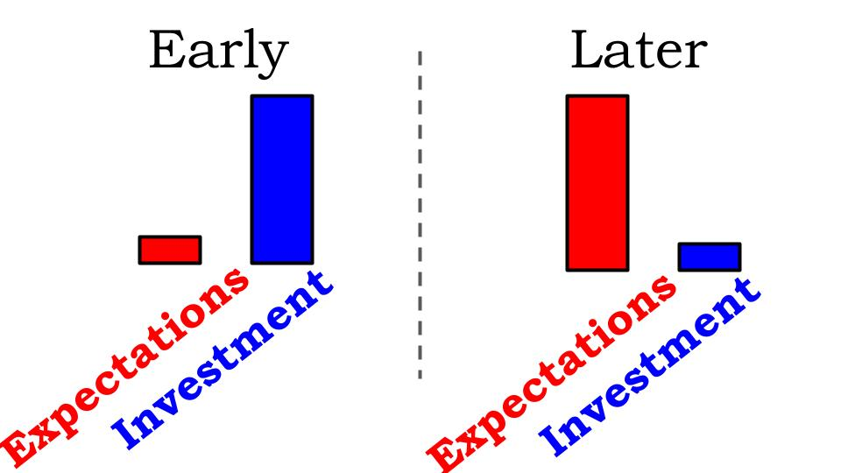

***Early in a relationship you have VERY low expectations.*** You don’t even think the other person knows you exist much less might be interested in you. So you INVEST like crazy. You write notes, you make phone calls, you drop by, you give gifts. As soon as she is willing at all, you take her on dates, do fun things together.

But later in a relationship those investments start to slip. Dates dwindle. Gifts, if they happen at all, happen only at Christmas and on a birthday, hopefully the anniversary if you remember it. Notes disappear. So the results are very predictable.

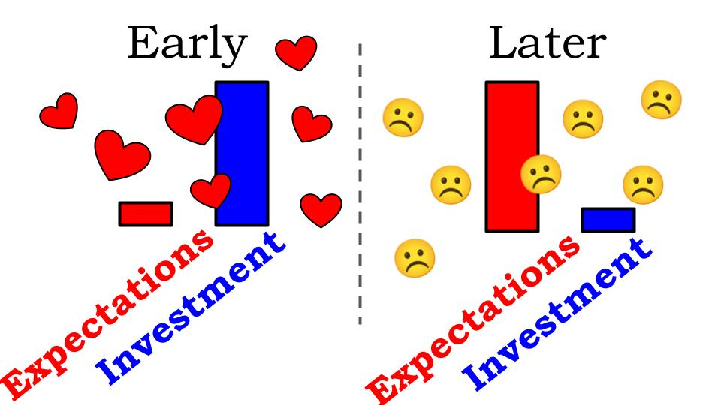

***Low expectations and high investment produces that thing called FIRST LOVE.*** Especially when both people are doing it. Giving and giving without expectation is the magic of chemistry. But as expectations grow and service dwindles, the difference between expectation and reality is called disappointment. You expect a thoughtful gift on your birthday and receive an Amazon gift card… you’re disappointed.

Over time:

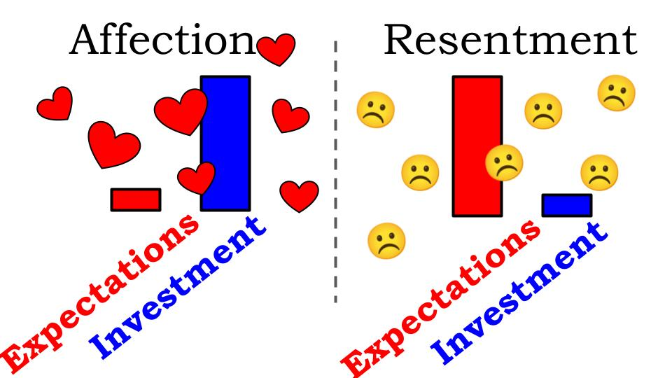

**Every relationship has a “love bank.”** The more deposits you make the more full your heart feels. The more withdrawals you make, the more your heart starts to feel empty and sad. That “first love” pattern produces affection. The other approach produces resentment. And the relationship struggles.

***This same pattern applies to your walk with the Lord.*** Early on, when you first heard about Jesus, your expectations of Him were very low. Death and hell. Judgment and condemnation. That’s what you knew you deserved from King Jesus. But what He gave you, through NO INVESTMENT of your own, was forgiveness and eternal life. The result was all those hearts: your first love. Affection. Joy. Delight. Gratitude.

But over time, your investment in the relationship dwindled, but at the same time your expectations of Jesus went up and up. You start to feel entitled to a certain amount of blessing and provision. “Come on, Lord, I’ve done A, B, C, for you – I’ve given and given, what’s in it for me?”

**Be Devoted:**

* Rekindle your **Affections**

“But I have this against you, that you have abandoned the love you had at first.” Revelation 2:4

***Where are you with the Lord right now?*** Are you still feeling all those heart emojis? Are you still overflowing with gratitude and joy in the Lord? Or, if you’re honest, are you feeling more disappointment, more resentment even? Do you feel entitled to better things than what God has given you recently? Have you lost your first love?

***Then it’s time to rekindle your affections.***

* Remember the infinite love of Jesus.
* Reset your expectations back to what you knew at first: all you deserve from God is death and hell. Period. Judgment, eternal suffering. Condemnation.
* BUT GOD. Review how good the good news really is. In spite of what you deserve, God has given you EVERYTHING.
* Jesus died for you. He paid 100%. He invested EVERYTHING. You benefit.

Second:

**Be Devoted:**

* Repent of your **Complacency**

“Remember therefore from where you have fallen; repent, and do the works you did at first.” Revelation 2:5

Here is the direct confrontation from King Jesus. REPENT. Remember where you once were. Come back. ***To repent means to turn around.*** To admit you’ve been going the wrong way and to make a full 180.

In order to repent of our complacency, we must first ADMIT to our complacency. Have we lost our first love? ***Do we even remember what it was like back in the early days of following Jesus?***

Notice in verse 4 the reference was to your first LOVE, but here it is to WORKS that you did at first. That’s an interesting reminder about ***a biblical definition of love.*** It’s not a feeling, it’s a commitment. It’s an action word. That’s not to say that feelings of affection don’t matter. They very much do. If you have little to no feelings for God that is a flashing warning light on the dashboard of your spiritual life, just as it is in your marriage.

It is very common for men to call their pastor and say ***“I’m a little frustrated with my marriage,”*** which translates to disappointed expectations in one particular room of the house we will call “the kitchen.” God has given us several very bright, flashy lights on our marriage dashboards and that kitchen one is front and center for most men. “He’s not talking about the kitchen honey.” Oh, gotcha. I’m with you preacher.

For women it might actually be the kitchen. But you’ve got warning lights too. The problem is when all the lights on your marriage dashboard have been flashing yellow, then they start flashing red and you just ignore them. This is also a problem in your spiritual life.

***How do you FEEL about the Lord Jesus?*** If your gratitude and joy have waned it’s not HIM that is the problem. That’s the one good thing in marriage, you can pretty much always be sure it is HIM that is the problem. But not with Jesus.

**What were the works** that you practiced early on with Jesus? You read your Bible like crazy, right? You were so enamored, so fascinated. You delighted to just be with Jesus. You were probably creative about it, using a journal, getting outside some times, having some extended times alone with Him. You probably went to special worship nights and other events. You probably talked with others within the church in small groups and outside of the church, sharing your love for Jesus with lost friends and family members.

So this leads to our final part of the exhortation:

**Be Devoted:**

* Renew your **Commitments**

“Repent, and do the works you did at first. If not, I will come to you and remove your lampstand.” Revelation 1:5

Now, we’ve been reading this letter very personally, as Jesus’ letter to YOU as an individual. But this verse shows us it is a corporate letter - **it is to US as a church**. It’s still very helpful to read it to each of us personally. But we also need to consider our affections and commitments to King Jesus as a church family.

The warning here is not to individuals to lose your salvation. ***It is a warning to the CHURCH in Ephesus to lose its health and vitality as a church.*** Unfortunately, this is all too often the reality for churches. They have **a life cycle** from birth, through growth to an S-curve type peak after which most churches settle into a long period of plateau and decline until they eventually wither up and die.

**Be Devoted:**

* Renew your **Commitments**

“If not, I will come to you and remove your lampstand from its place, unless you repent.” Revelation 1:5

Just as individuals are called to repent of our complacency, ***so churches must have seasons of reflection and repentance*** where we recognize our own affections and commitments have faded. We realized this over the last year regarding small groups. Oakwood has been about small groups for over 30 years, going back to the earliest days. At times we have had almost 200 people actively involved in groups. Now that number is much lower.

So as a church we are inviting everyone to plan to join a small group THIS WEEK! We have several new groups starting up this Tuesday and Thursday, if you haven’t found a group yet, contact me today or tomorrow and we will get you signed up for one of those new groups!

Two more verses as we finish out this letter from Jesus.

**Be Devoted:**

* Renew your **Commitments**

“Yet this you have: you hate the works of the Nicolaitans, which I also hate.” Revelation 2:6

Again, Jesus comes back to His affirmation of the church. Even as he has said some hard things to confront sin and complacency, Jesus still affirms the church’s faithfulness to stand firm against false teaching and sexual immorality that was trying to creep in among them. Then Jesus ends with a final exhortation and promise:

**Be Devoted:**

* Renew your **Commitments**

“He who has an ear, let him hear what the Spirit says to the churches.” Revelation 2:7

Very familiar line from Jesus’ public ministry. If you have ears to hear this warning and confrontation that in itself is a gift from the Lord – the gift of conviction of sin and the guidance of the Spirit. God is always speaking, always calling out to His church through the Holy Spirit. Do we have ears to hear?

**Be Devoted:**

* Renew your **Commitments**

“To the one who conquers I will grant to eat of the tree of life, which is in the paradise of God.” Revelation 2:7

The Bible opens and closes with **the tree of life** – the promise of eating and being satisfied with what God has provided for us in His wonderful paradise. The way has been closed to that tree of life for thousands of years. But one day soon that door will be opened and we will step into the new heaven and new earth God has prepared for those who love Him.

That gift, ***that provision is for those who conquer***. Those who overcome the many trials and tribulations of this life and this world. Will we be those who overcome the temptations of the enemy and the thorns and thistles of the world? We are not those who shrink back and are destroyed but those who stand firm and are commended. We are not a church that will have its lampstand removed, but one that will be applauded by King Jesus for being faithful and finishing the work He has called us to!

**Be Encouraged:**

* Jesus is **With us**
* Jesus **Sees us** and protects us
* Jesus **Knows us** and loves us

**Be Devoted:**

* Rekindle your **Affections**
* Repent of your **Complacency**
* Renew your **Commitments**

***So be encouraged.*** The Lord Jesus is with us. He sees us and protects us. He knows us and loves us. Rekindle your first love as you remember the overflowing, undeserved love of Jesus for you. Repent of your complacency and renew your commitment. ***And let’s do this TOGETHER*** as we prayerfully and faithfully walk with our Lord and Savior this new year!

Let’s pray.