Just Shut It
James 3:1-12

Happy Mother’s Day! I debated whether to choose a different Bible passage for today that was more Motherly. But what Mom doesn’t care deeply about the words her children use? What mother doesn’t teach her children, “If you can’t say something nice, don’t say anything at all”? Or, as in my very poetic title for today: Just shut it.

James is so terribly practical. We could talk very ambiguously about love and service and honor. But James cuts right to it with this passage on WORDS.
- You might think you love your wife, but if you don’t speak kindly and lovingly to her - you aren’t loving her well.
- You might believe that you love your husband, but if your words are more often critical and angry than they are affectionate and admiring, then you aren’t loving him well.
- You might think you love your children or grandchildren well, but if you regularly blow up at them in anger or you tend to neglect talking with them at all - you aren’t loving them very well.
- You might think you’re a very positive church member, but if you aren’t regularly building others up with your words - encouraging them, praying for them, listening to them - then you aren’t loving the church family well.

With our words it’s both what we SAY and what we DON’T say - it’s the self control to speak when we should speak and to be silent when we should be silent. As they say, “You are better off being quiet and letting people think you’re a fool or you can open your mouth and remove all doubt.” Look at how James summarizes it in verse 2:

“For we all stumble in many ways. And if anyone does not stumble in what he says, he is a perfect man, able also to bridle his whole body.” James 3:2

That would be PERFECTION. Maturity. To never stumble in what you say. To never slip up and speak out in anger or selfishness. To never remain silent when a word needed to be spoken. To maximize every opportunity, perfectly discerning the needs of the people around you.

What we will see here in James 3 are three principles about our words.

The Truth about Words:
- Your words Matter
- Your words Reveal who you are
- Your words Shape who you become

Our words matter BECAUSE they reveal who we are and they shape who we become. It’s no surprise that our words reveal who we are - every little outburst, every temper tantrum, every pity party is like a status report. But it’s also important that we see how our words are shaping us.

The Truth about Words:
- Your words Matter
“Not many of you should become teachers, my brothers, for you know that we who teach will be judged with greater strictness.” James 3:1

You probably know there are two different judgements, according to Scripture. The Great White Throne of Judgment, described in Revelation 19, is for NON-believers. Everyone great and small will stand before King Jesus, the Judge, and will be judged for everything they did, said and thought. Books will be opened to document every last detail. And everyone will be judged using the exact standard by which they judged other people during their lives.

1 Corinthians 3 describes a different judgment for BELIEVERS in Jesus. Some call this the Bema Seat based on this passage in 2 Corinthians.

The Truth about Words:
- Your words Matter
“For we must all appear before the judgment seat [Bematos] of Christ, so that each one may receive what is due for what he has done in the body, whether good or evil.”
2 Corinthians 5:10

This is a judgment of EVALUATION not of CONDEMNATION, since we know from Romans 8:1 that “there is now no condemnation for those who are in Christ Jesus.” But no condemnation does not mean no evaluation. There will be a final judgment for believers for a final purification as we step into eternity. 1 Cor. 3 describes it like the 3 little pigs. Jesus will basically huff and puff and see what’s left of the house of your life.

“Now if anyone builds on the foundation with gold, silver, precious stones, wood, hay, straw— each one's work will become manifest, for the Day will disclose it, because it will be revealed by fire, and the fire will test what sort of work each one has done. If the work that anyone has built on the foundation survives, he will receive a reward.”
1 Corinthians 3:12-14

Three kinds of good building material - gold, silver, precious stones. Three kinds of bad building material - wood, hay, straw. Use the good kind, there’s a reward. Use the bad kind, it gets burned up in that final judgment.

Think about your WORDS over the last week. How many of those words were gold, silver and diamonds? How many were wood, hay and straw? How many were toxic sludge? Look at verse 8.

The Truth about Words:
- Your words Matter
“No human being can tame the tongue. It is a restless evil, full of deadly poison.”
James 3:8

Animals can be trained. But taming the tongue is truly impossible apart from the Holy Spirit. The result: often our words are toxic, even deadly. We learned this at camp - there are warm fuzzies and cold pricklies. If you give someone a compliment and say something kind about them, it’s a warm fuzzy. If you say something rude or sarcastic or straight up mean, it’s a cold prickly. Our words can build up or they can tear down. Solomon pointed this out 1,000 years before Jesus:

The Truth about Words:
- Your words Matter
“The tongue can bring death or life; those who love to talk will reap the consequences.” Prov. 18:21, NLT

Words matter. For better or for worse. The way you speak to each other will determine the course of your marriage; it will define the tone and value of your parenting; it will influence your career path and the quality of all of your relationships.

The way we talk has consequences. We “eat the fruit of it.” Good words bring life. Bad words bring death, pain, destruction. And we all learned this as children, didn’t we? How many of you - be honest now - had your mouth washed out with soap? Tabasco sauce? We didn’t use those barbaric tactics with our boys, but that was standard parenting in the ‘70s and ‘80s. Today it would probably be called child abuse.

James has two specific applications for why words matter. First, they reveal who we are. And second, they shape who we become.

The Truth about Words:
- Your words Reveal who you are
“With it we bless our Lord and Father, and with it we curse people who are made in the likeness of God.” James 3:9

One minute we stand here singing songs about Jesus, the next minute we yell at each other in the car. One minute you are reading your Bible, the next minute you are bickering and fighting. We all live with this nasty but unavoidable dichotomy because we are fallen people in a fallen world. We long to live in Romans 8 but often fall back into Romans 7, doing the very things we don’t want to do.

The Truth about Words:
- Your words Reveal who you are
“From the same mouth come blessing and cursing. My brothers, these things ought not to be so.” James 3:10

We should not be split personality - Jekyll and Hyde people. We should not praise God and then tear down people, made in His image. As those who love God the natural overflow of that should be LOVE for people God made.

We should be whole people, with integrity and consistency. We should not be hypocrites who say one thing and then do another. “My brothers, these things ought not to be so.”

But our words betray us. They show what’s really going on inside us.

The Truth about Words:
- Your words Reveal who you are
“Does a spring pour forth from the same opening both fresh and salt water?” James 3:11

What comes out reveals what was in there. If fresh water comes out of your mouth, it means you are a freshwater spring. If salty, angry, bitter, resentful water comes out, it means you are a saltwater spring.

[CUP ILLUSTRATION]

I’ve done this a few times at Oakwood, but it’s a helpful illustration. If you’re holding a cup like this and I shake you, liquid spills out. In this case, it’s water. Now, why did water spill out? Yes, on one level the water spilled because you were shaken. But why did WATER spill out, as opposed to coffee or acid? Because water is what was in the cup.

All of us are shaken by the events of the day and the events of life. Sometimes we are shaken very violently. But when we react to that distress with anger, cursing, bitterness, lashing out at people around us - we can’t blame the situation. It simply revealed what was already simmering inside us.

The Truth about Words:
- Your words Reveal who you are
“Can a fig tree, my brothers, bear olives, or a grape vine produce figs? Neither can a salt pond yield fresh water.” James 3:12

Trees produce according to their kind. So do springs. And so do PEOPLE. What grows out of your heart and life will be revealed in your words. James chose all good options here with figs, olives and grapes. But he is certainly making a reference to Jesus’ teaching about a fig tree bearing thistles and grapes growing on thornbushes (Matt. 7:16). It just doesn’t work that way. What grows out of our hearts bears fruit in our lives and in our words.

So what do YOUR WORDS reveal about you?

The Truth about Words:
- Your words Reveal who you are
  - Is your heart full of worshipful Gratitude or raging Resentment?
“From the same mouth come blessing and cursing…” James 3:10

Are people blessed by your words - built up, encouraged, valued, appreciated?

Are people cursed by your words - torn down, discouraged, devalued, unappreciated?

Is Jesus honored by your words? Are others drawn to JESUS through your honesty, affection, integrity and interactions?

Or might people be turned away from Jesus because of your words? Is it possible that what people hear from you does not match up with the teachings of Jesus about love and mercy, goodness and love?
Here is the promise of Galatians 5:

- Your words Reveal who you are
  - Are you producing the Fruit of the Spirit?
“Walk by the Spirit, and you will not gratify the desires of the flesh… But the fruit of the Spirit is love, joy, peace, patience, kindness, goodness, faithfulness, gentleness, self-control.” Gal. 5:16, 22-23

You can’t make a grape or an apple by squeezing the seed in your hand. But you can create an environment where that seed can grow, over time. That is how it works with the fruit of the Spirit. You can’t force love, joy and peace to grow in your heart through will power. But you can create an environment in your life that is conducive to the growth of these virtues. Paul calls it “walking by the Spirit,” or “walking with the Spirit.”

If you planted an apple tree you would dig a hole, place the seed down in the hole, fill it with good fresh topsoil with some fertilizer already mixed in. Then you would water the seed and keep it moist for the next several weeks and months. In time you would see a little shoot come up, that would grow into a seedling and later a sapling. And you wouldn’t expect your first apple for 8-10 years. That little tree has to grow and mature to a certain point before it will be able to produce an edible fruit.

Thankfully the Holy Spirit brings SOME fruit much quicker than that. But other fruit - like peace, patience and self-control - can take DECADES.
The point for today is simply that the Holy Spirit is the One who must grow this fruit in you. You can’t make it grow. But you can place yourself regularly before God so HE can grow these virtues in you. You can set aside time every day to be with the Giver of love, joy, peace and everything else. You can meet with others more mature than you who can help you make progress and pray for you. You can study God’s Word and learn to increasingly fill your mind with the things of God rather than the rubbish of this world.

Notice how the fruit of the Spirit has everything to do with RELATIONSHIPS. And so do the works of the flesh.

- Your words Reveal who you are
  - Are you producing the Works of the flesh?
“Now the works of the flesh are evident: sexual immorality, impurity, sensuality, idolatry, sorcery, enmity, strife, jealousy…” Gal. 5:19-20

With the Spirit it is FRUIT. With the flesh it is WORKS. Fruit takes time and organic, natural processes, provided by God. What can you work up all on your own? It’s a much nastier list. And Paul’s point is that these things are “obvious,” everyone knows they are wrong from your conscience and from the very negative impact they have on your relationships. People might glorify the idea of an illicit sexual affair until they are the one sinned against. Then it’s not so glamorous. Then it’s heartbreaking. Devastating.

- Your words Reveal who you are
  - Are you producing the Works of the flesh?
“Now the works of the flesh are evident… fits of anger, rivalries, dissensions, divisions, envy, drunkenness, orgies, and things like these.” Gal. 5:19-21

Just as the fruit of the Spirit primarily impact our relationships, so do the works of the flesh.

Just to choose two contrasting examples from these lists - consider PEACE as a fruit of the Spirit and division as a work of the flesh. Are your words and your relationships producing peace, harmony and unity? Or are they stirring up division, confusion and conflict?

Peace is a fruit of the Spirit - something God is producing in a family, a small group, a church, a community. Conflict and division is a work of the flesh - something sinful people regularly stir up in homes, workplaces, communities and, yes (sadly) churches.

What do your words reveal about you? Is it fresh water coming out of you when you’re shaken? Or is it deadly poison? Toxic acid? Healing, refreshing love and peace? Or bitter, angry, divisive rage?

Some of you are here today feeling righteous because you don’t talk much, and sometimes that is a sign of wisdom and maturity. But sometimes silence reveals immaturity and stubborn pride. If I do something rude or unkind in my house I know to repair it all I have to do is say, “I’m sorry. I was wrong. Will you forgive me?” Just 9 words. It would be 10 but there’s a conjunction in there to trim it to 9. Am I the only one here or are there some other proud idiots in the room who struggle with those 9 words?

Sometimes silence is just a stubborn refusal to apologize. Sometimes silence is cowardice. There is a conversation that needs to be had. Not in anger, not for selfish reasons. But to address an important issue.

Let’s come back to verse 2 as we transition to our final point.

“For we all stumble in many ways. And if anyone does not stumble in what he says, he is a perfect man, able also to bridle his whole body.” James 3:2

Your words matter. First they matter because they reveal who you are - they expose what’s going on inside your heart. It is from the overflow of the heart that the mouth speaks. Fresh water or salty? One more point. Your words matter because:

The Truth about Words:
- Your words Shape who you become
“And if anyone does not stumble in what he says, he is a perfect man, able also to bridle his whole body.” James 3:2

If we can learn to manage our words, we can learn to manage every part of our lives. If we can’t control our words, it reveals that we can’t control the other parts of our lives either.

The analogy James uses is of a BRIDLE. If you’ve ever worked with horses, you know that a metal bit goes in the horse’s mouth and is held in place by a leather bridle.
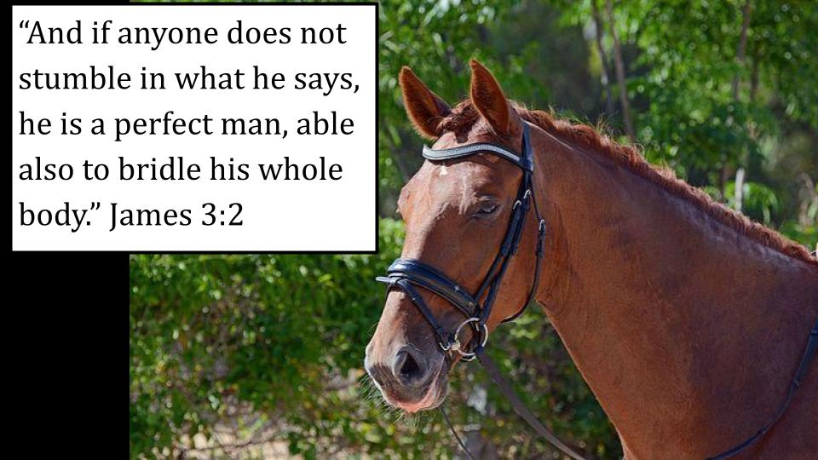
Horses do not like bits and bridles. The metal bar is uncomfortable in their mouths. And the harness is designed to force them to turn their heads when you pull left or right or pull back to get them to stop.

A well-trained horse will accept the bridle and respond to it. But horses are kind of like dogs - they might behave well for one rider who is confident and assertive and differently with a less confident rider.

My uncle had a horse named Fifi that was his pride and joy. He fed Fifi and cared for her for decades. When he rode Fifi, she trotted and galloped around however he directed her. But when I got on Fifi, from when I was 10 until well into my adult years - she would not have it. She would buck and wiggle. She would go right next to a tree to ram my leg into it. Then when Uncle Dave would look over, she would act like it was just to rub her own back on the tree. Totally innocent.

As soon as he looked away, she would give a little jump and toss me right off.

Now, was I confident and assertive? No. I was a big chicken for sure. Fifi made sure of that. But in my estimation, Fifi was not a very well-trained horse.

And often, with the Holy Spirit and the use of our words - we are just the same. We behave fairly well when Mom is in the room, or wife is in the room, or a respected older friend. But left to ourselves, or with a more rowdy group of friends, we might throw off the Holy Spirit altogether and just do whatever and say whatever.

- Your words Shape who you become
  - To manage your words, you must manage your Emotions
“And if anyone does not stumble in what he says, he is a perfect man, able also to bridle his whole body.” James 3:2

We learned in James 1 that “the anger of man does not produce the righteousness of God.” Therefore, we should be “quick to listen, slow to speak and slow to become angry.” Unfortunately, in our anger we don’t want to listen and we DO want to speak.

So how do we bridle our whole bodies, including our emotions?

We must become accustomed to the leading of the Holy Spirit. Many of us have been through Pastor Colin Smith’s excellent book Momentum. He walks through the Beatitudes as a sequential pathway for growth in the Christian life.
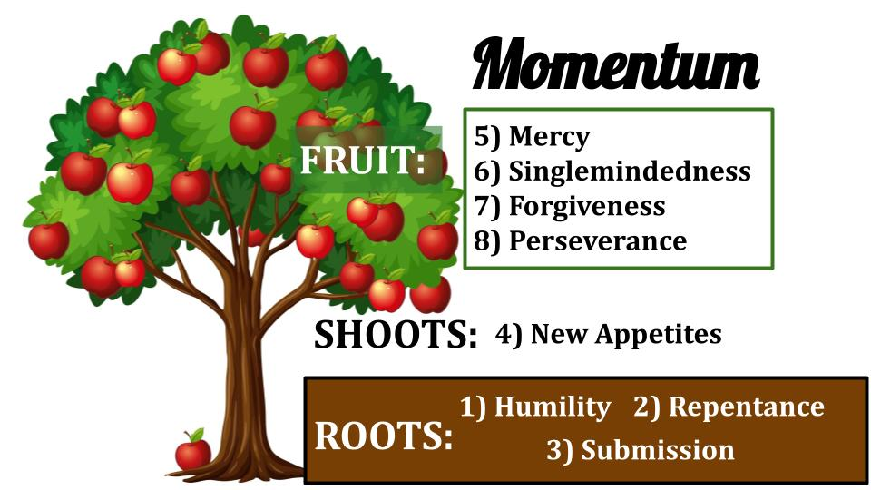
Humility - poverty of Spirit - is the first step, followed by repentance - mourning over our sin. The third part of this spiritual root system is MEEKNESS, which is actually a term that comes from training horses and is about submission. It is when the horse is broken to the master’s will and becomes familiar with the hand.

That is true meekness. Being under the hand of God; grateful for the leading of the Holy Spirit and submitted to His guidance. Those are the roots of a growing Christian life: humility, repentance and submission.

How is your MEEKNESS? How familiar are YOU with the guiding hand of the Holy Spirit? Do you buck like an untrained horse when the Holy Spirit tries to get His bit into your mouth? Do you try to spit it out and shake your head to maintain your independence and refuse His direction? Or are you trained? Are you tame? Are you “under the hand”?

- Your words Shape who you become
  - To manage your words, you must manage your Emotions
“If we put bits into the mouths of horses so that they obey us, we guide their whole bodies as well.” James 3:3

By guiding the mouth and head of the horse, you can control its whole body. By learning to control our tongues, we learn to control our whole bodies - especially our emotions.

How do you process strong feelings? I’ve found that people tend to run hot or cold. Some boil up quick and dramatically, their emotions heating up and often bursting out in words. Others run cold - under pressure they shut down and go quiet. Hear this: neither is BETTER than the other. That is more about your temperament and family of origin than about your character.

The question is how you MANAGE your natural tendencies. When you run hot, what do you do? Are you able to call a timeout to catch your breath, or do you just let fly the dogs of war? Have you learned to listen to the Holy Spirit so you can pause to pray or do you say ‘darn the torpedoes, full speed ahead’?

If you’re like me and you run cold under pressure it’s easy to feel righteous that you can be quiet when others get upset. But again, that’s not necessarily maturity. There have been 100 times when a more mature me would have quickly said the words, “I’m sorry. I was wrong. Will you forgive me?” But instead I stayed quiet, stewing in my cold, quiet juices.

It has been documented that a marriage can work with two hot-tempered people - it’s called volatile, and it is - but there’s more drama and heat there, even though there’s more conflict, so two people who run hot can have a good marriage.

Same thing with two who run cool. They avoid conflict and prefer to keep the peace. They won’t have the high highs, but they’ll avoid the low lows and can have a long, happy, quiet marriage.

Many of us are blessed to have one of each. This just means you have no choice but to talk things out and be patient with each other.

And this is a good lesson for us in all of our relationships. Just because you are wired hot or cold doesn’t mean everyone around you has the same mindset or approach. So you have to learn to be understanding of where people are and how they handle conflict. Maturity is learning to discern the situation and listen to the Holy Spirit’s leading in all of your conversations and interactions.

If we can learn to submit our EMOTIONS to the Spirit, we will learn to let Him guide our words which will help us learn to walk with the Spirit in every part of life.

- Your words Shape who you become
  - If you are Loving in what you say (and don’t say), you will become more loving in All you do
“Look at the ships also: though they are so large and are driven by strong winds, they are guided by a very small rudder wherever the will of the pilot directs.” James 3:4

What a picture of the Holy Spirit as our Captain - guiding us according to the course He is plotting. Instead of being driven by the strong winds of your own passions or by the strong winds and currents of our culture and the media. We need to learn to be guided by the small rudder of the Holy Spirit, listening to His still, small voice and not the other, much noisier things around us.

The Holy Spirit is shaping us into the image of Jesus - who is LOVE. If our words are guided by love then our lives will increasingly be shaped by love. But let’s remember, that takes time.

- Your words Shape who you become
  - Sin grows like a Fire; godliness grows like a Tree
“And the tongue is a fire, a world of unrighteousness… staining the whole body, setting on fire the entire course of life, and set on fire by hell.” James 3:6

I have a suspicion that James ran hot. Just guessing. He doesn’t seem to pull any punches, that’s for sure. Sin and negative words spread like fire. Think how quickly juicy gossip spreads. She did what? He said what? That politician did what? “A world of unrighteousness.” Deadly poison.

Your words matter. They have the power to ruin people, to destroy people - and to destroy you. Just a couple of words, spoken in anger, can kill a marriage. They can be like a knife to the heart of the person you promised to love and cherish and honor and protect. Unkind, disrespectful, unloving words can set a marriage on fire - in the bad way.

But words can also bring life. They can be like water to a small, struggling plant. You can breathe life back into the heart and mind of someone who has been beaten down by others.

But that kind of loving godliness grows slowly, like a tree. It takes time and prayer and daily repentance and submission to the Holy Spirit.

So, call your Mom and tell her you love her and are thankful for all she taught you about the importance of words. If she did wash your mouth out with soap, say thank you. And do what Mom would have you do today - find someone you can bless with your words. Warm fuzzies today. No cold pricklies.

Let’s pray.

