Just Repent
James 3:13-4:10

Listen to that last verse again:

“Humble yourselves before the Lord, and he will exalt you.” James 4:10

If you’ve been in church for a while that kind of language will sound familiar, even commonplace. Yes, of course - we should be humble. God is great and worthy of our praise, so we should humble ourselves before Him and trust Him to exalt us at the proper time.

As with so much of the book of James this is a rephrasing of a prominent teaching of Jesus who said on multiple occasions: “Whoever exalts himself will be humbled and whoever humbles himself will be exalted.” Don’t send the little children away, become like them by recognizing that you’re not such a big deal yourself.

“Humble yourselves before the Lord, and he will exalt you.”

Do we realize just how totally counter-cultural this verse is? Do we realize how much this runs exactly opposite to our culture and our own human desires? This passage presents a dramatic contrast between the wisdom of God and the wisdom of the world. The two things could not be more opposite. What the world considers wise and practical and sensible and good ranges from neutral to foolish to wildly immoral in the eyes of God.

I like to summarize the primary messages of our culture in these two common expressions:
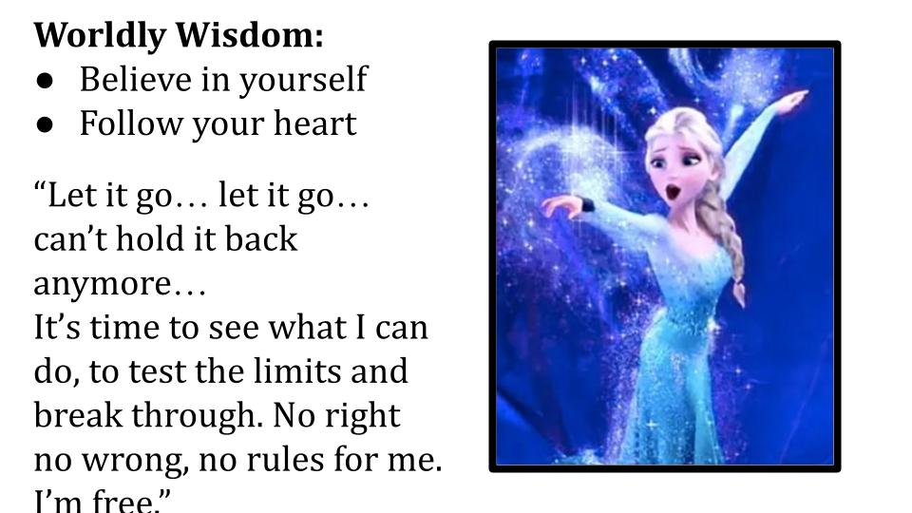
Elsa sings her heart out and I’ll admit the song is quite compelling. But look at what she’s articulating: there is a power inside of me that no one appreciates and that people (especially my parents) just want to suppress and control. No more of that. No more restraining my impulses, I am hereby committed to “let it go.” I need to unleash myself and anyone who stands in my way is in for it. “No right, no wrong, no rules for me. I’m free.” This is what our culture means by freedom: total, unlimited self-expression. The core value is authenticity. The anti-value is considered judgment and suppression.

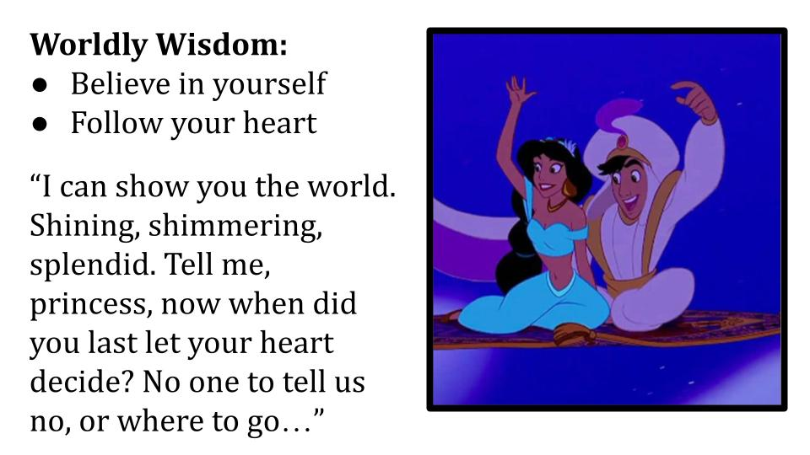
Now, lest we think it’s just this recent generation that is depraved, no no. This goes back much further.

Don’t get me started on what Aladdin actually meant by the magic carpet ride. Look at what he is doing - exactly like the DEVIL in the temptation account. Let me SHOW you the world. Look at everything you are missing - everything your parents are keeping you from. Just let your HEART decide. In other words: “Follow your heart.” NO ONE to tell us no. Or Where to go. Or what to do. Or what NOT to do…

You can hear the Devil’s whisper: “Just bow down to me and all the kingdoms of the world can be yours!” What does your heart want?

So let’s follow James to expose the foolishness and wickedness of worldly wisdom and then contrast it with the beauty and truth and goodness of spiritual wisdom.

“Who is wise and understanding among you? By his good conduct let him show his works in the meekness of wisdom. But if you have bitter jealousy and selfish ambition in your hearts, do not boast and be false to the truth.” James 3:13-14

After a scathing rebuke about WORDS and fresh and salt water springs, James shifts to the topic of WISDOM. Obviously our words are an expression of what is inside us - whether wisdom or foolishness; whether selfishness or service. You say you are wise? Prove it with your good works; prove it with your RELATIONSHIPS.

If the reality of your heart is bitter jealousy and selfish ambition don’t kid yourself that you are spiritual and WISE. That is not the wisdom of God - that comes from the other guy, the other place.

Worldly Wisdom:
- Confidence - “Believe in yourself”
“But if you have bitter jealousy and selfish ambition in your hearts do not boast and be false to the truth.” James 3:14

James is calling us to genuine self-awareness; to an accurate assessment of our own hearts. Notice the world doesn’t call it “selfishness” but CONFIDENCE. The message is “believe in yourself” which sounds very empowering, very positive. And it is partly true - even largely true. Kids especially do need to develop self-confidence that is grounded in their identity, personality and strengths.

But if you extend that thinking to its logical conclusion, what you get is straight up self-exaltation, under the guise of “being yourself.”

Worldly Wisdom:
- Confidence - “Believe in yourself” → Assertiveness - “Be yourself”
“But if you have bitter jealousy and selfish ambition in your hearts do not boast and be false to the truth.” James 3:14

Selfish ambition. The pursuit of your own desires. Philippians 2 tells us to “do NOTHING out of selfish ambition or vain conceit.” Instead, we are to follow the example of Jesus who humbled himself and went to the cross. The path we follow is of humility and service - the downward path to the cross. Not the upward mobility call of the American dream to believe in yourself, exalt yourself and ultimately to indulge yourself.

Think about the basis for social media: bitter jealousy and selfish ambition. Doesn’t that summarize the self-promotion of Tik Tok and really all the social media engines…? You look at other people and that stirs up jealousy. Then you present yourself as attractively and assertively as you can, hoping for those likes and follows. I say “you” because I am not on any social media. Partly because I’m 48 and just missed the party and partly because COVID made us sick of using Facebook, the social media for old people like us.

Over and over people are warning us for our own sake and especially for our kids and grand-kids - BEWARE of the Algorithm. Beware of social media. If you can’t see the product, you ARE the product. These companies do not have your best interests at heart. They are after their own bottom line, and do you know what they are selling? You. Your attention. Your heart. Your soul. James could not have known about the internet or social media, but he nailed the diagnosis:

Worldly Wisdom:
- Confidence - “Believe in yourself” → Assertiveness - “Be yourself”
“This is not wisdom that comes down from above but is earthly, unspiritual, demonic.” James 3:15

Anything that stirs up bitter envy and selfish ambition is of the devil. That is not godly wisdom. That is worldly wisdom which, when you peel it back is diabolical plotting. The devil’s schemes to steal and kill and destroy.

It dresses up like a beautiful young princess dancing in the snow. But really it’s a host of sadistic demons with blood on their fangs. And look at the result:

Worldly Wisdom:
- Confidence → Assertiveness → Anxiety
“For where jealousy and selfish ambition exist there will be disorder and every evil practice.” James 3:16

We’ll see in a moment that the result of worldly wisdom is both internal turmoil and external conflict. It messes you up and then it tries to ruin the people around you. Disorder, chaos, in your heart. In an attempt to build self-confidence and raise up a generation of assertive self-promoters what do we have? A generation of kids who need anxiety medication. “Take a chill pill,” used to be something you could say and now half the people in the room are like, “One second, ok here.” My chill pill.

Instagram did a study that revealed young girls who used their service had much higher rates of anxiety and suicidal thoughts than girls who did not.
https://www.mcleanhospital.org/essential/it-or-not-social-medias-affecting-your-mental-health

Why would this be? Because comparison is what that kind of social media is designed to do. The beauty and success of others is paraded in front of you constantly. And you try to join the parade but always feel like you don’t quite measure up. Anxiety.

And James reminds us it’s not just disorder, it’s “every evil practice.” What used to be just through normal peer pressure in actual relationships now is multiplied by “influencers” who look a certain way, dress a certain way and act a certain way - that is not driven by good morals but, again, by the other kind from the other guy.

And when people compromise on their morals and ignore the twinges of conscience, guess what? More anxiety. More stress over the fact that you aren’t living in line with basic human decency. We see the progression: believe in yourself leads to exalt yourself which leads to anxiety inside of you and conflict around you.

Worldly Wisdom:
- Confidence → Assertiveness → Anxiety
“You covet and cannot obtain, so you fight. You do not have, because you do not ask.” James 4:2

At first this verse seems like a non-sequitor. Why does James go from talking about relational conflict to suddenly talk about prayer? Again he is echoing the teaching of Jesus - “Ask and you will receive, seek and you will find.” And this fits perfectly because what’s another word for confident assertiveness? Pride.

And what does pride keep you from more than anything? Prayer. So let’s rename these things what they are.

Worldly Wisdom:
- Pride → Self-Exaltation → Anxiety
“You covet and cannot obtain, so you fight. You do not have, because you do not ask.” James 4:2

The world calls it confidence but it’s really just pride wearing makeup. The world calls it assertiveness, but it’s really just run of the mill selfishness. When you combine pride and selfishness what you do not get is a life of prayer. And when you take away prayer, you also take away peace and replace it with anxiety. It’s a perfect storm. And it doesn’t stop with you - it spills over into your relationships, so your internal turmoil becomes your relational conflict.

Worldly Wisdom:
- Authenticity - “Follow your heart” → Fulfillment - “Chase your dreams”
“What causes quarrels and what causes fights among you? Is it not this, that your passions are at war within you?” James 4:1

Here is the second half of worldly wisdom. Not only does the world say, “Believe in yourself,” but extends that thinking to your hopes and dreams with the very Disney expression, “Follow your heart!” This is considered basic authenticity along the lines of “be true to yourself,” and “Be who you are.” Both of which sound good and generally speaking are better than “fake it” or “conceal don’t feel.” But our culture is pressing the limits of how far this can go as the LGBTQIA+ revolution continues to actively target our children.

In the name of self-discovery and being true to yourself young children are being encouraged to cast off any inhibitions from their parents or religious upbringing - the kinds of things that in past generations were reserved for college experimentation. Now it’s happening in our elementary schools. And sometimes parents are intentionally cut out of the loop. It’s legitimately terrifying.

What is the result? VERY confused children (and parents, and teachers, and counselors). Because when one person is following their heart and chasing their dreams, what do you do when that heart and those dreams conflict with the heart and dreams of someone else?

CONFLICT.

Where do quarrels and fights come from? Our own hearts. Our own selfish, sinful desires - crashing into each other like a demolition derby. Even within ourselves our passions are AT WAR. Think of yourself when you were a teenager. You are like a rope in a 5-way tug of war. Parents, youth leaders, teachers, friends, the opposite sex, culture - depending on who you are with you feel pulled one way, then violently back the other. When it comes to girls, you hear from parents and church leaders, “Just say no.” Then your friends at school are like, “parents just don’t understand, just say yes.” Desires at war.

Then you grow up and get married and now you have two people with desires at war within them who now have an enemy they can easily line up in the crosshairs. YOU are the one keeping me from my real, deep desires. Follow your heart. Chase your dreams. Where will that take you? Not into a happy, long-lasting marriage. What if your heart tells you there must be someone else! You have a soul mate out there who is not your spouse. What if children are in the way of your pursuit of personal fulfillment? Demolition derby. Mutually assured destruction. Look at verse 2.

Worldly Wisdom:
- Authenticity - “Follow your heart” → Fulfillment - “Chase your dreams”
“You desire and do not have, so you murder. You covet and cannot obtain, so you fight and quarrel.” James 4:2

Remember that James is writing to BELIEVERS. This letter was meant to be read in small house churches. I don’t think actual murder was going on very often. But character assassination was. Backroom gossip and slander. We know there were issues with rich and poor, Jew and Gentile. So we can imagine the line of conversation:
- Can you believe Abraham was back again - the local homeless guy? His tunic smells so bad I can’t be in the room with him. What are the elders thinking letting that guy come to our service? We’ll have to meet outside every time!
- What about Agnes? She couldn’t dress with any decency if she wanted to because she’s too poor. And she hasn’t eaten kosher one day in her life, much less kept the sabbath. Our leaders are compromising principles every time we turn around. I don’t know how much more of this I can handle.
- Those two are nothing compared to poor, tragic Agatha. All she does is weep and weep. Come on, her husband died over a year ago. Get over it already! They keep trying to collect food and money for her - I’ve got problems of my own, I can’t keep funding some worthless do nothing widow!

That may not sound like MURDER - but that’s what James calls it.

Worldly Wisdom:
- Authenticity → Fulfillment → Conflict
“You desire and do not have, so you murder. You covet and cannot obtain, so you fight and quarrel.” James 4:2

You want something. Your “heart” tells you that you deserve it - even if it’s something as simple as peace and quiet. Someone in your small group or even in your house is making it difficult for you to get that thing. So you complain about them. Most likely not directly to them, but about them. You covet something - meaning you want something that belongs to someone else. The Biblical examples are your neighbor’s house, your neighbor’s wife, your neighbor’s servant, ox or donkey. Or anything else your neighbor has that you might want for yourself.

These desires at war - if we let them have their way - are what cause quarrels and fights among us.

Worldly Wisdom:
- Authenticity → Fulfillment → Conflict
“You do not have, because you do not ask. You ask and do not receive, because you ask wrongly, to spend it on your passions.” James 4:3
One problem is that our selfishness and pride keep us from praying at all. But sometimes we do go ahead and pray, but these prayers won’t be answered because they are SELFISH prayers, just about indulging our own desires. This is why Jesus taught us to pray “YOUR kingdom come. YOUR will be done.” Prayer helps us reorient around GOD’s kingdom and HIS desires, leading us to surrender our own will - like Jesus did in the Garden, “Not my will, but yours be done.”

Let’s call these things what they are:

Worldly Wisdom:
- Lust → Idolatry → Conflict
“You adulterous people! Do you not know that friendship with the world is enmity with God?” James 4:4

Here is the root problem: idolatry. Friendship with the world. Instead of worshiping God and seeking first His kingdom we worship ourselves and make ourselves at home in this world. We cozy up all friendly with the world. We settle into BABYLON. No wonder there is conflict in the home and in the church! Our lusts and idols are colliding with one another!
- I want financial security - yeah, well I want a new television!
- I want you home more - yeah, well I want to earn more money to pay for that new television.
- I want you to be more helpful in the kitchen - yeah, well I want you to be more engaged in a different room.

Desires at war. Kyle Idelman was right in his book a few years ago - these aren’t just desires at war, they are GODS at war. And that war is raging in our own hearts.

Do we see the war? Do you see that YOU are the main aggressor in the war? Your own heart? Your own desires? Until you see this and admit it you will not make progress in your marriage. And you will not grow as a Christian.

- This is step one of marriage counseling - take your hands off of each other’s throats (it’s hard to talk that way). Stop focusing on the other person and what THEY do or don’t do, and shift your focus to YOURSELF, your own heart, your own sin. That is the only way that real, lasting change can be accomplished.
- Let go of the other person. Whatever the issue - whatever the conflict. Let go. Make your peace with GOD yourself. Recognize your own sin, your own lust, your own desires, your own idolatry - confess and repent, experience the grace of God to YOU - and THEN you will be able to turn and actually see the speck of sawdust in the other person’s eye.

It really helps to remove that 2x4 from your own eye before you attempt Lasik surgery on someone else’s astigmatism.

Worldly Wisdom:
- Lust → Idolatry → Conflict
“Therefore whoever wishes to be a friend of the world makes himself an enemy of God.” James 4:4

The stakes are not low here. Just as our words provide a litmus test of our hearts - so do our relationships. Are you surrounded by peace, harmony and love? Or are your relationships marked by conflict, division, frustration and anger?

Here’s our first half summary:

 | Belief | Practice | Result
Worldly Wisdom | Confidence:  “Believe in yourself”  PRIDE | Assertiveness:  “Be yourself”  SELF-EXALTATION | Anxiety
 | Authenticity:  “Follow your heart”  LUST | Fulfillment:  “Chase your dreams”  IDOLATRY | Conflict

What the world calls confident assertiveness is just prideful self-exaltation and it results in deep internal anxiety and turmoil. What the world calls authenticity and fulflillment is actually lust and adultery unleashed, which causes continual relational conflict. Demolition derby. That is the “wisdom” of the world.
Thankfully, there is a better way!

“But the wisdom from above is first pure, then peaceable, gentle, open to reason, full of mercy and good fruits, impartial and sincere. And a harvest of righteousness is sown in peace by those who make peace.” James 3:17-18

Let’s contrast real spiritual wisdom with worldly wisdom. It is different in every way - beliefs, practices and results. The main thing to notice here is that spiritual wisdom shows itself in our RELATIONSHIPS. All of these descriptions are about how we relate to other people. And the result is PEACE.

Worldly wisdom causes inner turmoil and relational conflict. Spiritual wisdom produces inner peace and relational harmony. How can we experience this harvest of righteousness and become those who make peace? We NEED spiritual wisdom!

Spiritual Wisdom:
- Devotion - Trust God completely → Confession - Humble yourself
“You adulterous people! Do you not know that friendship with the world is enmity with God?” James 4:4

Our selfish, sinful hearts will draw us away from God to the things of this world. Our pride will keep us from seeing that this lust and idolatry is really what is happening. So the antidote to pride is CONFESSION. We have to be humble enough to admit what is actually going on inside us.

All of us are drawn to the things of this world in one way or another. We can all seek the comforts and pleasures of this earthly kingdom instead of God’s kingdom - it’s just a question of what flavor you prefer compared to what I prefer. Whatever your area of temptation and sin may be, the result is the same - by loving this world we make ourselves ENEMIES of God. And that is the absolute essence of foolishness!

Spiritual Wisdom:
- Devotion - Trust God completely → Confession - Humble yourself
“Or do you suppose it is to no purpose that the Scripture says: ‘He yearns jealously over the Spirit that he has made to dwell in us’?” James 4:5

Don’t wear out your concordance trying to find the OT reference for this verse. There isn’t an exact match for it. Most likely the Living Bible gets the sense best:

Spiritual Wisdom:
- Devotion - Trust God completely → Confession - Humble yourself
“Or what do you think the Scripture means when it says that the Holy Spirit, whom God has placed within us, watches over us with tender jealousy?” James 4:5, TLB

I don’t think James is quoting one single verse but is summarizing a frequent OT teaching that God is jealous for our affections. The jealousy of God is first mentioned in Exodus 20 as part of the 10 commandments.

https://www.thegospelcoalition.org/essay/the-jealousy-of-god/

It comes up again in Exodus 34 after the golden calf incident in which Israel immediately abandoned the true worship of God and made a statue to worship. God does not want to share our hearts with other gods. He refuses to be one of many. “The LORD our God, the Lord is ONE.” There is only ONE God. And thankfully, He is full of grace and mercy.

Spiritual Wisdom:
- Devotion - Trust God completely → Confession - Humble yourself
“But he gives more grace. Therefore it says, ‘God opposes the proud but gives grace to the humble.’” James 4:6

This one is a direct quote of Prov. 3:34 in the Greek Septuagint, which was the everyday Bible for first century Christians. Spiritual wisdom is to put God first because He alone is worthy of our worship and service. Only a fool would set himself in opposition to God - the Creator, the Judge, the Sustainer of all things, the Lord of the universe.

Do you want GRACE from God or opposition? Worldly wisdom - believe in yourself and follow your heart - places you in direct opposition to God. By exalting yourself you force God to oppose you.

But if you want grace from God, the only way to get it is to humble yourself before Him by confessing your selfishness, idolatry and sin. And that will give you peace!

Spiritual Wisdom:
- Devotion → Confession → Peace
“Draw near to God and he will draw near to you.” James 4:8

This short passage is filled with beautiful promises! God Himself will draw near to us on one condition - that we draw near to Him. God will give us grace if we will just submit ourselves to Him. The devil will FLEE from us if we just resist him in Jesus’ name. And don’t miss how this section closes:

Spiritual Wisdom:
- Devotion → Confession → Peace
“Humble yourselves before the Lord, and he will exalt you.” James 4:10

This is not a promise of IMMEDIATE glory, comfort and worldly pleasure. It’s a promise of ETERNAL glory, comfort, joy and blessing. We get some of that immediately in our relationship with God and each other. But we will have eternity to see what this means - if we humble ourselves enough to confess our sins.

Spiritual Wisdom:
- Devotion → Confession → Peace
“Cleanse your hands you sinners, and purify your hearts, you double-minded.” James 4:8

How do we cleanse our hands? By coming under the blood of Jesus. By confessing them to Jesus the Savior and asking Him to forgive us an purify us from all unrighteousness, as He promises to do in 1 John 1:9. True confession involves REPENTANCE - turning from our double-mindedness in which we love God and we love the world. It moves us to wholehearted love for God motivated by uncompromising TRUST in God.

Spiritual Wisdom:
- Devotion → Confession → Peace
“Be wretched, mourn and weep. Let your laughter be turned to mourning and your joy to gloom.” James 4:9

Here is a clear reference to the beatitudes in Matthew 5. There is a blessing for those who mourn - not in a general sense of being sad and gloomy like Eeyore. The blessing is for those who are grieved by their sin and by the brokenness of this world. If we are finding our happiness and life in THIS WORLD, it is actually killing us spiritually. So we need to replace that worldly laughter with spiritual mourning over our sin and idolatry.

If we will truly confess and repent, humbling ourselves before the Lord, He will change us from the inside out and empower us to live differently, for His kingdom!

Spiritual Wisdom:
- Eternity - “Seek first His Kingdom” → Ministry - “Love your neighbor”
“Who is wise and understanding among you? By his good conduct let him show his works in the meekness of wisdom.” James 3:13

True spiritual wisdom is revealed in good works - in a life that is different, a life devoted to God and His kingdom. What do we really seek first? What do we really love and prioritize? Are we guided by worldly wisdom or spiritual wisdom?

Spiritual Wisdom:
- Eternity - “Seek first His Kingdom” → Ministry - “Love your neighbor”
“But the wisdom from above is first pure, then peaceable, gentle, open to reason, full of mercy and good fruits, impartial and sincere.” James 3:17

To be pure in heart is to love God without any compromise, without any competing loves. Are we single-minded in our trust in God, our love for God, our devotion to God? Can we honestly say that we seek His kingdom first? Or are you building your own kingdom?

The test of our reality is found in our relationships. Are they pure, peaceable, gentle, reasonable, full of mercy and good fruit? Impartial - loving and serving even the poor and weak and unlovely?

Look at the results when followers of Jesus actually follow His wisdom!

Spiritual Wisdom:
- Eternity → Ministry → Harmony
“And a harvest of righteousness is sown in peace by those who make peace.” James 3:18

The anger of man does not bring about the righteousness of God. Only the wisdom of God can do that. And He will only give us that wisdom when we humble ourselves enough to ASK for it. That means turning from our pride and selfishness. It means confessing our lustful desires and worldly idolatry. It means placing our trust securely and entirely in God alone - and devoting ourselves to Him and His kingdom first and above all. It means we live for eternity not for the here and now; we store up treasure joyfully in heaven and deliberately shrink our barns here on earth.

Then we will increasingly see a HARVEST of righteousness. As we sow seeds of peace and love, the shalom of God will grow in our hearts and in our relationships.

As we prepare to gather at the Lord’s table let’s take some extra time to search our hearts and minds and invite the Lord to show us where we love the world too much and love Him too little.

Silent confession time BEFORE intro communion.

