Just Live it
James 2:14-26

Let me acknowledge an important issue up front and explain why we’re not going to focus on it this morning. You can dig into this as deeply as you want on the church blog. But it would actually miss the whole point of this section if we spent the next hour debating a theological nuance instead of trying to actually APPLY the text in front of us.
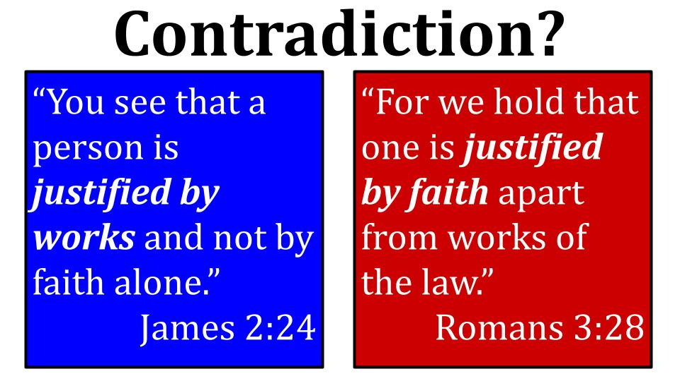
Here is the issue. At a glance, these two Bible verses seem to directly contradict one another. A young Catholic once pointed out to me that “the only time the Bible uses the phrase ‘by faith alone,’ it is to deny that we are justified by ‘faith alone.’” While that is technically a true statement it is like taking one phrase from a politician’s speech and making it say the opposite of what that person meant if you heard the whole speech.

Thankfully, we have the whole speech of James. Meaning we have his complete letter. If all we had was this one verse we might have to conclude that James and Paul didn’t like each other and had a serious disagreement at the heart of the early church. But when you look at the context of each of these verses you quickly see there is no contradiction at all and the two apostles were actually in complete agreement with one another.
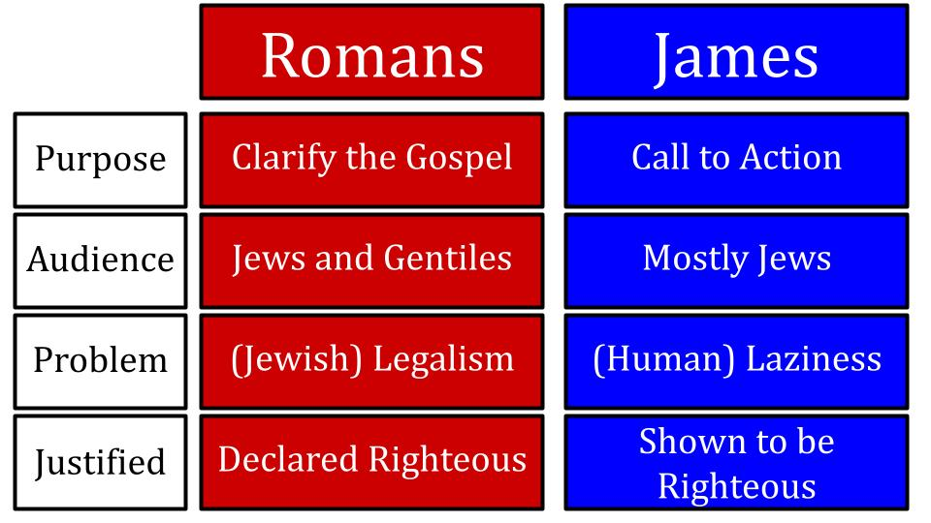
Different authors, different audiences, different goals in writing because different problems were being addressed. Paul was taking on the danger of Jewish legalism in the early church that was becoming more and more Gentile and had to figure out if circumcision and kosher eating and Jewish hairstyles were required for salvation.

James was concerned about much more practical realities of rich Christians living in luxury while poor Christians right down the street were starving to death. Laziness and apathy were in the bullseye for James as he very passionately said, “faith without works is dead.” So don’t kid yourself that you are “saved” if your life is no different than it was before. You may talk a good game but if you don’t actually love and serve and sacrifice - at least for other believers - then you don’t know the first thing about following Jesus.

Notice how the NIV and NLT help us by clarifying what James means by the word justified:

“You see that a person is justified by works and not by faith alone.” (ESV)
“You see that a person is considered righteous by what they do and not by faith alone.” (NIV) “So you see, we are shown to be right with God by what we do, not by faith alone.” (NLT)

The word “Justified” in English can mean both “declared righteous” as by a judge’s pronouncement and also “shown to be right” as by a lawyer’s explanation. The same is true of the Greek word. Like most words there is a range of possible meaning that is defined by CONTEXT. Once you understand the context, the apparent contradiction goes away.
It’s as simple as knowing the difference between the roots and the fruits. Paul is talking about the roots of faith - that salvation is by faith ALONE, not by works. James is talking about the FRUIT of faith - that saving faith is never alone - it must be proven genuine by good works. James agrees wholeheartedly with Paul that salvation is by faith alone - that you must receive the implanted word with meekness in order to be saved (see James 1). Paul agrees wholeheartedly with James that saving faith must express itself in works - just read Romans 6.

What we will see in James two today are two marks of dead orthodoxy followed by two signs of genuine faith. First James shows how useless and lifeless spiritual WORDS are if they are not accompanied by ACTION. Then James gives us two examples of OT heroes who exercised genuine faith.

Marks of Dead Orthodoxy:
- The expression of faith without any corresponding Action
“What good is it, my brothers, if someone says he has faith but does not have works? Can that faith save him?” James 2:14

To be orthodox is to have correct doctrine - rightly articulated beliefs. That is very important! You could certainly say, “What good is it, my brothers, to pray to the sun or the moon when those are merely objects in our solar system without consciousness or divine power of any kind?” A pastor friend who was doing a funeral for a non-church family was asked to read a prayer to a special TREE the family brought in for this part of the service. My friend wisely and immediately told them, “I don’t pray to trees.”

Right orthodoxy is important. But just because you can say the right words doesn’t mean you are actually saved. Jesus said that MANY people will say on the last day, “Lord, Lord.” They will call Jesus Lord - which is right doctrine. He IS LORD. And even on the day of judgment they will try to talk a good game: “Didn’t I go to church and pay my tithes and heal the sick and drive out demons and preach in your name?” And Jesus will say to MANY - “Depart from me, I never knew you.”

Just because someone SAYS they have faith, and just because they THINK they have faith in Jesus doesn’t mean they truly KNOW HIM. Some people can be flat out hypocrites who know they are faking it but want you to believe they are sincere. Other people can truly believe they are sincere in their faith but they are deceiving themselves because they are hearers of the word but not DOERS of it.

Marks of Dead Orthodoxy:
- The expression of faith without any corresponding Action
  - No practical evidence of Love for other believers
“What good is it, my brothers, if someone says he has faith but does not have works? Can that faith save him?” James 2:14

The key word here is ANY. Not “ANY corresponding action.” NO evidence of love. No works at all to back up the claim of faith. “Can that faith save him?” Clearly the answer is no. A faith that is all talk and no action is not genuine faith. It’s just bluster. James gets really concrete here:

Marks of Dead Orthodoxy:
- The expression of faith without any corresponding Action
  - No practical evidence of Love for other believers
“If a brother or sister is poorly clothed and lacking in daily food…” James 2:15

We are talking about life essentials here - food and clothing. This is a brother or sister in your own small local church. They were all house churches at this point, so it wasn’t like - “That person goes to the early service, I don’t even know their name!” Everyone knew everyone’s name. These were mostly Jewish gatherings - so everyone knew everyone’s FAMILY name going back generations.

- The expression of faith without any corresponding Action
  - No practical evidence of Love for other believers
“And one of you says to them, ‘Go in peace, be warmed and filled,’ without giving them the things needed for the body, what good is that?” James 2:16

You can hear the wind bag emptying here. GO IN PEACE. BE warmed and filled. God bless you brother. God bless you sister. I’ll be praying for you. Fffffftttt.

What good is THAT? Does that put food in their belly? Does that put clothes on their back? Does that put a roof over their head? Does that help them feel at peace?

Marks of Dead Orthodoxy:
- The expression of faith without any corresponding Action
  - No practical evidence of Love for other believers
“So also faith by itself, if it does not have works, is dead.” James 2:17

“We are saved by faith alone. But the faith that saves is never alone.” Martin Luther said that.
https://www.thegospelcoalition.org/themelios/article/the-epistle-of-straw-reflections-on-luther-and-the-epistle-of-james/

It is a helpful summary of the point here in James 2. Genuine, saving faith in Jesus is never alone. It always produces the fruit of a changed life. In other words, saving faith will show itself in good works. If there are no good works to be seen, there is no saving faith yet.

Again, the key word is NO. Even to be saved in the first place there must be some tangible “works”: confession of sin, repentance and profession of faith in Jesus. The first fruit of a changed heart is your relationship to sin - you turn from it, you repent. You turn to Jesus and ask Him to forgive you and start to change you. And He does.

He changes your heart so He can move in. His house-warming gift is the HOLY SPIRIT who immediately brings new freedom, new power, new desires and new guidance. The faith that saves is the faith that connects you into a living relationship with the Godhead - and that kind of faith TRANSFORMS. It changes you.

But remember our key verse: “Be doers of the word and not hearers only, deceiving yourselves.” It is very possible to be self-deceived. In fact, the more information we collect without obeying it the more vulnerable we are to self-deception. And it can grow to the point that our theology evolves to JUSTIFY our lack of service, our lack of love.
Marks of Dead Orthodoxy:
- The proclamation of doctrine that Justifies the absence of service
“But someone will say, ‘You have faith and I have works.’ Show me your faith apart from works and I will show you my faith by my works.” James 2:18

If we rewind 50-60 years this precise debate was raging under the heading of “Lordship salvation.” John Macarthur wrote the book, The Gospel According to Jesus, and for many of us that settled the debate. There is no salvation without LORDSHIP. You can’t have Jesus as Savior while denying Him as Lord. Romans 10:9 links the two inseparably.

But the TRUE DOCTRINE of salvation by grace alone through faith alone means that we are saved by professing faith in Jesus and that’s it - we cannot earn a single ounce of merit or worthiness with our effort and good works and religious observance. That truth led some people to this separation of Savior and Lord that Jesus never intended and the Bible never allowed.

“You have faith and I have works.” You emphasize the Lordship of Jesus and I emphasize the saving grace of Jesus. Can’t we just agree to disagree and get along? No. James says. No, we cannot. Because faith and works are inseparable, just as the identity of Jesus as Savior and Lord is inseparable.

Think about it this way. What if you came to me and said, “I like you fine as PASTOR but I don’t like you as a PREACHER.” I’d say, “None taken,” and then ask, “Now, why is that, do you think?” Well, you reply, I like the idea of you visiting me when I’m sick and listening to me when I’m discouraged and praying for me. But I don’t ever plan to actually LISTEN TO YOU. Oh, I’ll sit in the services and try to keep my eyes open but don’t expect me to write anything down or remember anything you say or actually read the Bible or - come on - actually DO ANYTHING differently.

Now, how would you expect me to feel about that? I want you as Pastor but not as Preacher, not as Leader?

How would your wife feel if you said, “Now I want you as my wife in the bedroom but I just don’t have time for you as a friend anymore - so don’t expect any date nights or special gifts or anything. Just be sure to save some energy for me at the end of the day, ok?” In other words, I don’t want you as friend, just as a lover.
Or turn it around and the wife says to the husband: “I certainly want you as provider - so keep working and filling my checking account. But that stuff in the bedroom is over. In fact, so is the kitchen while we’re at it.”

I think we get the point. None of us like to be divided. And neither does Jesus. If Jesus is your Savior it is BECAUSE He is your Lord. That’s the only way you get saved is by confessing with your mouth, “Jesus is Lord.” Those are empty words if you aren’t saying, “Jesus, be MY LORD.” Here is the point:

- The proclamation of doctrine that Justifies the absence of service
  - Correct beliefs by Themselves don’t guarantee saving faith
“But someone will say, ‘You have faith and I have works.’ Show me your faith apart from works and I will show you my faith by my works.” James 2:18

James is saying, “You might try to show me your faith apart from works - meaning just with words. But the better way, the only real way, is to show your faith BY your works.” In other words, TALK IS CHEAP. Do you walk the talk? You might say you believe in Jesus, but do you walk with Jesus? As John Mark Comer wrote very powerfully in his new book Practicing the Way are you an APPRENTICE to Jesus, committed to being with Him and becoming like Him?

Now James gets a little sarcastic.

- The proclamation of doctrine that Justifies the absence of service
  - Correct beliefs by Themselves don’t guarantee saving faith
“You believe that God is one; you do well. Even the demons believe – and shudder.”
James 2:19

“God is one,” was the Jewish “shema” - the creed they recited at every gathering based on Deuteronomy 6. “Hear O Israel, the Lord our God, the Lord is one.” It was the test of orthodox Jewish doctrine. James says, “You believe there is one true God. Awesome. So do the demons. And at least they have the decency to tremble at that fact.”

The point is: correct beliefs by THEMSELVES do not prove saving faith. The devil knows all the right doctrines. Jesus’ fiercest opponents - the Pharisees and teachers of the law - were the ones who knew the Bible BEST. Jesus made no pretense about those religious leaders being saved. He constantly shouted at them things like, “Woe to you, Pharisees and teachers of the law, you hypocrites! You travel over land and sea to win a single convert only to make them twice the son of hell that you are.”
What Jesus did not say to them was, “I’m so glad your doctrines are all lined up perfectly. That means you are good to go! Well done!”

No. Jesus repeatedly warned people not to be like the religious leaders that everyone knew were hypocrites. They can say all the right things but don’t mean a word. They pray long prayers but just for show. They put in large donations but not out of love. They fast and groan and everyone knows what they’re doing. Jesus, quite sarcastically says, “Well, that’s your reward then. Enjoy it.”

Ok, that’s the first half today.

Marks of Dead Orthodoxy:
- The expression of faith without any corresponding Action
  - No practical evidence of Love for other believers
- The proclamation of doctrine that Justifies the absence of service
  - Correct beliefs by Themselves don’t guarantee saving faith

What good is a faith that does not change you? No good at all. It’s dead. It’s a lifeless, worthless, false front. Hypocrisy. A whitewashed tomb. Looks ok on the outside but inside it’s full of death. Ok, so what are the signs of genuine faith?

Signs of Genuine Faith:
- Costly Obedience to the direction of God
“Do you want to be shown, you foolish person, that faith apart from works is useless?” James 2:20

James does not pull any punches. He gets right to the point. Do you want proof? I’ll give you proof going all the way back to Abraham. Then I’ll drive it home with another example you probably wouldn’t expect - Rahab. Yep. Rahab. Come on, you fool. Listen up.

Signs of Genuine Faith:
- Costly Obedience to the direction of God
“Was not Abraham our father justified by works when he offered up his son Isaac on the altar?” James 2:21

Ok. I know that’s going to distract some of you with the phrasing, so let’s use the NLT.

Signs of Genuine Faith:
- Costly Obedience to the direction of God
“Don’t you remember that our ancestor Abraham was shown to be right with God by his actions when he offered his son Isaac on the altar?” James 2:21 NLT

Let’s get back into the story of Abraham. He was 75 when the Lord called him to leave his homeland and his family and set out to a distant, unfamiliar place. Remarkably, the pagan sun and moon worshiper listened to the voice of God and went. His wife Sarai was 65 at that time, and still quite the hotty because twice Abe had to lie about her, claiming she was his sister, so he wouldn’t be assassinated so local kings could take her into their harems. Twice.

She was good looking, but sadly, could not have babies.

So when God promised Abraham that he would be the father of a great nation, with a great name, living in a beautiful promised land - it was a physical impossibility. They waited 12 years and nothing happened. Now Abe was 87 and Sarah was 77. They wanted to believe in the promises of God, but struggled to see how Sarah was every going to have a baby. So they did what everyone did in those days, if they could afford it - they brought in a surrogate. Sarah gave Abraham her servant, Hagar, as a second wife, more of a “servant wife.”

As you can imagine, it didn’t go well. In His grace, God blessed the child Hagar had and Ishmael become the father of a great nation on his own. But God renewed his promise to Abraham saying, “You will be the father of a great nation with offspring from SARAH.”

It was 13 more years later before Sarah conceived. 25 years total. Abe was 100. Sarah was 90. Holding a baby. Miracle of miracles! There was the acorn that would become the oak tree called Israel. Little baby Isaac.

Fast forward 13 years from that point. Isaac survived childhood, which was no small thing in ancient times. Generally you had a dozen babies in the hopes that 4-5 would live to adulthood. There’s Isaac the young teenager, running around, shooting his bow and arrow, playing with wooden swords. All of their hopes and dreams resting on his small but broadening shoulders.

Then God speaks to Abraham again and asks the unimaginable. “Take your son, your only son Isaac - the child of promise, and present him to me as a sacrificial offering.”

What?

Of all the crazy things in the Bible that is probably the craziest. Imagine that you were Abraham taking that three day hike with your 13 year old son. Every step you got closer to the mountain you’d see your hand with the knife, you’d see the stones for the altar, you’d see the fire consuming your precious little boy. Every. Step.

But Abraham obeyed the voice of God to take that journey. He hiked up the mountain with Isaac. He built the altar of stones and laid his 13 year old onto the altar, on top of the wood that the boy had carried. Whispering a prayer and lifting his eyes to heaven, Abraham took the knife and raised it over his son, preparing to plunge it into the boy’s heart. You obviously want a quick death in a case like this.

At the last moment, as the blade was about to plunge into Isaac’s chest, an angel shouted, “Stop.” Abraham looked up and saw a ram caught in a thicket nearby. God provided a substitute to take the place of Isaac, just as Isaac represented Jesus - the once for all substitutionary sacrifice for your sin and mine.

Through this act of obedience, Abraham PROVED the reality of his faith. He was declared righteous 25 years before when he took that first step of faith and left his homeland. That was when “he believed God and it was counted to him as righteousness.”

Now, 25 years later, Abraham showed that he was right with God.

Signs of Genuine Faith:
- Costly Obedience to the direction of God
“You see that faith was active along with his works, and faith was completed by his works.” James 2:22

This verse is the best summary of our whole lesson for today, and of true Biblical faith. Faith and works are not at odds, they are not separate things. They are connected and inseparable. Faith is what prompted Abraham to GO when God said Go. Faith is what enabled Abraham to hike for 3 days and lay his son on the altar. But that faith would not have been active and would not have been complete without the movement of his LEGS.

God said Go and he went. He packed up and moved. The work of moving ENGAGED the muscles of faith. And his faith was COMPLETED by his works.

- Costly Obedience to the direction of God
  - Even when it makes no sense from a Human perspective
“So you see, we are shown to be right with God by what we do, not by faith alone.” James 2:24 NLT

The actions of faith, the steps of obedience, the good works the Lord leads us to do - PROVE that we really have changed. They complete the faith like fruit on a tree complete the mission of the seed. The fruit fulfills the nature, purpose and identity of the tree.

The fruit of your life shows who you really are. As Jesus said, “By their fruit you will know them.” Look at how they speak. Look at how they love. Look at how they give, how they serve. By. Their FRUIT.

That’s the first mark of genuine, saving faith. You obey God even when it makes no sense. Even when it costs you. Second:

Signs of Genuine Faith:
- Courageous Risk for the people and purposes of God
“And in the same way was not Rahab the prostitute justified by works when she received the messengers and sent them out by another way?” James 2:25

If you asked for heroes of the faith among Jews, most would name Abraham and Moses. A far shorter list would include RAHAB. Her story comes into the conquest of the land God promised to Abraham, which he only camped and moved around on. Rahab lived in the city of Jericho, which was marked as the first major city for the people of God to attack after crossing the Jordan River.

As Moses had sent him in with 11 others 40 years before, Joshua - the new leader of Israel, sent two spies in to Jericho to get the lay of the land and test the spirit of the people there. Spies have never been warmly welcomed in any society, especially when war is brewing. So these two Jewish spies in enemy territory knew they were on a dangerous mission. And it wasn’t long before they were discovered and the local police were on their tail.

We don’t know how they chose their hideout, but the place they found shelter was the home of a prostitute named Rahab. Suddenly these two Jewish spies were completely at the mercy of a Canaanite of questionable morals and of desperate financial status. No doubt turning over the spies would have been of benefit to her. But in Joshua 2 we read what Rahab explained to the spies after she chose to hide them instead of turning them in.

Signs of Genuine Faith:
- Courageous Risk for the people and purposes of God
“I know that the LORD has given you the land, and that the fear of you has fallen upon us…” Joshua 2:9

Word had reached Jericho of the nation that had escaped from Egypt, over a million strong, and had marched up to the Jordan River, demolishing the two Riverside kingdoms of Sihon the king of the Amorites and Og the king of Bashan. Now the people of Jericho were melting in fear over the army they knew was closing in on them. So she begged the spies to be faithful to protect her and her family as she had protected them from the police. They promised to do so, and kept that promise when “the walls came a’tumblin’ down.”

The deal was that Rahab had to get all of her loved ones into her house, which was part of the wall of Jericho, and tie a scarlet cord in her window to show which was hers. And all the Jewish soldiers knew to spare anyone in that house with the scarlet cord. They were marked with red. They were set apart from everyone else in that city that was doomed to destruction.

Rahab traded her identity as a Canaanite and her allegiance to the city of Jericho for a new identity as a follower of Yahweh and a convert to Judaism. She risked everything on the God of Israel. And by risking everything, she gained everything.

- Courageous Risk for the people and purposes of God
  - Joyfully Trading this life for eternal life in Christ
“Rahab the prostitute… was shown to be right with God by her actions when she hid those messengers…” James 2:25 NLT

Her actions proved the reality of her faith. She had heard of the God of Israel, but if she had turned the men over to the authorities her “faith” would have been shown to be nothing in reality. But by protecting the Jewish spies and sending the pursuers off on a wild goose chase, Rahab’s faith was completed by her works.

And so Rahab has become a symbol for salvation for thousands of years. A Canaanite prostitute who abandoned her former life and was accepted into the family of God. In fact, she is listed in the genealogy that leads to Jesus. She ended up having a son named Boaz who married a non-Jew like his mother, a Moabite widow named Ruth. Boaz and Ruth had a great grandchild named David.

Rahab joyfully traded her former life for a new life serving the God of Israel. So here are the signs of genuine faith:

Signs of Genuine Faith:
- Costly Obedience to the direction of God
  - Even when it makes no sense from a Human perspective
- Courageous Risk for the people and purposes of God
  - Joyfully Trading this life for eternal life in Christ

What did that look like for you?

We are NOT at all saying that you are saved by works. James isn’t saying that, nor was Jesus, nor was the OT for that matter. But we are saying that good works are a necessary EVIDENCE of genuine faith. The last verse of this chapter sums it up powerfully: “As the body apart from the spirit is dead, so faith apart from works is dead.” Mic drop.

What does real faith look like? It looks like OBEDIENCE, even when the instruction doesn’t make sense. Real faith looks like risk and change - reflecting a realignment of your allegiance and priorities. Now you live for a new master, a new Lord. You have joyfully exchanged your old life for a new life in Jesus, following Jesus, walking with Jesus. And that means new priorities, new values, new habits, new forms of service.

Every follower of Jesus will do good works. But not all followers of Jesus will do the SAME KIND of good works. I am a TALKER, you may have noticed. So a lot of times the way the Lord leads me is to TALK to people. I will engage with strangers in doctors offices and at airports and in Panera routinely because I just like to talk to people. So Jesus has helped me use that conversational lifestyle for HIM - to talk to people about Jesus whenever He opens the door.

My wife, you may have noticed, is more of a WORKER. She can talk with the best of us if you get her one on one. But her default setting is to work, work-work-work. She is one of the most incredibly productive human beings on this planet. I truly don’t think it’s a contest. She is wired to organize and serve and the Lord has helped her use those super powers for her kingdom.

So when someone in the church is sick or in the hospital, or a neighbor is sick and struggling - the Lord tends to lead me to go and talk with that person and probably pray out loud for that person. And, at the same time, the Lord tends to lead Kristin to make a meal for the sick person or bake a loaf of banana bread or write up a friendly card and to pray silently for that person.

Sometimes the talker is led to do work and sometimes the worker is led to talk. But the point is to listen to what the Lord is telling YOU to do. And take the step He has placed in front of you.

Faith without works is dead. What is your faith in Jesus trying to grow in you today? What fruit is trying to burst from the vine? What step is the Lord leading you to take to love and serve someone? Good bet that like Abraham or Rahab you already know what the step is - let’s pray for the courage and strength to do it.

Pray.

