Just Live It (5/5/24)
Discussion Questions

Summary: “Faith by itself, if it doesn’t have works, is dead” (James 2:17). In other words, saying you believe in Jesus but not actually loving people is a false profession – empty words; hypocrisy. James shows us two marks of dead orthodoxy and two signs of genuine faith. Hint: the dead kind doesn’t love and the living kind does. What step of obedience, risk and love is the Lord leading you to take as an expression of your faith today?

James 2:24
“You see that a person is justified by works and not by faith alone.” (ESV)
“You see that a person is considered righteous by what they do and not by faith alone.” (NIV)
“So you see, we are shown to be right with God by what we do, not by faith alone.” (NLT)

Marks of Dead Orthodoxy:
- The expression of faith without any corresponding Action (v. 14)
  - No practical evidence of Love for other believers (v. 15-17)
- The proclamation of doctrine that Justifies the absence of service (v. 18)
  - Correct beliefs by Themselves don’t guarantee saving faith (v. 19)

“Not everyone who says to me, ‘Lord, Lord,’ will enter the kingdom of heaven, but the one who does the will of my Father who is in heaven. On that day many will say to me, ‘Lord, Lord, did we not prophesy in your name, and cast out demons in your name, and do many mighty works in your name?’ And then will I declare to them, ‘I never knew you; depart from me, you workers of lawlessness.’ Matthew 7:21-23

Signs of Genuine Faith:
- Costly Obedience to the direction of God (v. 21, 23-24)
  - Even when it makes no sense from a Human perspective (v. 22; Heb. 11:19)
- Courageous Risk for the people and purposes of God (v. 25)
  - Joyfully Trading this life for eternal life in Christ (v. 26; Josh. 2:8-13)

“‘Which of these three, do you think, proved to be a neighbor to the man who fell among robbers?’ He said, ‘The one who showed him mercy.’ And Jesus said to him, ‘You go, and do likewise.’” Luke 10:36-37

Get Started:
- Have you ever been sold or given a counterfeit? Maybe a fake bank note or knock off clothing item being presented as a name brand. How does it feel to be fooled in this way?
- How does it feel when you realize that a person you know is not who you thought they were? If they were concealing a criminal past, secret addiction or broken family relationship…
Dig In: Read James 2:14-26
- What stands out to you in this passage?
- Describe the situation in v. 15-16. How would you feel to be on the receiving end of, “Go in peace. Be warmed and filled”?
- We often pride ourselves on our correct doctrines. Are right beliefs alone enough according to v. 18-19? Why not?
- What do the examples of Abraham and Rahab teach us?
- What does it mean that “faith without works is dead”?

Move Forward:
A major goal of this series is to “be doers of the word and not hearers only, deceiving” ourselves. So let’s practice the S.O.S. exercise again with this passage.
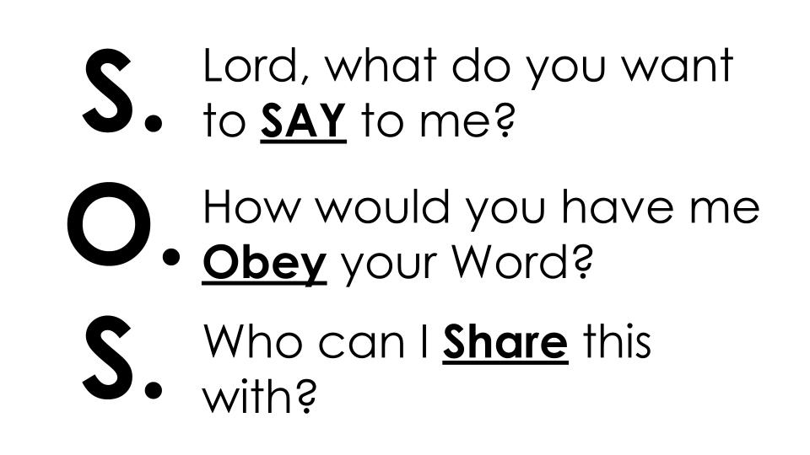
Have someone set a 3 minute timer and everyone take 3 minutes with this passage open in front of you to pray and ask the Lord these three questions.

You may want to break into micro-groups of 3 to share how the Lord is leading you.

- Be sure someone writes down what is shared so you can encourage each other throughout the week and touch base next week on how it went.

- Take some time to pray for one another, to have the wisdom and strength to be doers of the Word - putting your faith into action this week.

