You are Established
Matthew 9:9-13

“As Jesus passed on from there he saw a man called Matthew sitting at the tax booth and he said to him, ‘Follow me.’ And he rose and followed him.”
Matthew 9:9

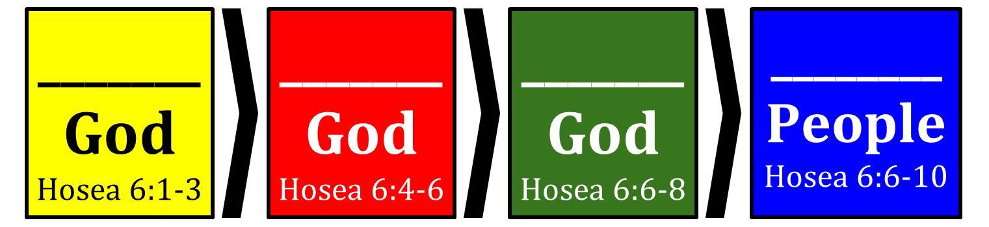
Layers of Commitment to God:

K_______ God (Hos. 6:1-3) →
L_______ God (Hos. 6:4-6) →
O_______ God (Hos. 6:6-8) →
L_______ People (Hos. 6:6-10)

“Those who are well have no need of a physician, but those who are sick. Go and learn what this means, ‘I desire mercy, and not sacrifice.’ For I came not to call the righteous, but sinners.” Matthew 9:12-13 (Hosea 6:6)

You are Established
Matthew 9:9-13

“As Jesus passed on from there he saw a man called Matthew sitting at the tax booth and he said to him, ‘Follow me.’ And he rose and followed him.”
Matthew 9:9

Layers of Commitment to God:

Know God (Hos. 6:1-3) →
Love God (Hos. 6:4-6) →
Obey God (Hos. 6:6-8) →
Love People (Hos. 6:6-10)

“Those who are well have no need of a physician, but those who are sick. Go and learn what this means, ‘I desire mercy, and not sacrifice.’ For I came not to call the righteous, but sinners.” Matthew 9:12-13 (Hosea 6:6)

