Know God’s Heart
Luke 15

What a beautiful chapter in Scripture! Three parables about lost things - Jesus very intentionally told them together as one unified lesson. Now, let’s rewind to verse one for the context:

“Now the tax collectors and sinners were all drawing near to hear him. And the Pharisees and the scribes grumbled, saying, ‘This man receives sinners and eats with them.’” Luke 15:1-2

Did you catch that word in verse 1? ALL. Can you imagine? Word was spreading about this rabbi who preached forgiveness. A Jewish rabbi who healed everyone who came to him and would hang out with the rabble - the outcasts - the unclean. ALL of the tax collectors and sinners were drawing near to hear him. Prostitutes. The demon possessed. Criminals. Pick-pockets. Tax-collectors, who were legal Rome-appointed pick-pockets. Zealots, revolutionaries, assassins. Lepers. Blind people. Others with diseases who were obviously cursed because of their sin or maybe their parents’ sin.

All of the riff-raff were coming to hear Jesus. So the Pharisees and scribes - the religious elite - the top ranking establishment Jews - began to grumble. And look what they accuse Jesus of: “This man RECEIVES sinners and eats with them.”

You’d think that anyone perceiving this about Jesus would be drawn to Him! You’d think that those religious men who had studied the Old Testament their entire lives would have gotten enough of a vision of the holiness and glory of God that they would be amazed and filled with hope that God could forgive and accept even THEM for their pride and their selfishness and sin.
But therein lies the problem. They did not see their sin because they were so focused on the sins of others.

But oh, brother and sister - dear friend - hear the gospel there in verse 2. THIS MAN - This Jesus - does receive sinners and eats with them. There is hope for you and me! Hope in His Amazing Grace! “I once was lost, but now I’m found; was blind but now I see!”

What we will see in Luke 15 is three burdens of God’s heart. May the Lord help us feel these burdens - to share the emotions of our loving Father in heaven - so we are moved to join Him in His work around us. First:

God’s Heart:
- Compassion for lost people
“What man of you, having 100 sheep, if he has lost one of them, does not leave the 99 and go after the one until he finds it?” Luke 15:4

Looking around at these tax collectors and sinners, maybe among the ragtag group that day there was a shepherd with some sheep. Surely Jesus had known local shepherds, and quite possibly as a young man growing up in the countryside village of Nazareth Jesus had helped a friend out with late night duty watching sheep. He may well have experienced that rush of emotion when you realize that one of the sheep you are supposed to be watching over is gone. It is not with the group anymore. It is missing.

Parents know this dreadful feeling well. We were in a big department store with the three older boys and suddenly turned around and only saw two. One was missing. Our hearts stopped as we scrambled around looking and calling. Within a few minutes - maybe it was only seconds - we found the little boy giggling and hiding in one of those circular clothing racks. It’s like those were designed to entice small children to play a quick, spontaneous round of hide and seek.

Another time we were at a dinner party with our church staff. Large gathering, lots of adults, lots of people, including the two teenage girls we used most often to babysit for our boys. So we didn’t worry a lot about keeping an eye on them, until someone came and asked, “Where are the little guys?” Our youngest at the time was around two and the worship pastor’s youngest at the time was around three, and was a pretty take charge kind of guy. And they led us on a merry chase, I tell you.

It was probably only 15 or 20 minutes. But that hunt felt like FOREVER. We pretty quickly determined the two little boys were not in the house or on the grounds. So several of us set out in cars, driving slowly around the neighborhood, calling their names. Finally they were spotted moving from one yard to another - and the straying boys were brought home, much to everyone’s relief.

I’m sure every parent in the room could tell a story or two like those.

That feeling of desperate, crippling terror. Your precious little one is gone. You don’t know where they are. They are too young to relocate themselves. Like a sheep. They must BE FOUND. So you mobilize a search party. You hunt and hunt until you find them.

That is how God feels about lost people. That is how God feels about tax collectors and sinners. The word “lost” is very appropriate for our friends, family members, neighbors and co-workers who don’t yet know Jesus. They are lost.

- Compassion for lost people
  - Confused
“What man of you, having 100 sheep, if he has lost one of them, does not leave the 99 and go after the one until he finds it?” Luke 15:4

They are confused. They don’t understand the situation. If the sheep could find its way back, it wasn’t really lost. But sheep are not like dogs in that way - if they wander away from the group they don’t have the sense of direction or the keen sense of smell to find their way back.

One of our elders here loves to send me video memes of sheep. Here is one of my favorites.
https://www.instagram.com/reel/Cu6tk_XLxgp/?igshid=MTc4MmM1YmI2Ng==
You can tell this poor sheep is confused. He doesn’t understand that the young guy is trying to help him and that the ditch is not a good, safe place for him. He also greatly overestimated his leaping ability.

- Compassion for lost people
  - Confused
“And when he finds it, he lays it on his shoulders, rejoicing.” Luke 15:5

In this first parable, Jesus pictures a good shepherd, not just leading his lost sheep home, but CARRYING it home. Whether the sheep was injured or just scared, the shepherd was taking no chances of that video happening, and wanted to get back to the flock quickly.

The point is that God has deep compassion for lost people - knowing they are confused. They are like the Ninevites to whom God sent the prophet Jonah. “They don’t know their right hand from their left.” Yes, those ancient enemies of Israel were cruel, violent and worshiped idols. But most of the reason for those facts is that they were confused. They were lost in their sin and didn’t know another way.

Fast forward to the lost son.

- Compassion for lost people
  - Crippled
“And took a journey into a far country, and there he squandered his property in reckless living.” Luke 15:13

Not only was this sinful prodigal confused - in pretty short order he was crippled by the effects of his sinful life. His money ran out, his “friends” disappeared, and he found himself in desperate straits.

Imagine a sheep that has gotten lost - it is terrified out in the wild, uncertain which way to go, extremely vulnerable to every predator - and then it gets trapped in thorn bushes or stuck in a ditch. When sheep are heavy with wool they are especially vulnerable to falling over and being unable to get up on their own. Again, we saw in the first parable how the shepherd had to first find the sheep and then carry the sheep home on his shoulders, presumably because it was injured.

One of the beautiful images in Psalm 23 is the phrase, “He anoints my head with oil.” Oil was one of the best healing treatments for cuts and scrapes in ancient times. It was like the Neosporin of the ancient world.

Lost people are not just confused in terms of what is right and wrong, good and bad, which way is up… they are crippled by the pain and brokenness of this world. The first person I ever led to Jesus was a 15 year old in the city of Chicago named Daniel. When I met him he had just been beaten out of the hispanic gang in the area, the Latin Kings. I was 20 years old, spending the summer in La Villita, the Little Village of Chicago’s south side.

Daniel was with me in my little red Dodge Colt, driving down a side street in that area when a group of teens saw him and whistled, pointing at the car. Suddenly lots of hispanic young men started walking and biking toward us and Daniel slumped down to get out of sight and said, “Get us out of here!” I turned around as quickly as I could and we raced the other way as quickly as those 4 cylinders could go. That was how I learned he had been in their gang and wasn’t anymore - so he wasn’t supposed to be in their territory anymore.

Daniel was lost. He was terrified. In a lot of ways he was crippled by his fears and the choices of his past. But our little team loved him and hung out with him and shared Jesus with him - and he found in Jesus security, peace, love, acceptance and new direction for his life. Plus he plugged in with the youth group we were working with and started to rebuild his life with Jesus at the center. He began to escape the confusion, brokenness and corruption of his past life. Look back at the prodigal son - out of money, working for a pig farmer:

- Compassion for lost people
  - Corrupted
“And he was longing to be fed with the pods that the pigs ate, but no one gave him anything.” Luke 15:16
Jesus chose PIGS on purpose here. Nothing would have better captured how a Pharisee felt about a tax collector better than this picture of a Jewish young man eating slop with pigs. Filthy. Disgusting. Abominable. Compromise. Corruption.

And how tragic that even though he wanted to eat the pig food, no one even let him do that! It doesn’t get any more desperate than this!

Do you feel God’s heart for lost people? Think about a friend or neighbor of yours who doesn’t know Jesus. Do you realize that person is confused. He doesn’t know what is true about God or himself. He doesn’t clearly perceive right and wrong. He probably is quite convinced that he is a good person and thinks of God - if there is one - more or less like Santa Claus. Sure, he’s got a list of naughty and nice but pretty much everyone is nice - he’s not going to actually give coal to anyone!

Your neighbor is not just confused, she is crippled. Think of the pain and brokenness YOU have experienced in this world - then take away the healing and support, the love and peace you get from Jesus and the church. Now, on top of the pain you have isolation, loneliness, despair. Is it any wonder there is a crisis of drug and alcohol use in our country? Is it any wonder there is a crisis of depression and suicide? People are trapped in their pain with nowhere to turn.

And your neighbor is corrupted with the virus of sin - it has spread to every cell in his body. Selfishness, pride, greed, lust, envy - all the deadly ones.

Oh Lord, have mercy on our friends and neighbors! Help them see that they are lost! Help them see that you alone have the power to change them! Give us YOUR heart for the lost people around us!

God’s heart overflows with compassion for lost people. But the keynote of this chapter is not sadness, but JOY.

God’s Heart:
- Celebration when a sinner repents
“But when he came to himself, he said, ‘How many of my father’s hired servants have more than enough…’” Luke 15:17

Here is the wonderful turning point we pray for with our lost friends, family members and neighbors: “he came to himself.” He suddenly realized that he was lost. His eyes were opened to the foolishness of the path he was on - he saw that it really was a dead end. He woke up.

And the first schock in the parable of the prodigal son is that when his father sees him, he doesn’t send out men to beat him up or cast him out, the father himself runs to embrace him!
God’s Heart:
- Celebration when a sinner repents
“His father saw him and felt compassion, and ran and embraced him and kissed him.” Luke 15:19

Not one ounce of anger or judgment - the father’s response was all love and affection. And then he called for a party!

God’s Heart:
- Celebration when a sinner repents
“Bring the fattened calf and kill it, and let us eat and celebrate!” Luke 15:23

It’s hard to overstate how shocking this whole parable was to the Jews in Jesus’ day. The fact that the younger son took his share of the estate when his father was still alive was unimaginably disrespectful. But the even bigger shock was the father’s reaction when the son came home. He could have been publicly stoned for his disrespect and sinful lifestyle. He certainly should have been publicly rebuked and hidden away for a while to prove his repentance. But look at the father’s rationale:

God’s Heart:
- Celebration when a sinner repents
“For this son of mine was dead and is alive again; he was lost, and is found.” Luke 15:24

This father was celebrating a RESURRECTION. And that’s what every conversion is - it is a complete transformation from death to life; from lost to found; from sinner to saint.

God’s heart rejoices every time a sinner turns from his sin and comes to Jesus in faith. This theme of rejoicing runs through this chapter.

God’s Heart:
- Celebration when a sinner repents
“There will be more joy in heaven over one sinner who repents than over 99 righteous persons who need no repentance.” Luke 15:7

Now, we could debate the level of sarcasm Jesus is expressing in this statement. The whole point of this chapter, arguably, is that those 99 “righteous persons,” aren’t really so righteous after all. So the thought that they “need no repentance,” is laughable.

In reality, while God’s heart rejoices when sinners repent, God’s heart is grieved when proud, self-righteous people think they don’t need to repent. But that’s our third point - there’s more to say here about repentance and faith.

- Celebration when a sinner repents
- The Double Miracle of repentance and faith
“He came to himself… And he arose and came to his father.” Luke 15:17,20

For someone to get saved a double miracle must take place. First, they must repent, then they must believe. To repent is to turn away from your sin and your old life. It is to let go of the life you have known. To repent means to turn around - it’s a directional term for making a 180.

And that is truly a miracle.
- When an alcoholic finally has that last drink.
- When an addict flushes the drugs.
- When someone closes the browser and installs covenant eyes on all his devices.
- When a married couple finally agrees to get counseling.
- When a workaholic accepts a demotion for the sake of his family.

Conviction of sin is a wonderful gift of the Holy Spirit. An early sign that God is working on someone is that they begin to feel uncomfortable with their sin and their lifestyle as it is. It’s a critical turning point when they truly repent - when they come to that place of not just feeling bad for their sins but actually turning from them. It’s one thing to be sorry, it’s another thing to repent. And that’s the first half of the miracle of salvation.
The second half is faith - and of course, the two parts go together like two sides of the same coin. The prodigal not only left his pig stall, he came home. He didn’t know what kind of reception he would receive from his father, which is why he rehearsed his little speech about being just a hired worker. But the father’s response shows the amazing grace of God.

- Celebration when a sinner repents
- The Double Blessing of salvation: forgiveness and justification
“Bring quickly the best robe and put it on him, and put a ring on his hand, and shoes on his feet.” Luke 15:22

This is a beautiful and significant picture of the grace of our God. When God sees true repentance and faith, He responds like this. He not only accepts the sinner who repents, God EMBRACES you. He lifts you up off of your knees and welcomes you home as a beloved son or daughter.

The good news of salvation is not just the forgiveness of sins. 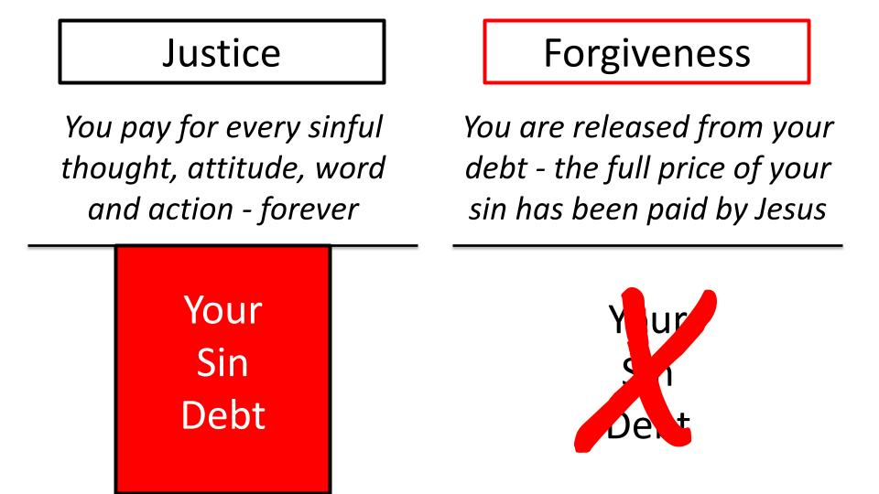
To be forgiven is to be released from your sin debt. All of that red below the line - the full price of your sin is ZEROED out when you call on Jesus to save you. Your sin is removed from you “as far as the east is from the west.” “It is nailed to the cross and I bear it no more, praise the Lord, praise the Lord, o my soul!” That is the MERCY of God to not give us the punishment our sins deserve. GRACE goes further!

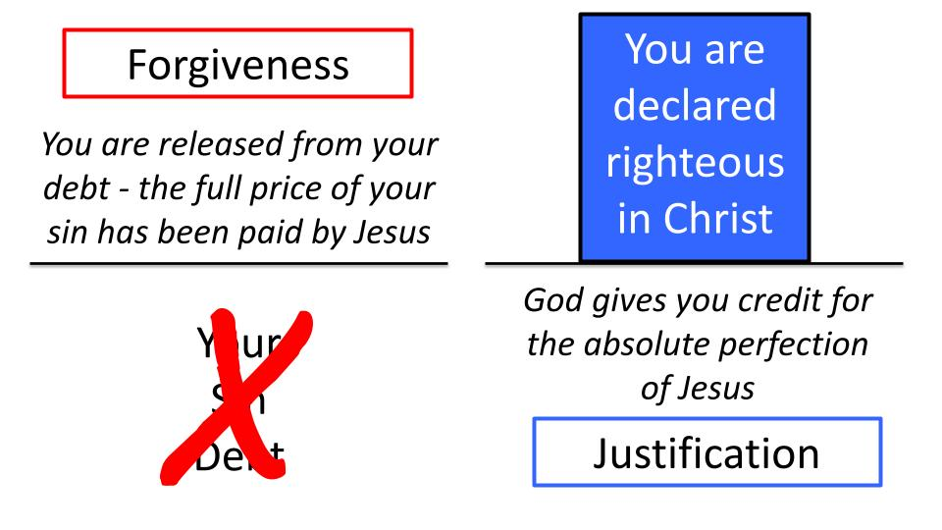
Forgiveness erases your debt; justification gives you credit for Jesus’ perfection. To be JUSTIFIED is to be pronounced RIGHTEOUS before God - to be declared PERFECT in Christ.

- The mercy of God takes away the judgment you deserve.
- The grace of God gives you infinite blessings you could never deserve.

This is what the father’s response to the prodigal son represents:

- Celebration when a sinner repents
- The Double Blessing of salvation: forgiveness and justification
“Bring quickly the best robe and put it on him, and put a ring on his hand, and shoes on his feet.” Luke 15:22

The young rebel should have stayed in his rags, barefoot and exposed for the poverty his sinful lifestyle had earned him. He should have stayed outside, or maybe slept in a barn with the animals for a while. That’s what justice would have given him.

But the father responded with mercy and grace. Mercy forgave the debt. The young man was immediately released from the obligation to pay back his half of the inheritance - a debt he could never scrape together. But grace went further. Grace put the best robe on his shoulders, a ring on his finger and new shoes on his feet. Grace restored him to the place of a SON in the family - not a servant on the grounds.

Do you feel the heart of God for sinners? How He longs to be merciful! How he longs to offer grace. “NOW is the time of God’s favor. NOW is the day of salvation.”

These are the days of Noah, the very last days, when the doors of the Ark of salvation stand wide open for anyone who would come to Jesus and be saved. For Jesus is the ultimate ARK of salvation. He stands with His arms open wide, willing to forgive and embrace everyone who comes to him in true repentance and faith.

God’s heart is filled with compassion for lost people. His heart celebrates when a sinner repents and comes to Jesus in faith. One more side of God’s heart that this chapter shows us:

God’s Heart:
- Concern for religious people
- Hard-working
“Now his older son was in the field, and as he came and drew near he heard music.” Luke 15:25

This parable is often presented as the parable of the prodigal son - as if there was only one son in this story. But the story begins by saying that a man had TWO SONS. The progression is from 100 sheep to 10 coins to 2 sons. Not 1 son, but 2. When the sinful prodigal comes home, the story is not over. The big brother was out in the field after another long day of work. That’s the first description of a “religious person,” or an “older brother,” they work hard. They do their best. They consider themselves “righteous people.” They pay their taxes, show up on time for work, stay married to their spouses, raise their kids, coach baseball and soccer. They teach Sunday School and attend a small group. They say their prayers and read their Bibles. They work hard, like this older brother.

When he heard what was going on:

God’s Heart:
- Concern for religious people
- Irritated by Slackers
“He was angry and refused to go in.” Luke 15:28

The second description of a religious person is that they are easily irritated by people less hard working than they are. We can certainly sympathize with this situation. Your little brother forces Dad to liquidate half of the family wealth, then takes all the cash and wastes it on prostitutes and booze. I think everyone would be rightly upset with this family situation. There is nothing positive about it.

And those of us who are familiar with this parable relish the mercy and grace of the Father for sinners like us - but we can easily gloss over what this meant for the older brother.
Think about it. Who was paying for this big, elaborate feast? Whose share of the estate did the fattened calf fall into? And the robe and the ring and the shoes?

In the mind of the older brother, everything else on the family estate was now HIS - because little bro had wasted his half. And the Father seems to acknowledge this when he says, “Everything I have is yours.”

But the telltale sign of the older brother attitude is anger. Counselors tell us that anger is like SMOKE. It’s a secondary emotion that points to something deeper - a source of the smoke, usually pain. Frustrated expectations. Resentment. Bitterness.

And the older brother gave himself away in this.

- Concern for religious people
- Irritated by Slackers
“These many years I have served you, and I never disobeyed your command, yet you never gave me a young goat that I might celebrate with my friends.” Luke 15:29

A therapist would have a field day with this line. “These many years.” NEVER once disobeyed a single thing. Wow. Impressive. NEVER so much as a goat party. Not even a spare rabbit here or there? Dad gave you NOTHING? Man, sounds like a pretty terrible dad there. So demanding with all of his commands, so unappreciative with your lack of parties.

Again we see the hard-working attitude of the older brother. He really did work hard on that family farm all those years. Did he have the best attitude - not so much. But he certainly worked hard. Was he as righteous and obedient as he claims here - probably not. Was he as neglected as he claims here? Certainly not.

But as the therapist would tell us - these are FEELING statements, not FACTUAL statements. That’s what never and always betray. The older brother FEELS NEGLECTED, feels mistreated by comparison with the younger brother. In other words, big bro felt entitled to the party himself. Little bro didn’t deserve that celebration - big bro did! He should get the robe and the ring and the shoes and the veal. Ah, that sweet, tender veal parm.

- Concern for religious people
- Ungrateful for what they have
“But when this son of yours came, who has devoured your property with prostitutes, you killed the fattened calf for him!” Luke 15:30

Here is the final description of a religious person - they are hard working, entitled, irritable and ungrateful. He doesn’t even claim the brother anymore - he is “this son of YOURS.”

Those of us who have been in the church for a long time can easily become like this older brother if we don’t watch our hearts carefully. We work hard. We serve the Father. We do our best to guard against sin and remain holy. We read our Bibles and pray. We serve and sacrifice. And all of this can lead us to feel entitled to certain blessings from God - so that if things don’t go the way we expect we get irritated, frustrated and even bitter. Instead of being grateful for God’s gracious provision in our lives we become resentful about what God has NOT given us.

If you haven’t yet read Prodigal God by Tim Keller, it’s a powerful and inspiring reflection on this parable of the two sons. And here is the punchline: the prodigal son had a lousy older brother. What would a good older brother have done in that situation? He would have left home, trekked across country to find the little scoundrel, grabbed him by the scruff of the neck and dragged him home at his own expense. Sadly, the prodigal’s brother did none of this. He stayed home, working and sulking, filled with self-pity and judgmentalism.

The prodigal son had a lousy older brother. But we don’t. We have the TRUE OLDER BROTHER in our Lord Jesus. Keller sums it up this way:

“Think of the kind of brother we need. We need one who does not just go to the next country to find us but who will come all the way from heaven to earth. We need one who is willing to pay not just a finite amount of money, but, at the infinite cost of his own life to bring us into God’s family, for our debt is much greater… We deserve alienation, isolation, and rejection… Our true elder brother paid our debt, on the cross, in our place…” Tim Keller, Prodigal God
Let’s pray and give thanks for our older brother, Jesus, who proved the heart of God - His compassion for lost sinners, His joy when sinners repent, and His concern for hard-hearted religious people. Like the Father who went out and entreated his older son to come in and join the party - Jesus pleads with all of us - both the younger brother rebels and the older brother religious folks - to come into the celebration of God’s amazing grace!

