Gospel Partnership
Philippians 4:10-20

“Fellowship” has become a very tame church word that makes us think about potluck dinners and card games. I think about the “fellowship hall” in the church where I grew up which was where the tasty treats were kept on Sunday morning. And my brother and I were mostly chased away from that table, but we found ways to escape the pursuit and dart back in to grab the goods. We enlisted help from our friends so one would create a disturbance to get “one eyed Gus” away from the table so the others could harvest. Later I got to know good ol’ Gus and he was a very nice older guy - but as a kid he was like Argus Filch in Harry Potter - a grumpy old rule-enforcer.

The even more magical word than fellowship was “afterglow.” That’s a pretty wild word that the church adopted to mean “cookies” after the evening service. If you want to increase your appreciation of the word “fellowship,” the cure is right here in the book of Philippians. We see the word twice in verses 14-15.

“Yet it was kind of you to share (koine) in my troubles… no church entered into partnership (koinonia) with me in giving and receiving except you only.” Philippians 4:14-15

I agree with the ESV here, that the best translation for the Greek word “koinonia” is not fellowship but PARTNERSHIP. The root word is about SHARING. Notice how Paul talks about the believers in Philippi sharing in his troubles - meaning his financial troubles which were related to his personal hardship of being on house arrest. In ancient times when you were in prison it was up to your friends and family to supply you with food and clothing, blankets and supplies. So Paul’s troubles would have been even worse if people like those in Philippi had not sent funds and supplies to him.

And this is why Paul wrote the letter - to thank this courageous and generous body of believers for their generous support. Look back in chapter one:

“Making my prayer with joy, because of your partnership (koinonia) in the gospel from the first day until now.” Philippians 1:4-5

Sadly, even though Paul planted several churches on his first couple of missionary journeys only one - only the church in Philippi - paid it forward by investing in the apostle as he continued to carry the gospel on. We saw last week in 1 Corinthians 9 how Paul used the church in Philippi to guilt, I mean motivate, the believers in Corinth to follow their example of giving even though they were facing extreme poverty themselves! But as it often is with kingdom math, that one church was able to meet Paul’s needs. He says at the end of chapter 4:

“I have received full payment, and more. I am well supplied, having received from Epaphroditus the gifts you sent, a fragrant offering, a sacrifice acceptable and pleasing to God.” Philippians 4:18

This is how we feel at Oakwood right now. Back in February and March we fell behind in our monthly giving and let the church family know. The result was giving in April and May that set records and helped us go from being 20,000 behind budget to being 23,000 ahead! We have been well supplied! We give thanks to the Lord for your generosity which is a “fragrant offering, a sacrifice acceptable and pleasing to God.”

So as we wrap up this short series on Stewardship here are four ways to grow in your giving that we find in Philippians 4. First:

How to Grow in your Giving:
- Kindle Concern for Gospel Workers
“I rejoiced in the Lord greatly that now at length you have revived your concern for me.” Philippians 4:10

Paul did a good job of staying in touch with the people he led to the Lord and helped organize into churches. He sent letters to them - some we have and some we don’t have. And he sent people to them - people like Timothy and Barnabas and Silas and Epaphroditus. So Paul was aware of the groups who remained concerned about him and prayed for him and those who kind of forgot about him or even became opposed to him. That happened pretty often as well.

But here we see the believers in Philippi have “revived” their concern for Paul. We can see how this takes place. You hear about a missionary or a church planter and at first you pray for them every day and watch for updates. You text and call and are very engaged. But over time, your concern and awareness and prayers and giving wane - they subside. Until something happens to rekindle your concern. Maybe it’s a specific need. Maybe it’s a visit or an email update.

But somehow the Lord rekindles your concern. And you begin to pray more. You set aside some funds. You meet a practical need. I’ve found that’s often all it takes to mobilize giving - just let people know about a need and their hearts are moved to respond.

I recently learned about a resource in our area called The Care Portal. It’s administered through Florida 1.27, a ministry supporting foster parents. This is a true story I recently heard from Brian, the founder and director of Florida 1.27. A caseworker met with a single mom in our area and told her that she had 9 days to find a bed for herself and a crib for her baby daughter or she would lose both of her children. The caseworker submitted this need into the Care Portal and it sent a notification to three or four churches in our area who are registered with Florida 1.27.

One of those church leaders forwarded the need on to people in his church who were signed up for this kind of thing. One of those people was an older couple who immediately clicked “accept,” for the need because they had a crib sitting in their garage waiting for grandkids that weren’t coming any time soon. And they could afford a new bed. So they contacted the single mom and arranged to meet with her to deliver the crib and bed. Three days from when the need was posted to when the single mom received the resources she needed to keep her children.

In the process, this couple offered to pray with her, which she happily agreed to. They invited her to church and over time she not only started attending but gave her life to Christ and became an active part of the church!

We are planning to start a support group for families looking to foster and adopt children, and we may well register with Florida 1.27 and engage with the Care Portal. Oakwood already has a lot of families who have fostered or adopted children - so we have experience in this area. Our concern has already been kindled by the Lord to meet this need. Very much like the Lord did with our ESL program. Many of you - the Lord moved your hearts to help start that program last year and to keep investing in it this year.

That’s the first way to grow in your giving: kindle your concern. Increase your awareness of Christian ministries, missionaries and initiatives. Read, research, ask around, meet with ministry leaders. Get ministry updates and pray through them. Ask the Holy Spirit to stir up your heart for what matters to God. Kindle your concern. Second:

How to Grow in your Giving:
- Totally Trust in the Lord
“Not that I am speaking of being in need, for I have learned in whatever situation to be content.” Philippians 4:11

We saw that in this moment Paul was “well supplied,” because of a gift the Philippian believers had already sent to him. But his “well supplied,” was still prison rations. He wasn’t sitting with his feet up sunbathing at a resort sipping Arnold Palmers. He had food, he had sufficient clothing - and with that he was content.

So let’s learn from the apostle Paul this key lesson he learned - “in whatever situation to be content.”

- Totally Trust in the Lord
“I know how to be brought low, and I know how to abound. In any and every circumstance, I have learned the secret of facing plenty and hunger, abundance and need.” Philippians 4:12

Paul had lived on both sides of neediness equation. He had lived with abundance and he had lived - as he was now - with serious need. We know Paul was a tentmaker - he provided most of his own financial and practical support by working with his own hands. It follows then that there were times when business was good - when he was able to make plenty of money to the point that not only were his own needs met but he was able to give to help others in need.

How do we handle this balancing act? How do we manage times of little or no financial provision? How do we navigate times of financial abundance? Both represent dangers to us. Whether you have a lot of money or very little money the danger is there to love and trust in money to save you. That’s the punchline here - and it is so significant and so often misunderstood.

- Totally Trust in the Lord
“I can do all things through him who strengthens me.” Philippians 4:13

I bet you’ve heard this verse quoted by a Christian athlete. Does it apply to football or track? Sure - in the sense that it applies to every part of the Christian life. “All things” is nicely comprehensive. But notice the context here: Paul is talking about finances.

The “all things” refers to times of financial plenty and times of financial desperation. Paul is saying that he learned how to avoid the love of money whether he had it or he didn’t.

I wonder if we realize how much of our faith and confidence and peace and joy are actually in our MONEY as opposed to in the Lord who strengthens us. Financial security always comes up as a prominent need and concern in marriage. Financial stress is one of the primary challenges to any marriage - and obviously not just for married people but for everyone.

Here is a little exercise to reveal what we really trust in.
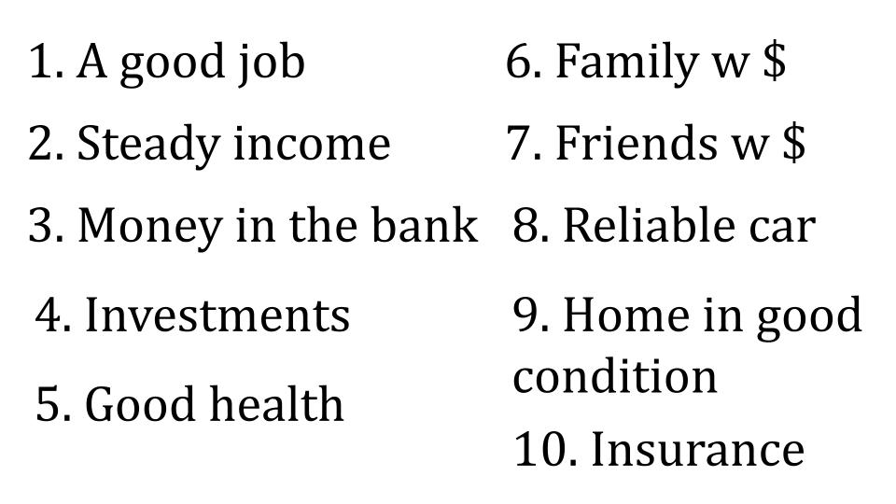
[With each click, take away 2 of these until they are all gone.]

It’s easy to say we trust fully in the Lord when we have lots of protections in place for our financial security. But when those protections start to fall away we realize that we actually trusted more in the safeguards than we did in the Lord.

Think of how many of these ten things Paul had going for him. We can’t be sure - but at this point, chained to a Roman soldier, he had no job, no income, no access to money in the bank even if he had some somewhere, no investments, probably some health challenges. No transportation and limited housing, no insurance, no immediate family and potentially no extended family that would support him since he left his radical Jewish commitments and embraced what his parents and siblings almost certainly believed was a cult.

So on this list of 10 things, in all probability the only thing Paul had was some friends with money. And those friends in Philippi themselves had almost none of these protections either.

Now come back to verse 13:

- Totally Trust in the Lord
“I can do all things through him who strengthens me.” Philippians 4:13

Do we really believe this verse? If you’re like me, you’ve probably applied this like:
- I have a big test on Friday or a big presentation for work, I can do it with Jesus giving me strength.
- I have a big game on Saturday, I can do it with Jesus.
- I get to preach on Sunday or teach a class, Lord Jesus please strengthen me.
- I need to have a hard conversation with a friend, Jesus help me.

All of these examples are focused on situations of OPPORTUNITY rather than desperate need. We’d be closer to what Paul means if we reversed them:
- I can’t afford school, so I don’t have any tests coming up - but I can get through this season with Jesus strengthening me.
- I don’t have time to play a sport because I have to work extra hours to pay the bills - Jesus help me!
- I’m living in a hard place with no church near me and nobody around who seems to really know and love Jesus - so I desperately need HIM right now!
- I don’t have any friends or family near me to help and support me - so I have to depend on Jesus completely!

Have WE learned the secret of being content in any situation? Do we know not only how to abound when things go well - but how to be brought low - how to face hunger and need?

Those are the moments when you don’t just pray casually here and there as a little spiritual exercise for the day. Those are the moments when you cry out to Jesus because if He doesn’t show up and strengthen you, you’ve got nothing left. You’ve got no hope.

“I can do all things through Christ who strengthens me” is along the lines of “for me, to live is Christ and to die is gain.” It means “I am all in with Jesus.” Jesus is my everything. I don’t need a job or a family or people who are saying yes to Jesus all the time - I just need Jesus. I don’t need a fat bank account or cash in my pocket - I just need Jesus. I don’t need an impressive degree or fancy job title - I just need Jesus.

We won’t really grow in our generous giving until we develop real concern for gospel workers and we learn the secret of really being content with Christ alone.

For most of us I’m guessing Jesus is the “cherry on top” of our generally comfortable lives. We are very glad to have that special, spiritual cherry on top. But really what we love and trust and live for is our comfortable lives. Pray today that the Lord would show you a missionary or ministry you can support financially - and make a contribution that you actually FEEL. Take a step that requires actual faith and risk - that forces you to actually say, “I can only do this if Christ strengthens me.” That’s step three:

How to Grow in your Giving:
- Proactively Partner in gospel ministry
“Yet it was kind of you to share in my troubles.” Philippians 4:14

Paul was so grateful for this small but faithful and generous church. He so appreciated their tangible kindness. It’s one thing to say to a missionary, “I’m praying for you.” It’s another thing to actually pray for them - and another level further to regularly give to support their ministry. The Philippians did both. They stood with Paul in prayer and they invested in his gospel ministry. They SHARED in his troubles. And they did it at a time when no one else was!

- Proactively Partner in gospel ministry
“And you Philippians yourselves know that in the beginning of the gospel, when I left Macedonia, no church entered into partnership with me… except you only.” Philippians 4:15

Remember, that word “partnership” is the Greek koinonia - fellowship, sharing. No one else partnered with Paul. No other church stood with Paul to help him bring the gospel forward where it had not yet been heard. Only this small, struggling group of believers in Philippi.

- Proactively Partner in gospel ministry
“Even in Thessalonica you sent me help for my needs once and again.” Philippians 4:16

They sent him tangible help - probably money. Maybe also food, a cloak, parchment to write on. But “help for my needs” almost certainly means financial help.

Is this how we approach missionary support these days?

It obviously isn’t since every ministry out there feels compelled to host an expensive annual banquet where they feed us great food in a fancy banquet hall and make a professional pitch to get a little slice of our money. Fall is approaching and I bet you’ve already gotten 10 invitations to different ministry banquets and you know exactly what will happen. You’ll hear about the ministry, you’ll be encouraged by the amount you gave last year and you will write another check at the banquet.

I’m not saying those events are wrong or inappropriate. I’m saying they shouldn’t be necessary for fundraising. They should be simple affairs to share God stories of all that He did because people gave and others served and babies were saved and refugees served and slaves set free and lost people heard the gospel and responded.
I’ve heard it said, “if every Christian gave 10% we could complete the great commission in a couple of years.” I bet that’s a true statement. Generally in the U.S. around one in three people is considered a “born again Christian.” I’m not talking about those who are confused about the gospel, I’m talking about those who really know Jesus and claim to follow Him as Lord. Around 30%. 332 million people live in the U.S. 131M households = 43M Christian households x $71K median household income x 10% = $305 BILLION.

https://www.ncfgiving.com/stories/what-would-happen-if-the-church-tithed/

Churches in American currently work with around $50B in annual giving. So if every Christian would simply start to TITHE, we would multiply every church’s budget by 6.

And we’ve seen in this stewardship series that tithing is the starting point of Christian generosity, not the end point. If we got serious about simplifying our lives, downsizing our standard of living and learning from the rest of the world about what is necessary vs. what is luxury we could certainly go further still.

Church leaders, just imagine if instead of struggling from month to month over the $57K we need if that number was multiplied by 6? We would have our full annual budget received in two months and the rest we could devote to ministries and missions!

The National Christian Foundation published an article posing this question:
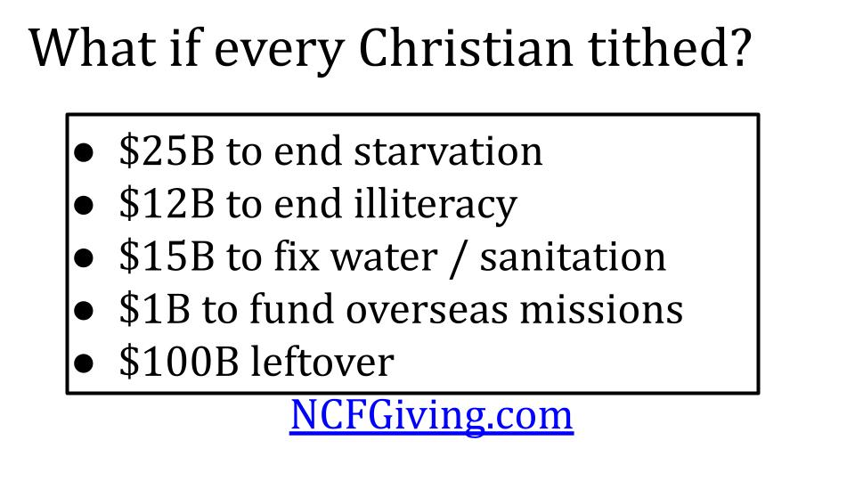
They suggested some practical uses to that kind of money. Little things like ending starvation and illiteracy. Oh, and reaching the remaining unreached people groups. With a few bucks leftover after those little projects - 100B or so.

Imagine if the Lord blessed us with a time of revival and it affected our giving? Our concern for gospel workers would increase, our confidence in King Jesus would increase and our investment in gospel ministry would increase. One more step to grow in giving:

How to Grow in your Giving:
- Invest for Eternity
“Not that I seek the gift, but I seek the fruit that increases to your credit.” Philippians 4:17

Paul was sincerely not looking for more financial support. Of course, he was grateful for that support and definitely still needed it as he was chained up in jail. But his desire was for the believers in Philippi to keep growing in the Lord - to keep producing the FRUIT OF THE SPIRIT. “The fruit that increases.”

Aren’t you glad that the way we grow in the Lord is like FRUIT not like a FACTORY? Our job is to stay connected with Jesus, the vine, and He has promised that as we abide in Him, we WILL bear much fruit! What we can produce on our own - what we can work up - is of the flesh and it’s lovely things like immorality, impurity, idolatry, envy, strife, division and conflict.

Giving is a fruit of the Spirit because it is the product of LOVE. And as we grow in love, that fruit increases to our CREDIT. Now, what does Paul mean here by credit? Is he talking about merit as if we earn God’s favor somehow? Of course not! We know that we are saved by grace alone through faith alone in Christ alone. Nothing we do - no matter how much we might give - adds a single point of merit to earn our salvation. No one has anything to boast about when it comes to salvation.

So what is the CREDIT Paul is talking about here? I think he is talking about treasure in heaven. He is talking about eternal reward. He is talking to believers who are actively seeking first the kingdom of God and His righteousness and assuring them that they have nothing to worry about but that they should experience the peace of God that passes understanding even as they give sacrificially to support gospel ministry. And look at the promise that concludes this section!

“And my God will supply every need of yours according to his riches in glory in Christ Jesus. To our God and Father be glory forever and ever. Amen.” Philippians 4:19-20

EVERY NEED. God does not promise to supply our every want. But our Father in heaven knows what we need before we ask, and He invites us - even commands us to ASK for our daily bread, believing that He will provide what we need. God does not give begrudgingly. He does not give out of lack or desperation. God gives “according to his riches in glory in Christ.”

Why? So that HE gets all the glory in the end. When Jesus comes back and we step into eternity with Him, we will see that every good thing we did was in Him and through His strength. Every dollar we gave, every hour we served, every person we reached with the gospel - it was all a gift of His infinite grace.

So let’s close with Paul’s prayer with which he opened this letter in chapter one:

“And it is my prayer that your love may abound more and more, with knowledge and all discernment, so that you may approve what is excellent, and so be pure and blameless for the day of Christ, filled with the fruit of righteousness that comes through Jesus Christ, to the glory and praise of God.” Philippians 1:9-11

This sums up our lesson for today. May the Lord kindle our concern for gospel workers - that our love would abound more and more. May the Lord strengthen our faith in Him - showing us HIS excellence, His righteousness, His glory and goodness. May the Lord help us approve what is excellent in the gospel ministries here in Tampa Bay and around the world. And may the Lord empower us to invest for eternity, so that WE might be filled with the fruit of righteousness as we give and so the world would increasingly be filled with the righteousness, justice and love of King Jesus, until He comes back.

Let’s pray.

