The Suffering Servant
Isaiah 53:1-12

Isaiah 53 shows us the pattern of Jesus’ life 700 years before he was born. This incredible prophecy anticipates the hymn in Philippians 2:

“Though he was in the form of God, did not count equality with God a thing to be grasped, but emptied himself, by taking the form of a servant, being born in the likeness of men. And being found in human form, he humbled himself by becoming obedient to the point of death, even death on a cross.” Philippians 2:6-8

Jesus is the eternally divine Son of God - of the same divine essence as God the Father, forever united with the Father in the loving unity of the Holy Spirit. Though Jesus is equal with God, fully God in Himself, He did not cling to His rights and privileges as the divine Son, but emptied himself - he laid it all down to become fully human. And as a human he did not insist on glory, comfort and privilege but refused all recognition and followed the path marked out in Isaiah 53 to be a man of sorrows, familiar with grief, despised and rejected by men on whom the sins of the world would be placed.

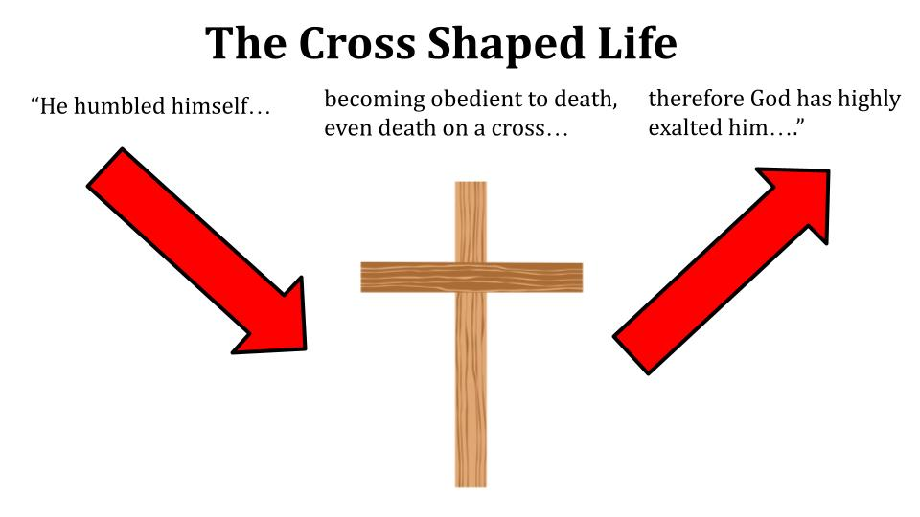
So we see the shape of Jesus’ life:

He started in glory and honor in heaven but DESCENDED to earth, taking on a fully human body and enduring every temptation and every trial that we face. The path of his entire life was downward in humble service, suffering and sacrifice, all the way to a Roman cross where He paid the full price for your sin and mine.

And remember how Jesus called people to follow him - saying “If anyone would come after me he must deny himself, take up his cross daily and follow me.” Jesus very clearly told people that being his disciple meant embracing a cross-shaped life. The symbol of Christianity is a cross not a couch.

So let’s study Isaiah 53 this morning and look at the three parts of this cross-shaped life: incarnation, redemption and resurrection.

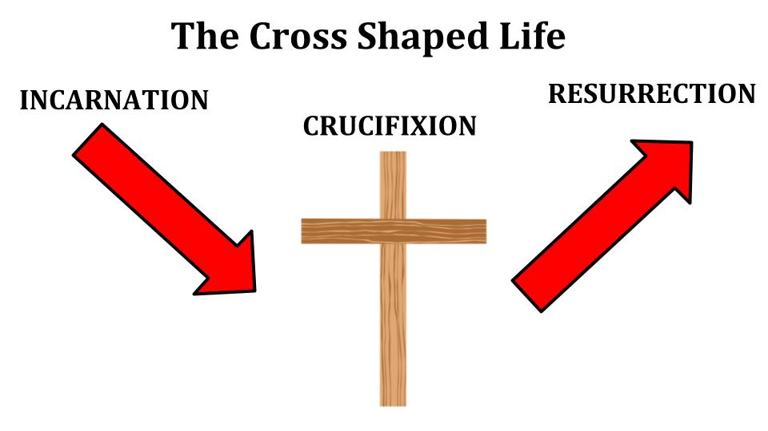
We will see what Jesus did, as foretold by Isaiah 53, and how it gives us an example to follow. The incarnation shows us that Jesus CAME - He stepped into our world, He came to live among us. The crucifixion shows us that Jesus served sacrificially to the ultimate extent. And the resurrection shows us that Jesus trusted the Father completely for His victory, vindication, and restoration to glory. First:

↘ Incarnation: follow the downwardly mobile pattern of Jesus’ life
- Enter: move into a dark place
“He grew up before him like a young plant, and like a root out of dry ground.” Isaiah 53:2

What language of vulnerability! Dry ground, cracked and hardened. If you’ve ever been to the holy land, you know that the land south of Jerusalem is dry, cracked and barren, leading down to the Dead Sea. The northern area of Galilee is like Hawaii - beautiful, well-watered through the Jordan River valley. But the picture here is more like Tatooine - barren, cracked desert terrain. But if you zoom in on a patch of dry ground you see a small shoot coming up - a little splash of green in the midst of all the sandy ground.

And this calls back to Isaiah 11 - the prophecy of a shoot emerging from the stump of Jesse. From King David’s descendants - cut off like a tree chopped down, in terms of actually reigning in Jerusalem. But from that stump of David’s dynasty a small shoot would emerge - little baby Jesus.

What could be more vulnerable than a human baby 2,000 years ago? Child mortality in ancient times was nearly 50%. Half of all children didn’t live past puberty.
https://ourworldindata.org/child-mortality-in-the-past

On top of the usual threats of disease and birth complications, Mary and Joseph had to flee with baby Jesus because King Herod was determined to neutralize the threat of a competitor king rising in his territory. So, the figurative soil of Jesus’ childhood was very dry ground. Nevertheless, “Jesus grew in wisdom and stature and favor with God and man.”

↘ Incarnation: follow the downwardly mobile pattern of Jesus’ life
- Enter: move into a dark place
“He had no form or majesty that we should look at him, and no beauty that we should desire him.” Isaiah 53:2

There was nothing exceptional about Jesus in his earthly life. He was just a normal child, in a normal Jewish family. He wasn’t particularly good looking; he wasn’t impressive in terms of personality or skills. And that’s the whole point. Jesus left the glory of heaven to enter the everyday experience of people like you and me.

“He was tempted in every way as we are, yet without sin.” This was the first part of Jesus’ downward trajectory in the incarnation, he came. He moved into the darkness, brokenness, and pain of our world.
And that is the first part of our calling as followers of Jesus - we are called to step into a dark place in this world. Jesus never intended the light of the world to huddle all together in clumps. He meant for his disciples to speak out all over this dark world, bringing the light of His glory everywhere.

↘ Incarnation: follow the downwardly mobile pattern of Jesus’ life
- Engage: lovingly connect with people
“He has borne our griefs and carried our sorrows.” Isaiah 53:4

Feel the wonderful truth of this verse. Jesus bore YOUR griefs. He carried YOUR sorrows. This is the footprints poem. You look back on your life and at times see two sets and at time one set of footprints. Lord, where were you in the hardest times, when I needed you most? Oh, my dear child - I never left you - those times when you only see one set of footprints, I didn’t leave you - it was then that I carried you!

The incarnation is the evidence that Jesus knows everything we go through. He knows our struggles and pain by severe personal experience. There is a special connection you feel when you meet someone who shares something you have been through:
- Oh, you’re a Cubs fan! What a unique life struggle!
- You’ve moved around a lot.
- A loved one has faced cancer.
- You’ve lost a member of your immediate family.
- You have a child dealing with a disability or other chronic challenge.
- You’ve struggled with addiction.
- You’ve lived through a divorce.
- You just had a baby.
- You’re raising teenagers.

Shared experience is the glue of relationships. And think about this with our Savior - He knows our every struggle. He carried our grief and bore our sorrows. He lived them. He experienced them.

Have you been betrayed? Have you been disappointed by your closest friends and co-workers? Have you experienced deep physical pain?

Jesus knows these things better than anyone.

There is a “fellowship of sharing in His sufferings, becoming like him in his death,” according to Philippians 3. And this is especially true when you enter someone’s world who is in pain and engage with them - when you connect lovingly with someone who is suffering. When you bear their grief; when you carry their sorrows.

Jesus entered, He engaged, and He also endured:

↘ Incarnation: follow the downwardly mobile pattern of Jesus’ life
- Endure: expect resistance and opposition
“He was despised and rejected by men, a man of sorrows and acquainted with grief.” Isaiah 53:3

Jesus did not come to earth to live the comfortable life of a famous and powerful earthly king. He could have! He would have been totally within his rights as the Son of God and the Messianic King from the line of David. You and I are not entitled to live as kings and queens in this world - but Jesus was exactly entitled to that, but he laid that down. He surrendered any expectation of comfort and glory and honor - and came fully knowing he would be rejected, despised, resisted and opposed.

Now - rewind to the days of Isaiah. As the Jews heard these words back then, who did THEY think it referred to? In some ways this was the standard profile of the Jewish leader - whether prophet, priest or king. Moses was often despised and rejected. David - opposed and betrayed. Jeremiah - captured, thrown in a cistern. Daniel - carried away as a slave. Isaiah himself certainly went through times of persecution and opposition.

But it must have been a head-scratcher for them looking to the future. The Messiah was supposed to be a conquering warrior, a triumphant king - anointed to restore the glory to Israel and reign on David’s throne forever. But a thoughtful student of prophecy could have put these pieces together with the others in Isaiah about the Servant of the Lord and possibly surmised that the Messiah would have to suffer - even die.

And Jesus was clear with His followers that we should not expect different treatment than he faced. If people hated him, why would they love us? If people rejected him, why would they celebrate us?

The first part of our calling is to follow Jesus in the incarnation - to embrace the downward mobility of the cross-shaped life by entering dark places, engaging lovingly with broken people and enduring rejection and opposition. That’s just phase one. Now into phase 2.

♰ Redemption: follow the self-less example of Jesus’ death
- Serve: humbly address real needs
“His appearance was so marred, beyond human semblance.” Isaiah 52:14

Jesus did not come to be served but to serve. Our series is called The Servant of the Lord, not The Slacker of the Lord or the Spoiled Child of the Lord. Isaiah 52 and 53 predicted the humble servanthood of our Savior - who would so fully enter our experience that it would actually disfigure his body - beyond recognition even.

This primarily applies to the crucifixion itself, but it also more broadly describes the life Jesus led of humble service. One of the most amazing things to me about Jesus is that we know next to nothing about his first 30 years of life. The humility of that fact is just staggering. We surmise that he lived the simple life of a carpenter, like his father Joseph - who probably died when Jesus was young, leaving him as the oldest son to take care of his family until his younger brothers grew up.

So, it’s not that Jesus started a life of humble service when he was baptized by John and started his public ministry. No. Jesus continued the lifestyle he had been born into and had embraced for his entire earthly life. He simply changed location.

And our job is to follow His example of not only entering the darkness of this world, but of taking the posture of a servant. We should not expect the ministry Jesus calls us to to be glamorous or popular or easy. We should expect it to look a lot like His ministry looked. In fact, if our lives and ministries DON’T look like Jesus’ life and ministry that should give us great pause and cause us to do a serious review of our priorities and practices.

Remember how Jesus pronounced BLESSING on those who were poor, hungry, sad and rejected and he pronounced WOEs on those who are rich, well fed, happy and popular? I summarized that for students one time as “rich, fat, happy and cool.” And doesn’t that pretty well describe the American church? That fact should cause us to pray with great humility. And service - should lead to:

♰ Redemption: follow the self-less example of Jesus’ death
- Suffer: surrender your Security and comfort
“We esteemed him stricken, smitten by God and afflicted.” Isaiah 53:4

Oh, we are obsessed with security and comfort. Think of a pioneer moving west in the days of America’s great migration, our great and terrible expansion. The settler would stake a claim - 40 acres or more. He would move his family onto the claim and start chopping down trees. He would build a simple log cabin to start with - just getting a roof over the heads of his family. He would clear a fence line to provide some degree of safety from the “Indians.”

And over the next couple of years the settler would work hard to plant fields and establish a life for himself and his family - linking together with other pioneers to form towns and build forts and bring civilization to the wilderness. The top priorities of a settler are security and comfort. A roof; walls; windows as soon as you can afford them, shutters in the meantime; fireplace; rife; neighbors for greater protection; a fort nearby in case the natives get restless. Over time security and comfort graduates to convenience and then luxury.

We can relate to this mindset, can’t we? A young couple sets out and we call it “nesting.” They get established. They get the basic necessities - a bed, a couch, a 75-inch TV, a PS5, of course a washer/dryer inside. Ok, you might prefer an X-box.

What would be on your list of NECESSITIES? Your “can’t live withouts”?

Do you see how we are settlers in our mindset? We are obsessed with comfort, security, convenience and even full-blown self-indulgence. That’s America. But as followers of Jesus should we be settlers? Should we be pursuing the American Dream? Should we be fighting hard for upward mobility, always pushing and stretching financially to improve our quality of life? “You’re meddling here, pastor.”

No - that’s Jesus doing the meddling. And Isaiah before him.

All I’m saying is that Jesus didn’t come as a settler. He was a sojourner. He was just passing through. He came to serve. He knew he would suffer. And ultimately:

♰ Redemption: follow the self-less example of Jesus’ death
- Sacrifice: lay down your life
“But he was pierced for our transgressions; he was crushed for our iniquities.” Isaiah 53:5

Jesus didn’t just wash his disciples’ feet - he laid down his life entirely for them. He didn’t just humbly and patiently serve them; he suffered the most unimaginable torment. What a vision Isaiah was given of Jesus, the Suffering Servant.
- Pierced; crushed

♰ Redemption: follow the self-less example of Jesus’ death
- Sacrifice: lay down your life
“He was oppressed, he was afflicted… like a lamb that is led to the slaughter.” Isaiah 53:6

- Oppressed; afflicted; slaughtered

♰ Redemption: follow the self-less example of Jesus’ death
- Sacrifice: lay down your life
“He was cut off from the land of the living, stricken for the transgression of my people… it was the will of the LORD to crush him.” Isaiah 53:8,10

- Cut off; stricken; crushed.

Isaiah isn’t done at that point, but I’ll stop there because we get the idea. This is why we call it the CROSS shaped life - not the COMFORTABLE Christian life. This was what Jesus’ whole life was aiming toward.

There is a key moment at the end of Luke 9 where it says, “He set his face to go to Jerusalem” (9:51). In Luke’s narrative he doesn’t rush straight to the city - but there is this sense of “no turning back.”

Have we set our faces to the cross as well? Or are we looking back at the world? Are we drawn to security, comfort, convenience and luxury?

The life of Jesus challenges us with the incarnation - to enter, engage and endure; with the crucifixion - to serve, suffer and sacrifice. And finally, we conclude on a more encouraging note:

↗ Resurrection: trust in the results of Jesus’ victory, now and forever
- Rest: rely completely on Jesus
“When his soul makes an offering for guilt, he shall see his offspring.” Isaiah 53:10

Here is the gospel truth in Isaiah 53 - the offering of the Lord Jesus was accepted - the resurrection proves that the sacrifice of atonement was acceptable to the Father and all of His wrath was satisfied. The result is that Jesus will see all of His children - adopted into the family of God through His blood sacrifice.

The arrow points downward to the cross, but that is not where the story ends. Because that’s not where Jesus’ story ended. He descended to the lowest place - indeed, into hell itself - but then he turned around, walked out of that tomb and ascended back to the highest place. Because Jesus humbled Himself, God the Father highly exalted Him!

↗ Resurrection: trust in the results of Jesus’ victory, now and forever
- Rest: rely completely on Jesus
“Upon him was the chastisement that brought us peace.” Isaiah 53:5

We labor now in the darkness and brokenness of this dying world. But this is only temporary. There yet awaits a sabbath rest for the people of God. Now we are in the wilderness, but the promised land is coming - and soon!

For all of eternity we will enjoy peace and joy in the presence of the Lord - but even now we can rest in Jesus’ victory and experience the peace of being reconciled with God and united with Him by faith. Hold fast to this gospel truth as Jesus holds fast to you! And keep reading:

↗ Resurrection: trust in the results of Jesus’ victory, now and forever
- Renew: experience His Healing grace
“Upon him was the chastisement that brought us peace, and with his wounds we are healed.” Isaiah 53:5

Now, this doesn’t mean that all of our physical ailments will be immediately healed. If only, right! No, that complete healing and restoration must await the return of Christ when he will wipe every tear from our eyes and make all things new. Until then we have spiritual healing, freedom and power - but still wrestle with these broken, dying bodies. One day these mortal bodies will be clothed with immortality - at the last trumpet we will rise and be changed. But even now we can experience the healing mercy and grace of Jesus.

Psalm 103 is true SPIRITUALLY in Christ right now - “he forgives ALL our sins and heals ALL our diseases.” Jesus took our ultimate disease of sin INTO HIMSELF on the cross - he bore our grief and carried our sorrows - taking them into His body as He died.

And as we experience the fullness of His love and grace, Ephesians 3 tells us we can be filled up with all the fullness of God. It’s by knowing how wide and long and high and deep is the love of Christ - by personally experiencing that truth - that we are filled with the Spirit of God. BY HIS WOUNDS - you can be healed.

Think about His back - whipped and scourged bloody.
Think about His head - pierced with thorns.
Think about His hands and feet - pierced by those long spikes.
Think about His lungs - suffocating from the weight of his own body.
Think about His eternal spirit - being consumed by the just wrath of God as sin overwhelmed him and His bond with God the Father was severed - and darkness covered the land.

By his wounds - we are healed. And look at verse 12 - this chapter doesn’t just communicate forgiveness of sins, it teaches JUSTIFICATION!

↗ Resurrection: trust in the results of Jesus’ victory, now and forever
- Renew: experience His Healing grace
“By his knowledge shall the righteous one, my servant, make many to be accounted righteous.” Isaiah 53:12

Jesus - the righteous one - the servant of the Lord - makes it possible for sinners like you and me to be COUNTED as righteous IN HIM. We can rest in His finished work and be renewed as we experience the grace of Jesus. And one more:

↗ Resurrection: trust in the results of Jesus’ victory, now and forever
- Rejoice: celebrate your eternal inheritance
“Therefore I will divide him a portion with the many, and he shall divide the spoil with the strong.” Isaiah 53:13

Jesus is victorious. You don’t divide a portion or split up the spoil if you lose. That’s what the winners get to do. Being with Jesus means being on the winning side. We stand with the Champion of all Champions - the King of all Kings - the great conquering warrior.

He faced sin and death on our behalf - and appeared to lose. But he conquered death by dying. When Jesus walked out of that tomb on the third day His victory was publicly announced. When he comes back, all of his enemies will become a footstool for his feet and we will reign beside him forever! This whole planet - the upgraded version of it - will the spoils to be divided among all believers.

Flip back to chapter 52 for our conclusion:

↗ Resurrection: trust in the results of Jesus’ victory, now and forever
- Rejoice: celebrate your eternal inheritance
“Behold, my servant shall act wisely; he shall be high and lifted up, and shall be exalted.” Isaiah 52:13

That is the verse that sets up all of chapter 53. It seems backward - but it’s just like the kingdom Jesus announced. Jesus descended to the lowest place - to hell itself - knowing that the Father would lift Him back up.

The same promise applies to us. Everyone who humbles himself WILL BE exalted. Humble yourself before the Lord and HE WILL lift you up.
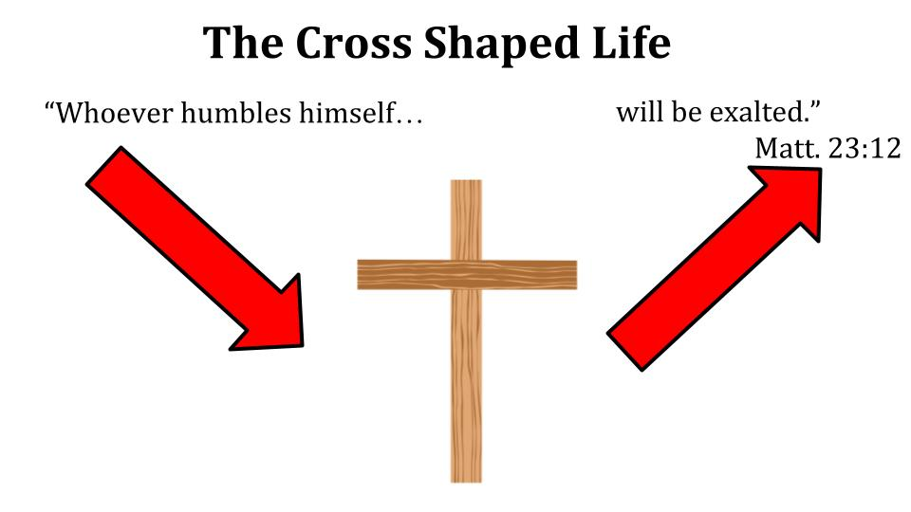
If you follow the DOWNWARD path of Jesus’ incarnation and crucifixion, you will experience the exaltation of Jesus that followed. But the converse is also true. If you exalt yourself, you will be humbled. If you refuse to die with Christ, then you will die in your sin. If you try to save your life you will lose it. The only way to save your life is to die with Christ and die to yourself - embracing a life of humility, service, suffering and sacrifice.

But when we embrace that downward path, we experience a fellowship with Jesus we can’t know any other way. It’s the fellowship of SHARING in His sufferings. And that experience is the foretaste of the final exaltation that will be ours when Jesus comes back.

Let’s pause here before I pray and invite the Lord to speak to us through this Scripture. If you want to use the prayer board and express a prayer of adoration or thanksgiving to the Lord - feel free to head over there now. Maybe you need to write out a prayer of confession - turning from some specific sin and asking Jesus to forgive you and cleanse you. Maybe you have a specific request - something you need to lay down at the feet of Jesus and surrender to His sovereign care.

You can use the prayer board or just do business with the Lord right where you are. Based on this passage you could write down an I BELIEVE statement - expressing a truth that the Lord has impressed on you today. And you can follow that with an I WILL statement - how will you respond today? How is the Lord calling you to move forward in faith and obedience?

Take a couple of minutes and ask the Lord to speak to you, then I’ll close our time of prayer and we will sing our final song.

