The Conquering King
Matthew 28:1-10

Some of us have heard this account of the resurrection so much that we don’t really know how to respond anymore. I hope no one actually yawned as it was read. But the words are so familiar and the idea so known to us that we may have lost our awe and wonder at the simple statement: “He is not here for he has risen.”

Try to put yourself in the situation of the early disciples. The women at least had the faith to go to the tomb that Sunday morning, after the Sabbath. The men were hunkered down - no doubt telling themselves it was practical and it was what the Lord had told them to do. But not feeling a lot of faith.

It’s an open question whether any of the 11 apostles actually expected Jesus to rise from the dead. What is beyond dispute is the passing reference in verse 17:

“And when they saw him they worship him, but some doubted.” Matthew 28:17

We can safely deduce that Thomas had his doubts - those are documented elsewhere. But it doesn’t say “one of them doubted,” but that some of them did - maybe most of them did. Even seeing Jesus alive, right in front of them, on the mountain he had told them to come to after he rose again - still, some of them didn’t believe it was happening.

Look at Mark’s account of the women at the tomb, after seeing the angel:

“And they went out and fled from the tomb, for trembling and astonishment had seized them, and they said nothing to anyone, for they were afraid.” Mark 16:8

That is how Mark chose to end his gospel account. Later scribes chose to add more of a “happy ending” to Mark, but most scholars believe that is how John Mark, the author, was led by the Spirit to end his gospel. “They said nothing to anyone, for they were afraid.”

Back, in Matthew’s account, we read this:

“So they departed quickly from the tomb with fear and great joy, and ran to tell his disciples.” Matthew 28:8

Matthew includes the fear that Mark focuses on, but shows that their joy eventually won out over their fear and they didn’t just flee from the tomb, they ran to the disciples. But even bringing the disciples to the aforementioned mountain and even seeing Jesus alive and well - some still doubted.

What is YOUR response to Jesus’ resurrection today?

As you just heard Matthew’s account read, how did you feel? What did you think about? How does your heart respond? Are you moved to worship at His feet? Does your heart stir with fear like the guards or like the women that morning? Do you sense the joy that this single truth proves all the other things Jesus said? Do you struggle with doubt - wondering if it can really be true?

Today as we reflect on Matthew 28 let’s walk through three RESPONSES to the resurrection of Jesus.

Three Responses to the Resurrection:
- Be Amazed
- Be Confident
- Be Bold

First, let’s join the women at the tomb and simply stand amazed at the awesome victory of the Lord Jesus over sin and death. Then let’s build up our faith and confidence like Thomas touching His hands and side. And let’s end, as Matthew’s gospel does, with a commissioning to be bold and bring this life-changing message to everyone we possibly can.

First, Mary Magdalene and “the other Mary” who was probably the wife of Alphaeus and the mother of James the son of Alphaeus or “Little James” for those watching the Chosen. Anyway, two Mary’s arrive at the tomb, probably also with Salome the mother of James and John.
http://www.livingwithfaith.org/blog/who-was-the-other-mary-at-the-tomb

Three Responses to the Resurrection:
- Be Amazed
“And behold, there was a great earthquake for an angel of the Lord descended from heaven and came and rolled back the stone and sat on it.” Matthew 28:2

The women arrived, according to verse 1 “to see the tomb.” They weren’t necessarily filled with faith that Jesus would be alive. In fact, Mark’s account tells us they went there with spices to anoint his dead body and help preserve it. We have to wonder how they planned to accomplish that feat given the heavy stone, the official seal on it and the guards stationed there to keep people from tampering with the tomb.

Still, the women had the faith to GO - which is worthy of recognition and is documented in all four gospel accounts. Luke tells us it was a group of women, and that they found the stone rolled away. John tells us that Mary Magdalene went first, earlier, while it was still dark. So probably she went alone at first, maybe got to witness the earthquake that Matthew describes and went back for reinforcements, returning soon after with another Mary or two Mary’s, Joanna, Salome. Props to the ladies. They went. And because they stepped out in faith to venture to the tomb, they got to experience the wonder and terror of that momentous day.

Listen to the description of the angel:

Three Responses to the Resurrection:
- Be Amazed
“His appearance was like lightning and his clothing white as snow. And for fear of him the guards trembled and became like dead men.” Matthew 28:3-4

This is shocking, startling, mind-blowing language. An angel of the Lord - one of the higher up angelic beings, maybe the very highest order; came down like lightning - in a blinding flash.
https://www.reasonablefaith.org/writings/scholarly-writings/historical-jesus/the-guard-at-the-tomb

There is an earthquake, a heavy stone that would take 2-3 strong men to roll back - was rolled back by the angel. The flash of light, the earthquake, the stone being rolled back was too much for the guards there who trembled and collapsed like dead men.

It’s not clear if these were Jewish or Roman guards - could have been either. On the balance they were probably Jewish temple guards - but even so they were grown men who would have been well prepared for any shenanigans from Jesus’ rag-tag disciples. But they were not prepared for an actual angel to blaze down from heaven, rock the earth with an Iron-man punch the ground move and knock them all over.

And the angel was so chill he just took a seat perched on top of the stone, waiting to greet the women. No doubt the women were trembling too since the angel immediately said:

Three Responses to the Resurrection:
- Be Amazed - Jesus really rose from the dead
“Do not be afraid, for I know that you seek Jesus who was crucified. He is not here, for he has risen.” Matthew 28:5-6

Can you feel the amazement of those first witnesses? Does your heart stir with wonder that this was possible? That it really happened? And it wasn’t this small, understated, Jesus sort of calmly woke from a nap, dematerialized through the stone and rematerialized outside of the tomb so he could chat things up with Mary and the other women.

All of these signs and markers are meant to remind Jewish people and all familiar with the Old Testament, that this is a God-event. This is not some contrived human event - like a “snatch the body away from the Jewish guards” Mission Impossible movie. This is not some hallucination or legendary story made up by later generations. This is a real life intervention of the God of Israel marking a significant moment in history.

Lightning, earthquake, people falling over like dead men, the angel of the Lord - who goes on to speak for the Lord… all of these things remind us of major moments in Israel’s past:
- Moses receiving the Law on Mount Sinai amidst thunder, storm clouds, earthquakes and lightning.
- The Angel of the Lord appearing to Joshua before the battle of Jericho.
- Elijah calling down fire from heaven in the contest with Ba’al.
- The glory of God descending to fill Solomon’s temple.

Our first response to the resurrection should be amazement. Jesus really did rise from the dead. We should not take that statement in stride and just have another sip of coffee. We should stagger in awe of the power of God to turn back death itself.

Jesus was dead. Fully dead. Not mostly dead. All dead. Sealed in a tomb. Buried. Gone.

Then, shockingly, he was back. Alive. Walking around. Talking. Eating.

Jesus did the impossible. And the stamp on this moment - the public seal of identification and approval was from the signet ring of Israel’s God. Earthquake, lightning, angel - that’s like God’s personal signature - “I did this. This was me.”

The Jews and Romans put their seal on the tomb to make their authority as public, visible and powerful as possible. “Don’t mess with this tomb - and if you do, you’ll face the wrath of the Jews and of Rome.” The angel probably smiled as he broke that seal without the slightest exertion. Zap. “Here’s a seal with a little more authority.”

Be amazed. That should be our first response to the resurrection. Second.

Three Responses to the Resurrection:
- Be Confident - Jesus really rose from the dead
“Do not be afraid, for I know that you seek Jesus who was crucified. He is not here, for he has risen.” Matthew 28:5-6

Four gospels by four different authors - Matthew and John for the original disciples, Mark and Luke for later followers of Jesus. Four slightly different resurrection accounts that fill in various details but that all agree on the key point - that Jesus was alive and people SAW HIM. Luke adds some more details in the book of Acts and Paul adds still more in his letters.

In the end, hundreds and hundreds of people saw Jesus alive. And remarkably, the very first one was a former prostitute named Mary Magdalene. Of all the details included in the resurrection accounts this one may be one of the most powerful to show the reliability of the witnesses we have. There was no reason at all to mention the testimony of a woman in ancient times. Sorry ladies, but women had no standing in court - not even in Jewish court. Their testimony was literally invalid, useless.

So the only reason to include the detail that Mary saw Jesus first and spoke with him was because that is how it actually happened. That fact would have added zero credibility to the early dissemination of the gospel message. Peter and John running to the tomb and finding it empty - that could be presented to the Sanhedrin. Mary talking with Jesus alone in the garden? Inadmissible. Irrelevant. So why did Matthew and the other gospel writers document the event this way? The only logical explanation is that it’s the truth.

Consider how we validate what are considered “facts” of history. Take, for example, Paul Revere’s midnight ride to rouse the American rebels with his horseback shout, “The British are coming!”

As it turns out, Revere didn’t shout “The British are coming.” He raced to specific homes of known and trusted revolutionaries, waking them up quietly with a knock. Loud shouts would have awakened British sympathizers, which was still the vast majority of Americans at that point in 1775.
https://www.businessinsider.com/false-historical-facts-2013-11
https://www.history.com/news/11-things-you-may-not-know-about-paul-revere#:~:text=Paul%20Revere%20never%20shouted%20the,out%20in%20the%20Massachusetts%20countryside.

So why do we imagine Revere riding alone and shouting “The British are coming!”?
The public alarm cry was a tradition that developed largely based on Longfellow’s poem of 1861, nearly 100 years after Revere.

https://poets.org/poem/paul-reveres-ride

So through the night rode Paul Revere;
And so through the night went his cry of alarm
To every Middlesex village and farm,—
A cry of defiance, and not of fear,
A voice in the darkness, a knock at the door,
And a word that shall echo forevermore!
- Longfellow, 1861

It’s a nice poem. But it produced a false idea about the exact nature of Revere’s ride. But this is the discipline of history - to sort out rumor and conjecture from fact. What we know from other sources is that it wasn’t just Paul Revere, there were two other riders with him. And by the end of the night over 40 men were riding in haste and spreading the word. But none of them were shouting “The British are coming.” If those words were used they were whispered.

But the women at the tomb - the first eyewitnesses that it was empty and the first person to see Jesus alive being Mary Magdalene - these are attested facts, confirmed by multiple sources.

- Be Confident - Jesus really rose from the dead
“Go quickly and tell his disciples that he has risen from the dead, and behold, he is going before you to Galilee; there you will see him.” Matthew 28:7

2-3 witnesses were required to prove something in a Jewish court. Matthew tells us of two women who saw the angel and the empty tomb: Mary Magdalene and the other Mary, the mother of James, the wife of Alphaeus. They set out to tell the disciples, then verse 9:

- Be Confident - Jesus really rose from the dead
“And behold Jesus met them and said, ‘Greetings!’ And they came up and took hold of his feet and worshiped him.” Matthew 28:9

https://answersingenesis.org/jesus/resurrection/the-sequence-of-christs-post-resurrection-appearances/

They touched his feet - they felt his very much alive physical body. They heard his very real voice. The natural response was to worship in awe and wonder. No doubt that small group of women never forgot this stunning moment - and told the story over and over again for the rest of their lives - as did all the people who saw Jesus alive after the crucifixion. Here is a visual presentation of the 10 post-resurrection appearances of Jesus documented in the Bible:

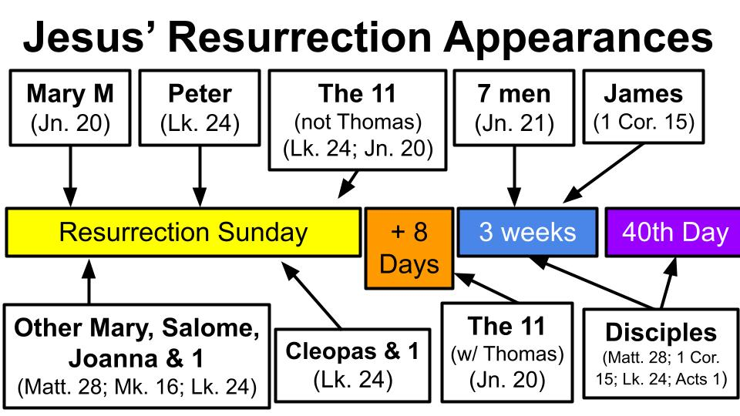
10 documented appearances. 12 apostolic witnesses including Thomas who needed extra convincing and Matthias, who was added later because he was there with them the whole time and was also a witness of the resurrection. 5 recorded women on different occasions. Different kinds of appearances in different places to different groups. And on one of the occasions, according to 1 Corinthians 15, around 500 believers were present - which could well be the event in view right here in Matthew 28.

The point is - be confident. Jesus really did rise from the dead. Here is how Paul said it in 1 Corinthians 15:

“For I delivered to you as of first importance what I also received: that Christ died for our sins… that he was raised on the third day… and that he appeared to Cephas, then to the twelve. Then he appeared to more than five hundred brothers at one time, most of whom are still alive.” 1 Corinthians 15:3-6

That last phrase is really important - “most of whom are still alive.” In other words, go talk with them. Go ask them what they saw. This was no hoax or hallucination - Jesus really did walk out of that tomb as a living, breathing human being.

Compare the Christian claim that Jesus rose again with the claims of Mormonism’s founder Joseph Smith.

https://www.equip.org/articles/problems-with-the-gold-plates-of-the-book-of-mormon-2/

Smith claimed that he “translated” the Book of Mormon from ancient golden plates like this replica.
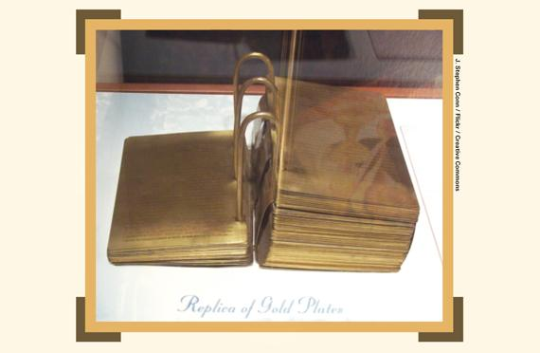
Joseph said he was visited by God the Father and Jesus Christ in 1820, then three years later by an angel named Moroni. The angel told him where he could find gold plates buried 1,400 years earlier on a hillside some three miles from his home in western New York. He found the stack of plates and began carrying them home when he was attacked by a man with a rifle. Joseph nimbly knocked down his attacker and ran home at top speed, evading two other attacks along the three-mile route - in New York hill country.

20 6 inch by 8 inch plates of solid gold would weigh over 200 pounds so Mormons are forced to get creative with what “gold-like” substance the plates were made of that would make it possible for a man to not just carry them three miles but to do so while running from and evading three separate men trying to assault their hero.

After “translating” what we have as the Book of Mormon the plates were taken back by the angel and never seen again. This became a problem for Joseph’s key leaders who wanted to see some evidence for the miraculous revelation Smith was claiming. So he took the “three witnesses” out into the woods and had them pray for hours on end, asking for “spiritual vision” to see the plates. After one gave up and left the other two supposedly saw the angel holding the plates and called to the third who ended up having a similar opportunity to “see” the golden plates - which, conveniently, vanished never to be seen again.

Well, sorry - 8 other people also wanted evidence so good ol’ Joe invited them into his tent one by one to see and touch the plates. So that gave Smith 11 witnesses plus himself for 12.

So take the two claims and hold them up side by side:

- Jesus rose from the dead and was seen alive by over a dozen people.
- Joseph Smith had 20 gold plates that were “seen” by a dozen people.

Four different gospel writers, plus the apostle Paul and the weight of the entire New Testament over against a hill country treasure hunter whose main training was in the use of a “seeing stone.” Compare dozens of witnesses over 40 days to the alleged visions of three and the later handling of gold plates by 8 others. The gospel accounts read like real history, with a ring of authenticity that mutually confirm one another. The story of Mormonism’s beginning is riddled with yellow and red flags by anyone who understands how history works.

But the resurrection of Jesus is a firm foundation for our faith - as we see back in Matthew 28.

- Be Confident - Jesus really rose from the dead
“Now the eleven disciples went to Galilee, to the mountain to which Jesus had directed them. And when they saw him they worshiped him, but some doubted.” Matthew 28:17

Just like the women outside the tomb, when the 11 saw Jesus, their immediate response was to fall down in worship. Yes, some still doubted - but those doubts would be overcome over the next couple of weeks as Jesus appeared to them and met with them and ate with them.

So how should we respond to the resurrection of Jesus? First, we should be amazed. We should stand back in wonder at the One who defeated the grave. Second, we should be confident. Jesus really did rise from the dead. That single fact changes everything! It validates everything Jesus said. It proves He is the Son of God. It confirms that His sacrifice for sins was accepted by the Father. “Because he lives, I can face tomorrow. Because he lives, all fear is gone…. And life is worth the living, just because he lives.” One more response to the resurrection:

Three Responses to the Resurrection:
- Be Bold - Jesus really rose from the dead
“And Jesus came and said to them, ‘All authority in heaven and on earth has been given to me. Go therefore and make disciples of all nations.’” Matthew 28:18-19

The resurrection didn’t give Jesus His authority, it proved His authority. Same thing with His visible ascension into heaven 40 days later. Being exalted to the Father’s right hand, seated in glory as Prime Minister of the Universe was simply a restoration to the eternal position He always had as the Son of God. But following the resurrection Jesus could back up His claim to have all authority with a very tangible sign. “You all killed me, but I came back to life.”

Jesus is the Lord of heaven and earth. He reigns over all things. Based on that infinite authority we have been sent out to make disciples of all nations. This should make us as bold as the early disciples. We haven’t seen Jesus in physical form, but we have all experienced His grace to forgive us and His power to help us over and over again.

Think what it means that Jesus rose from the dead. This means that we personally know the One person who can protect us from death! We know the One who made the full payment for sin and had His sacrifice approved by God the Father’s stamp of approval - the resurrection. “Paid in full.” Because Jesus rose from the dead, we can have confidence that we will live forever with Him. His victory over death means we can trust all of His other promises - like the fact that He will come back one day soon, He will triumph over all of His enemies, and He will restore all things, creating a new heaven and a new earth.

Imagine you were a research scientist studying pancreatic cancer - one of the most fast moving and lethal forms of cancer. What if one day, after years of research, years of trial and error, you came into the lab and looked at the results of your experiment from the night before and all traces of cancer are gone from the sample cells. You repeat the experiment five more times then show your supervisor. He also runs the test and comes to the same conclusion. You have found the cure for cancer!

Of course, you’d want to certify everything, get confirmation from some scientific peers, get FDA approval… But once you had all that, wouldn’t you be BOLD? Wouldn’t you do everything you could to get the word out? No one needs to die of pancreatic cancer ever again!

You would tell your close friends and family immediately, right? You wouldn’t wait for documented validation - you’d be sharing your excitement right away. But once it was official, you would run TV adds, you would sit as a guest on talk shows, you would pretty much talk about nothing else, right? You would be bold - obnoxiously bold. And people would understand - it’s a life and death issue! Time is of the essence. Every moment you waste could cost someone their life or the life of a loved one.

Brothers and sisters - how much MORE true is this of the gospel?

Knowing Jesus is a life and death issue! More than that it’s an eternal life or eternal death issue! Jesus is the only Savior for sinners - His Name is the only Name under heaven by which people can be saved. Apart from Jesus people are lost, enslaved, blind, dead IN SIN - their sin is on them and in them. They are serving the devil, mostly without knowing it. And because they are in sin, they are destined for the wrath of God - they are on their way to an eternity of misery, suffering and just punishment for their rebellion and idolatry.

This is probably not a verse that very many churches are using this Easter Sunday, but listen to Isaiah 34:2.

- Be Bold - Jesus really rose from the dead
“For the Lord is enraged against all the nations, and furious against all their host; he has devoted them to destruction, has given them over for slaughter.” Isaiah 34:2

Now, yes, we will get to John 3:16 in a minute, but just pause here in Isaiah. Does God love the people from all nations? Yes. But how does God feel about the sin, wickedness, rebellion and idolatry that is rampant among the nations? He is ENRAGED about it. He is FURIOUS against it. God does not feel lightly about sin, violence, evil and oppression. He hates it - it grates against His holy, loving nature.
- Think about human trafficking and the abuse of children.
- Think about forced marriage, polygamy and the abuse of women.
- Think about civil war, violence, cartels and genocide.

How can God feel anything but wrath and fury over these terrible evils and injustices?

The world today is exactly like it was in the days of Noah - it is filled with violence EVERYWHERE. Millions upon millions of babies slaughtered through abortion. Wars, violence, uprisings, conflicts. Domestic violence, drug abuse, criminal organizations, human enslavement.

What did the FLOOD teach us about the nature of God? He cannot tolerate sin. He cannot. God MUST punish sin. He will not do it in a worldwide flood again. But the seals, trumpets and bowls of Revelation describe the outpouring of God’s final judgments, His total wrath against evil and sin.

Sin is CANCER. It consumes people. It kills them from the inside. It destroys because it makes you into an ENEMY of God. Ok, let’s go to John 3 as we close. John 3:36 -

- Be Bold - Jesus really rose from the dead
“Whoever believes in the Son has eternal life; whoever does not obey the Son shall not see life, but the wrath of God remains on him.” John 3:36

For those who either don’t KNOW JESUS or who reject Him - “the wrath of God remains” on them. Do you feel the significance of that? They have a cancer that will consume them FOREVER.

But we have the cure!

We literally have the cure for the most dangerous, the most lethal form of cancer ever - we have the cure for the cancer of sin. His name is Jesus.
- What can wash away my sin? Nothing but the blood of Jesus!
- What can make me whole again? Nothing but the blood of Jesus!

The sacrifice of Jesus on the cross - symbolized in His blood - is the cure for sin. Because He died AND ROSE AGAIN, Jesus can forgive sin, heal hearts and protect us from death, shield us from the wrath of God.

Here is the summary for today:

Three Responses to the Resurrection:
- Be Amazed - Jesus really rose from the dead
- Be Confident - Jesus really rose from the dead
- Be Bold - Jesus really rose from the dead

First, be amazed. Never lose the awe and wonder of this impossible truth: Jesus rose. He was not there in the tomb because He had risen.

Second, be confident. The resurrection of the Lord Jesus is a firm foundation for your faith. We have rock solid reasons to trust in Jesus - the main one is because He lives.

Finally, be bold. Because Jesus rose, He proved that His sacrifice was sufficient. Jesus can save. Anyone who calls on Him - anyone who commits to Him - will be forgiven and reconciled with God forever! We have the cure for the cancer of sin - let’s not keep it to ourselves! Let’s share this life-changing good news with everyone we possibly can!

Let’s pray.

