Love
John 1:9-18

Wayne and Patty adopted Aaron as a baby, along with his older brother John. It was 1992. Details of the adoption are unclear, but the fact remains that the courageous birth mother carried Aaron to term and entrusted him and his brother to good, loving family.

As it happened, Wayne and Patty were strong believers who raised Aaron and John in church and taught them about hard work, family, and enduring faith.

This is Aaron Judge who just set the home run record, albeit for the Yankees. Judge gives all the credit for his success to God and his parents - saying he was raised to work hard, do what was right and trust in the Lord. 2 Cor. 5:7 is his life verse - “we walk by faith, not by sight.” He says, “We never know what’s around the corner but if we have faith in him, he will lead us in the right direction.”

Think of the gift that ADOPTION is. Two little boys who would have been raised in difficult circumstances, by a single mother, probably with few positive role models around them. Wayne and Patty took Aaron and John into their home - took care of all of their practical, emotional and spiritual needs, and raised them as their own sons. It wasn’t until Aaron was 10 and started to realize he looked pretty different from Mom and Dad that they sat him down to explain that he was adopted and what that meant. Judge said, “It wasn’t a big deal. They were the only parents I’ve ever known.”

Brothers and sisters - you and I were orphans - helpless and alone in a dark and dangerous world. Jesus came into this world - born as a helpless human baby - so he could later give his life as the purchase price for our ADOPTION. Look at John 1:12 that we just heard:

“But to all who did receive him, who believed in his name, he gave the right to become children of God, who were born, not of blood… but of God.” John 1:12-13

Today we are reflecting on the character quality of LOVE. Love sees someone in need and goes to them. Love presses in and presses on to help the one in need. And love pays the price to help. Jesus did all of these and more for us so we could become the children of God - born spiritually into God’s family simply on the basis of our faith in the Lord Jesus.

This Advent we are starting a new series on the CHARACTER of Jesus. For the next few months, we will study the thirteen perfections of Jesus and contrast them with the thirteen expressions of our sin. As we lift up the glory of Jesus, we will see the brilliance of His glorious character. The light of that glory will expose us as we truly are - showing how very far we fall short of His glory.

If you only ever compare yourself to other people you might think you’re a pretty good person. But when you start comparing yourself to Jesus you will get a more accurate view of your own heart and life. You’ll see how far you have to go, but you’ll also see how far Jesus came to get to you - and that He’s with you every step of the way from your sinfulness to His perfection. The grace of Jesus fills in that gap completely.

Today in John 1 we will see three expressions of Jesus’ love. To that perfect love we will contrast our own lack of love - our callous hearts, our indifference to the needs of others. But we won’t stop there. We will go on to see how Jesus calls us and helps us move from our selfishness and sin toward His perfection.

Three Expressions of Jesus’ Love:
- Love Shows up
“The true light, which gives light to everyone, was coming into the world.” John 1:9

Jesus is the light of the world. He is the full and final revelation of the nature and glory of God. Back in verse 4 John writes, “In him was life and that life was the light of men. The light shines in the darkness and the darkness has not overcome it.” Jesus is LIFE. “All things were made through him.” Jesus is the Creator of all things - the Giver of life.

But Jesus did not create everything and then stand back, like a clockmaker, and just watch the universe tick. He has remained engaged in every detail of the world from the first moment when He said, “Let there be light,” to the last trumpet when He will shout, “It is finished.” Hebrews one says that Jesus “upholds the universe with the word of his power.”

Think of this wonderful Christmas truth: Jesus, the Creator, the Life-Giver, the all sovereign Lord, the Light of all wisdom and truth CAME INTO THE WORLD. Jesus came. He showed up.

And consider HOW He came! He did not descend in glory with angelic announcements to the rich and powerful. He did not come robed in visible, glorious splendor. He did not come wielding limitless power and demanding instant allegiance and obedience. He did not come like any KING in history had ever come.

Jesus came as a baby. In fact, Jesus arrived on earth as an EMBRYO. The eternally divine DNA of the Son of God was woven together with Mary’s DNA by the unifying, life-giving power of the Holy Spirit. The conception of a baby is always a miracle of God’s sovereign power, but this conception was unlike any other before or after.

The virgin birth was not remarkable at all - it was like every other birth. It was the virgin CONCEPTION that was the miracle. Ladies, I’m not downplaying the agony and difficulty of birth - I’ve been through it four times and trust me, my part was just as hard as Kristin’s. Ok, you’re going to start throwing tomatoes. Her part was slightly more difficult than mine. I did come very close to passing out the first time when Seth was being slurped out of her abdomen via C-section. Thankfully the anesthesiologist saw me going white and helped me sit back down on my stool. It was a very traumatic moment.

The point is that LOVE shows up.

Three Expressions of Jesus’ Love:
- Love Shows up
“He was in the world, and the world was made through him, yet the world did not know him.” John 1:10

Jesus came to the world he had made, but they did not know him. They did not receive him as Creator. They did not acknowledge him as King. Aside from a handful of shepherds and some middle eastern skygazers, the whole world was totally unaware of Jesus’ birth.

But love doesn’t come in order to draw attention to itself. Love comes where it is needed whether it is wanted or not.

Three Expressions of Jesus’ Love:
- Love Shows up
“The Word became flesh and dwelt among us, and we have seen his glory…” John 1:14

The Word who was in the beginning - the Word who was with God, who in fact was God - one with the Father and the Spirit - the Almighty Creator - the eternal Son of God - became flesh. This is the deep mystery of the incarnation: that Jesus remained fully God while becoming fully man. He was not a 50/50 cotton/polyester blend. He was 100% divine and 100% human. Mary was truly his mother. God the Father was truly his father.

Jesus did not just appear human, he became human. And he came to DWELL. He lived among God’s people, the Jews, for 30 years - just LIVING. We can safely assume that since Joseph was a carpenter, Jesus was raised and trained as a carpenter too. Historians guess that Joseph died when Jesus was young since there is no mention of him in the gospel accounts and when Jesus is dying he appoints John the apostle to take care of his mother. That wouldn’t have been necessary if Joseph was still around. So Jesus most likely spent 10-15 years making tables and chairs, brooms and cabinets, bowls and bats. Ok, they didn’t have baseball but he probably made fun toys for children in addition to practical things for grown ups. This sets up the second expression of Jesus’ love. It not only shows up…

Three Expressions of Jesus’ Love:
- Love Serves
“He came to his own, and his own people did not receive him.” John 1:11

Jesus was a Jew, in the line of Judah, descended from David - the line of kings. He came to the Jewish people and lived in the region of Judea, mostly among Jews. Yet the Jewish people did not receive him. They did not recognize him and follow him. Especially in his home town of Nazareth he was too familiar. The people there were so resistant to the idea of Jesus being “somebody” that he literally wasn’t able to do miracles there because of their unbelief!

But Jesus had not come to be served but to serve. That’s what love does - it shows up to GIVE not to TAKE. This is what John the Baptist, Jesus’ cousin, testified about him:

Three Expressions of Jesus’ Love:
- Love Serves
“John bore witness about him, and cried out, ‘This was he of whom I said, “He who comes after me ranks before me.”’” John 1:15

Jesus had the highest rank in the universe - standing at the right hand of God the Father, reigning as the Prime Minister of every galaxy. Colossians 1 tells us that Jesus retains that supremacy, “that in everything he might be preeminent.” Philippians 2 beautifully describes the humble ministry of Jesus, who “though he was by nature GOD did not consider equality with God a thing to grasp or cling to - but humbled himself and took on the nature of a servant, being born in human likeness.” Jesus EMPTIED HIMSELF.

That doesn’t mean he gave up his divinity, it means he stripped off the glorious trappings of the eternal Son of God and allowed himself to be dressed in weak, frail, MORTAL humanity. The incarnation is like putting an Olympic sprinter in a suit of armor. The sprinter’s nature has not changed, but his situation has changed - now limited by the armor over the top. It’s not a perfect analogy but it gives us the idea of how limited Jesus must have felt for those 33 or so years that he lived on earth.

Hebrews tells us that he “was tempted in every way that we are, yet without sin.” Jesus - the Lord of all glory, the giver of the Law, the incorruptibly righteous One - struggled with temptation. Every temptation. He was tempted IN EVERY WAY. C.S. Lewis helpfully points out that Jesus endured the FULL power of every temptation because he is the only one who never once gave in.

You and I can’t know the full strength of a temptation because at some point we give in. Maybe we make it to a level 4 or 5 temptation and then cave. Maybe we only ever make it to a 2 or 3. “Eat some Halloween candy. It’s right there.” That’s level 1. Mostly I cave immediately and grab that tantalizing Reese’s cup. Sometimes I resist and it goes to level two as my eyes scan the contents of the bowl. I’m not as tempted by the fruity candy - but the chocolate bowl is a stronger pull. That’s level 2. Some days I might make it to level 3 or 4 before I give in.

But only Jesus knows what a level 10 temptation feels like. And he knows what every kind of temptation feels like. That is how much our Savior loves us - that is how far he was willing to go to share our experience - to be a sympathetic high priest who could truly, sincerely pray for us, knowing what our struggles feel like.

Love shows up. Love serves. It enters darkness, brokenness and pain in order to bring light and healing and grace. That is our third expression of love:

Three Expressions of Jesus’ Love:
- Love Sacrifices
“For from his fullness we have all received, grace upon grace.” John 1:16

Jesus came to GIVE. Grace is the Greek word CHARIS which means undeserved gift. The charismata in the Bible are the gifts God gives us by His Spirit. Jesus does not give out of poverty or lack - He gives out of his own fullness, out of His abundance. Jesus is the overflowing fountain of life and love, of peace and joy, of hope and security and every spiritual blessing.

“From his fullness we have all received, grace upon grace.”

Ted Olsen is one of my heroes in the EFCA.
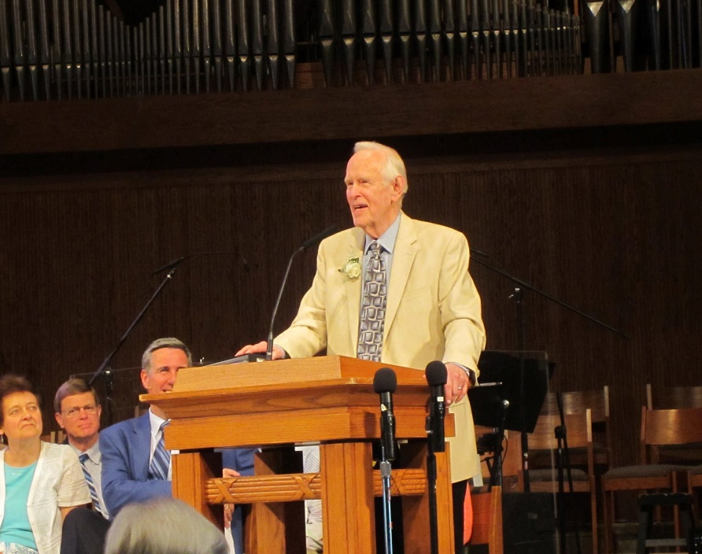
He turned 81 when we were in Chicago serving at the Orchard and we celebrated his retirement after sixty years of pastoral ministry in the Free Church. All that “retirement” meant is that the church was going to stop paying him the meager, part time salary they were paying him. But as far as I know he continued to love and serve the seniors at the Orchard and I would be willing to bet he continues to do so now, as he is able.

I interviewed Ted one time to capture some of his heart and stories from the old days of the EFCA. And the way he summarized everything - from youth ministry to thriving preaching ministry to difficult conversations and conflicts - the heading over sixty years of ministry was “ALL OF GRACE.” At 81 he said, “If I ever write a book that will be the title - All of grace.”

Ted experienced the fullness of Jesus’ grace - and I experienced three years of Jesus’ grace THROUGH TED - praying with him, visiting people with him, being encouraged by him. “All of grace.”

This is what we have all received from the Lord Jesus - “grace upon grace.” Look back at verse 12 again:

Three Expressions of Jesus’ Love:
- Love Sacrifices
“But to all who did receive him, who believed in his name, he gave the right to become children of God.” John 1:12

Jesus GAVE. That’s what love does: it GIVES. The only way to give is to pay the price for something. What did Jesus have to give up in order to give us the gift of adoption? How is he able to make this offer to all of us, that we can become children of God?

The answer, obviously, is the cross. It cost Jesus EVERYTHING. He had to give up his life in payment for your sin and mine. That was the only way we could be reconciled with the holy God of heaven. Our adoption was not free - it was infinitely expensive. Jesus had to die so we could live forever as sons and daughters of God.

These are just three of the expressions of Jesus’ love. There are a thousand more.

- Look up at the Perfection of Jesus’ Love
  - Love shows up
  - Love serves
  - Love sacrifices

Just pause for a moment right now and look up at the perfection of Jesus. Take in the amazing love of our Lord and Savior. He came to us in all of our need. He showed up. He entered our broken world and fully experienced our struggles and hardships. He did not come to be served but to serve. He gave. He healed. He listened. He was patient. By and large he was not accepted. Most people ignored him. Many people called for his death. But Jesus didn’t resist or avoid the path that led him to the cross.

He gladly gave up his life. He took the path of service and sacrifice. “For the joy set before him he endured the cross.” The joy before him was US - our adoption, our inclusion in the family of God.

That’s LOVE. That’s what love looks like. That’s what love does. It seems someone in need and shows up. It serves that person, sacrificing for them - giving up everything if need be.

Look up at the glory of the Lord Jesus. Bask in the light of His perfection. But then we have to look back down. We have to see ourselves in the light of Jesus’ glory.

- Look down at the depth of your sin - Indifference
  - Ignoring the needs of others
  - Serving yourself
  - Using others

While Jesus is perfect in love, you and I fall so far short.

Remember the Good Samaritan? Three people walked by the man in need - beaten and bloody on the side of the road. The priest and the Levite ignored his needs. Presumably they were too busy with more important things - probably to do with the temple and “worshiping God.” Of all people, it was a Samaritan - a half-Jew, half-Gentile compromiser - who showed love to his neighbor.

How often are we that Good Samaritan and how often are we the priest or Levite? Where Jesus saw us in our need and came, how often do we walk by? How often do we tune out? Love shows up. Indifference looks the other way.

Love serves others in need. Self-love serves yourself. It puts YOU first. Your needs; your desires; your plans; your things; your money.

Love sacrifices for others. Self-love uses others. They are a means to the end of our own gratification.

In the light of Jesus’ perfect love do you see the depths of your own sin and selfishness? If we only compare ourselves to other people it’s like holding up a flickering candle to ourselves. In that light we look pretty good. But next to the humble servanthood and the total self-sacrificing love of Jesus, what we call love looks more like self-gratification.

The Gospel-Nourished Life:
- Look up at the Perfection of Jesus’ love
- Look down at the depth of your sin - Indifference
- Experience His Grace - paying for our adoption
- Extend His grace to others in sacrificial service

Two more steps as we close. This is what my friend and mentor, Scott Lothery, calls the Gospel Nourished Life. First you look up at the perfect character of Jesus. In that piercing light we are able to see the depth of our sin. That prepares us to be nourished by the gospel - to feed on the banquet of grace Jesus offers in Himself. The gospel is the power of God for our complete salvation - from conversion to glory. The gospel bridges the gap from our utter sinfulness to Jesus’ untarnished perfection.

In this case, we are focusing on LOVE. We look up to see the amazingly sacrificial love of Jesus - it shows us what true love is. Then we look down to see our own indifference. The opposite of love is not hate - it is apathy. Love acts. It serves. Anti-love simply does nothing.

Now apply the gospel. What did Jesus do for us because of his love? He paid the price for our adoption. This is the gospel medicine that will cure us of our selfishness if we let it. This is the gospel energy bar that will empower us to serve others and to make sacrifices that would otherwise be impossible. This is one entree in the gospel feast Jesus offers us in himself.

If you want to grow in love; if you want to become more like your loving Savior - think about the cost of your adoption. Think about the price Jesus paid to cover your sin, to cleanse you from it, to change you from a wicked sinner into a precious child of God…

We’ve given everyone an APPLE SEED today. Pick it up and hold it in your hand. Squeeze that seed. Blow on it. Focus your thoughts on it. Make that seed into an apple. Come on. The genetics are there. What’s wrong with you? I did it with mine! Ok, that’s a lie. Thankfully our character quality today is not honesty.

But that’s the point. You can’t make that seed germinate and sprout and become an apple. You know that the seed in your hand has the POTENTIAL to produce not just one apple but a whole tree full of them. But it will have to be planted in a conducive environment with plenty of good soil, water, and sunshine. And it will take time, attention, and protection. The typical apple tree will take eight years to mature and start bearing fruit.

The Bible does not say, “the product of the Spirit is love, joy, peace, patience.” The Holy Spirit does not manufacture fruit in an assembly line. LOVE is one of the FRUIT of the Spirit. Love will begin to grow in your life as you develop your relationship with Jesus. You can’t make yourself more loving any more than you can make that seed into an apple. But you can make your life a better environment for the fruit of love to grow.

The water and fertilizer for the fruit of the Spirit is the GOSPEL - the grace of the Lord Jesus. This is how to nourish your spiritual life - to learn to feed on the truth and glory of the good news of what Jesus has done for you. Every week as we look up at one character quality of Jesus, we will look down at our own sinfulness but then we will slow down to experience the grace of Jesus specifically applied to our point of need in order to help us grow to be more like him.

Love is beautifully expressed in the gospel idea of adoption. How did you become a part of the FAMILY of God? He adopted you. How? Jesus paid the price. That’s how far His love was willing to go: the ultimate sacrifice.

As you experience that kind of love it will enable you to extend that kind of love to others. You will GROW UP to be a little more like Jesus.
- Who is the Lord placing on your heart right now?
- Maybe it’s someone you are struggling to love and serve.
- You need to remember how much Jesus has sacrificed for you; how much He gave up to serve you - that is the only way to keep loving, keep serving, keep sacrificing for someone who does not deserve it.

And, of course, none of us deserve it.

I’ve told you before about Pastor Manny. He became my youth pastor in 1991 when I was a sophomore in high school. He stayed at that church in Chicago until this past August - 31 years. You can see from what he is wearing that he is a man of enduring faith. Manny and his wife, Ann, have three biological kids. Early in their time at our church they wanted to grow in their experience of God’s love and to show their kids what love looks like up close.
So they adopted a baby girl named Belinda. She’s in this picture with Manny’s parents, who are now home with the Lord. Dear, dear people. Belinda was born to a troubled young woman in the city of Chicago, strung out on drugs and alcohol, totally unable to take care of a baby - and afflicted with AIDS. As a result, Belinda was born with fetal alcohol syndrome and HIV. She was part of a University of Chicago clinical study, along with five other HIV babies. The doctors overseeing the study told Manny and Ann that most of these babies wouldn’t see their first birthday.

They were right. Five of the six babies died in that first year. But not Belinda.

This is Belinda with her sister and two brothers - just a couple of years ago.

Manny and Ann adopted Belinda to show their kids the beauty and power of the love of Jesus. In the process, they showed me and the rest of the youth group and the entire church family - and over the years, half of the people in Chicago.

Adoption is a powerful and practical demonstration of love. It is a picture of the gospel. You take a helpless orphan into your home. You pay the price - and it is often a heavy price - to make that child a part of your family.

That is what God has done for us in Christ. That is what His love looks like. Let’s experience that love this Christmas so we can have more love to share with others!
Let’s pray.

