Sent
Jonah 1:1-3

We spent the last four weeks getting an orientation to the idea of CALLING, using the GPS framework - Gifts, Passion and Story. You can discover your unique assignment from God at the convergence of those three signals. It helps to know your natural and spiritual gifts - your sling and your harp. It helps to identify your passion - the cause or group of people that most moves your heart. And it helps to understand your story - how God has prepared you through blessing and brokenness to minister to others. When you put those three signals together and they all point in one direction, that may be the Lord calling you to a special assignment!

Now for the next eight weeks we are going to take a journey through the book of Jonah to learn WHAT NOT TO DO when God calls you. Jonah is probably the FUNNIEST book in the whole Bible. Notice from the outset that every person and every creature in this book obeys God immediately - except God’s prophet. The storm, the fish, the plant, the worm - even the pagan sailors, the King of Nineveh and the entire city full of Gentiles! Everything obeys God. But not Jonah.

And I love the way Jonah ends, with God still reasoning with His wayward prophet, trying to help Jonah see how lost the Ninevites were.

“And should not I pity Nineveh, that great city, in which there are more than 120,000 persons who do not know their right hand from their left, and also much cattle?” Jonah 4:11

The last words of this prophetic book - this word from the Lord - are “and also much cattle.” That’s hilarious! If anyone thinks God doesn’t have a sense of humor, just have them read Jonah. But before we laugh too hard at Jonah, let’s realize why this book is in the Bible… because every one of us TENDS TO BE JONAH.
- God calls us to a new assignment and we run the other way.
- God uses all kinds of life circumstances to get our attention but we keep running away from him anyway.
- If things go according to plan, we complain.
- If things don’t go according to plan, we complain.
- We feel like we are the only ones who suffer and no one cares about us, least of all God.

So let’s use this book as a mirror - as the Bible so often is - and expose the Jonah-like tendencies of our hearts, so we can be more like the storm, the sailors, the fish, the plant and the worm! Let’s be those who hear God’s voice and quickly move to OBEY Him. Because that is the main point of the book of Jonah, and of our whole series on Calling. And it’s our summary for Jonah 1 today:

- Hear God’s Voice
- Know God’s Heart
- Obey God’s Call

Fulfilling your calling comes down to hearing from God and stepping forward in obedience. It’s really that simple. We can fail at either side - either we don’t listen well, so we don’t hear from God. Or we hear just fine, we just refuse to obey. That’s why we are spending eight more weeks on this subject - because it takes time for God’s Word to break through to our often hard hearts. We are - let’s admit it - like Jonah.

So, before we open the book Jonah wrote, let’s turn back to 2 Kings 14 to get some background on this prophet from Gath-Hepher.

“In the fifteenth year of Amaziah the son of Joash, king of Judah, Jeroboam the son of Joash, king of Israel, began to reign in Samaria, and he reigned forty-one yars. And he did what was evil in the sight of the Lord.” 2 Kings 14:23-24

“He restored the border of Israel from Lebo-hamath as far as the Sea of the Arabah, according to the word of the Lord, the God of Israel, which he spoke by his servant Jonah, the son of Amittai, the prophet, who was from Gath-hepher.” 2 Kings 14:25

This is a fascinating section in the Bible. First, we are told that this was an evil king. He reigned 41 years but did evil in the sight of the Lord, not departing from the path set by the first king of Israel in the northern kingdom, the original Jeroboam.

And yet, this evil king did one good thing that was worth writing down: he restored the border of Israel. He extended the kingdom where enemies had come in. And King Jeroboam accomplished this “according to the word of the Lord through the prophet Jonah.” In other words, the Lord told Jonah to tell the king - go take back that land. Jonah obeyed the Lord and delivered that message. The king obeyed Jonah and sent the army to take back the land.

Apart from the book of Jonah, that is all we know about this prophet. Pretty mixed bag. On the one hand, he was a recognized prophet and the one word of the Lord given to him came about which validated him as a true prophet. On the other hand, he served an evil king and there is no record of him confronting that king for his idolatry as so many of the other prophets of the Lord did - much to their own suffering.

So, I will taunt you with the question that my Hebrew professor posed to my class: based on everything we see in 2 Kings 14 and the book of Jonah, would we conclude that Jonah was a TRUE PROPHET or a FALSE PROPHET? Most of us have always come to the book of Jonah assuming he was a true prophet of the Lord who just had some obedience issues. But if you look at it the other way so many other details jump off the page - like his prayer in chapter 2. Was that real repentance? Or was that pious platitudes just looking for a way out of that fish?

Now, the best sign that Jonah did eventually repent is the fact that we have the book of Jonah at all. How else could these details have been collected if Jonah didn’t write the story himself or at least share it with someone else to write down?

So, thanking the God of second and third and 100th chances, let’s open to Jonah 1 and study the three principles of calling that come from the first three verses of this book. First:

- Hear God’s Voice
“Now the word of the Lord came to Jonah the son of Amittai, saying…” Jonah 1:1

If you’re familiar with the Old Testament you’ve seen this phrase many times - “the word of the Lord came” to so-and-so. That’s how it worked with prophets in the OT. Sometimes it was rare, sometimes it was frequent - but the Word of the Lord only came to a small handful of people and only at specific times known only to the Lord. We don’t know how it worked but however the Lord spoke to the prophets they knew it was Him and they knew what they were supposed to say or write.

Peter says, “They were carried along by the Holy Spirit.” Paul says, “they were inspired,” - that God breathed His words into them as they wrote.

Here in Jonah 1 we don’t know how the Lord spoke, but Jonah knew it was God and he knew exactly what God wanted from him. Look at verse 2.

- Hear God’s Voice
“Arise, go to Nineveh, that great city, and call out against it, for their evil has come up before me.” Jonah 1:2

In this case I wonder if it was the Lord Jesus Himself appearing to Jonah - as He did several other times in the Old Testament. Before Jesus got His fully human body He was still able to appear on earth in human form. In that case we would change the first letter of the WORD of the Lord to an uppercase - that’s who came to Jonah, the eternal Word of God, Jesus.

It doesn’t seem like a dream or vision, but one way or another the Lord spoke these words to Jonah very clearly, very specifically. There was no question where he was supposed to go, what he was supposed to do or why. Go to Nineveh. Call out against them and their evil. God sees it and wants it to stop.

Now think about Nineveh in those days. 120,000 people was a mega-city. Three days to walk across. Don’t forget all the cows there. This was the capital of ASSYRIA. This was the late 8th century B.C. - 780 years before Jesus.

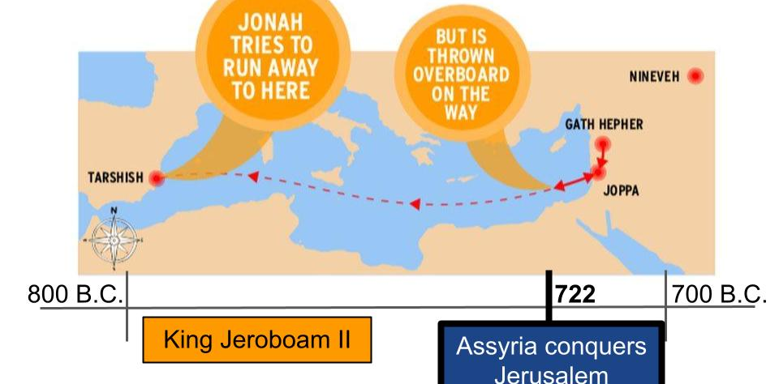
Assyria was the great and growing threat - the dark, Mordor-type shadow looming over Israel in the north. If there was a place where the dark Lord sat in his dark tower it was Nineveh itself. Jonah must have felt like Frodo and Sam being sent into the heart of darkness on an utterly hopeless mission. All of that is Lord of the Rings by the way. I know some of you don’t get my references. Unlikely heroes called hobbits - little guys - are sent to destroy the ring of power. But the only place you can destroy that ring is where it was forged - which is where the big bad guy lives.

Remarkably, Frodo and Sam accepted their fate on the doomed mission and went. Jonah ran the other way. Exactly opposite direction. Now, let’s relate to Jonah a little. He was a Jew. More than that, he was a PROPHET for the Jews - which was not a common vocation - it was a huge privilege. He probably thought of himself as a 4 star general. You don’t send your general out on the front lines of military combat. But that’s what it felt like for Jonah - go walk directly into the enemy camp - right to their capital city. There may have been a hobbit-like part of Jonah that was comfortable in Joppa, in Israel, his home - that wanted to work in his garden and smoke his pipe. But I think the larger part of Jonah was his ego. He felt too important for a suicide mission - or just too selfish.

The Assyrians were notorious for how they treated prisoners. They were the terrorists of ancient history - stringing up the people they conquered in creative and gruesome ways to instill fear in the hearts of every nation they set out to conquer. No doubt Jonah knew this and was legitimately afraid for his life.

The first key to being used by God is to hear God’s voice. Jonah definitely heard God’s voice. But Jonah was stuck on the second key.

- Know God’s Heart
“Arise, go to Nineveh, that great city, and call out against it, for their evil has come up before me.” Jonah 1:2

It seems Jonah was stuck, as God’s people have often gotten stuck, with a focus on Israel alone. He could not understand or would not believe that God cared about other nations - especially wicked, idolatrous nations like the Assyrians. You’d think a prophet of the Lord would have caught on quicker.

God wasn’t sending him to congratulate the king of Assyria. He wasn’t sending his prophet to affirm the brutality or idolatry of the Ninevites. He was sending Jonah to CONFRONT their sin. But Jonah gives something away later in the book when he explains why he didn’t want to go in the first place.

- Know God’s Heart
“O Lord, is not this what I said when I was yet in my country? That is why I made haste to flee to Tarshish; for I knew that you are a gracious God and merciful, slow to anger and abounding in steadfast love, and relenting from disaster.” Jonah 4:2

When God saw the sincere nationwide repentance of the Ninevites, His heart was moved with compassion and He relented from the disaster He had decreed for them. In a startling move for GOD, He changed His mind and instead of wiping out this wicked nation, He forgave them!

Seeing this outcome, Jonah was depressed to the point of suicide. He said, “I knew it. I knew you would forgive them. I knew you wouldn’t blow up the city like I wanted. That’s why I ran the other way.”

Here we get to the real reason Jonah ran. He was AFRAID that God would be merciful. He went to Nineveh, kicking and screaming, hoping to see Sodom and Gommorah style fireworks. He wanted to see the deathstar explode in slow motion.

When God showed mercy to Nineveh, Jonah was ANGRY. Jonah 4:1 says this thing displeased him exceedingly. He was furious. And he sulked and fussed and wanted to die.

That is not the response of someone who understands the heart of God.

Now, let’s relate to Jonah. If someone abuses your daughter - serious, personal, disgusting abuse. What do you want for that person? Be honest. Consider that terrible situation. You don’t want mercy for that person - you want justice. You want fire to rain down from heaven and consume that person - but slowly; they can’t just die right away. They need to suffer as your little girl suffered. They need to pay for their evil.

If a doctor totally misses a diagnosis that should have been obvious… Like when my Mom had this brown discoloration behind her thumb nail ten years ago and her primary care doc said, “It’s nothing, don’t worry about it.” If she had listened to that opinion she might not be around anymore. Thankfully she went to a dermatologist who got a biopsy and found melanoma. But what if she hadn’t? What if that doctor’s casual response had cost me my Mom? How would I feel about that doctor?

Or let’s make it international. If your son was deployed with the military and was serving in Afghanistan a couple of years ago, drove over an IED and was killed - how would you feel about the Afghanis responsible? Would you pray for their salvation? If the Lord told you to hop on a plane and head over there, would you DESIRE their repentance and conversion? Or if we’re honest, in that situation - which was Jonah’s situation - we would all want what Jonah wanted. We would want God to wipe those evil enemies off the face of the earth. We would want justice not mercy.

Oh, do we know God’s mission? Do we understand the heart of God? Do we really want what He wants?

- Know God’s Heart
“The Lord… is patient, not willing that any should perish but that all should reach repentance.” 2 Pet. 3:9

Do we really believe this? Do we really share God’s heart for the truly lost, the truly evil? Do we really love our enemies and pray for those who persecute us and our brothers in the Lord?

“For God so loved THE WORLD that He gave his only Son…” “This gospel of the kingdom will be preached in ALL NATIONS, and then the end will come.” Or fast forward to the end of the story:

- Know God’s Heart
“A great multitude that no one could number, from every nation, from all tribes and peoples and languages, standing before the throne and before the Lamb, clothed in white robes.” Revelation 7:9

Every nation. This is God’s mission, God’s PROMISE: He is gathering people from every nation, every culture, every background to be with Him for eternity. Jonah did not get that. The question is, do we?

Now, as a church, Oakwood has been after this for all 40 years we’ve been around. From its earliest days Oakwood was supporting and sending missionaries to the ends of the earth. To this day we support 16 or 17 missionaries devoted to bringing the good news of Jesus to the world. Not all churches are like Oakwood, with such a commitment to global missions. And our current elder board and missions team want to keep increasing that commitment in terms of financial investment, short-term teams and long-term missionaries we support.

What about you? Are you invested in God’s mission to gather people from every nation? Do you PRAY for the global harvest? Do you give to support missionaries out on the frontier? Have you GONE on a short-term missions trip recently?

Most of us are not as flagrant as Jonah. When God said go east, Jonah went west. Most of us are quite content to just stay put. We hunker down. We change the channel. Part of the reason is we aren’t listening to God very well. Another reason is that we just don’t know - we don’t deeply know God’s heart. But Jesus made it abundantly clear:

- Know God’s Heart
“Go therefore and make disciples of all nations.” Matthew 28:19

That’s it. That’s the mission. Make disciples. And don’t stop until you’ve reached EVERY tongue and tribe and nation. Finishing the Task and the Joshua Project tell us there are around 1,000 languages left that still don’t have a single verse of Scripture.

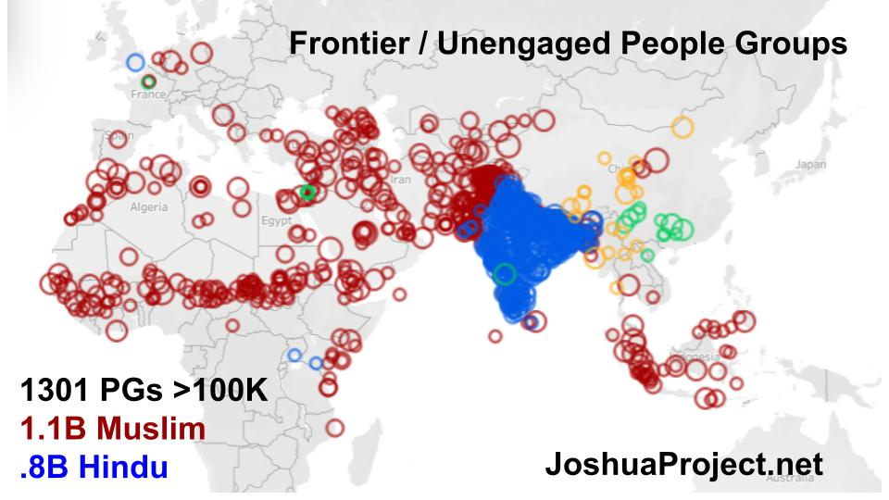
This graphic from the Joshua Project shows the 1301 UNENGAGED people groups over 100K in population. The red ones are Muslims, accounting for over 1B people. The blue ones are Hindu, obviously concentrated in India, adding up to 800M people. Around 2 BILLION people remain ENTIRELY UNENGAGED with the gospel - not a single Christian, no church anywhere nearby, no Scripture. Rick Warren took over Finishing the Task last year and identified the 3 B’s these unengaged peoples need: a Bible, a Believer, and a Body (a church).

https://www.ncfgiving.com/stories/finishing-the-task-bibles-believers-and-bodies-of-christ-in-every-people-group/

The GOOD NEWS is that of those 1301 unengaged groups, over 1,000 now have organizations or denominations committed to ENGAGING THEM. A plan and process is underway to FINISH THE TASK. And Jesus has promised that this task WILL be finished. The only question is whether we will help. Will we be a part of this - the mission of God?

And let’s zoom in on ourselves here. Do we have God’s heart for our own NEIGHBORS?
Listen to the last verse of Jonah as God patiently explains to his angry prophet. “You are angry about a plant you didn’t grow…”

- Know God’s Heart
“Should not I pity Nineveh, that great city, in which there are more than 120,000 persons who do not know their right hand from their left?” Jonah 4:11

What a description of lost people! They don’t know their right hand from their left! They are enslaved to their sins. Their hearts are hard - they don’t even realize the wickedness of their sin. Their minds are darkened - they can’t think straight. They’re in deep and ongoing pain - their sin has produced layers of consequences in them and around them.

They don’t know their right hand from their left.

Do you know God’s heart for your lost friends and family members? Do you share that heart?

One of the best things we can do to connect with God’s heart is to PRAY. Lift up by name the people you know who are lost - who are far from God. Prayer becomes most powerful when it connects directly with things that matter most to God - like LOST PEOPLE. Ask God to give you His heart for your neighbors. Ask Him to help you grow in love like His. A love that seeks and saves the lost one. A love that leaves the comfort of home to go some place new, unknown, even dangerous in order to serve someon. It’s the path of sacrifice. But that’s the loving heart of God!
Do we hear God’s voice? Do we know His heart? The third key to being fruitful in your calling:

- Obey God’s Call
“But Jonah rose to flee to Tarshish from the presence of the Lord.” Jonah 1:3

God said, “Go east.” Jonah went due west. This verse shows us it wasn’t an accident that he went the opposite way. He was deliberately fleeing from the presence of the Lord. Jonah knew that he couldn’t stay in Israel and remain a prophet of the Lord. The rule was, once you received the word of the Lord you had to go share it. It wasn’t an optional assignment. You couldn’t pick and choose.

Just ask Balaam. There’s this rather comical story in the Old Testament of this weirdly commercial, mostly corrupt prophet named Balaam. One Jewish king tried to hire him because he knew Balaam’s prophecies came true. But he tried to hire Balaam to curse another Jewish king. It was a time of civil war. Balaam tried to refuse but the first king insisted, so Balaam said, “Listen, I’ll pronounce blessings and curses, but I don’t get to decide where they fall - that’s just not how this prophecy thing works.”

Three times Balaam tried to curse the selected king. But three times what came out of his mouth were blessings - because God had promised to BLESS His people, Israel. The King was furious but Balaam said, “I tried to warn you!”

Back in Jonah 1, listen to the description of Jonahs’ flight from the Lord:

- Obey God’s Call
“He went down to Joppa and found a ship going to Tarshish. So he paid the fare and went down into it, to go with them to Tarshish, away from the presence of the Lord.” Jonah 1:3

Did you catch the repetition? Twice Jonah WENT DOWN. Anything moving away from Jerusalem in the Old Testament is described as a going down. Anything moving toward Jerusalem is going up. We generally refer to going north as going up - but they referred to going to Jerusalem as going up.

Jonah was going down. Away from Jerusalem. Away from the Lord. Away from his calling. He went down to Joppa. Then he went down into the ship. What an ominous description! You can almost hear the door to his quarters in that cheap inner chamber with no balcony view as it clangs shut, closing him in. Shutting him out of the presence of the Lord.

What has the Lord called YOU to do? Have you heard His voice? Have you been praying through your GPS - your gifts, passion and story? How is the Lord leading you? Have you taken steps toward your calling? Have you stalled and stayed put? Or have you been like Jonah and run the other way?

Jonah heard God’s voice but did not know God’s heart and did not obey God’s call.

But think about JESUS.
- The eternal Son of God heard the voice of His Father. Together with the Holy Spirit the Godhead set a plan in motion to save this world they had made.
- When the Father said, “It’s time,” the Son heard and obeyed.
- Jesus knew the Father’s heart. He understood the plan and what it would cost.
- And Jesus came. He left His glory in heaven and came all the way down to earth. He humbled himself, being born a totally helpless human baby. He lived in utter obscurity in this backwater town in Israel.
- He lived a life of prayer, of holiness, of perfect devotion to God and humble service to His people, the Jews.
- And the destination of His life was a rough Roman cross.

Jesus obeyed the Father’s call - all the way to the cross.

Let’s not be like Jonah. Let’s be like Jesus!

It was five years ago last July that Kristin and I had to make a decision about coming to Oakwood or not. We had been in Chicago for three years at that point and our oldest son was about to be a senior in high school, with three other boys right behind him. Some of you know that Seth had some health challenges so we struggled with whether it was a good time to move across country.

And my initial conversations with leaders at Oakwood were pretty direct and frank - the church had been through some challenging times. If we came, there would be some hard issues to address.

In my follow up zoom with the search team, I remember signing on to that call planning to say “Thank you - love you all - but it’s just not the right time for us, not the right fit.” But something happened on that call that enabled us to hear God’s voice very clearly saying, “This is it. This is the next assignment for you.” We sensed a sincere readiness in the leadership of Oakwood to move forward on mission - we could tell this was a group that knew the heart of God and that wanted to move forward together.

We heard God’s voice. We knew God’s heart and trusted He would provide for us. And we stepped out to obey God’s call. We moved to Florida in August of 2017, preached one Sunday and then Hurricane Irma came in. Since we are still here and there haven’t been more hurricanes we are going to chalk that up to Caribbean weather patterns rather than God’s direct judgment on us for leaving Chicago.

In all seriousness, we are so blessed to be here at Oakwood. We know God called us here five years ago and we are thankful to say that He clearly continues to call us to serve here in Tampa Bay. The Lord is at work throughout the city and we are following His heart into opportunities all over the world.

So, Oakwood - let’s get after it! One prayer at a time, one conversation at a time, one step of obedience at a time! Our neighbors and the nations are waiting.

Let’s pray.

