Streams in the Desert
Psalm 63

“A Psalm of David, when he was in the wilderness of Judah.” Psalm 63 prescript
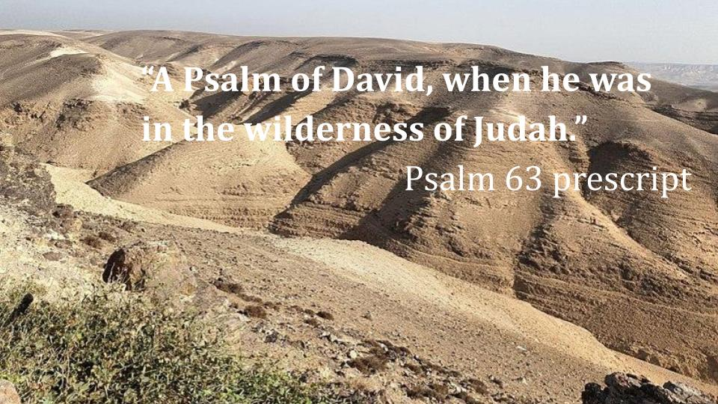
https://bible.org/seriespage/15-wilderness-judea-ultimate-getaway

This picture is not of Tatooine - it’s the wilderness of Judah, outside of Jerusalem. David spent considerable time in this region - first as a young shepherd looking for hard to find green pastures and quiet waters; and later as a young man running from King Saul and his army. The bad news is that there is almost no water, like the ashen wasteland of Gorgoroth that Frodo and Sam had to cross to reach Mount Doom. The good news is that in the wilderness of Judah there were lots of places to hide. At one point there were 65 different monasteries scattered throughout this desert area because they could find peace and solitude, with no concern that civilization would encroach on their prayer retreat.

Psalm 63 is one of those Psalms that provides the context for the writing. We don’t know exactly when this was - but it was one of the many times David was hiding in caves out in the wilderness, like Obi-wan, watching over Luke while hiding from the Inquisitors.
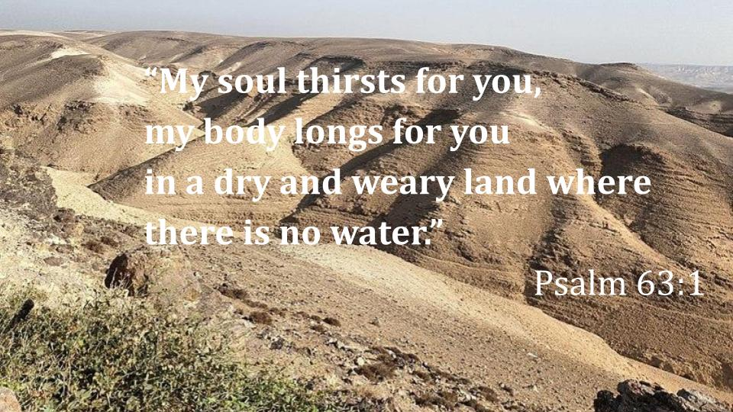
Those were not pleasant excursions for David - not vacations. They were desperate, fearful escapes. And every day was a faith journey, trusting the Lord to provide water and food and a place to stay. David’s experience was like the nation of Israel. For 40 years the people of God wandered in the same kind of desert land - and their only hope was that God would lead them to water and provide the food that they needed for each day. Which, of course, He did.

Psalm 63 is a vivid picture of our desperate need for God and of His generous provision for us. We will look first at our need, then at God’s gift and finally draw application for how we can best experience God’s gift to meet our needs. First:

Our Need:
- Soul and Body thirst
“My soul thirsts for you, my body longs for you…” Psalm 63:1

This Psalm shows four needs - leading with the first two right away in verse one. David rightly starts with his SOUL, but connects his spiritual needs also with his physical needs. We all feel this reality. Our bodies are always thirsty - always needing more nourishment, more strength, more endurance; and our souls are always thirsty - always needing more meaning, more hope, more joy.

But David rightly identifies the actual need: for the LORD. He doesn’t say “my body longs for food and water,” but that “my body longs for YOU.” This is where we get it wrong most of the time. We translate our soul needs directly to the physical. We go to food, we go to drink, we go to exercise, we go to medications, we go to the doctor, we go to the beach - looking for something that will meet our deepest needs - and of course nothing will, because nothing can EXCEPT GOD HIMSELF. But because God is invisible and because He often feels distant, we settle for the quick fix most of the time because we misdiagnose the problem as a physical problem with a physical solution when it’s actually a spiritual problem that can only have a spiritual solution. Think of Thor after everyone dusted and he felt he had failed. Instead of facing his sadness and pain and actually dealing with it he escaped into alcohol, food and video games. Or Po, in Kung Fu Panda, on his quest to find inner peace - which, he eventually learned - cannot be found in your circumstances but only when you come to ACCEPT the life you have been given and to forgive all who have failed you.

Our Need:
- World thirst
“...in a dry and weary land where there is no water.” Psalm 63:1

Our souls and bodies are constantly thirsty because we live in a barren world. Yes, there are lots of good things because God’s original creation was so good. But our world is fallen, broken, cracked and damaged in every area. And there is no WATER that can really fix our soul and body thirst. Everything in this world, at best, is a short-term solution - a small reprieve. Just like David finding a cave to hide in for a night or a few days, we find little places in the world that serve as refuges and oases for us - like Simba hiding out with Timon and Pumba, running away from his true calling as the Lion King. But no house, no family, no job, no vacation, no hobby, no amount of financial security - nothing in this world can bring real healing to our bodies or lasting satisfaction to our souls. And David points to one more need we have at the end of the Psalm:

Our Need:
- People thirst
“Those who seek to destroy my life… the mouths of liars will be silenced.” Psalm 63:9,11

David’s whole life he faced danger. As a young person he was a shepherd and faced the dangers of lions and bears coming to threaten his sheep. He was probably only 15 or 16 when he went toe to toe with the giant, Goliath, in single combat. Then, even though he served King Saul faithfully as a musician and a war general, David was still in frequent danger because of Saul’s jealousy and paranoia. And even when David became King he faced dangers from foreign nations and from his own sons seeking to take his place. Much of his life was on the run, like Sylvie, the Loki variant who was kidnapped as a young girl and spent her life running from the TVA.

Psalm 63 ends with two specific people dangers - military and political. David was attacked in every way you can imagine. Some people were amazingly faithful to him through all the ups and downs of his 40 year reign. His 30 mighty men were examples of this. But David was betrayed even by his own family members and sometimes his closest advisors, as Loki betrayed his father, his brother, his homeland and all of earth.

And we all feel these needs. We live in a dry and weary land. Thankfully, God meets us in the desert of our need with His generous provision!

God’s Gift:
- Eyes to see His Sufficiency
“So I have looked upon you in the sanctuary, beholding your power and glory.” Psalm 63:2

This is a very PHYSICAL Psalm - as David is very aware of the needs of his body. But he directs his physical needs to the spiritual realm - turning his eyes upward toward the Lord. Even though he could not go to the tabernacle or the place of the future temple to worship, David lifted his eyes to see the glory and goodness, the power and wisdom of God.

We need eyes to see both our true needs and what God has given us to meet those needs. Paul prays for this in Ephesians 1 - that the Holy Spirit would enlighten our eyes, enabling us to see and really appreciate “the riches of our glorious inheritance in the saints.” This is a miracle of God’s grace and power. On our own we cannot see this - we cannot understand or appreciate all that God has given us in Christ.

But it starts with the shift David models for us in verse 2. Yes, he acknowledges and expresses the problem in verse 1, but he immediately turns his attention from the problem to the solution.

So often we stay there on the problem - we keep looking down at this broken, barren world instead of looking up to the One who has the power and the glory to help us. How are your eyes today? What are you seeing? What are you looking at? Oh, Lord, would you give us eyes to see your power and glory! That is God’s first gift for us in our need. Second:

God’s Gift:
- Lips to taste His Steadfast Love
“Because your steadfast love is better than life, my lips will praise you.” Psalm 63:3

In Psalm 34 David wrote, “Taste and see that the Lord is good.” Here he declares that God’s HESED - His steadfast, covenant love is better even than LIFE.

Do you believe that? Do we really believe this is true? That God’s LOVE is better than life?

We say it. We often sing it. But have we TASTED IT? Have you so experienced “how wide and long and high and deep is the love of Christ,” that you KNOW IT is better than life? Have you come to that place, like the Apostle Paul, where you can say, “To live is Christ and to die is gain”?

There is no substitute for personal experience. I could tell you about the best Gyros on the planet from this little Greek place in Chicago; or the best deep-dish Pizza from Lou Malnati’s.
I realize this is cruel and unusual right before lunch time. But if you have never had a Krispy Kreme right off the line, right after that beautiful sugar shower - you just haven’t yet tasted and seen. You might imagine what these things are like, but until you experience it for yourself, you don’t know it personally. Ok, back to the Bible - I’m merciful.

God’s Gift:
- Lips to taste His Steadfast Love
“Because your steadfast love is better than life, my lips will praise you.” Psalm 63:3

One application of this point is to EVANGELISM. When you have something amazing, you talk about it, don’t you? You find a new restaurant or try a new item - like the California Skillet at Village Inn - and you tell your friends. You bring them to try it. Or you see a great movie or get hooked on a show - you talk it up. As I have done even today with Loki and Obi-wan. If you have never seen the original Matrix then your eyes have not yet been open to the truth and no one can explain it to you because there is a “world that has been pulled over your eyes,” until you experience it for yourself and are set free.

One reason we don’t share the gospel as much as we should is that we don’t EXPERIENCE the wonder of being forgiven, the soul-stirring joy of knowing Jesus, the eternity-changing power of the Holy Spirit inside us. If we regularly tasted the goodness of God - if we really KNEW his steadfast love for us - we would talk about Him more. So arguably the best thing you can do for your evangelism is to spend some more time in prayer and the Bible. Experience again for yourself all that God has done for you in Christ. Remember the beauty and wonder of the gospel. Pray Ephesians 3 for yourself - that the Holy Spirit would help you TASTE the truth of your forgiveness and filling. We need eyes to see the truth, we need lips to taste and experience God’s gift for ourselves.

God’s Gift:
- Hands to Surrender to Him in worship
“So I will bless you as long as I live; in your name I will lift up my hands.” Psalm 63:4

David moves from eyes to see the Lord to lips to taste His love to hands lifted up in worshipful surrender. What does your POSTURE say about your relationship with God? We are not a big hand-raising church, but we are an expressive church. When I grew up, in my church, really the only acceptable posture for worship was standing stiff and straight, holding your hymnal nice and steady and singing a moderate baritone. It wasn’t until I went to Bible Camp and then to college that I saw other people with more open, expressive approaches to worship.

The Bible describes all kinds of different postures and practices for worship - from flat on your face to kneeling to standing to sitting to hands up to laying on your side for over a year if you’re Ezekiel. It’s about being yourself and expressing YOUR heart to the Lord. But some postures communicate specific things:
- Arms folded across your chest is a guarded, wounded position.
- Head down, bowed low can be humble contrition or broken despair.
- Hands clenched in fear and worry…
- Hands up in worship can be surrender and joy
- Or shaking fist held up in the sky in defiance and rage.

The Psalms invite us to express ourselves honestly and openly to the Lord. All postures and emotions are vividly and dramatically presented in the Psalms. Read verse 9-11 and you can see there is a place for holy rage, as we call on God for justice and vindication.

Your body should express what you’re feeling inside. AND sometimes the way you move your body can impact the way you’re feeling inside. Clench your fists real tight as you think about a worry or concern in your life. Hold it close to you. Then lift those hands up to the Lord and open your hands to Him. Let it go. Release your worries and concerns to Him. “Cast ALL YOUR anxieties on Him because He cares for you!”

God’s Gift:
- Hands to Surrender to Him in worship
“My soul will be satisfied… and my mouth will praise you with joyful lips.” Psalm 63:5

Verse 1 makes it clear that this is not a happy, worry-free time for David. But he calls himself to worship, commits to the discipline of praising the Lord and rejoicing in the Lord even when his life was difficult. Sometimes you don’t want to open your hands in surrender, you don’t want to raise your hands in wholehearted worship - but you discipline yourself to come to worship; you discipline yourself to open your Bible; you remain committed to bowing your head in prayer - you pry your own hands open and the Lord meets you there in that place of brokenness and surrender.

Open your eyes, taste and see, lift your hands in surrender and the fourth gift:

God’s Gift:
- A Heart to Trust Him
“My soul clings to you, your right hand upholds me.” Psalm 63:8

In verse 1 David said his soul thirsts for the Lord. In verse 5 David said his soul would be satisfied with the steadfast love of the Lord. Here in verse 8 he says his soul will cling to the Lord, resting in His all-powerful hand. What a beautiful picture! David clings to the Lord - holding fast to Him - only to see that the Lord’s right hand is already upholding Him. It makes our small efforts to hold onto the Lord seem small indeed to know that God’s hand is under and around us - nothing can snatch us from it, nothing can separate us from His love, He hems us in behind and before us - His right hand will hold us fast.

Think of a young child learning to swim. Dad is right there the whole time - his hands right underneath the child, holding her up. But she still has to trust Dad and start swimming on her own. Then she grabs onto Dad only to find that his hands were underneath her all the time.

This Psalm is a beautiful picture of where God’s infinite generosity meets our desperate need. We are thirsty in every way in a dry and barren world, but God meets our need with the streams of living water that flow from His throne. Our application comes in three commitments we see here to actively receive these gifts that God offers us.

Our Commitment:
- Seek the Lord
“O God, you are my God; earnestly I seek you.” Psalm 63:1

This commitment runs all through the Psalm. It is basically a poem in which David exhorts himself and all of God’s people to make and hold to this commitment - to seek the Lord earnestly. It is filled with promises:
- verse 3, “my lips will praise you.”
- Verse 4, “I will bless you as long as I live.”
- Verse 5, “My mouth will praise you with joyful lips”
- Verse 6, “I remember you and meditate on you”
- Verse 8, “My soul clings to you” and
- Verse 11, “the king shall rejoice in God.”

Because our world is so broken and our hearts and bodies so weak, we need to steady ourselves with the simple commitment and discipline to stay the course; to keep going; to never, never, never give up.

When you are sad, when you are struggling, when you are in pain - the danger is to STOP seeking the Lord; to let yourself drift. We can get lazy in reading the Bible and make excuses instead of praying. This is one of the key reasons we need each other - especially in the darkest valleys. To come back to the Thor example - what brought him out of his funk in New Asgard? A few friends and a new mission.

For David, it was also close friends who kept him going.

“And three of the thirty chief men went down and came about harvest time to David at the cave of Adullam, when a band of Philistines was encamped in the Valley of Rephaim. David was then in the stronghold, and the garrison of the Philistines was then at Bethlehem.” 2 Samuel 23:13-14

“And David said longingly, ‘Oh, that someone would give me water to drink from the well of Bethlehem that is by the gate!’ Then the three mighty men broke through the camp of the Philistines and drew water out of the well of Bethlehem that was by the gate and carried and brought it to David.” 2 Samuel 23:15-16

Turned out David was so moved by this courageous act of devotion that he refused to drink the water and poured it out as an offering to the Lord. But the point was that David had close friends who cared about him so much they were willing to risk their lives to make sure David knew they were there for him.

I hope you have friends like this - and have experienced this kind of loving presence. Often in the church we communicate this kind of affection and support through a MEAL TRAIN. It’s not that people would starve without meals being brought to them - it’s that the meals represent genuine love, and it’s something tangible people can do when you’ve just had surgery or just lost a loved one or are going through a hard time. You’ve heard of the 5 love languages. I’ve often said that in the Anderson house, one of our primary love languages is FOOD.

Commitment one is to keep seeking the Lord. Friends can help you hold on to the Lord and remind you that He is always holding on to you. The second commitment is related but more specific:

Our Commitment:
- Sing to the Lord
“My lips will praise you… I will bless you as long as I live… My mouth will praise you with joyful lips…” Psalm 63:3-5

You may not consider SINGING a spiritual discipline but it very much is. You may not know all the songs we do here, you may not like all the songs we do here - but it is important, when you are here - that you SING. It is literally good for your soul.

Why is singing good for your soul? Because the music and the lyrics help translate the gospel from your head to your heart. We very carefully choose songs that glorify Jesus and present important aspects of the gospel.

Sometimes when you can’t articulate a prayer yourself, borrow that prayer from a song you love. Turn on Christian radio or a special playlist and let the truth of God’s love wash over you. At first you might just listen, but it will have even more impact if you lift up your own voice and sing. Most of my drive time I listen to podcasts, but sometimes I will bust out singing as part of my drive time prayer.

Chris Pratt’s Marvel character, Star Lord, is all about the music. His Mom, who died when he was a child, gave him a mix tape of classic rock songs that serve as the soundtrack for the Guardians of the Galaxy movies and for Quill’s life. The songs are central to how he copes with the many hardships of his life. Significantly, Quill references Kevin Bacon and Footloose on several occasions - indicating the power of dancing in addition to music. And Quill’s space mentor, the ruthless Ravager Yondu, has a very memorable moment declaring, “I’m Mary Poppins, y’all,” referencing one of the most feel good musicals of all time that is all about LIFE CHANGE, largely through MUSIC.

In a fascinating confession, the famous German atheist Nietsche once said, “Without music, life would be a mistake.” Like the goo shouldn’t have even bothered to evolve into higher critters if they wouldn’t be able to make music.

The point is - SING. If you’re musical, then obviously make singing part of your regular routine. But even if you’re not musical, it’s important for your heart and soul to sing both here with us at church and on your own. It’s a spiritual discipline that helps connect you with the Lord by helping you appreciate Biblical truth in a deeper, personal way. One more commitment:

Our Commitment:
- Savor the Lord
“But the king shall rejoice in God; all who swear by him shall exult.” Psalm 63:11

The last three verses are King David celebrating the JUSTICE of God. Those who were attacking David with swords and with words would all face God’s justice in the end - and David was confident that they would come out the worse for it.

“All who swear by Him shall exult, FOR the mouths of liars will be stopped.”

Vindication is coming for those who are faithful to God - especially those who suffer for the gospel. And that truth - of a final judgment day - should give us great joy. Even though we suffer now, even though the gospel is vehemently opposed, even though Christians are persecuted and killed every day, our reward will last forever and our joy will exceed anything we can imagine.

So REJOICE in the Lord. Paul commands this twice in Philippians 4 - to a church facing severe hardship in the first century - but those believers were still willing to send money to help Christians who were struggling in Jerusalem and to help Paul continue on his mission.

Have you learned how to not just read your Bible but to REJOICE in the Lord as you read your Bible? It was John Piper more than anyone who helped me see that not only is it acceptable for us to DELIGHT in God, it is necessary if we are to glorify Him that we learn to ENJOY HIM.

“God is most Glorified in us when we are most Satisfied in Him.”
John Piper

We must get beyond DUTY to DELIGHT if we are to truly please God. Learn to SAVOR the goodness of God. Experience the fullness of His infinite love - rest there, revel there.

Something that has fueled my joy in the Lord recently is a podcast called MAVERICK. It tells the story of Bishara, a Muslim in central Africa who is given a Bible while he was away from his family for a while. He knew that even having a Bible in his possession was a serious crime for his strict Muslim family, so he hid it for three weeks before daring to read it. But he felt drawn to the book and started reading it secretly, late at night. And as he read through that whole book he encountered the person of Jesus Christ - and, fully knowing that it would cost him everything, committed his life to Jesus.

I don’t want to give away the surprises and twists and turns in the story. Suffice it to say there are miracles and more miracles in what happens to and around Bishara. He certainly faced more death threats and endured more beatings than any of us can imagine in our comfortable, suburban homes. But he also saw more miracles - people cured from life threatening diseases, a paralyzed man able to walk - stories from the pages of the Bible coming to life all around him - and dozens, hundreds of Muslim family and friends who began responding to the gospel and coming to Bishara to learn what it means to follow Jesus. Check out the Maverick podcast - and be encouraged by the power of the Bible, the grace and mercy of the Lord Jesus, the sovereign plans of God - who is worth serving and loving even if it means you will suffer and die.

That is the testimony of King David. That is the story of the Apostle Paul. That is the experience of Bisahara in Africa - and it is your story and mine as well. Yes, we live in a dry and weary land where there is no water. Our soul and body yearns for more - we long for life and joy that can only be found in the Lord. Praise be to God, He offers us exactly what we need in HIMSELF. God’s generosity comes exactly to the point of our need - so David can say with absolute certainty, “My soul WILL be satisfied as with the richest of food.” He didn’t know where his next meal would come from. He didn’t know where the next attack would come from. But David committed to seek the Lord, to keep singing the praises of God and to savor the goodness of God, no matter what.
Let’s pray.

