Biblical Meditation - Psalm 19 (NLT)

The Psalms are a resource for God´s people in so many ways! They are a guide for prayer, a primer for worship, an encouragement for faith, an outlet for sadness, pain, anger and every other emotion. And, as we will see today, the Psalms are a resource for MEDITATION.

Christian meditation is totally different from eastern meditation. The goal of Buddhist meditation, for example, is to empty your mind entirely. The goal of Christian meditation, by contrast, is to FILL your mind with truth and with God. The goal of eastern meditation is detachment. The goal of Christian meditation is ATTACHMENT to God.

Psalms like Psalm 19 are a wonderful resource for this kind of Biblical meditation. And Psalm 19 in particular calls us to use all the resources we can to draw near to God and to please Him. Look at verses 12-14, the conclusion and application of this Psalm:

"How can I know all the sins lurking in my heart? Cleanse me from these hidden faults. Keep your servant from deliberate sins! Don’t let them control me. Then I will be free of guilt and innocent of great sin. May the words of my mouth and the meditation of my heart be pleasing to you, O Lord, my rock and my redeemer." Psalm 19:12-14, NLT

How can you know your own sin and idolatry when it hides itself best from you? How can you find deep internal cleansing from sin and live in true freedom and victory? How can you take every thought captive and bring it into obedience to Christ? How can you be transformed by the renewal of your mind? How can we make verse 14 true for us - that our words and thoughts will truly be pleasing to the Lord, our Rock and our Redeemer?

The answer to the requests in verses 12-14 are in the worshipful prayer of verses 1-11. If we learn to meditate on creation and on Scripture then the words of our mouths and the thoughts of our minds will be pleasing to the Lord. Let´s look at these twin disciplines to help us grow in prayer!

- Meditate on Creation
"The heavens proclaim the glory of God. The skies display his craftsmanship." Psalm 19:1

If you ever need a boost to your worship, a greater sense of awe and wonder, get out into the countryside on a clear night and look up at the night sky. We walk our dog most evenings around sunset, so we get to see the waxing and waning of the moon and some movement of the constellations. But in a suburban area like ours you can´t see much in the night sky because of the streetlights and other city lights.

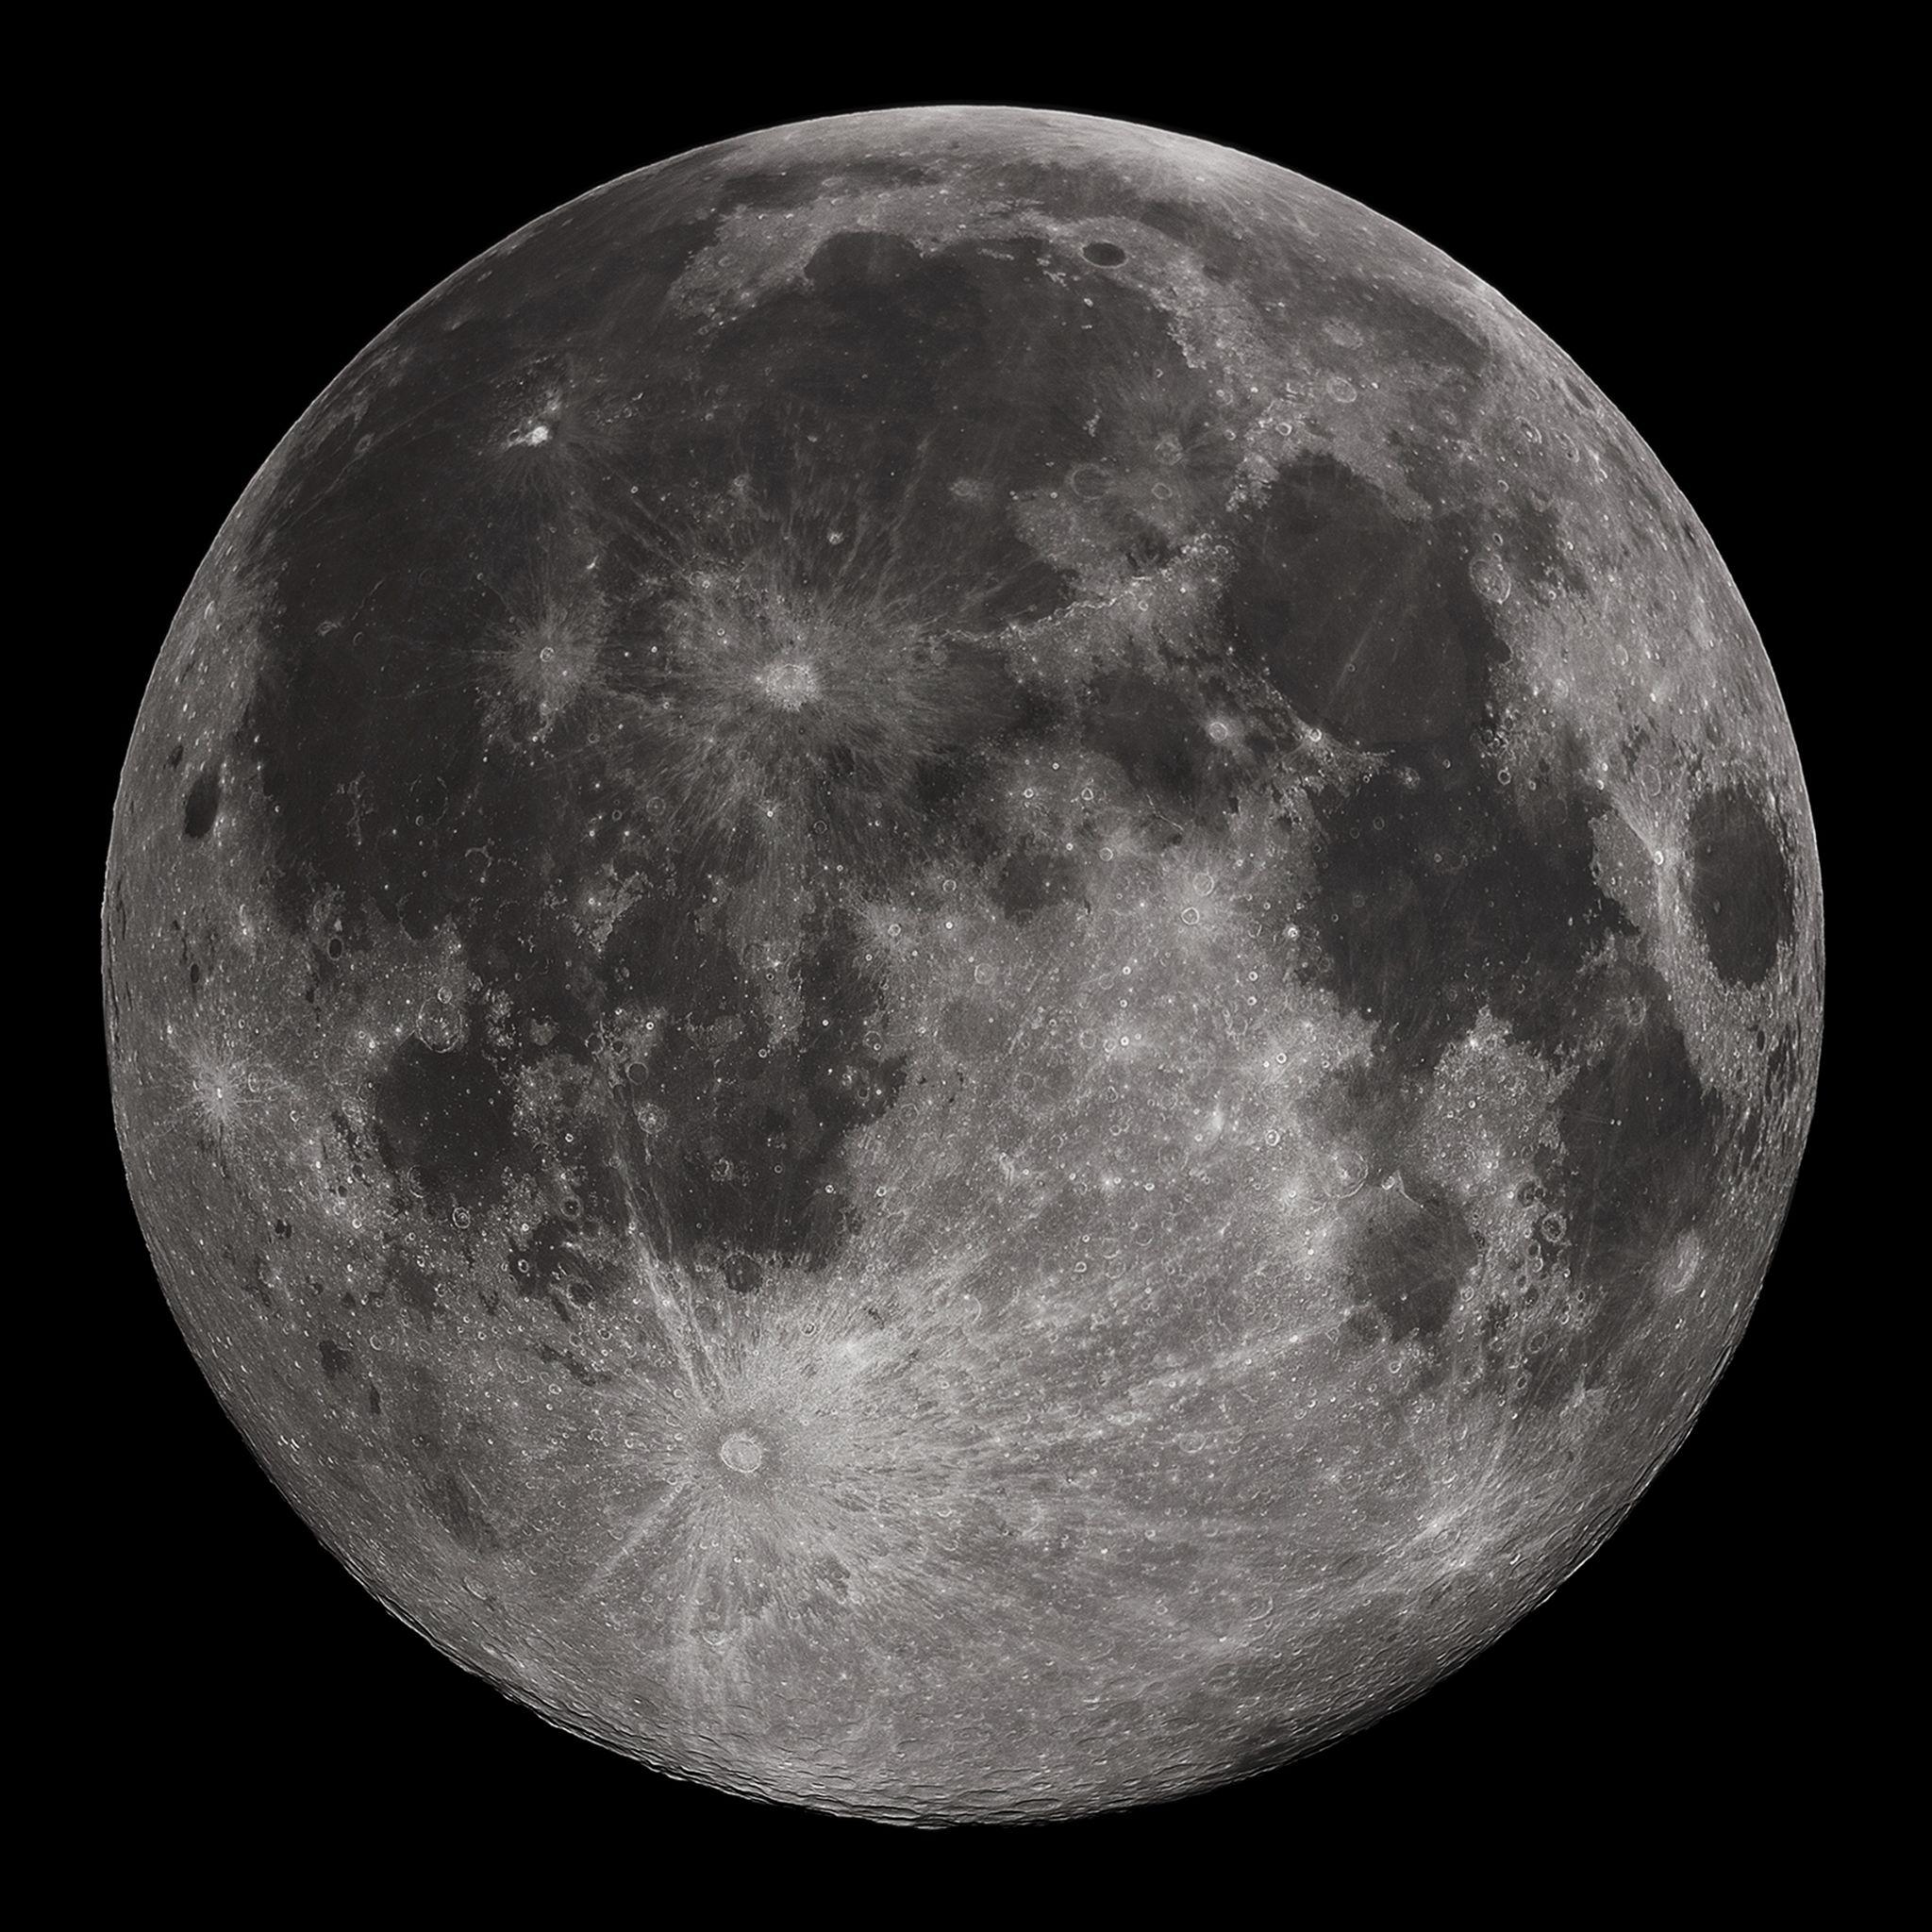
Our son Micah, who just finished 6th grade, had a special event at his school this year where he went to a back area on the school campus at 9 at night and his teacher had set up three different telescopes to look at various features in the night sky. The one I got to look at for a little while was aimed at one of the large ¨seas¨ of the moon.

Of course, these aren’t seas in the sense of having water in them, that is just what they are called. They are really just big craters. But it’s inspiring to zoom in for a closer look at our shiny, white constant companion - the Moon. Astronomers tell us that the moon helps us in numerous ways - stabilizing our rotation and guiding our ocean tides, among other forms of assistance.

But the moon is just the closest, most visible item in our night sky. The scale of the universe itself staggers the imagination.

https://www.youtube.com/watch?v=eGd7G92Gv00 [show 3 min clip from this]

- Meditate on Creation
  - The book of Nature sings the praises of God
"The heavens proclaim the glory of God. The skies display his craftsmanship." Psalm 19:1

Whether you look at the vastness of the cosmos or zoom in to focus on one particularly amazing feature, the heavens proclaim the glory of God. 100s of billions of stars in 100s of billions of galaxies like ours - numbers like this are beyond what we can comprehend. And how does Genesis 1 describe God´s mind-blowing creation of this nearly infinite expanse of stars, planets, comets, asteroids, nebulae and more? ¨He made the stars also.¨ that’s it. Not a big dramatic effort - just the swinging of God’s hand like a painter spattering some paint on a blank canvas - God said, ¨Stars¨ and whoosh - the universe was populated!

- Meditate on Creation
  - The book of Nature sings the praises of God
"Day after day they continue to speak; night after night they make him known."
Psalm 19:2

Creation sings a song of praise to the Creator non-stop! All throughout the day the birds and the fish and the lizards and the armadillos, the turtles and the gators, the dolphins, and the manatee - they continue to speak. Night after night the stars and planets, the moon and the outer galaxies shout the praises of the Lord.

- The book of Nature constantly sings the praises of God
"They speak without a sound or word; their voice is never heard. Yet their message has gone throughout the earth, and their words to all the world." Psalm 19:3-4

Without a sound, without a deliberate word, the creation of God speaks of God´s power and glory, of His wisdom and creativity. He is truly an INFINITE GOD - there is no limit to His power; there is no way to measure His generosity. ¨His eternal power and divine nature have been clearly seen, being understood from what has been made,¨ as Paul writes in Romans 1.

How do you meditate on creation? Do you consider this a spiritual discipline? Don´t forget that we live in a tropical paradise. Those of you who have been in Florida for decades may not realize that there is this place called the Midwest where the sky is GRAY most of the time. Yes, it´s because there are clouds in the sky, but a lot of the time you don´t see the individual clouds, you just have this general gray overcast. Is it any wonder that northerners are grumpy? They don’t get enough vitamin D from the sun. A pastor friend of mine has served in Connecticut for 30 years. He calls those discouraging times ¨Senior Days¨ - cold, gray, and bitter.

We have very few of those down here! We have almost constant sunshine, all kinds of animal life around us, ready access to lakes and some of the most beautiful beaches on the planet.

When you go for a walk, doesn’t it nourish your soul? As you walk around your neighborhood or walk through a community park, slow down enough to really SEE the world God has made. Let walking become a form of WORSHIP for you. Creation is always singing God’s praises - if we will just slow down long enough to listen!

King David pivots in verse 5 from the heavens and skies in general to the sun in particular.

- Meditate on Creation
  - Reflect on the Details of the world
"God has made a home in the heavens for the sun." Psalm 19:5

Our great golden sun is too bright to look at directly - in itself a theological statement. No one can look at God and live. If we can´t even look at one of the medium size, medium brightness stars in the galaxy without burning out our retinas why would we think to look casually upon the glory of the Creator God of the universe? Listen to how King David describes the glory of the sun:

  - Reflect on the Details of the world
"It bursts forth like a radiant bridegroom after his wedding. It rejoices like a great athlete eager to run the race." Psalm 19:5

What is more eager or excited than a groom on his wedding day? What is more poised to burst from the blocks than a sprinter waiting to hear the starter´s gun? The sun breaks over the horizon with radiant glory, its brilliant rays piercing immediately as far as eye can reach. It rises each day and runs its circuit with unstoppable speed and unshakeable endurance.

  - Reflect on the Details of the world
"The sun rises at one end of the heavens and follows its course to the other end. Nothing can hide from its heat." Psalm 19:6

Where would we be without the sun? Our planet would plunge into darkness, it would cool off and freeze. Plants would all die. Then animals would all die. The moon is helpful to us for a number of reasons, but the sun is absolutely essential. Is there a theological lesson here? The sun is too bright and glorious to look upon directly. It can be overwhelming in the direct heat. But we desperately need its light; we need its heat; we need its nourishment for our plants and trees.

So, the sun reminds us, and teaches us of our need for God! We need His light. We need the warmth of His presence. We need the nourishment of His Spirit - His life moving within us. His light and heat can be overwhelming - but we cannot live without them!

Opportunities for worship are all around us if we will just look! Some of you enjoy gardening for just this reason. Many of us enjoy visiting parks like Lettuce Lake or Upper Tampa Bay Conservation Park. This is why it is so fun to get out onto a lake or out into the Bay on a boat. Open the book of Nature! Read, study, and meditate on all that God has made! This is a spiritual act of worship!

Most of you know that I am not much of an outdoorsman. Until this year I had not caught a fish of any kind since I was a young teenager angling for bullheads in a neighborhood pond. Those are bottom feeders that will eat anything, FYI. No skill needed to catch them. A few guys at Oakwood have gotten into ocean fishing, and I got invited out a couple of months ago.
That, ladies and gentleman, is a 29 inch, 12 pound REDFISH. And it was the only Red anyone caught on that outing. So you can see I am now a skilled fisherman. Actually the captain baited the line, cast the line for me, helped land the fish and took the picture. And I dropped the fish twice before succeeding in getting this picture. That´s probably why the fish looks so distressed, other than being out of water.

The point is that opportunities are all around us to study the book of nature - to meditate on creation and fill our minds with the glory of God! Here is a quote from Spurgeon to wrap up this first point:

“He who forgets the humming of the bees among the heather, or the cooing of the wood pigeons in the forest, the song of the birds in the woods, the rippling of rills among the rushes, the sighing of the wind among the pines, needs not wonder if his heart forgets to sing and his soul grows heavy…

“A day’s breathing of fresh air upon the hills, or a few hours’ ramble in the beech woods umbrageous calm, would sweep the cobwebs out of the brain of scores of our toiling ministers who are not but half alive. A mouthful of sea air, or a stiff walk in the wind’s face would not give grace to the soul, but it would yield oxygen to the body, which is next best.” Charles Spurgeon

That is the first exhortation of Psalm 19 - to meditate on Creation. Then David shifts in verse 7 from creation to Scripture. If we want our words and thoughts to be pleasing to the Lord, we need to fill our minds with the truth and glory of God. We cannot do that with creation alone. We need the Bible!

2. Meditate on Scripture
"The instructions of the Lord are perfect, reviving the soul. The decrees of the Lord are trustworthy, making wise the simple." Psalm 19:7

The most helpful single discipline to strengthen your spiritual life and help you grow in the Lord is to learn to MEDITATE on God’s Word. To meditate is to slowly soak in truth, like a cup of hot water soaking up flavor from a tea bag. It takes time and heat to draw out all the richness from a tea bag. You cannot do it quickly.

We need to let our minds SOAK in the flavorful richness of God’s Word. We need to let Scripture seep into every corner of our thoughts. David tries to help us EXPERIENCE the beauty of the Bible here in verses 7 through 9 with three balanced couplets. These are classic examples of Hebrew parallelism - the primary feature of Jewish poetry.

(1A) "The instructions of the Lord are perfect, reviving the soul.
(1B) The decrees of the Lord are trustworthy, making wise the simple.
(2A) The commandments of the Lord are right, bringing joy to the heart.
(2B) The commands of the Lord are clear, giving insight for living.
(3A) Reverence for the Lord is pure, lasting forever.
(3B) The laws of the Lord are true; each one is fair." Psalm 19:7-9

Three poetic parallel verses. Six different words for God´s Law. Six different results or benefits of Scripture. 12 total expressions. Even the structure of these three verses shouts out symmetry and balance!

Just showing these verses to you in this way suffocates them a little. Yes, you can analyze the structure and grammar. You can take it apart and break it down. But these words and phrases are meant to be EXPERIENCED. There is something the parallel poetry DOES as you read it and meditate on it that goes beyond the mere meaning of the words. You FEEL the truth that God´s Law is good, reliable, beautiful, and pure. You FEEL the life-giving effect of knowing God through His Word.

If these verses remind you of Psalm 119, well done! You know your Bible! Psalm 119 is an elaborate ACROSTIC - with 8 verses for each letter of the Hebrew alphabet - and within each section the first letter of each verse uses that section´s letter of the Hebrew alphabet. You can see how that would have helped Jewish people memorize such a long Psalm and MEDITATE ON IT! And Psalm 119 is filled with parallel phrases like these in Psalm 19.

Parallelism has a COMPOUNDING EFFECT. The phrases build on each other, clarifying each other and doubling the impact and force of each other. You can place them side by side and feel the impact - God´s law is perfect and trustworthy; His instructions are right and clear; His Word is pure and true. Those are the declarations about Scripture, in beautiful balance with one another. And the results also clarify and compound each other: reviving the soul and giving wisdom; bringing joy to the heart and insight for living; lasting forever and providing fairness.

Again, it´s not so much about processing the content as it is about EXPERIENCING THE MESSAGE. As you slowly turn these phrases over in your mind you feel them land in your heart one after another. And this process of meditation does something in your brain. It

2. Meditate on Scripture
- The only thing in this world that is consistently true and Reliable
"The instructions of the Lord are perfect, reviving the soul. The decrees of the Lord are trustworthy, making wise the simple." Psalm 19:7

These six phrases invite us to contrast the beauty and glory of God´s Word with everything else in this world. Nothing else in this world is perfect and reliable, consistently true and good. Only Scripture meets this standard. Creation is fallen - and while there is a lot of beauty in this world there is also a lot of brokenness. People are very fallen - corrupted by sin. Even the best people are not always true and reliable. Every one of us is susceptible to deception and sin. As soon as you start believing, “That would never be me,” guess what? It could be you.

Someone once said, “If you think you are not in danger of sexual sin you must be stronger than Samson, more devoted than David and wiser than Solomon.” Or to translate to more modern examples, “If you think you are not in danger of abusing power you must be more strategic than Bill Hybels, more catalytic than James MacDonald and more passionate than Mark Driscoll.”

Even those examples show the dangers of meditating on the wrongs things. It is easy for us to let our thoughts dwell on issues in the news - to fill our minds with worry and negativity. But the Bible calls us away from those fears and that path to discouragement, back to the refreshing, peace-giving well of God’s Word. Do you want something that will revive your soul? Do you want to be wise even if you are simple? Learn to know and love the instructions and decrees of the Lord!

2. Meditate on Scripture
- The only thing in this world that is consistently true and Reliable
"The commandments of the Lord are right, bringing joy to the heart. The commands of the Lord are clear, giving insight for living.” Psalm 19:8

We need more JOY for our hearts. We need more insight for living. Therefore, what we need more of is more BIBLE. That is the source of truth. That is the unchanging, firm foundation upon which we can build our lives. That is how we can find clarity in confusing times. That is where we can find peace in the midst of terrible storms. God’s Word is where we can take refuge, where we can rest.

2. Meditate on Scripture
- The only thing in this world that is consistently true and Reliable
"Reverence for the Lord is pure, lasting forever. The laws of the Lord are true; each one is fair.” Psalm 19:9

Verse 9 shows us another interesting feature of Hebrew parallelism. Did you catch this detail as we went through this Psalm? Of the six statements in a row, one of them is different. “Which one of these is doing his own thing? Which one of these just isn’t the same?”

Five of the six are synonyms for Scripture. But this one in verse 9 is not - instead David mentions “reverence for the Lord,” or “the fear of the Lord.” The phrase fits with all the others in terms of timing and word flow. And it fits thematically. But when you slow down enough to take it all in, you see that it is different - it is not a synonym for Scripture - so it draws attention to this phrase over the other 5. And that, in itself, is a beautiful and powerful fact about God’s Word - the details all matter! The order and placement of every word, every phrase is deliberately inspired by the Holy Spirit of God!

Do you feel the impact of this? “Reverence for the Lord,” is what moves you to read the Bible in the first place! If you don’t fear God and respect His glory and His Name you won’t give Him the time of day. “The fear of the Lord is the beginning of wisdom.” That is step one on the road to salvation.

But have you noticed that reverence for the Lord is also the RESULT of reading Scripture? The more you study God’s Word the more you KNOW HIM and the more you revere His infinite wisdom and glory and goodness in abject awe and trembling, awe-filled terror.

This is the GOD OF HEAVEN with whom we are doing. If I casually open this book and flip through it like a People Magazine, I have missed the point of it altogether. This is the express verbal articulation of the Creator and Sovereign Ruler of all things. This is the personalized, customized, itemized record of the covenant God of Israel and His in depth interactions with His people. When we open this book we step into HOLY GROUND - and we are fools if we do so without reverence and awe. “Reverence for the Lord is pure, lasting forever.”
Do you feel the blessing of really studying and meditating on the words of the Bible? It lets those little soul grenades sink into our hearts and minds so they can really detonate and not just bounce off like Red Leader in A New Hope, “It didn’t go in. Just pecked it on the surface.” We need to let each verse of Scripture hit us like Luke’s Force-guided proton torpedo to have maximum impact on the Death Stars of our idolatry. How is that for a Star Wars analogy. You are totally lost. Maybe go organic. Bible verses are like seeds - you have to let them into the hard, thorny soil of your heart so they can germinate and grow and bear fruit.

To let the Bible in we need to MEDITATE on it. We need to slow down in our reading and praying long enough to live with the words. To turn them over and around so we feel them. Because the “Laws of the Lord are true; each one is fair.” God’s Word is clear, accurate, consistent, trustworthy, and altogether righteous - because it is the expression of His consistent, trustworthy, and altogether righteous CHARACTER. That is our last point for today:

2. Meditate on Scripture
- Our connection to God’s life, wisdom, joy, power, righteousness etc.
"They are more desirable than gold, even the finest gold. They are sweeter than honey, even honey dripping from the comb.” Psalm 19:10

The Bible connects us with God. It is the light that shines into the darkness of our world and our hearts so we can see the truth of who we are and who God is.

When I was younger and heard verses like this, “The Law of the Lord is sweeter than honey,” in my heart I said, “Nuh-uh.” I don’t get Honeycomb cereal very often but, in spite of what Mom says, KIX is not just as good. Mueselix is not a valid replacement for Captain Crunch. I know when I’m being duped.

If you read through Leviticus with this verse in mind you will get that same 2nd grade Darin kind of feeling. It does not strike you as sweeter than honey or more desirable than gold. You will probably say, “I’ll take the gold, thanks. Probably what you want in this economy anyway.”

What makes the Bible better than gold and sweeter than honey is not the words of Scripture themselves but the God with whom those words connect us. Most of you know my wife is amazingly efficient and practical. I say that with the utmost reverence and affection. She was raised by two first-born military kids and was herself a firstborn military kid. So structure, planning, and efficiency are literally in her blood. One of the casualties of that Maggard programming when it collided with my Anderson DNA was my great quantities of accumulated STUFF. We moved 13 times in our first 20 years of marriage, and she used each of those moves as a chance to PURGE - getting rid of all superfluous items, which tragically included my MS and HS trophies. (We have now lived in the same place for 4 years in a row and plan to stay right there for many years to come!)

All of that to say, one of the things that Kristin has kept, one of the treasures that she has made sure to protect - is our letters and cards to each other. If you read through some of these letters the words themselves would probably not be that earthshattering to you. But for us, each milestone, each moment, each anniversary, each communication expressed something significant from the other’s heart. So, we treasure those.

Do you see that is what the Bible is? It is a collection of God’s love notes to His people. We have the awesome privilege to read their mail! And sometimes we blush. But mostly we sit back in wonder to see the full extent of God’s unconditional, eternally long-suffering, sacrificial, all-glorious love! These words in Psalm 19 were a gift God gave to David and through King David to the nation of Israel around 3,000 years ago. The timing was no accident. God knew what David needed right then, right there. He knew what Israel needed. And as we study and meditate on this passage today, God KNEW that we would be dealing with this on July 10, 2022 - and intended it as a love letter that would arrive for us precisely today.

2. Meditate on Scripture
- Our connection to God´s life, wisdom, joy, power, righteousness etc.
"They are a warning to your servant, a great reward for those who obey them.” Psalm 19:11

God’s Word blesses us with His love, His power, His goodness, His holiness. And it also protects us from sin and temptation and danger if we let it. There is great reward in meditating on Scripture. And there is great protection in listening to the warnings it contains.

Just over 100 years ago the esteemed New Testament professor at Princeton Seminary - John Greshem Machen - left the seminary where he had taught for 20 years to found Westminster Seminary on the truth of God’s Word. Princeton was in the middle of the Fundamentalist v. Liberal controversy that embroiled America in the 1920s. Not only were the central doctrines of Christianity being attacked by the modernists, but the idea of truth itself was being questioned.

From the enlightenment to the industrialization of modern times, human reason, creativity, and industry had produced one marvel after another - transforming society from mostly farming type villages to mostly urban city dwellers enjoying every new advance in technology. With those massive cultural shifts came the convictions of HUMANISM - that life is fundamentally about us and even religion is about what you feel and experience, not the basic word and phrases written in ancient creeds.

Machen stood firm and immoveable on the truth and importance of those ancient creeds. As a student of the Bible and teacher of the New Testament, J. Gresham Machen became a lightning rod - criticized and attacked by the growing commitment to tolerance and global understanding over against old-school, rigid, inflexible fundamentalism. Machen joyfully stood with the Old School Princetonians B.B. Warfield and Charles Hodge, and the theologians they revered, particularly Augustine and Calvin. This led him to write:

“Liberalism on the one hand and the religion of the historic church on the other are not two varieties of the same religion, but two distinct religions proceeding from altogether separate roots.” J. Gresham Machen, Christianity and Liberalism.

If the battle was warming up 100 years ago, it has reached a fever pitch today. The cancer of liberalism has spread throughout the culture to the point that it is celebrated today not only to question basic doctrines of Christianity but even basic institutions like marriage and basic facts like male and female gender. We need the resolve of men like Machen to hold fast to Scripture and stand firm in the face of controversy.

“Over against [the pragmatist, modernist] attitude, we believers in historic Christianity maintain the objectivity of truth… Theology, we hold, is not an attempt to express in merely symbolic terms an inner experience which must be expressed in different terms in subsequent generations; but it is a setting forth of those facts upon which experience is based.” J. Gresham Machen, What is Faith?

This is a fitting conclusion for today. Do you want to experience the Lord afresh? The way to do so is through His Word - through TRUTH. If your experience of the spiritual is through anything else, how can you be sure you are experiencing the LORD?

May the words of our mouths and the meditations of our heart be pleasing to the Lord - as we fill our hearts with worship, fueled by a wonder at all God has made; and as we fill our minds with truth, feasting on the depth and diversity God has supplied for us in the banquet hall of Scripture!

(John Piper, Contending for our All.)

