The Flood
Genesis 6-7

“The Lord saw that the wickedness of man was great in the earth and that every intention of the thoughts of his heart was only evil continually… So the Lord said, ‘I will blot out man…’” Genesis 6:5,7
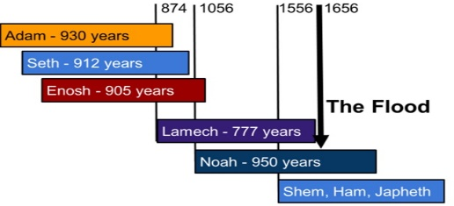
The Lord Saw...
- Every S__________ (6:5,11; Rev. 20:12)
- Every T____________(6:5,11; Rom. 1:23-28)

“Nothing is covered up that will not be revealed, or hidden that will not be known. Therefore whatever you have said in the dark shall be heard in the light, and what you have whispered in private rooms shall be proclaimed on the housetops.” Luke 12:2-3

The Lord Said...
- He will P____________ sinners (6:13,17; Lk. 17:26-27; Gen. 2:17; 3:19; 6:7; 7:16; Rom. 2:6-8; 2 Thessalonians 1:7-8; Rev. 21:8)

- He will S__________ anyone who comes to Him in faith
(6:8, 17-18; Hebrews 11:7)

"If he did not spare the ancient world when he brought the flood on its ungodly people, but protected Noah, a preacher of righteousness, and seven others... then the Lord knows how to rescue the godly from trials and to hold the unrighteous for punishment on the day of judgment." 2 Peter 2:5,9 (NIV)
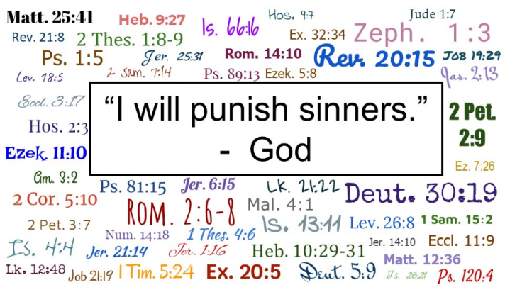

The Flood
Genesis 6-7

“The Lord saw that the wickedness of man was great in the earth and that every intention of the thoughts of his heart was only evil continually… So the Lord said, ‘I will blot out man…’” Genesis 6:5,7

The Lord Saw...
- Every Sin (6:5,11; Rev. 20:12)
- Every Thought (6:5,11; Rom. 1:23-28)

“Nothing is covered up that will not be revealed, or hidden that will not be known. Therefore whatever you have said in the dark shall be heard in the light, and what you have whispered in private rooms shall be proclaimed on the housetops.” Luke 12:2-3

The Lord Said...
- He will Punish sinners (6:13,17; Lk. 17:26-27; Gen. 2:17; 3:19; 6:7; 7:16; Rom. 2:6-8; 2 Thes. 1:7-8; Rev. 21:8)
- He will Save anyone who comes to Him in faith (6:8, 17-18; Heb. 11:7)

"If he did not spare the ancient world when he brought the flood on its ungodly people, but protected Noah, a preacher of righteousness, and seven others... then the Lord knows how to rescue the godly from trials and to hold the unrighteous for punishment on the day of judgment." 2 Peter 2:5,9, NIV

