Orientation to the End of the World Part 2
Revelation 19:11-16

Today we continue our overview of the end of the world. Last week we looked at the first three stages of the end times: increasing birth pains, the rapture of the church and the Great Tribulation.

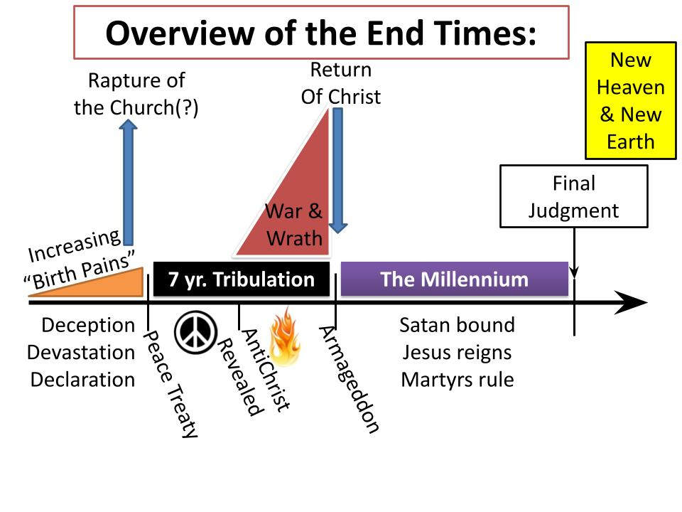
Today we begin with the return of Christ and move through the millennium to the final judgment and the eternal kingdom.

You can see in this diagram how things will increase in intensity. As bad as the “birth pains” right now might feel, we can be sure they are mild compared to how the Great Tribulation will be.

But our attitude toward the end of the world should not be fear and panic - it should be confidence in the Lord Jesus and joy that our full and final redemption is drawing near. When we see Jesus break through the clouds, His glory revealed in blinding majesty, everything else will fade to insignificance - our brief and momentary suffering in this life, even the terrors of the Great Tribulation - in fact, everyone on the planet will freeze in that moment and every eye at one time will see the Lord Jesus.

Listen to how Jesus describes it in Matthew 24:

“Immediately after the tribulation of those days the sun will be darkened, and the moon will not give its light, and the stars will fall from heaven, and the powers of the heavens will be shaken.” Matthew 24:29

After teaching what to expect in the great tribulation - the abomination spoken of by Daniel, indicating the rising of a sinister but compelling world leader - “IMMEDIATELY AFTER” those days, all of these celestial signs will take place. The sun and moon darkened, the stars falling, the heavens shaken - those are the signs of the Day of the Lord. Many of the prophets wrote of that great day of judgment that would bring history to an end and usher in the glorious eternal kingdom of the Lord- with perfect righteousness and justice.

Matthew continues:

4. The Return of Christ - The End of History
“Then will appear in heaven the sign of the Son of Man, and then all the tribes of the earth will mourn, and they will see the Son of Man coming on the clouds of heaven with power and great glory.” Matthew 24:30

In other words - GAME OVER. When Jesus comes back it is the ultimate Return of the King. It’s like the end of Robin Hood, King Richard had been away at the crusades, but when he came back it was all over for the evil Prince John. Remember the revealing of Aragorn in the battle for Minas Tirith, with his star-imprinted banner flapping in the wind before his invincible army? (That’s the end of the Lord of the Rings if you’ve been in a coma for the last 50 years.) It’s the great lion Aslan walking up to the door of that little shed in Narnia’s Last Battle. The only way “further up and further in” is past the Lion - for He is the King - that is Aslan’s country.

When the King comes back, the story is over - or nearly so. Those fiction stories, and countless others, give us a glimpse of the kind of joyful anticipation we should feel when we think about the return of the King - the True King of Kings.

For King Jesus will set everything right once and for all. Listen to Revelation 19:

- The Return of Christ - Victory with a Word
“From his mouth comes a sharp sword with which to strike down the nations… He will tread the winepress of the fury of the wrath of God the Almighty.” Revelation 19:15

Jesus started history with the words, “Let there be light.” He changed history on the cross with the words, “It is finished.” We don’t know what word he will use when he comes back, but “It is finished” is one word in Greek - TETELESTAI (Jn. 19:30; Rev. 16:17 uses GEGONEN “it is done.”). Another strong contender is the Hebrew word SHALOM - which is what he said to the storm on the sea of Galilee. We might hear it as “ENOUGH.” or STOP. Like when your Mom walks into the room and all the boys are scuffling about something and she uses her big voice and that’s that.

When Jesus comes back, He comes back to reign. When He came 2,000 years ago, He came to serve, to suffer and to die. When He comes back, it will be to take His rightful seat on the throne in Jerusalem, receiving the honor and worship of all people on earth.

More on the return of Christ in a couple of weeks. On to stage 5.

- The Millennium
“And he seized the dragon, that ancient serpent, who is the devil and Satan, and bound him for a thousand years.” Rev. 20:2

Now, chronology in Revelation is not clear. So again, we must exercise exegetical humility here. To our American minds, chapter 19 presents the return of Christ, and chapter 20 follows directly after. So it seems that after Jesus comes back he will reign on earth, on David’s throne in Jerusalem for 1,000 years. We will spend a Sunday on this, so stay tuned for more details.

But for now, as part of our orientation to the end of the world, just know there are three different evangelical views on the Millennium. I’ll show you them in visual form.

First the Post-Millennial view - meaning the Return of Christ will come AFTER a symbolic “1,000 years.”

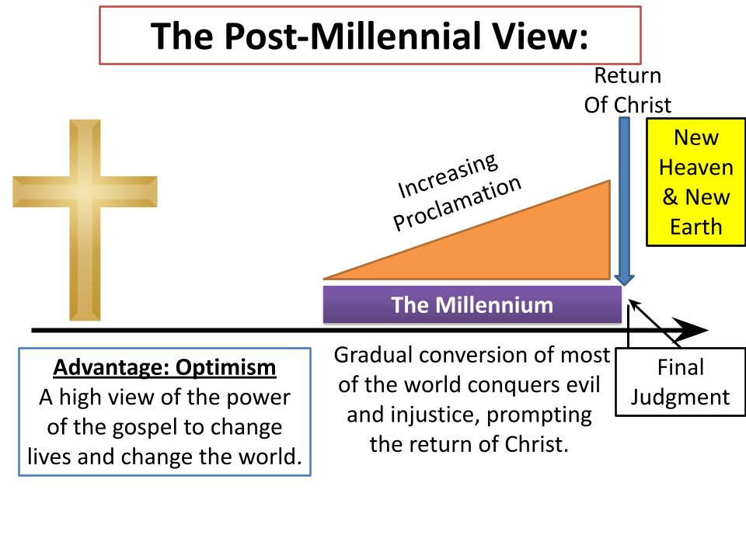This view I picture with an increasing wedge, showing the advance and victory of the church, bringing the gospel to all nations and establishing the reign of Jesus on earth in fulfillment of the Lord’s prayer, “Your kingdom come, your will be done on earth as it is in heaven.” So this is the most OPTIMISTIC view: things will get better and better until Jesus comes back.

In this view, presumably, we are in the millennium now - either dating back to some point in the middle ages or, more likely, to the resurrection of Jesus as the beginning of a long symbolic age of “the reign of Christ on earth.”

As you might guess, almost no one holds this position anymore. It was very popular at the end of the 1800s - after slavery was abolished, as revivals continued to sweep across Europe and bear fruit all over the world, through the establishment of massive missionary agencies - believers thought the end was in sight and the kingdom was right over the next horizon.

But then WWI happened. And then WWII happened. And since then no one really maintains this cheerful, “we are winning” idea anymore. Maybe we need some optimistic Gen Z kids to bring this view back. Post-Millennialism is the optimistic, “the world will get better and better” idea and then Jesus will come back.

The middle ground view is more of an ongoing battle called “A-Millennialism.”

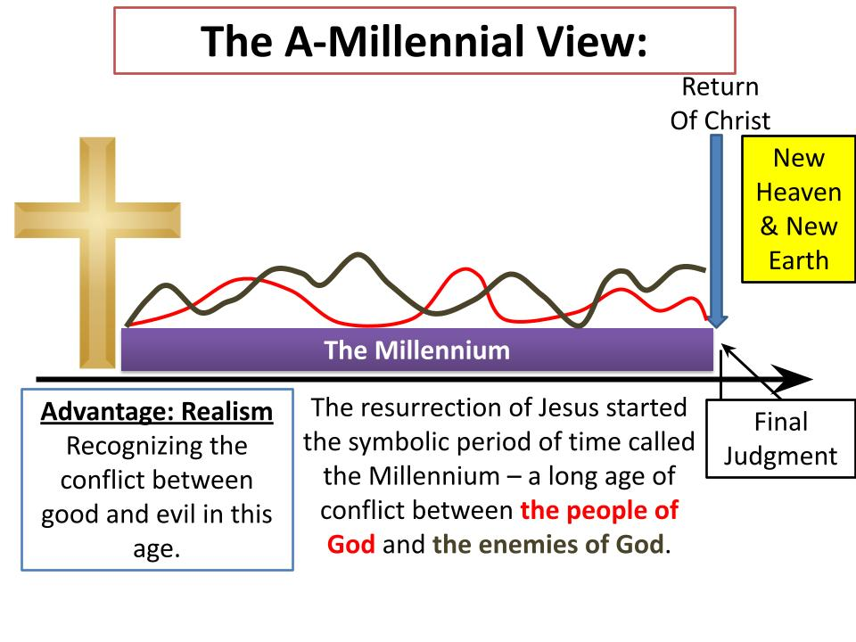

Like the Post-Mil view, the A-Mil position sees the 1,000 years as a symbolic period of time - an “age of completion.” Since the resurrection, good and evil have been at war - sometimes the church surges ahead, in the victorious power of Christ, sometimes evil seems to prevail. And so it goes, back and forth until Jesus comes back in glory.

The advantage of this view is REALISM. While in some ways it might seem that Satan is bound or restrained and Jesus reigns victorious, in other ways we feel the spiritual battle of Ephesians 6, and sometimes the flaming arrows of the evil one find their mark.

One more view on the Millennium.

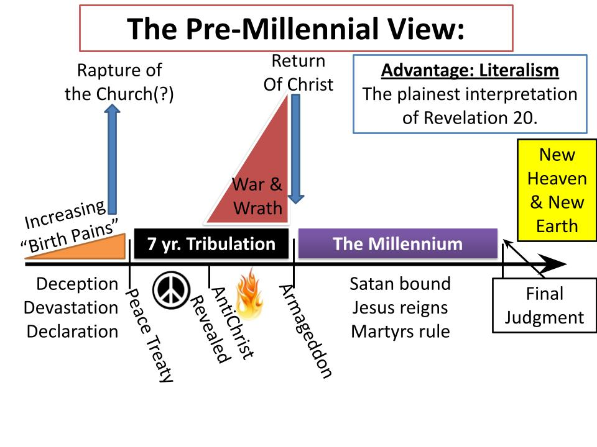
Historically the EFCA has been a Pre-Millennial movement. As you can see in this chart, this view places the return of Christ BEFORE His 1,000 year reign on earth. This is the simplest interpretation of Revelation 20. It certainly gives the best explanation for the devil being bound and chained up in an abyss. It’s hard to believe the devil is restrained to that degree right now or that he has been since the resurrection.

So, assuming this latter position, of Pre-Millennialism - that there will be a literal 1,000 years after Jesus returns, in which He reigns on earth:

The two purposes of the Millennium are 1) to fulfill the remaining promises to ethnic Israel in terms of the full boundaries of the land and the Messianic King reigning on the throne in Jerusalem and 2) to prove the justice of God once and for all.

In terms of the promises to Israel, there are three views on the nature of Israel.

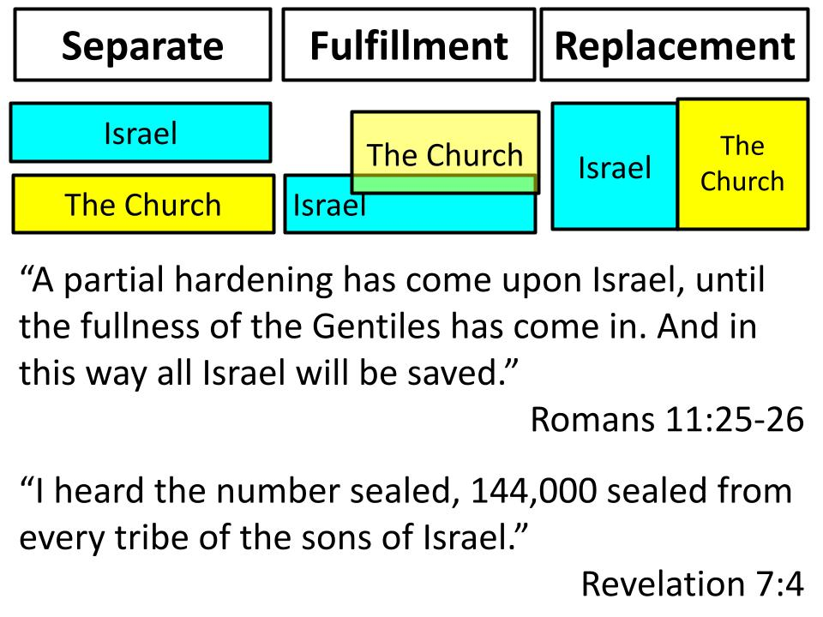

The school of thought called Dispensationalism sees a clear and firm distinction between Israel and the Church - they are separate. From Abraham through John the Baptist God was working in and through Israel. Then with the calling of the apostles and the founding of the church God put that work with Israel on hold and started “the Church Age,” which continues today. The Great Tribulation and the Millennium are not about the church or for the church - the tribulation is the purification and vindication of Israel and the Millennium provides the fulfillment of the remaining promises to Israel.

The middle ground position sees the church as the FULFILLMENT of Israel. This view also sees the need for God to fulfill promises to Israel - about the borders of the land and the Messianic King reigning in Jerusalem in a time of peace. The church is the SPIRITUAL fulfillment of Israel and is the “new people of God.” But PHYSICAL, ethnic Israel, still has a place in God’s plan for history.

The stronger version of fulfillment theology is REPLACEMENT - that the church is the New Israel and all the promises of God to Israel are both SPIRITUALLY and physically fulfilled in the church. So when you see Romans 11 saying “all ISRAEL will be saved,” that refers to all SPIRITUAL Israel, meaning anyone who gets saved and is grafted into the church becomes the true Israel, the new People of God. And in Revelation 7 when 144,000 are sealed by God from “Israel,” that 12 x 12 x 1,000 total number is a spiritual total for the full number of believers to be included in God’s holy, perfect people.

I show you these different interpretations not to overwhelm you with data but simply to show you there are points of disagreement and discussion among otherwise like-minded believers. So let’s be gracious and understanding with each other, recognizing that a lot of ink has been spilled on these topics and we aren’t likely to resolve them in a 40 minute sermon. My key concept for us is “exegetical humility.”

There are things in the Bible we must be rock solid in our commitment to - like the personal, bodily return of Christ and the literal, physical resurrection of Jesus and salvation by faith alone. But a lot of these matters related to the end of the world are difficult to fully understand and resolve, but we know they will “Pan out” in the end. So don’t stress about it and for sure let’s not fight about it. Let the questions drive you deeper into the text of Scripture to wrestle with the nature of Israel and what Paul means in Romans 9-11.

On this question I come down in the fulfillment spot - seeing the Millennium as the fulfillment of the remaining promises to Israel. For example:

5. The Millennium
- Fulfills remaining promises to Israel
“The young man shall die a hundred years old, and the sinner a hundred years old shall be accursed.” Isaiah 65:20

Isaiah 65 describes an age of peace, with the lion laying down with the lamb, with peace on earth and blessing from God. But this is not yet heaven or the eternal kingdom - because people die and sinners are there. So I think the Millennium as an actual 1,000 years with Jesus reigning on earth is the best explanation for prophecies like this one. And this leads into the second purpose for the millennium - to vindicate God’s justice once and for all.

For 1,000 years Jesus Himself will reign over the entire world in perfect justice and peace, with the devil locked up and powerless. At the end of that 1,000 years of peace and blessing the devil will be released and look what happens according to Revelation 20:

5. The Millennium
- Proves God’s Justice
“Satan will be released from his prison and will come out to deceive the nations… to gather them for battle; their number is like the sand of the sea.” Rev. 20:7-8

After 1,000 years under King Jesus surely most of the world would remain faithful to Him, right? Not even close. As soon as the devil is released the whole world chases after him to make war on King Jesus and try to destroy Jerusalem. Is God just to condemn sinners who refuse to bow the knee to King Jesus? Indeed, He has no other choice. “Their condemnation is deserved.”

To paraphrase C.S. Lewis: every person has a lifetime to say to God “Your will be done.” But for those who refuse, in the end, God says to them, “Very well - YOUR will be done.” Hell is God’s monument to human freedom. He does not force anyone to worship Him.

It’s important to notice that after the 1,000 years there is no cataclysmic battle in heaven or on earth. When Jesus returns in Revelation 19 he strikes down the nations with the sword of his mouth and zap, battle over. King Jesus grabs the antichrist and his false prophet and tosses them into the lake of fire. No contest. No sword fighting. It’s a Navy Seal against a toddler. Ant - boot.

Then in Revelation 20 when the devil is released and armies gather around the saints in Jerusalem and again - there is no battle - no clash of calvary or barrage of artillery. Fire simply falls from heaven to consume God’s enemies and the devil is tossed into the lake of fire with the other members of his false trinity. All done. All gone. Game over.

The return of Christ, the Millennium and the final victory of Jesus should give us tremendous encouragement and the ability to endure great hardship and even persecution. When Stephen was being stoned to death, the Lord peeled back the curtain of heaven and allowed him to see right into the throne room of God. When we go through times of suffering - and should the Lord bring us into times of persecution and opposition to the gospel - this is our BLESSED HOPE and our confident assurance that when Jesus comes back, it will all have been worth it.

In the Insanity of God, that is a point the author comes back to again and again as he interviews Christians who have suffered, often being in prison for years and years. Over and over they say, “Jesus is worth it. Jesus is worth any amount of suffering. He is worth even the loss of my freedom, the loss of my health, the loss of my family. Jesus is worth it.”

[Story from Insanity?]

Stage Six follows right after the Millennium in Revelation 20. The devil and his false trinity are defeated and condemned to the lake of fire. Then God turns His attention to people.

- The Final Judgment
  - Books with Sin Lists
“Then I saw a great white throne… And the dead were judged by what was written in the books, according to what they had done.” Rev. 20:11-12

Every action, every thought, every desire is meticulously documented in heaven - recorded in the books of divine reckoning. The accounting there never misses a detail and those line items are preserved forever. But notice there are two books that are opened in Revelation 20.

The first set of books are the judgment books - detailing everything you’ve ever done. But there is one other book - the Lamb’s book of life.

- The Final Judgment
  - One book with Jesus’ List
“If anyone’s name was not found written in the book of life, he was thrown into the lake of fire.” Rev. 20:15

If your name is in the book of life, guess what? Your SIN LEDGER is gone! It is removed from the heavenly library and nailed to the cross. That was part of the sentence that got Jesus crucified - your sins and mine. But since all of those sins were placed upon Jesus on the cross, they no longer exist in the judgment registry. Your judgment book is gone. Jesus paid it all!
Oh, aren’t you glad your name is in the Lamb’s book of life! Don’t assume this is true for you. “Work out your salvation with fear and trembling.” Many will say on that final day, “Lord, Lord, didn’t I go to church every Sunday; didn’t I teach Sunday School; didn’t I go to prayer meeting once in a while; didn’t I donate to the church.” (That’s a paraphrase of Luke 6.) To MANY PEOPLE like this Jesus will say, “Depart from me, I never knew you.”

Do you KNOW Jesus? Does Jesus know YOU? Are you united with Him by faith? Do you belong to Jesus? Are you committed to Him in a personal relationship?

If you are, your judgment will be short and sweet. Jesus will stand next to you, look up at the Father and say, “This one is with me.” And He will guide you into the final stage - stage 7.

- The Eternal Kingdom
  - Eden Restored
“Then I saw a new heaven and a new earth, for the first heaven and the first earth had passed away.” Revelation 21:1

The final judgment will purge the last remaining evil from the universe, allowing the holy city of Jerusalem - the glorious dwelling place of God - to descend from heaven and be united with a newly re-made earth. Just as God walked with man in the original creation, so peace will be fully and wonderfully restored in the new heaven and earth. All chaos and evil, all sadness and suffering and death will be gone.

The new heaven and earth is like Eden all over again - but really so much better, so much richer even than that. In the garden there was no sin, so there had been no forgiveness, no grace, no restoration. There was fellowship and harmony with God and there was gratitude for all He had made. But there was something significant - hugely significant missing - GRACE.

For the endless ages of eternity we will revel in the wondrous grace of God. Not one of us deserve to be with God and enjoy Him forever. All of us should be exposed for all we have done in our sin ledgers - and the wages we have earned for those sins is death and eternal condemnation. BUT GOD.

The one who has been forgiven little, loves little. But the one who has been forgiven much, LOVES MUCH. Oh brothers, sisters, we have been forgiven SO MUCH - and this is why we have eternity to praise and worship and celebrate the Lord Jesus.
We still cannot really appreciate the glory of the cross - the unfathomable mystery that the Son of God bore sin for us - he BECAME SIN for us, so we could become the righteousness of God.

For when we see Jesus, we will become like Him and at that moment of joyful recognition, we will be GLORIFIED. Our mortal bodies will be transformed into immortal bodies. Our remaining sin will be purged away and we will be forever free from the last remnants of selfishness, pride, lust, greed, impatience, envy and everything else - gone in the blink of an eye.

“Those He justified, He also GLORIFIED,” says Romans 8. THAT is the true joy and beauty of heaven. Have you ever wondered why John takes a whole chapter in Revelation 21 to describe the holy city of Jerusalem? Pearls and gems the size of buildings! We say, “Oh, that’s HEAVEN.” No. It’s not heaven. It’s the CHURCH. It’s a visual representation of YOU AND ME - of us together with believers through all the ages! This is how God sees us - or how He will see us forever and forever.

- The Eternal Kingdom
  - God’s People Perfected
“And I saw the holy city, new Jerusalem, coming down out of heaven from God, prepared as a bride adorned for her husband.” Revelation 21:2

How does a groom look on his bride? Don’t take that thinking too far at this moment. Slow down guys. We’re still in the ceremony, not beyond that. Beauty. Wonder. Love. PERFECTION. The white dress. The hair and makeup. Everything is flawless. The groom is overwhelmed with love for his bride.

That is how Jesus feels about us. This is why eternity will be indescribable joy - because it is the final fulfillment of the relationship with Jesus we have always dreamed about. This whole life experience is a long distance relationship - then we will see Him face to face. This whole life we struggle with intimacy with Jesus because our sin is still an obstacle. Not anymore in eternity. All sin and sadness and suffering and evil is gone forever.

There is nothing that stands between us and Jesus. We are GLORIFIED, perfected, translated to have immortal bodies just like HIS immortal body. And so we will be with Him forever!

So here is the summary of your orientation to the end of the world:

The End of the World
- Increasing “birth pains”  - (Secret “Rapture” of the church)  - The Great Tribulation  - The Return of Christ | - The Millennium  - The Final Judgment  - The Eternal Kingdom

You can read more on the church blog or stay after the service today for a Q&A right here in this room after a 15 minute break.

Here is our main application for this series. The Lord Jesus Christ reigns over all things. He is in control of every detail of our lives and all of history including the way history comes to its dramatic conclusion. So trust in the Lord with all your heart. Don’t worry about any of this - it will pan out in the end.

But don’t ignore all of this either. The Lord has given us these details in Scripture to help us prepare - so we can encourage and prepare each other to stand firm to the end. If my understanding of the prophecies is correct we have a lot of challenges coming our way before it’s all over. Be prepared. Stand firm. Keep working for the Lord.

And hold onto the truth - the Lord Jesus is coming back SOON. Amen! Come, Lord Jesus! When Jesus comes back it will mean justice and the final defeat and destruction of all of God’s enemies. It will mean the fulfillment of all of God’s remaining promises to Israel and to us. It will mean 1,000 years of peace on earth, and then the final judgment, the final purification. And then - eternal joy - the life we were truly made for in the world that was perfectly made for us!

