Orientation to the End of the World
Revelation 6

Last week we started our series FINALE - highlights from the book of Revelation on what to expect when the world is ending. Here was our lesson last week from chapter one:

The End of the World
- Be ready  - Be faithful  - Be confident | “The revelation of Jesus Christ, which God gave him to show his servants the things that must soon take place.” Revelation 1:1

The book of Revelation is the UNVEILING of the glory, power and plan of the Lord Jesus Christ - that is what God revealed to John on the island of Patmos. When we just think about the end of the world it can freak us out, studying charts like this.

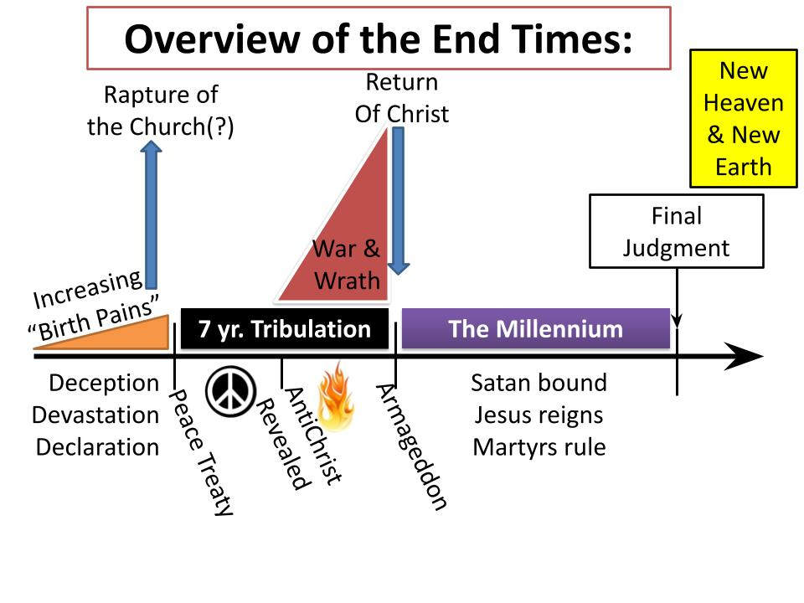
- Increasing devastation on earth in famines, earthquakes, wars and conflicts;
- Increasing persecution of Christians - growing in frequency and intensity like birth pains.
- The antichrist being revealed and taking over the world, demanding that everyone worship him;
- The sun being turned to darkness and the moon to blood, the stars in the heavens falling to the ground; the rivers and lakes being dried up; mountains thrown down…

The DAY OF THE LORD is the intense and terrifying expectation of God’s people, filled with powerful images of how the world will dissolve in the fire and lightning of God’s raging fury.

If we focus on these scary details related to the end of the world, we can quickly become overwhelmed with fear. But that is not what God wants for us. The antidote to this kind of fearful anticipation is to focus instead on Jesus Christ. That is how Revelation begins and ends - and it is the theme all the way through!

How do the saints of God overcome? By the “blood of the Lamb.” When John sees the Lion of Judah, the victorious Messiah of Israel, he is shocked to see this triumphant king looked like a little lamb, covered in blood, looking as if it had been slain - and yet it was alive.

Our calling is 1) to be ready - paying attention to the signs of the times; 2) to be faithful - protecting our holiness and working in obedience to Jesus’ commands; and 3) to be confident - trusting in the Lord Jesus Christ, who is with us to the end of the age!

Today we jump to chapter six of Revelation, but look with me briefly at chapter 4-5. After seven letters to the churches in Asia Minor, John suddenly sees heaven opened and the glory of God revealed on His majestic throne, surrounded by celestial beings and constantly exalted in praise:

“Worthy are you, our Lord and God, to receive glory and honor and power, for you created all things, and by your will they existed and were created.” Revelation 4:11

Then in chapter five, John’s vision zooms in on the glorious One seated on the throne, to see in His right hand a scroll, sealed with seven seals. Clearly this is an important document, held by the all glorious King! But tragically, there was no one with the authority to open the scroll. So John began to weep that the message could not be heard because the scroll could not be opened. But then John saw the Lamb.

It was an unusual lamb, for sure - with seven horns and seven eyes - in addition to the fact that it was covered in its own blood and somehow alive even though it had been slaughtered. The lamb approached the throne and took the scroll, and the angels and celestial beings all began to sing:

“Worthy are you to take the scroll and to open its seals, for you were slain, and by your blood you ransomed people for God.” Revelation 5:9

Then the hosts of heaven - every angel in the universe picked up the song with the smaller group around the throne:

Jesus Reigns over All Things
“Worthy is the Lamb who was slain, to receive power and wealth and wisdom and might and honor and glory and blessing.” Revelation 5:13

Then every living thing on earth (5:13) joined in the heavenly song - every single creature on land and sea and sky shouted out the glory of God forever!

So the clear and beautiful and resounding message of Revelation 1-5 is that Jesus REIGNS over all things! He alone is worthy, He alone has the authority to bring history to an end. Christ alone is exalted above the heavens - He is the Alpha and the Omega, the beginning and the End. He set the world in motion by saying, “Let there be light,” and He will bring history to its conclusion by shouting the words, “It is finished.” Everything that happens in the chaos and madness of Revelation happens according to the sovereign will and divine decree of the Lord Jesus.

So as we get an overview of the end times today and then look more closely at some of the details over the coming weeks, don’t lose sight of this primary heading over the whole book of Revelation, which is also the message of the whole Bible - Jesus Christ is Lord. He reigns. He rules. He is in control. Trust Him. Rest in Him. Be confident in Him. Focus on Him. If we keep our eyes fixed on the glory, power and wisdom of Jesus, nothing else can shake us.

So with that preface in mind, let’s take a bird’s eye view of the end of the world today. Consider this your ORIENTATION to the End Times. There are seven key events or stages to how the world ends. Let’s walk through them one at a time, I’ll show you a couple of key passages for each stage and you can read more about each one if you are so inclined. This week we will touch on the first three stages. Next week we will cover the remaining four.

Stage 1 is…

- Increasing “Birth Pains”
“All these are but the beginning of the birth pains.” Matthew 24:8
- Deception & Devastation

In Matthew 24 and Mark 13 Jesus outlines for his disciples what to expect when the world is ending. He provides four specific signs to watch for so we are not surprised or caught off guard. Non-believers will be shocked when the end comes, like the people were in the days of Noah when the flood came, or like those who are robbed by a thief in the night.

He says watch out for INCREASING deception in terms of false teaching, false christs. He says to watch out for increasing wars, rumors of wars, conflicts, violence and evil. There will be increasing disasters in famines, earthquakes, we can imagine hurricanes, tsunamis, tornadoes and volcanoes being on that list.

And the key point is “BIRTH PAINS.” Right now we see intermittent little squeezes - braxton hicks pre-labor contractions. When the real thing starts kicking in - when active labor begins - Christians should very quickly see what’s going on. Jesus goes from labor pains and giving birth to the analogy of SEASONS:

- Increasing “Birth Pains”
“From the fig tree learn its lesson… when you see all these things, you know that he is near, at the very gates.” Matthew 24:32-33
- Deception & Devastation

Pregnant women are not surprised when active labor kicks in. They know the baby is coming and each day it becomes more and more imminent. Similarly, people are not shocked when springtime arrives. At first it seems gradual, but then suddenly the flowers appear, buds start to cover the trees, the weather warms up. You can tell if you’re paying attention at all. Paul gives us one more analogy:

- Increasing “Birth Pains”
“You are not in darkness for that day to surprise you like a thief.” 1 Thes. 5:4
- Deception & Devastation

He says we are “children of light,” and calls Christians to stay awake and not be like those who hide in the darkness because their deeds are evil or like those who get lulled to sleep in these ever darkening days.

There are four birth pains to watch for, and we are certainly seeing them, and it does seem they are increasing. Revelation 6 presents the active labor of the birth pains, the final stage before the “birth” of the Great Tribulation, as the first of the seven seals are opened and the four horsemen of the apocalypse are released.

- Increasing “Birth Pains”
Matthew 24 signs | Revelation 6 horsemen
Deception  “Many will come in my name… and lead many astray.” v. 5  Devastation | - A Conqueror  - War  - Famine  - Death

The first horseman rides a white horse and is dressed in white - appearing to be a great hero, and winning victories wherever he goes. The fact that he is all in white and is victorious has led some scholars to conclude that he represents the church victorious, bringing the gospel to the nations. But since the fifth seal shows us lots of martyrs waiting under the throne of God and the tone of Revelation six is not so much “church victorious,” most Bible scholars believe the white horseman represents the antichrist in particular and all false teachers and evil rulers in general.

Paul expanded on this explicitly in 2 Thessalonians 2, describing the antichrist as the one referred to in Daniel’s prophecy, who eventually causes the “abomination of desolation” in the temple area. So as we’ll see, one of the clearest and most obvious signs Christians need to be watching for is an impressive world leader who will appear to bring peace and victory.

Most infer from this key fact that there must be some terrible global disaster, or multiple disasters that allow a world ruler to emerge. COVID-19 certainly set the table for massive lockdowns and a global response to a pandemic. I believe we are one coordinated terrorist attack and one economic meltdown away from a world that joyfully embraces a confident and powerful ruler.

The other three horsemen correspond closely with the other birth pains - wars, conflicts, violence - and the famine that always follows after wars, with death close behind.

As we think about the scroll from God’s hand that Jesus, the Lamb is opening one seal at a time, it’s important to remember that a scroll cannot be opened until ALL the seals are broken. There’s a “no peeking” rule with these kind of important documents.

So it’s not until the seventh seal is broken that the end of the world actually begins - that is when the birth pains give birth to the Great Tribulation and the Day of the Lord. But we’re not to that point yet. We’ve just gotten through the first four seals. The fifth corresponds to the other two birth pains:

- Increasing “Birth Pains”
Matthew 24 signs | Revelation 6 - 5th Seal
Persecution  “They will hand you over.” v. 9  Proclamation  “This gospel will be proclaimed…” v. 14 | “I saw under the altar the souls of those who had been slain for the word of God and for the witness they had borne.” v. 9

Here John sees, under the altar in the glorious presence of the Lord - the souls of the martyrs throughout the ages. Under the altar is where the priests would splash the blood from the sacrifices they placed upon the altar. So the martyrs - their deaths, their blood - is seen as accepted by God as a worthy sacrifice, an offering of praise to Him, held in His presence under the altar before His throne.

And notice the word of God to these martyrs who cry out for justice:

- Increasing “Birth Pains”
Matthew 24 signs | Revelation 6 - 5th Seal
Persecution  “They will hand you over.” v. 9  Proclamation  “This gospel will be proclaimed…” v. 14 | “They were told to rest a little longer, until the number of their fellow servants should be complete.” v. 11

Justice is coming for all who have been persecuted for the name of Jesus. But that final reckoning is not yet here - so the martyrs must wait, resting in the holy of holies before God.
- This is a great encouragement for those of you who have suffered in this world at the hands of a person.
- If you’ve been abused, if someone has hurt you - their day of reckoning is coming. You want that justice now, but God calls you to wait, to rest in Him, knowing that justice will be served, and soon.

For all believers, this is a call to bold and steadfast endurance, no matter what. In this world you will have TROUBLE, Jesus said. TRIBULATION. For some of us that will be little “T” tribulation - the regular trials and suffering of life. Some here may see the Great Tribulation - the big “T,” with all that means. No Christian will avoid trials and tribulations - but we can rejoice in them for how they draw us closer to Jesus and allow us to encourage others in their own sufferings.

We should not be surprised when persecution increases and opposition to the Name of Jesus and the exclusive truth claims of the Bible become increasingly unpopular and eventually illegal. Persecution will increase as the end approaches, and part of the reason it will increase is because the proclamation of the gospel will also increase. There is a “Full number” of martyrs that will be reached - a full number who will fly from this world directly to the throne room of God. And correspondingly, there is a “full number” of gentiles that will be reached and will respond to the gospel (Rom. 11:25)!

We can’t control the first three birth pains - deception, devastation and persecution will happen when they happen and to the degree that God allows and directs. But the fourth sign of the end we can influence - and we must! This is our mission! And for the first time in history, the finish line is in sight. But, brothers and sisters, we HAVE TO GO! We have to get out there to our neighbors and the nations - there are people to reach, there is work to be done!

So keep praying to the Lord of the Harvest for workers to be sent out into the harvest field here in Tampa Bay and all over the world. Then get up and be part of the answer to your own prayer by sharing the gospel with someone in your life!

Hold on to the promise in Matthew 24:14 -

- Increasing “Birth Pains”
“This gospel of the kingdom will be proclaimed in all nations, as a testimony to them, and then the end will come.” Matthew 24:14
- Persecution & Proclamation

Our mission is UNSTOPPABLE. Jesus is building His church and the gates of hell will not prevail against us. We like to quote that verse about Jesus building His church - but keep in mind that is a military metaphor in which the church is an army assaulting a fortified city with iron gates. Our mission is a military invasion into enemy territory. Jesus didn’t send us to organize picnics at the beach. He did not commission us as travel agents setting up Caribbean cruises. Our mission is to bring the gospel to the ends of the earth.

Some of us have been reading the book the Insanity of God, which is filled with stories about the persecuted church. One of the places the church has been growing most rapidly in the last thirty years is China - which is one of the plcaes Christians have been most persecuted. But nothing can stop the rapid multiplication of believers. The more the government tries to stop the church, the more the church continues to grow.

Pastors in China - all house church leaders - expect to be thrown in prison for three years at a time. In fact, if a pastor has not yet been to prison the church views him as not having earned his stripes. They see prison as their proving ground - the place where true faith and character are tested. They see prison as their SEMINARY - the place where God grows their pastors and prepares them for fruitful ministry.

Two young pastors laughed about when they were in prison and the various creative ways they were tortured. The latrine was a hole in the middle of each cell. Cruel guards would hold them over that hole in different ways, twisting their arms and toying with them before finally pressing their faces into the sewage. It was disgusting and terrifying - and it happened every day for three years. But the pastors who shared that suffering looked back and actually laughed at how the torture backfired - it forced them to depend completely on Jesus, to cry out for help every single day. It forced them to pray and let go of any sense of self-sufficiency.

And one of the recurring themes of this book on persecution was WORSHIP. Often in the darkest moments of pain and suffering the Lord would give a believer a new song - and he or she would simply begin to sing. The author calls these HEARTSONGS and was inspired by how transcultural it was - how music spanned all cultures and backgrounds - and how God used a new song to not only encourage the believer in their darkness but to reach other prisoners and even guards with the gospel.

SONG STORY

It was Paul and Silas in modern times. We see these things in the book of Acts. The truth is they still happen - they are happening all the time, all over the world. The proclamation of the gospel is increasing in boldness and fruitfulness. Disciples are multiplying, especially in Asia, Africa, and the Middle East. And often the more persecution, the more multiplication. The devil must be so frustrated!

Ok, all of that is stage 1: birth pains. Stage 2 -

- (The Secret Rapture of the Church)
“For the Lord himself will descend from heaven with a cry of command… Then we who are alive, who are left, will be caught up together with them in the clouds to meet the Lord in the air.” 1 Thessalonians 4:16-17

This is the key passage that talks about the “rapture,” which is the Latin word for being “caught up.” Now, you say, “Pastor, why is this event in parentheses?” Good question. There are different views on this one, as there are on some other points we’ll get to next week.

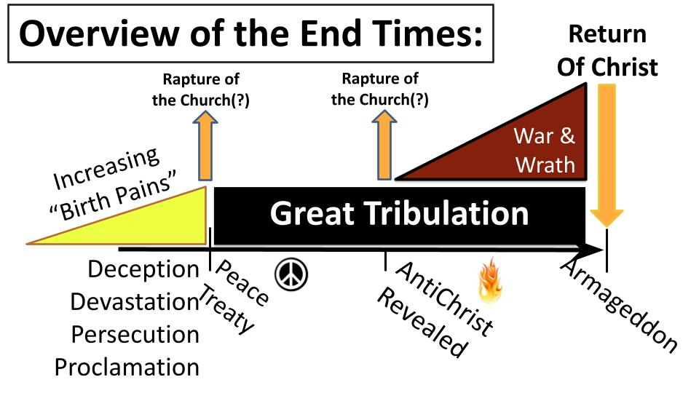
Some Christians believe in a “Pre-tribulational” rapture - that Jesus will come FOR the church before the Great Tribulation begins. Then He will come again WITH the church at the end of the 7 year tribulation. There are several reasons people hold this view but the two main ones are that 1) the tribulation is about the final purification of ISRAEL and isn’t for the church and 2) the tribulation is the final outpouring of God’s wrath on an evil and sinful world, and Christians are not meant for wrath; plus the church is not mentioned after chapter 3 of Revelation - so, this view has the hope that Christians will be vanished away, swept up into heaven, before all hell breaks loose on earth.

A variation on this view is the “Mid-trib” rapture - as you can see the other arrow in the middle of the Tribulation. Since the Antichrist will set up the appearance of “peace” on earth through a treaty with Israel, the first half of the tribulation will be relatively “peaceful.” But in the middle of those seven years the Antichrist will betray the treaty by doing something abominable to Israel, and that is when the wrath of God will be unleashed on the earth. If events follow that basic timeline, a mid-trib or “Pre-Wrath” rapture could take place.

Personally, I hold the other position called the “Post-tribulation” rapture. This view sees the rapture and the return of Christ as one event, rather than two separate events. The main reason I hold this view is that 1 Thessalonians 4 sounds a lot like Matthew 24 and Revelation 19.

All of these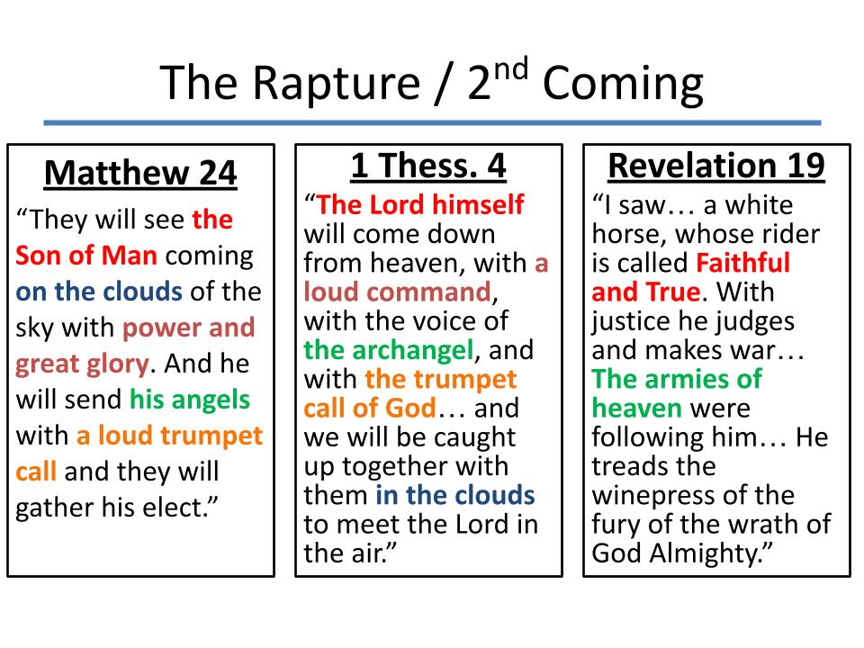
All of these passages mention angels and a trumpet, plus clouds and dramatic VISUAL events. I struggle to see 1 Thes. 4 as a SECRET, hidden, quiet event. Plus, on the whole, the teaching of Jesus and the message of Revelation is about ENDURING through tribulation, not being rescued FROM it. So the plainest reading of Scripture - to me - is that these three passages describe the same event - the return of Christ at the end of the seven year tribulation.

Now, of all of the Biblical beliefs I hold, this is the one about which I would be most happy to be wrong! And Biblical prophecy is notoriously tricky, so the pre-trib rapture is just crazy enough that it might actually be right. In the end, all of us need to be “Pan-tribulational, trusting in the Lord Jesus that everything will PAN OUT alright in the end.

If the “Left Behind” pre-tribbers are right, it will be a dramatic beginning to the Tribulation as millions and millions of Christians suddenly vanish. If not, the start of the Tribulation may be a little harder to pin down, but there are three key features of the Tribulation to be aware of - here are the first two:

- The Great Tribulation
- A Conquering Leader
- 3.5 years of Peace
“The ruler who is to come… will confirm a covenant with many for one ‘seven.’” Daniel 9:26-27

600 years before Jesus was born the Lord gave Daniel several dramatic visions of how history would play out. One set of visions talk about 69 weeks - 69 clusters of 7 years which amounts to roughly 483 years, which translates to 477 modern years since the Jewish calendar only had 360 days.

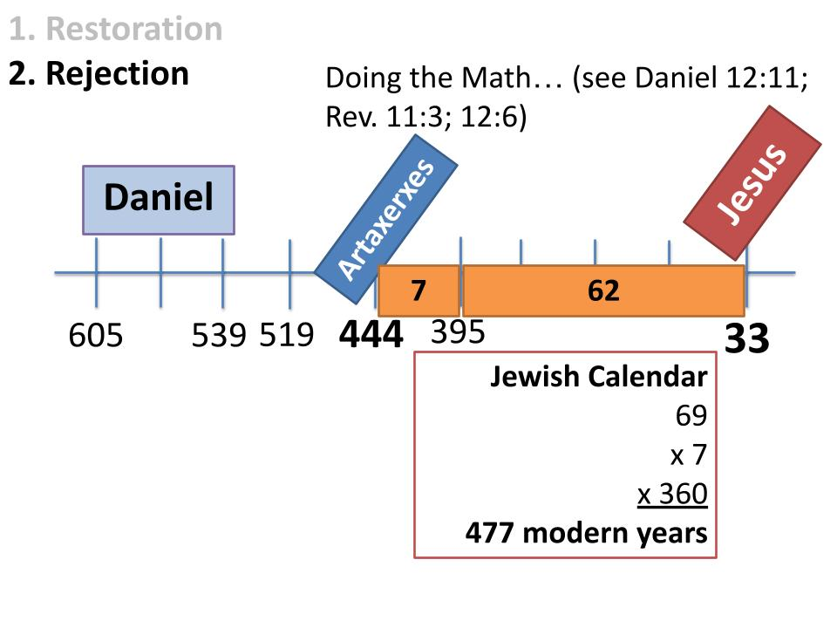
From the decree of Artaxerxes, allowing Nehemiah to return and start rebuilding the walls of Jerusalem to the resurrection of “The Anointed One” of Daniel’s prophecies was precisely 477 years - 69 “sevens,” exactly. Now, did any of the Jews in Jesus’ day figure out this prophetic puzzle? No. As far as we know not a single one did. Only with the advantage of retrospect and lots and lots of study of prophecy with some pretty serious math majors helping out did someone piece this together.

So this gives us a lot of humility as we look ahead. Nobody figured out the significance of Jesus’ first coming, so let’s be humble when it comes to interpreting the signs related to his second coming.

- The Great Tribulation
- A Conquering Leader
- 3.5 years of Peace, 3.5 years of Wrath
“In the middle of the ‘seven’ he will put an end to sacrifice and he will set up an abomination.” Daniel 9:27 (NIV)

The point that seems clear is that the Great Tribulation will include the rise of a prominent world leader who will broker a peace with Israel, and apparently the entire world, and will maintain that peace for 3.5 years. But in the middle of that final week of history, this powerful and charismatic leader will betray that covenant and defile the temple area.

The detailed prophecies of Daniel 9-11 were explicitly fulfilled in a terrible Greek ruler named Antiochus Epiphanes who ruled over Israel in the second century B.C. He was the one who destroyed Jerusalem, crushing the revolt of the Maccabees, from which the Jews celebrate Hanukkah, the miracle of the oil for the lamps in the temple that never ran out. Furious at their attempted rebellion, Antiochus slaughtered tens of thousands of Jews, enslaved thousands of others and put an end to their sacrifices.

And the exclamation point on his conquest of the temple area was when he set up a statue of Zeus and offered a pig as a sacrifice on the Jewish altar. It was “an abomination of desolation.”

https://www.ligonier.org/learn/devotionals/abomination-temple

That was 200 years before Jesus’ ministry. In Matthew 24, after talking about the birth pains, Jesus made reference to Daniel’s prophecy:

- The Great Tribulation
- A Conquering Leader
- 3.5 years of Peace, 3.5 years of Wrath
“When you see the abomination of desolation spoken of by the prophet Daniel, standing in the holy place.” Matthew 24:15

This took place 40 years later when Roman General Titus conquered Jerusalem, crushing another rebellion and completely demolished the temple. So Biblical prophecy creates a pattern for us to watch for related to the end of the world. Daniel saw a sinister and crafty ruler who would rise and deceive many, making peace in Israel but a treacherous peace. Antiochus Epiphanes did this in 168 BC as an initial fulfillment. General Titus provided another fulfillment. Both point ahead, like little “A” antichrists who defiled the holy place in Israel - showing us the kinds of things to expect when the real evil Ruler arrives. The rising of the Antichrist as a world leader marks the beginning of stage 3 - the Great Tribulation.

So you see the progression in this chart. The four birth pains increase and intensify, eventually giving birth to the Great Tribulation, which will begin with the rapture of millions of Christians and/or the rising of a great global leader who will make peace in Israel, unifying the world, or at least the major world governments around the middle east.

Now, let’s apply this as the early disciples should have

- The Great Tribulation
- A Conquering Leader
- 3.5 years of Peace, 3.5 years of Wrath
“When you see the abomination of desolation spoken of by the prophet Daniel, standing in the holy place.” Matthew 24:15

Jesus did not want his disciples to panic every time a new Roman governor showed up, or every time a Roman army passed by. No doubt that happened quite frequently in the 30s, 40s and 50s AD. Then it intensified under Nero in the 60s. Paul was martyred in Rome. Peter was martyred in Rome.

You wonder if the believers in Jerusalem debated, when they heard about Peter and Paul being killed, if Nero was the Antichrist and if their executions marked the beginning of the Great Tribulation. But as abominable as those killings were, they were not “the abomination of desolation” in the holy place of the temple. Peter and Paul were both killed in Rome, not Jerusalem. It was the temple area that was the focus for Antiochus Epiphanes and for the future Antichrist. And it was the same through the 60s AD, leading up to the destruction of Jerusalem in AD 70.

When the temple was torn down, and not one stone was left on another, all debate ended. The believers then had no doubt anymore - “That’s what Jesus was talking about.” That is how it will be for us when the Antichrist is revealed and strolls into Jerusalem to establish some kind of peace. It will be clear. It will be obvious. It will fit.

Listen to how Paul describes the Antichrist in 2 Thes. 2. In the middle of the Great Tribulation, around the 3.5 year mark, this ruler will betray his covenant with Israel and defile the temple.

3. The Great Tribulation
“The man of lawlessness is revealed, the son of destruction, who opposes and exalts himself against every so-called god or object of worship, so that he takes his seat in the temple of God, proclaiming himself to be God.” 2 Thes. 2:3-4

This passage goes on to describe the many signs and wonders this Antichrist will be able to perform, to win over those who are not followers of Jesus, or are not established enough in their faith in Jesus. But this false Messiah will not rule for long, for the true Messiah will return. That is the fourth event in the end times sequence and we will get into that next week.

But this will be our conclusion for this week:

- The Return of Christ
“And then the lawless one will be revealed, whom the Lord Jesus will kill with the breath of his mouth and bring to nothing by the appearance of his coming.” 2 Thes. 2:8

When Jesus comes back it will be in great power and glory, with all the hosts of heaven. There will not be a great battle. The angels won’t duke it out for hours and days with flashing swords and dramatic military movements. Jesus will simply kill the Antichrist “with the breath of his mouth,” and bring him to nothing.

As Luther’s great hymn says it, “The prince of darkness grim, we tremble not for him; his rage we can endure, for lo his doom is sure; one little word shall fell him.”

So we end today as we began - rejoicing in the supremacy of Christ! The Lord Jesus reigns over all things, including the details of history and the exact sequence of end times events. So don’t panic. Don’t worry. Jesus is in control.

No matter how things play out, our job is the same - trust Jesus; serve Jesus; proclaim the good news about Jesus! And He will build His church victorious - until He comes back!

Let’s pray.

