One Man, One Woman - The Gift of Marriage
Genesis 1:26-31; 2:20-25

Today we place the sixth block in our Biblical worldview.

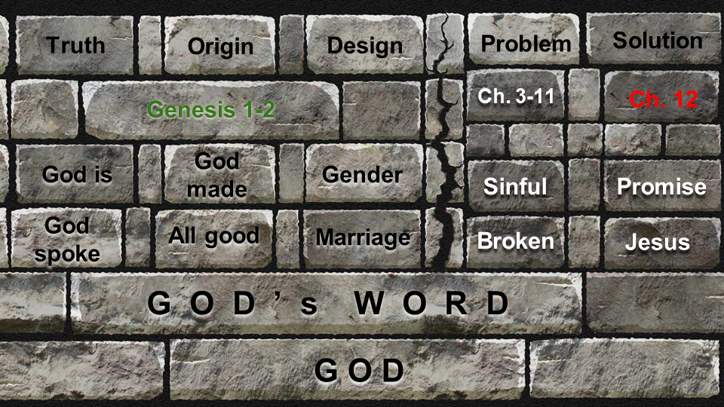

The unshakable foundation of our worldview is God and His Word. Since God is perfectly faithful and trustworthy, everything in His Word is true and reliable. That is the first question any worldview must answer: what is true, and how do you know? The Bible opens with the truth that God exists, and the understanding of God provides clarity about all other truth. And we know about God’s nature and mercy because God spoke in the pages of Scripture.

From TRUTH we moved to ORIGINS seeing that God made everything, including you and me. Every worldview must answer the question - where did all of this come from? Was it just random chance over billions of years, or was there a Designer to explain all of this precision design? It takes far more faith to believe in random chance than it does to believe what the Bible says, that God spoke and everything leapt into being. And it’s important to see at the end of Genesis one, in God’s original creation there was no death or disease, no sin or corruption - everything was “very good.”

Last week we applied the truth of God’s creation to His intentional DESIGN and purpose for humankind. God formed everything, including you. He filled everything. And He named everything - including you and me. That includes every detail of your life - including your gender. God made no mistakes. To question or rebel against God’s design is like fighting against gravity.

That is what we will see today as we study marriage. God, the Creator, designed humans to reflect His image - and He gave specific instructions and parameters for how we can flourish in relationship and in society. When you follow the Owner’s Manual for marriage, life will go better for you and those around you - such as your children. When you violate the principles in the Owner’s Manual, you bring pain and suffering on yourself and those around you.

For example, God designed marriage to be between one man and one woman for a lifetime. If either member betrays their commitment to one another and commits adultery, it fractures the union of marriage, destroys the trust that the relationship is based on and creates a massive disruption in the whole family system. Our culture has tried to institute a ridiculous policy called “no fault divorce.” Many have argued that “we will be better off and the kids will be better off” after a divorce. No one is better off after a divorce. Everyone loses. Everyone suffers. The husband, the wife, the kids and the whole society.

Marriage provides the central institution that the family is designed to be built around. When you try to build a family without a marriage relationship, the family will struggle. Just look at a few statistics of the results of fatherless homes:

https://www.fatherhood.org/father-absence-statistic

Children Raised without Fathers experience:
- 4x risk of poverty
- 7x risk of teen pregnancy
- 3x risk of gun crime

Or look at it another way:
https://www.liveabout.com/fatherless-children-in-america-statistics-1270392

Children Raised without Fathers represent:
- 63% of teen suicides
- 90% of runaways
- 71% of dropouts
- 85% of behavioral disorders
- 75% of drug addicts

With all of the discussion last year around Black Lives Matter, I think the best single response was Black WIVES Matter. In the complicated and often tragic history of African Americans in our country - one of the most problematic trends has been the trend of young men getting girlfriends pregnant and then moving on to the next relationship. This obviously causes great harm to these young single moms and to the children raised without a father figure. But it also causes great harm to the men who abandon their responsibility and distort the image of God in them that should have offered protection and provision for the woman they were with.

I’m not saying that’s the whole problem or that marriage would be the whole solution. All I’m saying here is that marriage is a wonderful blessing that God built into His original creation. When you follow the rules God set up for marriage, your life will be better and your whole community will flourish. When you reject and rebel against God’s rules, you invite pain and suffering instead.

As we study Genesis 1 and 2 we will see three gifts of marriage. For those here who are married, I hope this is encouraging and helpful to strengthen your commitment to one another. For those who are not married, hear this: these gifts are still yours IN CHRIST. In the eternal scheme of things, marriage is a metaphor - just like the family - to show us the relationship Jesus wants to have with His Church. We are the Bride of Christ. So the gifts of God that we enjoy to some degree in human marriage we will enjoy completely and eternally with Jesus, our Bridegroom!

Here is the first gift of marriage:

- Your spouse is God’s Provision to bless you
“Male and female he created them. And God blessed them.” Genesis 1:27

Genesis 1 makes it clear that humans are distinct from everything else God made. It’s not like the animal pyramid we learned in school - kingdom, phylum, class, order, family, genus, species (kings play chess on fat guy’s stomachs - how did you learn it?). The animal pyramid has humans on top of a gradually increasing food chain - so we are right next to the other prominent predators, like lions and tigers and bears, oh my.

But in the creation account, there is no mention of lions or tigers or bears. They are simply listed along with the other “creeping things that creep on the earth.” Animals, plants, birds and fish are listed down here, together. And humankind is listed up here, totally separate. Animal rights are fine, in their place. We are stewards of creation and must be responsible to care for everything on this planet. But it is wildly out of whack when people fight tooth and nail for the protection of pit bulls in kill shelters but they want no defense for unborn baby in a mother’s womb. Do yous see how upside down it has become? People will fuss and fret over obscure little birds that might be disrupted by oil exploration but they won’t even talk about the horrors of partial birth abortion.

That’s what happens when the foundation of your worldview is YOU. Everything is off kilter when the foundations are swamp and sand.

Genesis 1:28 is another way we see the uniqueness of mankind in God’s creation. This is the only place in Genesis 1 that we see God BLESSING. He did not bless the sun, moon and stars. He did not bless the oceans and rivers. He did not bless the birds or fish or animals that creep on the ground. The only thing on the planet that God blessed was the man and woman.

And the reason God singled out the man and woman for His singular blessing is that they alone reflect His image. Nothing else in creation has a soul. Nothing else has a responsible moral will. Nothing else has the relational capacity of a human being. Humans alone are made in the image of God which means we are spiritual beings in our essential essence - “not this crude matter.” We have God’s capacity to love and trust and honor and worship. We have God’s commission to “fill the earth and subdue it” - to rule over all things as God, the Creator, would rule. We are His stewards, sent to manage all He has made.

God blessed the man and the woman. There is one other thing God blessed. In Genesis 2, God blessed the seventh day - making it holy, set apart as a day for worship and for rest. Arguably the primary reason God gave us Genesis 1 and 2 is to help us understand the rhythm of work and rest - and the good gift that Sabbath rest is for us. The Owner’s Manual says, “work for 5 or 6 days, then take a full day off.” That is the life God blesses. If you violate the manual and work constantly, the engine of your body will begin to run rough and problems will come soon after.

Just as God blessed the Sabbath, so God blessed the man and woman. He blessed Adam and Eve in many ways - with the world He made, with the garden He placed them in, with all of the plants for their food, with all of the animals for them to interact with, with all of the work for them to do in managing the garden.

But our focus today is on the gift of marriage itself. Other than relationship with HIM - the best gift God gave to Adam and Eve was each other: the gift of marriage itself. We see in Genesis 2 how Eve is God’s provision for Adam. But Adam was clearly also God’s provision for Eve.

How do you view your husband or wife? Do you see them as a GIFT and a blessing? Do you see them as God’s good, generous, kind provision for you?

Now, anyone who has been married for more than a year or two knows that there is great blessing in marriage. But there is also challenge, hardship, struggle. If marriage was a blessing from God, why does it sometimes feel like a CURSE? We will see the answer to that next week in Genesis 3. The fall changed everything. What was easy and painless in the garden became painful and difficult when they got kicked out of the garden.

The curse of marriage is called SIN. And as bad as the sin may be in your spouse, your biggest problem in marriage is the sin in your own heart. Here is your two minutes of free marriage counseling for the day. Listen up.

Whatever the problems are in your marriage - trust, communication, time, kids, money, sex - those problems are just SYMPTOMS. The disease is called sin and that sin is located in your own heart.

Let’s say you were feeling tired all the time. That’s your symptom - fatigue. You conclude that is your problem, so you treat the symptoms - by drinking more coffee and energy drinks. This gives you a small boost in energy, but then you actually feel worse. Finally you see a doctor and he tells you that you have heart disease. Your arteries are clogged. Fatigue is a symptom of a much bigger disease - so you need to have bypass surgery and make some changes to your diet and exercise. The answer is not more coffee and energy drinks.

Often when people come for marriage counseling, they want the equivalent of more coffee. Treat this symptom. Help with this problem. Fix this little piece. And a lot of symptoms in marriage do have specific treatments. Take Financial Peace University, it will help a ton with your money issues. Quit porn altogether, once and for all. You want to boost your marriage in the bedroom, guys, you can’t be undermining trust every once in a while by looking at other women. Set up regular date nights and one or two annual getaways. Your marriage needs time and attention. Put in the time.

But those tips will just treat SYMPTOMS. They will not begin to heal the disease - which is the sin that is deeply rooted in each of your hearts. The only treatment for the heart disease of sin is the gospel. So that is your marriage key for today: stop focusing on the sin of the other person and take a long and hard look at the sin in your own heart. Selfishness. Pride. Hard heartedness. Lack of patience. Lack of love. Unwillingness to submit. Refusal to adjust. There is plenty of sin in YOU - that is your issue to deal with.

Do you see the point here? If you begin to believe that the curse in your life is your spouse, that belief will ruin your marriage. The antidote to that lie is the truth here in Genesis 1:28. “God blessed them.” Your spouse is not your curse. They are one of God’s greatest gifts and blessings to you. Believe that. And don’t focus on THEIR SIN - focus on YOUR SIN - and if both of you do that, you will pretty quickly begin to see great healing and vibrancy restored to your marriage. Judging and punishing each other will spiral into divorce. Accepting and enjoying each other will grow into a flourishing marriage.

That’s gift 1 - your spouse is God’s provision for you. Gift 2 explains this further.

- Together you can reflect the Completion of God’s image
“In the image of God he created him; male and female he created them.” Genesis 1:27

The image of God was built into Adam, but it was not complete until he had Eve beside him. “You complete me,” was one of the cheesier lines in any romantic comedy, but it expresses an important Biblical truth. Your spouse completes you physically, emotionally, practically and spiritually.

For the unmarried, again, hear this - you are not DEFICIENT - you are not missing anything. You actually have the advantage over married couples that JESUS completes you. He is the perfect husband. Where you are weak, He is strong. The more you learn to depend on Jesus, the more He will complete you in every way.

For those of us who are married, there are some significant implications of this truth - that you complete each other.

Your strengths and weaknesses were designed by God to make you better together.
“The man gave names to… every beast of the field. But for Adam there was not found a helper fit for him.” Genesis 2:20

Adam went through all of the animals - what must have been a fun and fascinating project for someone who had never seen the Nature Channel or a National Geographic special with whales breaching in slow motion. But at the end of this taxonomy project, Adam came to a discouraging conclusion - he was alone. There was no partner for him. All of the animals had mates and fellow memebrs of their species, for God created all things “according to their kinds.” But for Adam, there was no mate, no partner, no one like him.

Like Tarzan, he could not find “someone like me” - not even a stranger. Like Tigger, he was discouraged to have no one to bounce with. Like Sven, he was “Lost in the woods.” (Come on, those were pretty good.) And so, the Creator again stepped in.

Your strengths and weaknesses were designed by God to make you better together.
“The Lord God said, ‘It is not good that the man should be alone; I will make a helper fit for him.’” Genesis 2:18

Genesis 2 gives us a whole chapter of detail again highlighting how humans are different from everything else God made. With everything else God simply SPOKE and it existed. Only with the man did God get His hands dirty. Only with the man did God breath life into his nostrils. Only with the woman did God take a piece from a living creature - significantly, taking a rib from Adam, and fashioning the woman from that rib.

When Adam first saw Eve, he said:

Your strengths and weaknesses were designed by God to make you better together.
“This at last is bone of my bones and flesh of my flesh; she shall be called woman.” Genesis 2:23

The literal translation of this cry from Adam is “Wowsers!” Ok, that’s not what the Hebrew means but it is the essence of the exclamation. Don’t you feel Adam’s “at last,” after seeing all these animals that just didn’t fit for him? Can you see the significance of Eve being made from a bone of Adam’s body?

They were made for each other! God designed the perfect counterpart for Adam. HELPER is not a derogatory term, as it can be used today - like your “assistant” in the office who is basically a poorly paid intern that everyone treats terribly. No, helper means completer - it means balance, symmetry, WHOLENESS. Eve was a helper FIT FOR HIM. She balanced him out. She filled in his gaps.

If you picture Tom Cruise and Renee Zelwegger (from 30 years ago) as Adam and Eve, Adam pretty much said to Eve - “you complete me.”

Is this how you view your spouse? Do you see them as God’s good gift to you? As a wonderful blessing of God’s generous and sovereign grace? Do you see them as FIT FOR YOU? As God’s custom masterpiece to balance you out?

I graduated a year ahead of Kristin and started right away as a youth pastor. Kristin graduated the next May and we got married. So I was a youth pastor for a year before we got married. And it was funny those first few months as Kristin began to see how I was doing ministry.

Now keep in mind - Kristin is the firstborn child of two firstborn military kids. She was raised by an officer in the army who is among the most intentional and disciplined people on the planet - and married to one of the also most intentional, structured and organized people on the planet. Kristin, as a true firstborn, lived up to the expectations in her family and was meticulous, organized, intentional, careful, kind, sweet, wonderful, amazing.

Now me. I was the baby of four, born to two babies. (Now, my parents aren’t true babies like I am in birth order, but they both had older brothers.) Being “on time” in my childhood meant that we got there eventually. Life was about relationships, open doors, having people over - it was messy, sometimes disorganized, even a little cluttered - but it was fun and beautiful. At one point all of my high school friends knew the code to get into my house, so there was no doorbell needed - people just came and went.

Now, when you hear these differences, the marriage veterans smile because they know our first year of marriage had to be interesting. And it was.

I was a fly-by the seat of your pants youth pastor playing basketball, planning bike trips, rafting trips, ski trips, group meetings, outreaches - it was super fun and thankfully nobody died though one rafting trip did have a close call. But Kristin very gently began to suggest things that might be helpful. “I see you are making a calendar of events - maybe if you printed that up and sent it out like a week or two BEFORE the month started, that might be better than a week or two AFTER the month started.” GENIUS! I said.

Organization and administration is one of our differences. When we did a marriage assessment in our pre-marital counseling our pastor flagged two very large contrasts. Kristin is a very highly structured and organized person - like a 99. I was a very unstructured person, like a 2. I am also like a 97 as an extravert, and she is a 3 as an introvert. But we knew these things about each other, and the stars in our eyes were very bright so we just smiled and dreamily said, “We know…”

Those of you who work with Kristin in ministry have seen her incredible ability to organize things. At first I was tempted to get annoyed that she wasn’t spontaneous enough or flexible enough - but pretty quickly I learned that our differences were advantages if I was willing to embrace them and not fight against them.

To my surprise, I took Myers Briggs a couple of years ago and actually tested as a J now. 21 years married to this amazing woman rubs off on you. I’ve become more organized, more disciplined, more structured, more likely to be on time. I even plan stuff more than a week or two in advance! Impressive, right?

Because I’m spontaneous by personality, I have a very real weakness of being impulsive. Kristin’s caution and discernment can make her reluctant to take risks, but our life together has shown that once we carefully work through a decision, Kristin has been amazingly willing to embrace risk and change - and, for example, move from Chicago to Florida with three teenagers and a 3rd grader.

Kristin and I took a marriage class together in college by a professor who had written a book called Celebrate the Differences! So, we brought that mindset into our marriage and have been blessed for 21 years by how very different we are.

Do you see your differences as a blessing or as a curse? Can you see how your husband or wife completes you? How their strengths complement your weaknesses, and their weaknesses enable you to best use your strengths? Together you reflect the full image and glory of God in ways you could not do by yourself.

Part of that reflection is the beauty of mutual submission and service. The perfect relational harmony that has eternally existed within the Godhead is what we glimpse in a good marriage. God the Father loves and honors the Son. God the Son submits to and gives that glory back to the Father. The Holy Spirit is the love that flows back and forth between Father and Son - such a real and tangible love that He is the third person of the Trinity.

That is the love we glimpse in marriage. The same Holy Spirit fills you with the love of God and enables you to give that love to one another. When you serve, when you give, when you love - that reflects the beauty and glory of our Triune God.

And also, think of it this way. God is shaping you more and more into the image of Jesus Christ. In the process of SANCTIFICATION God is making you more holy, more righteous, more loving, more good. But just like shaping a statue out of marble requires chipping and chiseling, so sanctification requires some sharp tools. And marriage is one of God’s sharpest tools to change us.

Gary Thomas wrote a thoughtful reflection called Sacred Marriage. He wrote:

“What if God designed marriage to make us holy more than to make us happy?” Gary Thomas, Sacred Marriage

Thomas has since clarified that holiness in marriage is the only path to happiness in marriage. So the two are not at odds. And of course, the more holy and Christ-like we become, the more we will serve and love like Jesus - and the happier our marriages will be.

But the point is significant. God is shaping us to be perfect. And to do so He must chip away at our selfishness and stubbornness and rudeness and harshness and over-sensitivity and every other flaw and sin. Marriage helps expose our selfishness and sin - and this is another good gift from God.

One more gift.

- Your lifelong Union is built on commitment, trust and mutual service
“Therefore a man shall leave his father and his mother and hold fast to his wife, and they shall become one flesh.” Genesis 2:24

Marriage is a gift. Your spouse is God’s PROVISION to bless you. Together, you reflect the COMPLETION of God’s image. And marriage is the gift of UNION - in marriage God makes the two into one.

This again is the mystery of marriage and part of how we reflect the unity of relationship in the Godhead, and how we represent the union of Christ and the church.

Practically speaking, to protect and grow your UNION - which is best defined as INTIMACY - there are three essential ingredients: commitment, trust and service. Kristin and I made a video called “Marriage is a Piece of Cake” showing the three layers of emotional, spiritual and physical intimacy.

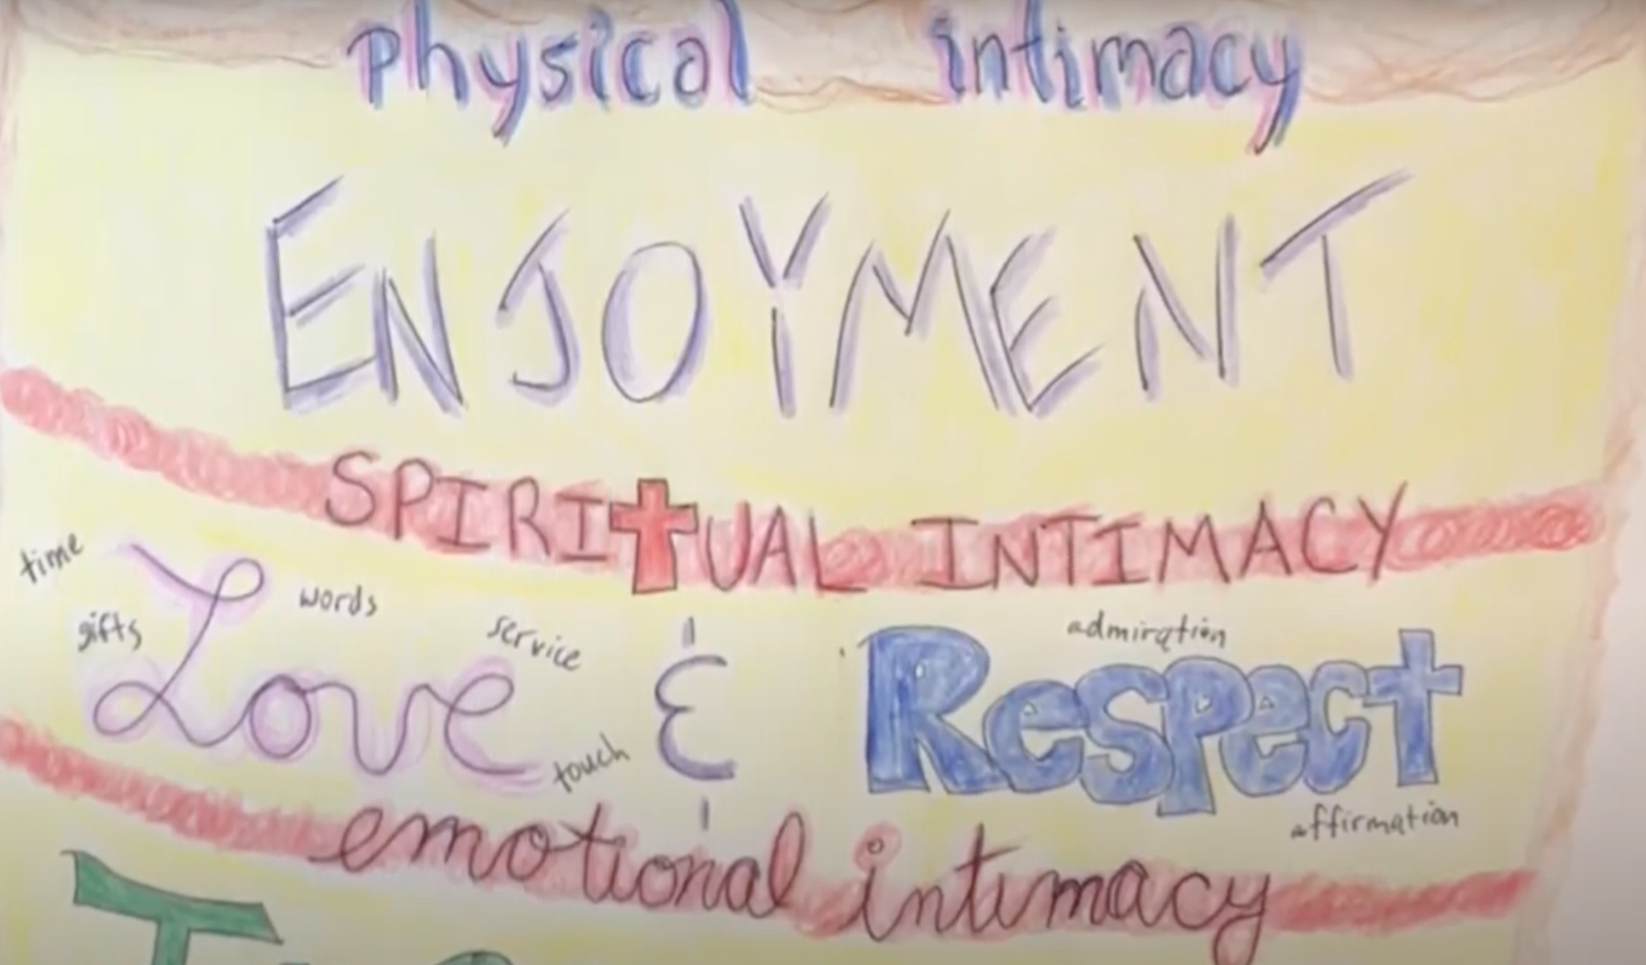

Physical intimacy is the icing on the cake. You can’t have a relationship that is just a pile of icing - unfortunately. No - thankfully. Emotional intimacy is built from commitment, communication and trust. Spiritual intimacy is the result of mutual love, respect and service - as empowered by the Holy Spirit. Then, physical oneness is the natural result. But take away any of those ingredients, and the first thing to go will be the good stuff in the bedroom. Take away commitment and you erode trust. Take away love and affection, take away respect and admiration, you are attacking the center of your relationship.

But that is right where the gospel applies to marriage! We can never do everything perfectly. No one is perfectly loving or totally respectful. So marriage is one of the best arenas to grow in grace - to accept and continue to serve someone who fails you over and over again. To forgive as you have been forgiven - not because they deserve to be forgiven, but because neither of you deserves the lavish love with which God has blessed you.

I pray that you can see the goodness and generosity of God in your marriage. Here is your assignment for this week: write a note or record a video expressing these three messages to your husband or wife.

Assignment:
Express to your spouse in writing or video:
- You are an amazing blessing from God to me
- You complete me in these wonderful ways
- I am committed to loving, respecting and serving you - no matter what!

Let’s pray.

