Encourage One Another
Acts 20:1-12

Have you ever been a part of a small group that was filled with ENCOURAGEMENT? I certainly hope so. I hope all of us here today would say, “That’s my Community Group! You should come and join us this week!”

Oakwood is filled with gifted encouragers! We are a relational church with believers who love Jesus and share that love with each other. That’s not just marketing either, it’s a sincere observation after almost four years here.

I’m in two men’s groups at the moment, and both are filled with guys who do a great job of encouraging and challenging one another. A good small group has both, doesn’t it? We encourage and support and lift each other up. But we also push and admonish and challenge one another. Biblical encouragement means both. It is not just about warm fuzzy positive thinking and positive affirmation. It’s about calling each other UP to stronger faith, greater devotion, more intentional service.

Anyone who knows sports knows how this works. A good team needs this full sense of encouragement: both a positive attitude with relational chemistry AND mutual exhortation, calling each other to step up and give everything you have.

We’ve seen this over and over with Paul in Acts. He uses words to build others up but he also challenges them - pushes them to follow his example of giving everything to Christ and the kingdom. He calls them UP to higher devotion, greater commitment, more missional living.

Here in Acts 20 we see three ways to encourage one another - three ways to call each other up in the Lord. First:

How to Call one another Up:
- Spend Time Together
“After the uproar ceased, Paul sent for the disciples, and after encouraging them, he said farewell.” Acts 20:1

The unmistakable emphasis of this section is TIME. Luke documents the movements of Paul in terms of where he went, who he went with and whom he went to see. This shows how PERSONAL Paul’s ministry was, how RELATIONAL it was. Paul was on a mission to reach as many people as possible with the gospel. But that was the point - he was reaching PEOPLE with the gospel. Everything he did was about people.

And the only way to be effective with people, is to spend TIME with them. There are no shortcuts.

- We know this in our families. The only path to QUALITY TIME is in the midst of QUANTITY TIME. If you cut short quantity, you will not experience quality.

- We know this in the business world. Connections - relationships - are everything. You have to learn how to authentically show your clients that you care about them. No one wants to be used. No one wants to be the means to advancing your corporate agenda.

- How much more, then, is this essential in ministry!

Do we prioritize quality TIME with one another in the church? Do you make sure that you are here every Sunday? Do you linger after service to catch up with people? Are you consistent in your small group? Are you open and honest, really sharing life with people? Look at Paul’s example here!

How to Call one another Up:
- Spend Time Together
“He came to Greece. There he spent three months… Waiting for us at Troas… we stayed for seven days…” Acts 20:3,6

You can feel the tension Paul was wrestling with - between advancing the mission and hanging with people. He was drawn back to Jerusalem because he sensed it was time to press on to the frontier - to go on to Rome and then to Spain. He felt his work in this region was concluding, that others could continue it. He wanted to press forward with his mission. But he knew that the key to sustaining a gospel movement was relationship. The new believers and new churches had to be established in the love of Christ. And to be established in Him they had to feel the love of their leaders. They needed TIME with him and his team.
So he spent three months in Greece - probably Athens and Corinth. Then he went back through Macedonia to visit Philippi, Berea and Thessalonica. Look at the map to see his path:
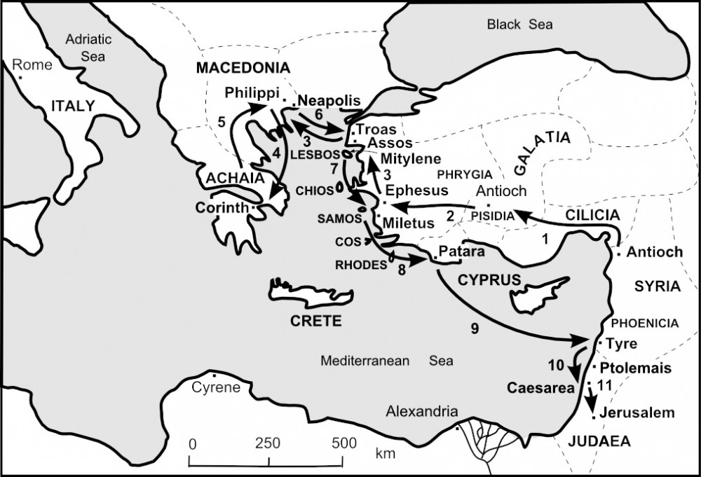
Notice verse 3 - “He was about to set sail for Syria,” but then “he decided to return through Macedonia.” Paul was led by the Spirit and by his simple love for people to go back through Macedonia. He delayed his return to Antioch and Jerusalem in order to visit with his beloved brothers and sisters. And look at the list in verse 4 of who went with him.

How to Call one another Up:
- Spend Time Together
“Sopater the Berean… accompanied him; and of the Thessalonians, Aristarchus and Secundus; and Gaius of Derbe… and the Asians…” Acts 20:4

Seven names Luke just rattles off. One from Berea, two from Thessalonica, two from Derbe and two others from Asia - probably Ephesus. Paul had been traveling around that region for almost ten years over his three missionary journeys. Through that time he had appointed elders in a couple dozen cities, recruited people to come with him, sent some ahead or behind him. Paul was all about ministry as a team. He was all about people; all about relational ministry.

So what’s the application here? Spend TIME together! If you want to be an encourager, if you want to call people UP - spend time together.
- Yes, this applies to your marriage. You need to prioritize date nights and getaways and daily communication. Spend time together.

- Yes, this applies to your family. Call your Mom and Dad. Call your kids and grandkids. Facetime, Zoom, text. Get together. Live and in person, whenever you can.

- Yes, this applies to your church friends. Be regular in church attendance. Don’t miss a Sunday for no reason - come for worship and fellowship. Be consistent in your small group. Stay connected with an accountability partner. These things all take TIME. Spend time together.

- Yes, this applies to your unchurched friends. There is no shortcut, no way around this. If you want to be effective in reaching people for Jesus, you have to spend time with friends, co-workers, neighbors who are far from God. Have coffee. Have meals together. Have them into your home. Barbecue, block party, hang out.

Encouragement happens in the context of relationship and relationship happens in the context of TIME together. It’s obvious, but we tend to miss the obvious things. Second principle to call people up.

How to Call one another Up:
- Speak Truth to one another
“Paul sent for the disciples, and after encouraging them, he said farewell.” Acts 20:1
- parakaleo - to call alongside

The word for encouragement in the Bible is the Greek word PARAKALEO - which is the name of the Holy Spirit, the comforter, the Encourager, the PARAKLETE. It combines two words - alongside and to call. So the word literally means “to call alongside.” It’s an invitation. To encourage someone is to invite them to come along with you.

Isn’t that a beautiful picture of what the Holy Spirit does for us as believers? He calls us to come alongside Him. Just as Jesus called His disciples saying, “Come, follow me,” so the Holy Spirit encourages us every single day saying, “Come along with me!”

This is exactly what we see Paul doing in Acts - calling people to come along with him to hear the good news of Jesus and then to share that good news with others. Some he literally said, “Come with me on my next trip.” Others he encouraged to come along with Him spiritually and join in the journey that is Christianity.

How to Call one another Up:
- Speak Truth to one another
“When we were gathered together to break bread, Paul talked with them… and he prolonged his speech until midnight.” Acts 20:7

Paul was a talker. We have a lot of the New Testament because he was also a writer. Paul used a lot of words to encourage believers - calling them to follow him as he followed Jesus.

In his relational ministry Paul was probably also a good listener. But here we see him teaching at length. Why? Paul had a sense that he would not be back with this particular group of Christians. He had a feeling, from the Holy Spirit, that his path was taking him elsewhere. At this point Paul thought that would be Rome and then Spain. And he did end up in Rome but then went to jail.

But those five plus years Paul was in house arrest in Rome, guess what he was doing? Writing letters to encourage believers - which is why we have Ephesians, Philippians, Colossians, 1 & 2 Timothy, Titus and Philemon.

Paul’s writings give us a great example of Biblical ENCOURAGEMENT. There is a lot of positive affirmation and loving affection. But Paul certainly does not stop there. We often think of encouragement simply as positive affirmation - being nice. But Biblical encouragement goes beyond this to speak truth - to exhort and implore, to urge and correct.

Of course, this takes discernment. Let me be clear what I am NOT saying and what the Bible is NOT saying. Yes, we are called to speak truth to each other. But remember the word here is “call alongside.” We are NOT to impose truth on others we are not obeying ourselves. That is called hypocrisy. That creates a culture of judgment. That would make us like the Pharisees - the religious leaders Jesus most strongly condemned.

Let’s remember Jesus’ words to get the plank out of your own eye first before doing detailed cataract surgery on someone else. Our goal is not to create a police state where everyone is rebuking and correcting everyone else in the name of “encouragement.” But on the other hand, we don’t want to lose any sense of accountability and discipleship in the church.

So this needs discernment. It needs prayer. It needs relationship - and lots of love and concern. But when all of those things are in place, we must be people of TRUTH.
- Men, if you see a brother drifting in his love for the Lord and his spiritual habits, call him alongside you - connect with him to see how he is doing and ask how you can pray for and encourage him.

- Women, if you see a sister becoming negative and critical and possibly bitter, call her alongside you - connect with her, listen, pray, see how you can pray with and encourage her.

- Young people, if you see a friend being drawn into a peer group of non-believers who are drawing him or her into practices that concern you - don’t ignore it! Don’t brush aside your concerns. Meet up with your friend. Listen to what’s going on. Express your concerns. Ask how you can pray.

One of our major goals as a church is to become more evangelistically engaged and effective. This extended sermon series through Acts is intended to ENCOURAGE that. We are trying to strike the balance between positive affirmation and strong exhortation. Our Community Groups are trying to find this balance - pushing everyone to pray for non-believing friends and neighbors; challenging everyone to connect relationally with those who are far from God and to have spiritual conversations that point them to Jesus.

We don’t want to create a police state of rigid accountability where you get shamed if you haven’t shared the gospel this week. But at the same time, we don’t want believers to remain stuck in a pattern of disobedience to the great commission. Our job is to exhort you to “do the work of an evangelist.” Our job is to equip you to “make disciples.” Our job is to inspire you, knowing that God has positioned you to reach people only you can reach.

How to Call one another Up:
- Speak Truth to one another
“Paul talked with them… and he prolonged his speech until midnight.” Acts 20:7
- Affirmation and Exhortation

The affirmation side is that God has created you for good works. He has prepared them in advance for you to walk in them. You ARE God’s masterpiece, uniquely enabled to reflect God’s glory right where you are.

The exhortation side is - GET AFTER IT! Don’t just sit there, walk across the street to your neighbor’s house. Bake some cookies or buy some flowers or just take a walk. You don’t have to present the whole Romans Road or the Bridge illustration in the first conversation. I would generally recommend you don’t lead with those. But you do need to learn your neighbors’ names - you do need to demonstrate that you care about them.

You say to me, “Yeah, but Pastor - WHO IS MY NEIGHBOR?” Does that question sound familiar as you say it? Does it ring a bell for you? A lawyer tried to trick Jesus by asking about the greatest commandments. “Trying to JUSTIFY himself,” he asked that question “who is my neighbor?” Jesus’ response was the parable of the Good Samaritan.

A man was beaten and robbed and left for dead on the side of the road. A Jewish priest saw the man but passed by and ignored him. A Levite also saw the man but also ignored him. The one who cared for the injured man was a Samaritan - a half-blood, compromised non-Jew. Hence, “the Good Samaritan.”

How often do we see a person in need and “cross to the other side”? How often do we sense the Holy Spirit leading us to engage with a neighbor or co-worker and we “cross to the other side.” And we try to justify ourselves by pointing out all the important things we have to do - all the people we do help and show concern for. Just like the priest. Just like the Levite. No doubt they had important work to be doing.

Ok. Did you feel that? That was my best attempt at biblical ENCOURAGEMENT. I am trying to work with the Holy Spirit to call you UP. Come alongside the Holy Spirit. Come partner with Him in reaching lost people with the gospel. Feel affirmed that you are uniquely equipped to reach people. But also feel challenged to do the work. Don’t ignore the calling.

How can we call one another up? How can we encourage one another? First, spend TIME. Second, speak truth. Third.

How to Call one another Up:
- Share in Trials with the hurting
“As Paul talked still longer… being overcome by sleep, he fell down from the third story and was taken up dead.” Acts 20:9

Of all the reasons to have your name recorded in the Bible, this has to be one of the most embarrassing. We don’t know anything about this young man named Eutychus except that he fell asleep during a sermon. Granted, it was a crazy long sermon that literally went on all night. But still, documented for millennia is the fact that this silly young man chose to sit in an open window and then had the poor judgment to fall asleep there.

Regardless of how it happened, this was an instant tragedy. A group of believers was together being trained by the apostle Paul and suddenly one of their promising young men was dead. You’ve gotta love Paul. No fanfare. No extended prayer meeting. No long incantation to invoke a resurrection.

How to Call one another Up:
- Share in Trials with the hurting
“Paul went down and bent over him, and taking him in his arms said, ‘Do not be alarmed, for his life is in him.’” Acts 20:10
When the others picked him up, he was dead. When Paul picked him up, he was alive. This isn’t because Paul was a magical faery creature. It was simply God’s will to give the early church a miraculous experience of His grace.

The application for us is that Paul entered the tragedy. He went straight toward it with love and faith. In this case, God acted to raise the young man from the dead. In another situation, as with Job, Paul might have just sat there in the pain and sadness with this group.

This is part of the ministry of encouragement the Lord calls us to - to share in the trials of the hurting - to enter the pain with them; to sit in it. The biblical word for fellowship is built from the word for sharing. We share life together - both the joys and the sorrows. We rejoice with those who rejoice and we mourn with those who mourn. Here is the result in verse 12.

How to Call one another Up:
- Share in Trials with the hurting
“They took the youth away alive, and were not a little comforted.” Acts 20:12

When someone enters your pain, you feel loved. You feel comforted. It doesn’t make the pain go away, but it adds a feeling of comfort. To encourage one another, to call someone alongside of you - sometimes you must sit down with them.

Tim Keller wrote a helpful book called Walking with God through Pain and Suffering. The book expounds on that title, teaching that you can’t run through a time of pain and sadness - you can’t hurry through it. But you don’t have to lie down in it either. You can walk. You must walk. And always remember you don’t walk alone. The Lord is our good shepherd who walks with us through every dark valley.
And one of the Lord’s best gifts to us is brothers and sisters to walk with us through those dark valleys.

We had a friend in our church in Kentucky whose husband left her and who had never worked, so she had to reinvent her life. She went through a season of depression - quite understandably. And the church family walked with her through this time. At a couple of low points people had to go to her house and help her just get out of bed for the day. That was enough of a victory - just getting out of bed. The next week, they tried to get her to take a walk outside. Over time they tried to coax her into looking for a job.

It was a long and difficult process. But the church family was very beautiful in that dark valley. I’m sure you’ve seen it and I hope you’ve experienced this yourself.
- When you lose a loved one - I hope you have some friends who will weep with you.

- When you face a scary disease or diagnosis - I hope you have a brother or sister to walk through the treatment together with prayer and love and faith.

- When you hit a vocational transition - losing a job or being forced into retirement - I hope you have one or two close friends who can process your fears and talk through options together.

- When you hit an emotional low point - like our friend in Kentucky - I hope you have a couple of friends, maybe a small group, who will keep knocking on your door, keep calling and stopping by.

So here is our summary:

How to Call one another Up
- Spend time together  - Speak truth to one another  - Share trials with the hurting | “Therefore encourage one another and build one another up, just as you are doing.” 1 Thessalonians 5:11

If we are going to encourage each other and build each other up - we have to spend time together; there is no other way. We have to speak the truth to one another in loving ways. And we need to share in the trials of those who are hurting.

These were Paul’s instructions to the church in Thessalonica - to continue doing what they were doing - encouraging one another and building one another up. That instruction was specifically related to death and loss. Christians should not grieve like others who have no hope for eternity. We do grieve, but we grieve with the blessed assurance that we will see each other again and spend eternity together in the glorious presence of our Lord in a re-made, reunited heaven and earth!
Who has done this best for you? Who has encouraged you and challenged you? Who has called you UP in your walk with the Lord?

I have had many people invest in me, starting with my parents and the E Free Church I grew up in. But let me brag for a few minutes on my father-in-law. Kristin’s parents obviously invested well in her. But they have also poured into me for the last 25 years that Kristin and I have been together.

We had the blessing to hear from Pastor Mike a few weeks ago - he and Kathi are missionaries we support as a church, and they provide training in character and strategic planning for movement leaders all over the world.

As soon as I met them, I learned that their family was all about spending time together. We believed so much in spending time together that we lived together with them, off and on, for 4-5 years. We still get together for holidays with the whole Maggard clan. When Mike and Kathi became missionaries in 2011, they committed from the beginning to traveling together - and they have. Thousands of miles, all around the world, even to places like Pakistan and Afghanistan - they go together. They say, “If we die, we die together!”

So, I learned from Mike the importance of time together and have been very blessed by the time I have spent with him. He also models the importance and power of speaking the truth in love. He and Kathi are exceptionally gifted and intentional encouragers with the art of words. Kathi has made several needle point projects we display in various parts of our house - featuring key Bible passages and conveying their love and prayer for us as a family.

When I was finishing my undergrad studies, I had some flexible hours available so I set up an independent study and asked Mike for a list of books he would recommend for someone heading into ministry. He gave me a list of 10 books or so and through that semester I read those books, wrote summaries and reviews of them and then processed the content with him.

At every crossroads decision point we have come to, Mike and Kathi have been wise counselors for us - encouragers who have spoken the truth we needed to hear in loving ways. In the challenging times, they have been there to support us and build up our faith in the Lord. In the celebrations, they have been there to rejoice with us and praise the Lord with us.

My in-laws have been tremendous encouragers for us - they have called us alongside them - called us up.

I hope you have people like that in your life. And I hope we can all be those people for others! Let’s pray!

