Receive the Word
Acts 17:1-15

If you knew there was a simple way for you to be healthier, STRONGER and more energetic, wouldn’t you want to know about it? Of course, you’d immediately and rightly be skeptical - worried about some kind of scam or sales pitch about the latest energy drink or diet fad. But if a close friend seemed noticeably different after using a product or embracing a new set of habits, wouldn’t you be interested to learn more about what was helping them feel better and live healthier?

I do not have a miracle product today for your PHYSICAL health. I’m afraid we are stuck with healthy eating and some degree of exercise. As much as I wish we could subsist on Reese’s Peanut Butter Cups and Moose Tracks Ice Cream, with a steady regime of couch-sitting - that is a recipe for future problems, not a pathway to health and vitality.

No, I do not have a miracle product for your physical health. But I DO have a miracle product for your SOUL. There IS a resource that if you use it regularly it WILL strengthen your faith, it WILL increase your hope, it WILL deepen your joy.

It’s called the Bible. You nod your heads and say, “Of course, Pastor, we know. Read your Bible, pray every day and you’ll grow, grow, grow.” Yes, it’s one thing to know something - like eat healthy and exercise 3-4 times each week. Or read your Bible, pray every day and you’ll grow, grow, grow. But it’s another thing to wake up to the alarm and lace up your shoes. It’s another thing to roll out of bed, grab that cup of coffee and open your Bible.

Like any habit - at first reading your Bible may take some effort. But of all the habits in your life, believe me when I tell you - this one discipline has the potential to have the greatest impact, the greatest return on investment.

Let’s turn to Acts 17 for some immediate nourishment from God’s Word. And let’s learn from the believers in Berea how we can FEED ON God’s Word - how we can be strengthened by Scripture. We will see three commitments to cultivate - three disciplines to develop. First:

How to be Strengthened by Scripture:
- Welcome the Word Warmly
“Now these Jews were more noble than those in Thessalonica; they received the word with all eagerness.” Acts 17:11

We are going to spend most of our time in just this one verse today. You can see right away it’s a contrast. The Jews in Berea welcomed Paul and his team in a notably different way than the Jews in Thessalonica. Some of the Jews in Thessalonica “were persuaded and joined Paul and Silas” (v. 4) but most of the Jews in that city became jealous, formed a mob and beat up the apostles’ host, dragging him violently out of his house.

Those same Jews who chased Paul and Silas out of Thessalonica followed them to Berea and chased them out of there as well. But in between this rabble-rousing persecution the Jews in Berea welcomed Paul and Silas and in v. 11 - “received the Word with all eagerness.” They welcomed the Word Warmly. Most of the Jews in Thessalonica rejected the gospel with cold severity. But in Berea they were eager, receptive, and warmly hospitable!

What is your attitude to Scripture these days? Is your heart warm, welcoming and receptive to the seeds of God’s Word? Or are you cold and hard, resistant to the Bible?

How can we warm up our welcome for the Word?

How to be Strengthened by Scripture:
- Welcome the Word Warmly - A) SHOW UP
“Now these Jews were more noble than those in Thessalonica; they received the word with all eagerness.” Acts 17:11

The first thing you notice as you read through Acts is that some people show up and others do not. When Paul and Silas arrive in the synagogue in Berea, the ones who heard the message and had a chance to receive it were the ones who had already chosen that day to COME.

Some Jewish congregations were more active and more receptive. Others were more stagnant and resistant. The same distinction tends to apply to most church congregations today. Some churches have people who simply SHOW UP, and others have people who are irregular and inconsistent.

https://www.pewforum.org/2019/10/17/in-u-s-decline-of-christianity-continues-at-rapid-pace/pf_10-17-19_rdd_update-00-018/

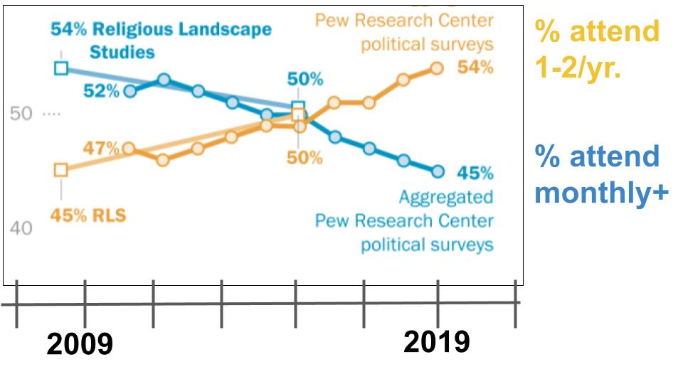Before COVID, the typical American churchgoer attended a worship service once or twice each year. You can see the trend from 2009-2019 in this direction. There has been a 9% increase in very infrequent attendance and a 7% decrease in more consistent attendance.

At Oakwood, even during COVID, our statistics are way better than this. But even here our average Oakwood member attends a worship service 2-3 times per month. We have our faithful core of 20% who are here just about every Sunday. But the other 80% cycle through and fill the seats the rest of the time.

Let’s be honest that we are all more American than we realize - and attendance at worship reflects this. We are all about our personal freedom. And just about any reason to not be in service on Sunday is considered totally acceptable. Sports, travel, vacation, extended family, a busy weekend, a stressful time at work, a need for a little “me time.”

But look at the pattern in Acts:

How to be Strengthened by Scripture:
- Welcome the Word Warmly - A) SHOW UP
“On three Sabbath days he reasoned with them from the Scriptures… And some of them were persuaded.” Acts 17:3-4

Their weekly routine was pretty similar to ours - they probably gathered in the Synagogue on Saturday, which was their Sabbath day, but the practice of coming together weekly for worship and Biblical teaching was ingrained in the faithful Jew. Tradition… Tradition!

If you had lived in Thessalonica back then would you have missed the preaching of Paul and Silas because you were out of town on vacation? Because you were catching up on work? Because you were taking the kids to a soccer tournament? Because you were out too late Friday night and just didn’t get up for Sabbath worship?

How consistent are you in Sunday worship? Is the corporate gathering so important to you that almost nothing will keep you from showing up? Are you EAGER to hear from God’s Word? Are you excited to lift your voice in praise to our glorious Savior?

The first application today is simply to COME - make a commitment to show up for worship. Prioritize worship and the Word. Then, when you’re here:

How to be Strengthened by Scripture:
- Welcome the Word Warmly - B) LISTEN UP
“Now these Jews were more noble than those in Thessalonica; they received the word with all eagerness.” Acts 17:11

A few believed in Thessalonica, but it seems that most of those in Berea believed. Their attitude toward the apostles and toward God’s Word was “more noble,” or more “admirable.” This better character quality was manifested in how they responded to Paul’s preaching. It wasn’t that Paul preached better in Berea - it’s that the people LISTENED BETTER.

When you come to a service, do you consider yourself a passive observer or an active participant? Do you take notes on paper or on your phone? Do you underline your Bible or highlight in your Bible app?

Are you actually LISTENING or is your mind already halfway to the Lightning game or to your other afternoon plans?

People retain less than 10% of what they hear. You know how I know? I can’t remember what I preached last week. How in the world can YOU? Look at the learning pyramid:

https://www.educationcorner.com/the-learning-pyramid.html#:~:text=The%20Learning%20Pyramid%20suggests%20that%20Audio%2Dvisual%20learning%20methods%20only,sound%2C%20pictures%2C%20and%20graphs.

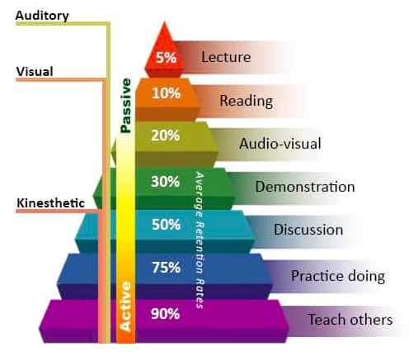
The more PASSIVE you are as a learner the less you will retain. The more ACTIVE you become, the more you will remember and gain from a worship service. And this also applies to your daily reading of the Bible as we will see in a minute.

This is why most of our small groups discuss the sermon! We know that if we just show up from week to week and don’t discuss what we hear, it will mostly just bounce off. But if you prayerfully prepare for Sunday morning, engage with your full attention while you are here, begin to digest and discuss the passage through your Sunday and then continue that discussion in your group, do you see how much more value you will get from the weekly engagement with God’s Word?
Do you see how you can warm up your heart to be more receptive to God’s Word? Do you see how these simple practices will strengthen you spiritually?

How to be Strengthened by Scripture:
- Welcome the Word Warmly - B) LISTEN UP
“Now these Jews were more noble than those in Thessalonica; they received the word with all eagerness.” Acts 17:11

What is your attitude toward God’s Word? Warm or cold? Active or passive? Are you committed to showing up? Are you committed to listening well? That’s the first discipline to develop in your faith. Here is the second.

How to be Strengthened by Scripture:
- Study the Scriptures Seriously - A) READ DAILY
“They received the word with all eagerness, examining the Scriptures daily.” Acts 17:11b

Now consider the times 2,000 years ago. This was 1,500 years before the printing press. The average Jew and the average Christian in the first century did not have any scrolls or parchments with Scripture. Synagogues, if they were affluent enough, would save up and purchase a Torah scroll and as much of the rest of the Old Testament as they could. But only the wealthiest people back then would have any part of Scripture in their personal home.

The average person had to pay attention at their worship gathering, for one thing. And they had to go back to the synagogue for more access to Scripture and teaching. This is why Scripture MEMORY was so important in those days. The Bible you had with you was the Bible you had worked to memorize.

So we have the great privilege today to read the Bible every day. The Bible you hold in your hand - whether it’s paper or on a screen - is more Bible than any previous generation ever had access to. You have dozens of translations, hundreds of study tools, thousands of devotional guides and reading plans. If you don’t yet have the YouVersion Bible App, you should get that right away. It makes daily reading so convenient and communal. You can share with your family or close friends what you’re reading.

If you want to grow stronger in your faith, and I hope you do… If you want to deepen your relationship with God, and I hope you do… If you want to experience more peace and joy in your life - READ the Bible every day! Set the time aside. Prioritize this as your most important appointment of the day. The Bereans went down in Biblical history for their warm reception to the gospel and to their diligence to study the Scriptures every day!

How to be Strengthened by Scripture:
- Study the Scriptures Seriously - B) WRITE THOUGHTFULLY
“Examining the Scriptures daily to see if these things were so.” Acts 17:11

The Bereans didn’t just hear the gospel and say, “Sure, sounds good.” They came back day after day to study the Old Testament and confirm what they were hearing. This was no small task. The Old Testament is filled with clues that point ahead to Jesus. But the idea of a Messiah who would die on a cross was unthinkable in their set of expectations. They had to go back and review everything to see if that could really fit. Eventually that would have led them to passages like Isaiah 53 where they could read, “He was pierced for our transgressions, he was crushed for our sins, the punishment that brought us peace was upon him and by his wounds we are healed.”

I’m sure you’ve learned that if you’re going to remember something, you need to write it down. How many times have you come home from the store and your wife is like, “Did you get the vitamins or the milk or whatever” and you’re like - “Ohhhh… that’s why I went to the store!” We have found if we don’t text each other or walk in with a good old fashioned paper list - we will forget something, or most things.

One of the most helpful practices to develop your relationship with God is to get a journal. It doesn’t have to be frilly and flowery and pink. It can be a manly, leather-bound thing or a basic college-ruled notebook. These make great gifts, btw. And you don’t want to start this discipline trying to write a page and a half every day. First of all, you’ll get a cramp and carpal tunnel because we never write anymore. But also, you’ll get discouraged and will quit. Just write down one or two lines. Write one verse, word for word. Pray those words back to the Lord. Express a simple prayer thanking God for something you learned about Him today. Keep is short, keep it simple.

But if you get in the habit of writing some notes you will find your time in the word leaps in value - mainly because you’ll remember more of what you’re reading. And the more you remember God’s Word the more it will change you - because it will get deeper into your heart and mind.

One more encouragement on this point.

How to be Strengthened by Scripture:
- Study the Scriptures Seriously - C) REVIEW REGULARLY
“They received the word with all eagerness, examining the Scriptures daily.” Acts 17:11

Another advantage of keeping a journal is that you can review how the Lord is speaking to you from day to day, week to week - even year to year. You can share key insights with friends - because they are there on the page. If you meet once or twice a month with an accountability partner or unveiled friend, I encourage you to bring your journal. Flip through it before you meet and bring one item that really encouraged you and one issue that really challenged you. Let this discipline increase your openness and honesty in relationship.

Review what you are learning on your own and with one or two friends.

Welcome the Word warmly. Study the Scriptures seriously. One more commitment to cultivate to be strengthened by God’s Word.

How to be Strengthened by Scripture:
- Get to the Gospel quickly
“Explaining and proving that it was necessary for the Christ to suffer and rise...” Acts 17:3
This was the essence of Paul’s ministry - explaining the cross. He resolved to “know nothing but Christ and him crucified.” That was the message. Jesus died for you. And yes, the Messiah had to die in humiliation so he could rise in glory. That was your humiliation, your condemnation - and mine. That was the price to pay for it. Jesus had to die. But he did not stay dead! “Death could not hold him. The grave could not keep him from rising again!”

Like Paul, this is our job as evangelists - getting to the cross quickly in our relationships and conversations. And this is also our job as students of the Bible - get to the gospel quickly. Sometimes when you read Scripture the good news of Jesus jumps out at you right away. Other times you have to dig a little deeper to find it. But trust me, the light of the gospel is always there if you chip away in the right places.

It’s important as you read the Bible to get to the gospel - otherwise you might draw the wrong conclusions as you read. The Bible is filled with commands and warnings, especially in the Old Testament. Without the light of Jesus, which illumines every part of the Old Testament, you might get discouraged with the pounding, relentless demands of the Law or the constant reprimands and rebukes of the prophets. But when you remember that Jesus fulfilled the Law and you remember that Jesus bore the brunt of all the condemnation predicted for God’s people - the light of the gospel will shine in your heart and fill you with joy for all the Lord has done!

Here are three questions that might help you as you read your Bible:

3. Get to the Gospel Quickly
- How does this passage point to Jesus?
- How does it present the gospel?
- How does it call you to respond to King Jesus?

Let’s say you’re reading a Psalm - a great practice is to read one Psalm each day. Let’s say you are reading a sort of angry Psalm of David like Psalm 35 -

“Contend, Lord, with those who contend with me. Fight against those who fight against me… May those who seek my life be disgraced and put to shame.” Ps. 35:1,4
- How does this passage point to Jesus?

Now, you might well read this and pray for some current situation - and be encouraged, the Lord gives you permission to pray justice over your life. But you don’t want to stay in that mode for very long. Move on to the gospel. Get the idea? How does this point to Jesus?

Do we have enemies? Kinda sorta. Did Jesus have enemies? Yes! Did he suffer terrible injustice? How did he respond? He chose not to fight back! He chose not to put his enemies to shame. Instead, he let those enemies win, he let them kill him - in order to save us!

Ok, that was an easy one, right? How about a prophet, like Habakkuk?

“I am raising up the Babylonians, that ruthless and impetuous people… guilty people, whose own strength is their god.” Habakkuk 1:6,11
- How does it present the gospel?

Sometimes you read the prophets and just wonder what God is saying, what is He doing? But trust me - the gospel is there just beneath the surface if you just dig a little.

Why did God raise up Babylon - that ruthless, terrible, godless nation? He enabled Babylon - for a time - to conquer Israel to make a point, right? Israel had sinned. They had consistently rebelled against God’s prophets and leaders - continually rejecting God’s Law and His way and becoming more and more like their neighbors - more and more like Babylon. So, after threatening judgment for years and years, judgment finally came in the conquering armies of Babylon.

JUSTICE is the beginning of the gospel. Understanding what we deserve for our sin is the beginning of understanding the good news. Otherwise, why did Jesus have to die? If we just needed a little education, a little inspiration, why the cross? The cross is because we were such wicked, obstinate, rebellious sinners! Read the prophets. Feel the warnings. God’s Word is living and active - let it speak to you. America - guess what - we are the new Babylon! Those warnings and prophecies are more relevant today than ever. God has raised up America - for a time - but our day of reckoning is coming too because we, as a nation, have rebelled against God for years and years.

One more. Come on pastor, try something challenging. Ok - Ecclesiastes.

“So I hated life, because the work that is done under the sun was grievous to me. All of it is meaningless, a chasing after the wind.” Ecclesiastes 2:17
- How does it call you to respond to King Jesus?

Ok, wow. Some passages in the Bible take a little more digging. But track with me here. The principle is the same - study, dig in. And one way or another, beat a path to the cross. It’s there, you just have to find it.

Ecclesiastes is by King Solomon - who was not a model follower of the Lord. He started out well enough - asking for wisdom - but finished very poorly, making life and the kingdom all about HIMSELF. Is that what a good king should do? Of course not! A good king SERVES HIS PEOPLE!

Aren’t you glad that Jesus is a GOOD KING and not a self-serving king like Solomon became? How does a passage like this call us to live? Live in devotion to our True King, Jesus - and not following the example of the bad king, Solomon! If you follow that path - even if you become king and have 1,000 wives you’ll find in the end it’s all empty, hollow and depressing anyway.
Plus, the key in the Bible is always to keep reading:

“A person can do nothing better than to eat and drink and find satisfaction in their own toil. This too, I see, is from the hand of God, for without him, who can eat or find enjoyment?” Ecclesiastes 2:24-25
- How does it call you to respond to King Jesus?

Even Ecclesiastes points to the Lord to find any meaning and happiness in life. It’s always there if you look! So here is our summary:

How to be Strengthened by Scripture:
- Welcome the Word Warmly
- Study the Scriptures Seriously and
- Get to the Gospel Quickly

There is a magic bullet for your spiritual life - it’s called the Bible. This is our spiritual food! This is our IV when we are discouraged and struggling. The feeling can sometimes be to stop reading the Bible when you feel down, but we need to do the opposite - keep reading! Keep studying! Keep memorizing!

Let’s be inspired today by John Wycliffe as we close today. Wycliffe lived in the 1300s in England, serving as a priest and professor in the Catholic church, mostly at Oxford University. Initially he was concerned about abuses in the monastic system, and increasingly he came to call for its total abolition. Monks were supposed to be poor, he argued - not actively seeking financial gain, as most of them were in those days. As a forerunner to Luther and the Reformers, Wycliffe attacked the doctrines of purgatory, transubstantiation and the selling of indulgences for the forgiveness of sins.

What we most know John Wycliffe for is his commitment to translating the Bible from Latin into English - the common language of his day. The Roman Church and the King fought against him for decades on this point, insisting that only the priests were qualified to read the Bible in English and serve as interpreters for the common people.

But Wycliffe pressed on with his translation of the New Testament, and was effective in distributing it since hundreds of manuscripts still survive today. This in spite of the fact that all of his writings were condemned and commanded to be burned.

But Wycliffe knew that there could only be one authority. Early in his career he fought for the authority of the king of England over against the Pope in Rome. Later in his career he insisted on the authority of the Bible alone over against king, pope and anyone else.

After Wycliffe died, his followers continued to use and distribute the English Bible. When they were captured for this, many of them were burned at the stake with the Bible scraps tied around their necks and burned up with them. The followers of Wycliffe were disparagingly called “BIBLE MEN.”

May we stand boldly in the tradition and conviction of John Wycliffe! May we rejoice to have the Bible tied around our necks! May we stand firm on the authority of Scripture alone - rejoicing in the light of truth we have from the Lord in His Word. May we feed on the Word of God, receiving it daily into our minds and hearts and lives. Above all, may we celebrate the glorious truth of the gospel that leaps off every page of God’s Word!

