One Church, One Mission
Acts 15:2-3, 30-41

Let’s start today with a two question quiz. Don’t stress out. It’s just pass/fail.

Pop Quiz
- How many churches are in Tampa Bay? __________
- Our mission is to reach: A) Carrollwood; B) Tampa Bay; C) the World

You probably know there are 3.1 million people who live in the Bay area. But do you know how many churches there are? I’ll give you one hint - there are 224 SBC churches just in Hillsborough County. Some of you detectives out there sense that clue was a misdirection - because it was.

How many churches are there in Tampa Bay? Someone got it. ONE! How many churches are there in the whole world? Not thousands. Not hundreds of thousands. One. The body of Christ is not divided. He has one body, filled with one Spirit, united around one mission.

Ok, so what’s the mission? To reach Carrollwood, Tampa Bay or the World? Now you’re suspicious of my little quiz. Rightfully so. The answer, of course:

Pop Quiz
- How many churches are in Tampa Bay? __One__
- Our mission is to reach: A) Carrollwood; B) Tampa Bay; C) the World

All of the above. We first reach the people closest to us in our “Jerusalem.” Then we continue on to reach our Judea and Samaria which includes every part of Tampa Bay. But that is not the end of the mission! We have been commissioned to make disciples of ALL NATIONS - to be witnesses for Jesus “to the end of the earth.”

Of course, these two realities go together. Our little church can’t fully reach even Carrollwood much less Tampa Bay and much much less the entire world. But THE ONE GLOBAL CHURCH can reach every single person on this planet - if we unite together around that common mission and share our people and resources to finish the task!

Today in Acts 15 we will be challenged to make three transformations.

Three Transformations:
- From Church Growth to Gospel Saturation
- From Collection to Mobilization
- From Competition to Collaboration

The first is a dramatic change of mindset - a revolution to the operating system of how most Christians think and most churches operate. For 30-40 years - the entire history of Oakwood in fact - the church in America has been designed using principles from the church growth movement. A lot of good things came from this movement but like many good things, it has created some unfortunate unintended consequences which now necessitate dramatic changes that are needed in how we do church.

Those are the other two transformations. Most churches are designed to COLLECT - to gather people and resources in from a region like a museum - to keep, store and showcase what God is doing in our local church. Because of this mindset and history, most churches subconsciously view other churches as competitors rather than partners.

Let’s walk through these three transformations as we study and apply Acts 15.

T1: From Church Growth to Gospel Saturation
“While they were worshiping the Lord and fasting, the Holy Spirit said, ‘Set apart for me Barnabas and Saul for the work to which I have called them.’” Acts 13:2
- The growth of our church is important but insufficient

If we rewind to Acts 13, a major turning point in church history - the leaders were having a prayer meeting - an extended time of worship and prayer. In the midst of that season, the Holy Spirit spoke clearly to the leadership team, calling them to send Barnabas and Saul out on a mission. This took place in Antioch, so these believers had already moved out from Jerusalem. But the Lord wanted to be sure they didn’t settle in forever there. He wanted to keep them MOVING FORWARD.

The growth of the church in Jerusalem was exciting and important for the expansion of the early church. But it was not the end of the story or the completion of the mission. It must have been very tempting for the believers to want to stay on that mountain top experience in the rapidly growing church in Jerusalem, where miracles were being done and more and more Jews were turning to the Lord.

Persecution forced them to scatter but then the same temptation started over again: to get comfortable in your new city, in your new church and settle in. As they worshiped and prayed the Lord made it clear: “You’ve got to keep moving on this mission. Take two of your best people and send them on.”

It’s like that opening scene in Saving Private Ryan. When Tom Hanks’ character gets to the beach at Normandy on D-Day, he finds soldiers hiding behind obstacles, cowering in the sand. He shouts at them - “You stay here, you’re dead men.” As a Captain, his job was to keep the men moving forward. They had to advance on the defenses to make room for the next wave of troops coming up and to protect everyone from the deadly enemy fire.

The same thing is true for the church. If we stay here, we die. Small churches all over our country are experiencing this all the time. Groups of believers huddle together and over time - if they don’t reach out and bring anyone else in - those churches die. Upwards of 3,000 churches close every year. Thankfully about the same number are started every year in this country. But as we sit here this morning, 75 churches are having their final service before closing their doors. If we stay here, we die. https://www.greatopportunity.org/starting-more-churches

The growth of OUR CHURCH is important. If we are not effective in reaching our NEIGHBORS it is silly for us to talk about reaching the NATIONS. But just reaching the people closest to us is not the end of the mission.

T1: From Church Growth to Gospel Saturation
“You will be my witnesses in Jerusalem, and all Judea and Samaria, and to the end of the earth.” Acts 1:8
- Our mission is to reach the city and the world!

Jesus sent his disciples out to “make disciples of ALL NATIONS.” Then in Acts 1:8 He promised that this mission would succeed - and we are here in fulfillment of that promise. This is how Jesus said it in Matthew 24:

T1: From Church Growth to Gospel Saturation
“And this gospel of the kingdom will be proclaimed throughout the whole world as a testimony to all nations, and then the end will come.” Matt. 24:14
- Our mission is to reach the city and the World!

This is our mission: not just to grow our church; not just to reach our city. Our mission is to bring the good news of Jesus Christ to every single person on the planet. In the end, the Bride of Christ will include people from “every tongue and tribe and nation.” So there is lots of work yet to do in gathering in all of these lost sheep - all of these scattered children of God!

This is the first transformation. We want to see our church grow - but that is not an end in itself. It is important but insufficient. As Robert Coleman said so well: “We have not been called to hold the fort but to storm the heights. Our field is the WORLD.”

So our vision is to first reach out in Carrollwood - to engage everyone we can in our circles of influence. Then we want to work together with the other gospel-preaching churches in our city to reach all 3.1 million men, women, and children who live in Tampa Bay. But even that is not the end goal. We must press on until literally everyone on earth has heard about Jesus and had a chance to respond. Only then “the end will come.”

There is work to be done. The finish line is in view. We’re not in the home stretch yet, but we are in the last 5 miles of the marathon, I believe.
- Isaiah saw a vision the glory of God being revealed and all people seeing it at once.
- Habakkuk saw the glory of God filling the earth as the waters fill the sea. He saw GOSPEL SATURATION!

Let’s pray for the gospel saturation of our communities, our city and our world! And let’s get to work to help finish the task - until everyone has heard about Jesus!

The first transformation is from church growth to gospel saturation. The second transformation:

T2: From Collection to Mobilization
“Paul and Barnabas and some of the others were appointed… sent on their way by the church.” Acts 15:2-3

When a troubling issue arose, the church in Antioch chose two of their key teachers and leaders, along with a few other respected members, and sent them to Jerusalem. Six times in Acts 15 we hear that someone was SENT. This is how a healthy church should operate: joyfully and quickly SHARING our people and resources with one another as needed.

In the One Church of Jesus Christ we should operate like a healthy family. If your brother needs a nice calculator and you have one from last year - you pass it along. If your sister needs a new phone and you just upgraded, you give her your previous model - you don’t charge her for it. If your Mom needs a place to stay, you make sure she has a place to stay. If your son needs a little cash, you share that magical amount that says, “I care” but also says, “You have a job and need to save a little more for next time.”

Six times in this chapter we see that someone sent. But ten times in this chapter we see the church addressing each other as FAMILY, starting in verse 1.

T2: From Collection to Mobilization
“Some men came down… and were teaching the brothers… Paul and Barnabas… brought great joy to all the brothers.” Acts 15:1,3
- We should share our people and resources like a healthy family

When Peter stands up at the Jerusalem council, he addresses the gathering as “Brothers.” When they all wrote a letter to the Gentile believers, they addressed it both FROM the brothers and TO the brothers.

T2: From Collection to Mobilization
“The brothers, both the apostles and the elders, to the brothers who are of the Gentiles in Antioch…” Acts 15:23
- We should share our people and resources like a healthy family

And the chapter ends with Judas and Silas encouraging the brothers and sisters in the church in Antioch, then being sent back to Jerusalem “by the brothers.”

This repetition of the phrase “brothers” is neither accidental nor incidental. It’s important. The early church was welcoming Gentile believers as FULL MEMBERS of the family of God. They were not calling them cousins or servants. They were calling them BROTHERS.

And because they knew they were one family in Christ, they did not withhold blessings from one another. They actively, intentionally and sacrificially shared their people and resources with one another.
- Barnabas was one of the most encouraging people in the early church. That is who they sent to Antioch.
- Saul was one of the most promising young leaders. They sent him too.

Then the church in Antioch followed the same principle. They did not keep Barnabas and Saul - they did not try to COLLECT AND STORE these encouraging and inspiring leaders. They joyfully sent them out on mission.

Sharing people and resources applies first within our church family. Do we happily encourage volunteers to jump over from one team to another? When kids ministry needs a few more people do we begrudge that need and KEEP “OUR PEOPLE” on our list? Or do we make the sacrifice and allow a greeter to jump over to preschool; a gifted singer to move over to elementary TreeHouse? When a new small group needs to start, do we resist and resent it if a gifted couple leaves our group? Or do we celebrate the obedience of these leaders and encourage them to go where they are needed?
But this shift from collection to mobilization also applies here in Tampa Bay and in the world. We should consider it a WIN when one of our own follows the call of God to serve and use their gifts for the kingdom.
- Oakwood has raised up and sent out missionaries this way. Pete and Mary Ellen Kluck were the first missionaries sent out from Oakwood 31 years ago. They served in Cameroon for 14 years, and in the mercy of God - came back!
- Craig and Carolyn Clendinen were sent to Washington, D.C. (Virginia) in 2005 to work with Wycliffe/SIL with Government Relations and Advocacy. In 2011, they moved to Tanzania, Africa. In 2012, they moved back to the U.S., but Craig continues to travel all over the world
- Nick and Sofia Audas were here for their college ministry. Oakwood supported them as they went with Cru to NYC - and continues to support them as they transition into a new assignment.
- Colleen Darlington went on some trips to the Czech Republic and decided to stay there. We rejoiced to release her to serve the church there.
- Jose and Maria Cariaga retired from their medical practice to spend half their time in their ancestral home of the Philippines, reaching out with the gospel there.
- Those are a few of our official missionaries we support. But we have also sent members out into ministry. Kevin and Christine Rexroad were a part of the church family here for many years. The Lord called Kevin out of 20+ years working for Verizon to help Wycliffe with their digital translation process. So we joyfully sent them to Orlando a year or so ago.

Finally, I so appreciate how the church enables me to tithe my time to the city of Tampa Bay. I consider it my hobby to network and it is such a blessing to help connect, unify and give leadership to a growing coalition of gospel-churches. You all know I like to be busy, so you also share me with our denomination as I give leadership to the EFCA Network - the relational association of our 5,000 or so pastors, missionaries, chaplains and ministry leaders in the movement.

As we work to reach every part of Tampa Bay the Lord may call some of you to help plant new churches and start new ministries. The leaders of Oakwood sincerely believe the kernel of wheat principle. We can only grow as followers of Christ as we DIE TO OURSELVES. And the kingdom can only grow as kernels of wheat fall into the ground and die. We happily lay down our own goals and plans in service to God’s bigger plan to reach the city and the world with the gospel.

The Lord may call some of you - especially our young people - into overseas missions. We should not resist or resent this, but should rejoice to see our kids obeying Jesus and devoting themselves to His mission.

The mission is not just to grow Oakwood church. The mission is to reach every people group on the plant. So we cannot be content with COLLECTION - just gathering people into our church. Instead, we must pursue MOBILIZATION.

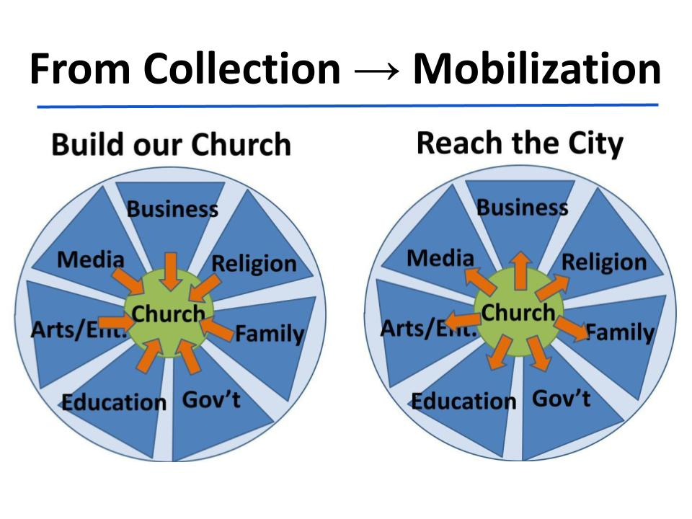
If all we want is to grow our church, we will become COLLECTORS. We will think of the church as a museum to display our trophies - and we will not want to let any of these trophies go. Our purpose will be to gather people from all sectors of the city - from education, government, media and business - and draw them into our church. You can see where the CENTER OF GRAVITY for a church growth model is THE CHURCH. It is like the BORG in the old Star Trek and wants to ASSIMILATE everyone in, not letting anyone back out.
But the mission of the church is not collection but MOBILIZATION. Jesus did not say, “Come, follow me and I will make you collectors of people.” He said, “I will make you FISHERS of men.” We reach people and then teach them to reach people. In other words, we are MOBILIZERS. We gather people FROM the city so we can send them back out as salt and light INTO the city.

One more transformation we need to make.

T3: From Competition to Collaboration
“So when they were sent off, they went down to Antioch… After they had spent some time, they were sent off in peace by the brothers to those who had sent them.” Acts 15:30,33

Here are three of the six uses of the word “SENT” in this chapter. In this case it refers to Judas and Silas, two brothers from Jerusalem who were sent along with Barnabas and Paul to go back to Antioch with the decision of the council. Judas and Silas were respected leaders in the Jerusalem church. It’s clear from what happens next that Judas went back, but Silas ends up going on Paul’s next missionary journey with him.

So the apostles and elders in Jerusalem sent two of their best to Antioch and only one came back! This was not the age of cell phones and text messages or even the telegraph. This was the day when the fastest thing around was called a horse; over there, the pace was probably more about the camel. So the fact that Silas went with Paul meant he had the blessing of the church in Jerusalem to go. That was the mission!

T3: From Competition to Collaboration
“Barnabas took Mark with him and sailed away to Cyprus, but Paul chose Silas and departed, having been commended by the brothers to the grace of the Lord.” Acts 15:39-40

The church in Jerusalem did not view the church in Antioch as a competitor. Had they been seeking only glory and credit for the expansion of the church, they might have seen it that way. But they saw themselves as ONE FAMILY - One Unified TEAM. That’s our final lesson for the day.

T3: From Competition to Collaboration
“Barnabas took Mark... but Paul chose Silas and departed, having been commended by the brothers...” Acts 15:39-40
- We should work together like a unified team

We play a lot of soccer here at Oakwood and one of the first things you learn, and one of the most important things you try to teach as a coach is TEAMWORK. One player, no matter how talented, simply cannot be effective in soccer. You might beat one or two, even three or four poor defenders on your own. But there are still seven more waiting to take you on and if they work together, you can’t possibly stop them. You need your team! And they need you!

One of the best ways to discourage a soccer team is to have a couple of great players who won’t pass to each other. They both want to score, they both want the glory, so they dribble, dribble… lose the ball. Dribble, dribble, lose the ball.

Sadly, that is what the American church has been doing for the last few DECADES. Everyone wants their name, their brand, their denomination to get the glory - so we don’t pass the ball. We don’t share our people and resources. We don’t work together. It’s all separate mini-kingdoms, not one unified kingdom.

Thankfully, this is beginning to change in Tampa Bay. But it is only a beginning. We must begin to see each other as a single family with a single mission - to reach every part of Tampa Bay and every people group on earth. To accomplish a God-sized mission like it’s obvious that we need each other! We must operate as a team.

The remaining unreached people groups represent the most difficult challenge to missions. They are unreached because they are hard to reach. It will take lots of prayer, lots of creative ideas, lots of collaborative effort to begin to enter these places and people groups that don’t want Christians to come in.

The good news is that places that are resistant to pastors and missionaries are open to business people. They don’t want our religion - in places like the Middle East. But they do want our business. They want our trade. They want our ideas. They want our people. So we can send programmers and investors, teachers and nurses, doctors and lawyers to Saudi Arabia and north India - places missionaries cannot go. And those business people - those every day Christians - can bring the gospel with them.

But we won’t do things like that if we worship the idol of church growth. Then we will commit to COLLECTION rather than mobilization. Then we will view other churches as competitors rather than collaborators.

Let me close with a cool story from a pastor friend of mine named Dan, from Chicago. I’ve mentioned him before because he came to Christ in college when he said to a roommate - “I hear there are dragons in the Bible, let’s check that out.” They spent the day reading Revelation and got scared right into the kingdom. He was a youth pastor in the northern suburbs of Chicago, then stayed at his church as lead pastor.

When I met him in 2015 he had been there at that church for 25 years. He knew the other pastors in his suburb, called Gurnee. They met together every month to pray and eat. Many of them had been youth pastors together. As they prayed for their city of 40,000 people they talked about ways they could reach the area together - and set about doing it. They did some service projects, renovated some schools, cleaned up some parks.

But that wasn’t really reaching people with the gospel. So 10 churches took a radical and risky step. They SHARED THEIR DATABASES. That’s right. They actually piled all of their people lists into a shared database and plotted all of their people onto a map, with each church represented by a different symbol. Then they were able to zoom in on each neighborhood and see how many Christians were there. What they found amazed even the pastors.

Just by sharing 10 databases they realized the neighborhoods were already HALF REACHED. So they started hosting neighborhood prayer meetings, bringing believers together from the different churches to talk about how they could reach the remaining neighbors together.

Let’s pray for this kind of gospel saturation - this kind of mobilization - this kind of collaboration!!!

