Four Fields
Acts 14:1-28

In the parable of the Sower Jesus described different kinds of soil - the hard path, the rocky ground, the thorny ground and the good soil that produces 30, 60 even 100 fold. Using this framework to think about missions, a training program has been developed called The Four Fields.

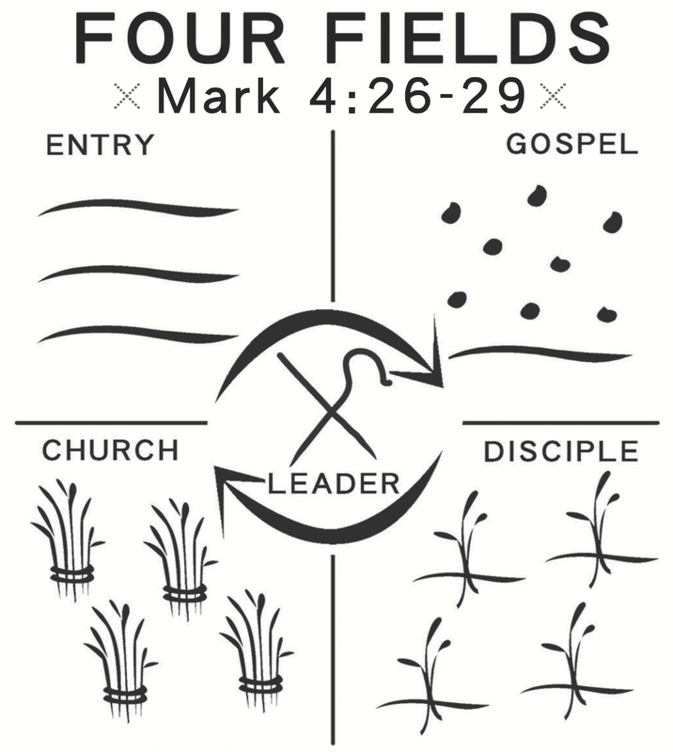

When a missionary first arrives in an unreached place, it is considered an EMPTY field - with no existing church, no known believers. The gospel is not yet planted there. It’s an empty field.

But as missionaries begin the work, they begin to sow the seed of the gospel. As people respond, they make disciples. As disciples grow, churches begin to form. By working this four-fold process of 1) entering a field; 2) sharing the gospel; 3) training disciples and 4) planting churches the result can be a MULTIPLYING movement in which disciples make disciples who make disciples and so on.

This process is exactly what we see in Acts 14. When Paul and Barnabas arrived in Iconium, it was an empty field. The gospel had not been heard there. No churches existed.

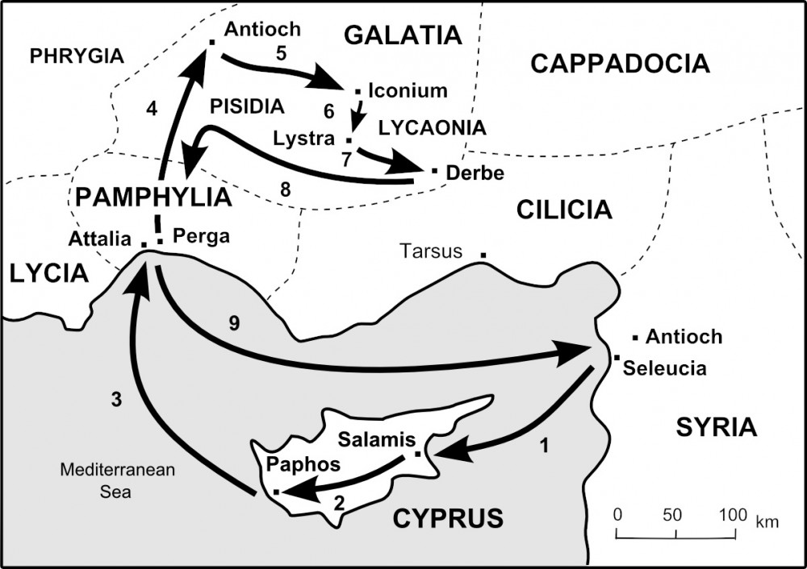
This was true of all the places Paul went on his first missionary journey. And this process is repeated over and over again in Acts: the missionary team enters a new village; they share the gospel; they train disciples and they establish churches. Lather, rinse, repeat. It was a clear, simple, reproducible process. So they kept working it, and it is a process that continues to bear fruit all over the world today.

As we walk through these four fields, and the four PRACTICES of a kingdom worker, let’s prayerfully apply these practices in the different fields in which we live and work right now!

First, the empty field.

- Empty Field
  - Enter with prayer and care
“Now at Iconium they entered together into the Jewish synagogue.” Acts 14:1

Since Paul and Barnabas were Jews, and since Paul was a trained Pharisee, he was licensed to teach in any synagogue of worshiping Jews. So it was natural for them to ENTER the empty field of Iconium through the Jewish synagogue. As we saw in Acts 13, there was both a practical reason to start there and a theological reason to go “to the Jew first.”

The point for us is that we need to find ways to ENTER the various fields in which we live. Think about your neighborhood. How do you connect with your immediate neighbors? How do you enter their lives? How do you make conversation? How do you develop your relationships?

We have found holidays to be helpful in this regard. Our neighborhood goes crazy on the 4th of July, Halloween and New Year’s Eve. Everyone comes out, large groups walk around together. And whenever fireworks are remotely appropriate, people spend thousands of dollars to outdo the cul-de-sac across the way. So we have made a point of being outside for these events and trying to learn names and start getting to know the people right around us.

Since an Oakwood family lives right behind us, we worked together with them to run some Saturday soccer last fall - which proved to be another effective way to ENTER the field of our neighborhood. Our subdivision has an active Facebook presence, so we posted the soccer thing a couple of times and several kids and families came to check it out.

I’ve shared before how Jason and I meet regularly at Panera - and that has been a way for us to enter the community here around church.

And we’ve had to do some tree-trimming and fence work by the church, so that has given us some contact with immediate neighbors to get their phone numbers and make connections with them. Similarly, lots of families from the community around here have been coming to our soccer clinics - so that has been a great way for us to enter this Carrollwood field.

- Empty Field
  - Enter with prayer and care
“Now at Lystra there was a man sitting who could not use his feet.” Acts 14:8

The idea is find a way to connect with people. Paul and Barnabas used their cultural connection to enter the synagogue. Then in Lystra, Paul saw a man crippled from birth and was led by the Holy Spirit to heal the man. This public miracle was another way they entered an empty field, demonstrating CARE for a person in pain.

That’s the application for us. Outreach begins with prayer and care. We enter our various fields by first praying that God would give us a heart for the people around us and open doors for us into relationship. Then, as we get to know people, we simply care for their needs so they can see and feel the love of Christ.
- Maybe your next door neighbor has a health issue and you can pray with them.
- Maybe you have an elderly neighbor who could use some help with yard work or a home repair.
- Maybe you have a co-worker who has been really stressed and you can buy them coffee and offer a listening ear.
- Maybe you have a family member dealing with serious problems and you need to schedule an extended visit with them.

The first step is to ENTER the field. Enter with prayer and with care. SEE the people who are already in your day to day life. Notice them. Listen to them. “We don’t tend to care about people we don’t know” (God Space). To start caring we need to start noticing. That’s how we enter the empty field and start planting seeds. That’s our second practice as kingdom workers:

- Seeded Field
- Share the Gospel
“They entered the Jewish synagogue and spoke in such a way that a great number of both Jews and Greeks believed.” Acts 14:1

Having found a way to enter the community and engage with people, the apostles took the initiative to share the good news of Jesus Christ. Suddenly a place with no gospel light was filled with a burst of glorious truth. Suddenly a barren field with no spiritual seeds felt gospel seeds breaking through and bursting with life. Many heard and many believed!
This point - of boldly proclaiming the gospel - is clearly the main emphasis of Acts 14 and all of the missionary journeys of Paul. References to sharing the gospel come up six times.

- Seeded Field
- Share the Gospel
“So they remained a long time, speaking boldly for the Lord.” Acts 14:3

Then, when they were chased out of Iconium:

- Seeded Field
- Share the Gospel
“They fled to Lystra and Derbe… and there they continued to preach the gospel.” Acts 14:7

Everywhere they went, they found a way to enter the new field and immediately shared the good news. In Lystra, after healing the crippled man and the people tried to worship Paul and Barnabas, they addressed the crowd:

- Seeded Field
- Share the Gospel
“Men, why are you doing these things? … We bring you good news…” Acts 14:15

They deflected attention away from themselves and spoke clearly and directly about JESUS - the good news of the living God who came to bless all nations.

When Jewish troublemakers stirred up opposition and even when Paul was stoned and left for dead, they simply went on to the next town:

- Seeded Field
- Share the Gospel
“When they had preached the gospel to that city and had made many disciples they returned to Lystra…” Acts 14:21

This was Paul’s pattern: find a way to enter a community and right away share the good news of Jesus with them. Now, we are wise to take some time to build relationship with people and get to know them before rushing to the four spiritual laws or the bridge diagram.

But I bet most of us go the other way and take time and then more time and then more time to build relational bridges and we pretty much NEVER get around to having that gospel conversation. We don’t want to offend, we don’t want to harm the relationship. So we continue the prayer and care phase indefinitely.

There is a balance here. The book God Space calls it “God’s Teeter-Totter” - balancing LISTENING and WONDERING. We need to listen well to people and show we care. But we also need to move the conversation along toward truth and God and eventually the gospel.

A principle I’m finding helpful is to Follow Spiritual Interest. If you have a family member who just doesn’t want to talk about God or religion, leave them be for a while. Keep praying and loving, but don’t push the gospel agenda. Move on to the next person in your world and see if they are more open.

When Jesus sent his disciples out to a village he told them to look for a “person of peace.” They would know they had found this person because he or she would WELCOME them in. A person of peace is open to relationship, open to interaction, open to spiritual discussion and very quickly open to the gospel.

Do you hear that key word? OPEN? If the people you are reaching out to are consistently CLOSED, it may be time to move on to someone else.

Another way to think about it is again the fishing analogy. If you spend an hour in one spot and the fish just aren’t biting, it’s time to move on to another spot. Maybe it’s time to change your bait or change your time of day. Maybe it’s time to go out with an experienced fisherman and get some pointers. This is what we are trying to do as leaders at Oakwood - share ideas, challenges and victories.

Don’t get discouraged because evangelism is hard. Of course it’s hard. Be glad you haven’t been stoned and left for dead recently. Our job is not to win converts. Only God can change a heart. Our job is to sow the seed, to cast the line - to share the gospel. We leave the results with God. We are simply the messengers. But the messenger MUST deliver the message.

Practice one is to enter an empty field with prayer and care. Practice two is to share the gospel, so you now work in a seeded field. Then we move on to the third practice of a kingdom worker:

- Growing Field
- Train believers to obey Jesus
“A great number of both Jews and Greeks believed.” Acts 14:1

Winning the lost is only the beginning of disciplemaking. As we share the good news and people respond, it is our job to train them in what it means to follow Jesus. Notice what happened in verses 2-3.

- Growing Field
- Train believers to obey Jesus
“The unbelieving Jews stirred up the Gentiles and poisoned their minds... So they remained for a long time, speaking boldly for the Lord.” Acts 14:2-3

Sometimes under pressure and opposition the missionaries moved on to a more responsive area. But sometimes, with a brand new work in the region, they felt that under opposition they should stay longer to help the believers get more established.

As we train believers, we should expect the same kind of opposition Jesus and the apostles faced.

- Growing Field
- Train believers to obey Jesus, expecting Opposition
“An attempt was made… to mistreat them and to stone them.” Acts 14:5

Wherever Jesus went the religious leaders of his day increasingly opposed and eventually persecuted him to the death. Peter and the apostles faced growing persecution. Now Paul and his team face the same kind of increasing opposition.

In v. 19 the “attempted mistreatment” escalated to actual stoning.

- Growing Field
- Train believers to obey Jesus, expecting Opposition
“Jews came from Antioch and Iconium, and having persuaded the crowds, they stoned Paul and dragged him out of the city.” Acts 14:19

This is part of working in a growing field. As believers grow - good wheat - at the same time the weeds grow up too, and attempt to choke out the wheat. Jesus taught us that this reality was an inevitable part of the kingdom until the end when the wheat and chaff will be separated. For now, they must grow up together and there will be conflict and division.

That is what the gospel always does - it divides.

- Growing Field
- Train believers to obey Jesus, expecting Opposition
“But the people of the city were divided; some sided with the Jews and some with the apostles.” Acts 14:4

Jesus said that his message would divide even within families. You can’t remain undecided about Jesus. Eventually you must either commit to Him as Lord, giving everything to Him. Or you must reject Him, going your own way. As people realize this a division inevitably takes place.

And this is precisely what we are seeing in our country now. The gray area of civil discussion is fading into the black and white of life and death, abortion or saving babies, recognizing your God-given gender or claiming the opposite gender identity. The time may come soon when people have to choose between remaining faithful to the teachings of the Bible and being in the good graces of our government.

Brothers and sisters, may we all be firm enough in our commitment to Jesus that such a decision would not even raise a question for us. We are JESUS people. We are KINGDOM people first. We will not compromise no matter how far down the rabbit hole our political leaders go. We will not abandon our convictions even if it means limiting our lifestyle, prison or ultimately even death.

That was always the threat looming over believers in the first century. And the cloud of tribulation looms over us today. Look at verse 22.

- Growing Field
- Train believers to obey Jesus, expecting Opposition
“Strengthening the souls of the disciples, encouraging them to continue in the faith, ...through many tribulations we must enter the kingdom of God.” Acts 14:22

The believers then didn’t know when the next Roman persecution would break out. We don’t know when persecution might come in earnest here. But we do know that “in this world we will have TROUBLE.” That means tribulation. We should expect opposition. Eventually there will come persecution.

My job is to train all of us to OBEY JESUS; to expect opposition and be strong enough to endure it, no matter what.

How strong is your faith? Are you ready for your next challenge? Your next struggle? Something is coming, it’s just a question of when.

That’s how it works in a growing field. One more practice. Enter an empty field. Share the gospel in a seeded field. Train disciples in a growing field. And finally:

- Harvest Field
- Multiply disciple-makers to continue the work
“And when they had appointed elders for them in every church, with prayer and fasting they committed them to the Lord.” Acts 14:23

After encouraging the disciples and preparing them for persecution, they appointed elders and then the missionary team moved on. This was an essential part of Paul’s method - leaving.

You enter a field. Plant seeds. Nurture early growth. Appoint leaders. And move on.

Think about it. This was JESUS’ method too. He trained the 12 for three years, then left. Toward the end of the three years he pulled back and had them doing most of the work already. From the start he prepared them for when he would be gone.

Look at the four fields diagram.

At the center of the four fields is a LEADER. In this case, Paul. The circular arrows represent working the cycle - implementing the four practices of a kingdom worker. First, you enter the field. Then you seed the field by proclaiming the gospel. Then you train disciples in the growing field. And finally you set up churches in the harvest field so you can move on to another empty field.

In the process of working in the four fields, new leaders are developed. This is what movement leaders are learning all over the world. As soon as a sinner repents and believes in Jesus it’s important to train them to obey Jesus. A key step in that obedience is to begin sharing the gospel. So they train believers to start sharing the gospel boldly from their earliest days as Christ followers.

Those who are faithful and fruitful in this become the obvious leaders to continue the work. This is how movements can multiply - because they don’t depend on one central leader, but they can rapidly empower and release many workers into the harvest field.

https://www.movements.net/blog/blog/2020/6/17/224-god-calls-and-shapes-a-movement-pioneer

Lipok grew up in a broken home in the Naga region of northeast India. At the age of 11 he started using drugs and developed an addiction that would plague him for the next 20 years. In an effort to gain some discipline he joined the military, but that only made his addiction to heroin worse because he had more money and more access.

Finally, he was busted for his drug use and drug sales and he went to prison. That is where he heard about Jesus and, with nothing else to do, enrolled in Bible school. He began learning the Bible, but Lipok’s heart had not yet changed.

After a couple of years going through the motions of obedience to Christ, Lipok finally bowed his will to the Lord and miraculously all desire for drugs was taken from him.

Having finally surrendered to Christ and having been released from prison, Lipok went back to his home area of Nagaland and began to share the good news that had changed his life. He led many to saving faith in Jesus and saw many miracles like his own. He started planting churches and wanted to see a movement.

But Lipok was limited by his own church background. He had grown up in the Naga region that was nominally Christian. To him, a real church had to have a building and a certified pastor. He didn’t feel qualified to baptize new believers, so he hired a certified pastor to do baptisms for him.

Then Lipok went to a disciple-maker training where he was challenged to describe the ideal evangelist. They began to talk about Billy Graham. Everyone agreed he was a great example of an evangelist - impeccable character, excellent theological training, amazing eloquence and experience. Yes, the ideal evangelist is Billy Graham!
But then they opened the Bible to John 4.

“Many Samaritans from that town believed in him because of the woman's testimony, ‘He told me all that I ever did.’” John 4:39

How did that village of Samaria hear the gospel? Was it from Jesus? Was it from the apostles? No. It was from the lips of the five time adulteress, Samaritan woman!

So who is the qualified evangelist Jesus will use to reach people? The answer leapt out at Lipok - ANY BELIEVER. EVERY believer is qualified to share the gospel and baptize new believers!

So he started to baptize believers on his own, released from feeling the need for a certificate. And beyond that, as other disciples led people to faith he refused to baptize them and asked, “Who do you think should baptize you.”

In one community where outreach was moving and many had come to faith he asked this question - “Who do you think should baptize these new believers?” Everyone in the meeting pointed to one man who had been a Buddhist monk until just recently coming to faith in Christ. He had become a zealous evangelist and had led most of them to follow Jesus. So now they saw him as the leader God had raised up to shepherd them.

So that former monk baptized the new believers and Lipok trained him to train and care for the believers in that village.

Do you see the Four Fields method of multiplication? Lipok, like Paul, was in the center of this developing movement. With every new village he would find a way to enter and share the gospel. As people responded he would not only train them to obey Jesus, but he would watch for a person of peace among them to assist with the training so in field four - the harvest field - he could establish new churches that would carry on the work after he had moved on.

In that way, a movement began to spread like wildfire all over the Naga region. Lipok shares how he had to get himself out of the way - his traditions and prejudices - so disciples and churches could multiply!

We are somewhere between a seeded field and a growing field. We are not seeing a multiplying harvest, but we want to! Let’s pray that the Lord would move in us and through us and around us to mobilize workers into HIS harvest field!

