Acts 11:19-30
19 Now those who were scattered because of the persecution that arose over Stephen traveled as far as Phoenicia and Cyprus and Antioch, speaking the word to no one except Jews. 20 But there were some of them, men of Cyprus and Cyrene, who on coming to Antioch spoke to the Hellenists also, preaching the Lord Jesus. 21 And the hand of the Lord was with them, and a great number who believed turned to the Lord. 22 The report of this came to the ears of the church in Jerusalem, and they sent Barnabas to Antioch. 23 When he came and saw the grace of God, he was glad, and he exhorted them all to remain faithful to the Lord with steadfast purpose, 24 for he was a good man, full of the Holy Spirit and of faith. And a great many people were added to the Lord. 25 So Barnabas went to Tarsus to look for Saul, 26 and when he had found him, he brought him to Antioch. For a whole year they met with the church and taught a great many people. And in Antioch the disciples were first called Christians.
27 Now in these days prophets came down from Jerusalem to Antioch. 28 And one of them named Agabus stood up and foretold by the Spirit that there would be a great famine over all the world (this took place in the days of Claudius). 29 So the disciples determined, every one according to his ability, to send relief to the brothers living in Judea. 30 And they did so, sending it to the elders by the hand of Barnabas and Saul.
- Persecution causes growth
Illustration:
According to the Smithsonian Diamonds are made of carbon so they form as carbon atoms under a high temperature and pressure; they bond together to start growing crystals. Because of the temperature and pressure, under these conditions, carbon atoms will bond to each other in this very strong type of bonding where each carbon atom is bonded to four other carbon atoms. That's why a diamond is such a hard material because you have each carbon atom participating in four of these very strong covalent bonds that form between carbon atoms. So as a result you get this hard material.
Isn’t this a picture of how the church should function? When pressed we should deepen our faith and know we are in the center of His will.
Explanation:
Acts 11:19-21, 19 Now those who were scattered because of the persecution that arose over Stephen traveled as far as Phoenicia and Cyprus and Antioch, speaking the word to no one except Jews. 20 But there were some of them, men of Cyprus and Cyrene, who on coming to Antioch spoke to the Hellenists also, preaching the Lord Jesus. 21 And the hand of the Lord was with them, and a great number who believed turned to the Lord.
Stephen, early leader, killed for his faith in Christ.
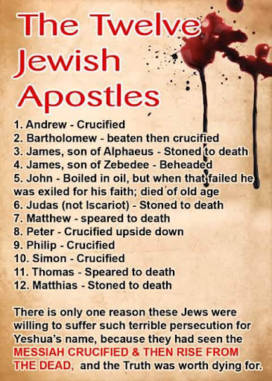
Rather than retreat, the church moved forward, in so doing they took the gospel to new places and the gospel flourished!
Argument: Should we expect persecution? YES!
James 1:2-3: Count it all joy, my brothers, when you meet trials of various kinds, ³ for you know that the testing of your faith produces steadfastness.
I Peter 4:12…16: Beloved, do not be surprised at the fiery trial when it comes upon you to test you, as though something strange were happening to you.
Yet if anyone suffers as a Christian, let him not be ashamed, but let him glorify God in that name.
Acts 5:41: Then they left the presence of the council, rejoicing that they were counted worthy to suffer dishonor for the name.
Ephesians 6:12: For we do not wrestle against flesh and blood, but against the rulers, against the authorities, against the cosmic powers over this present darkness, against the spiritual forces of evil in the heavenly places.
I John 3:13: Do not be surprised, brothers, that the world hates you.
Application:
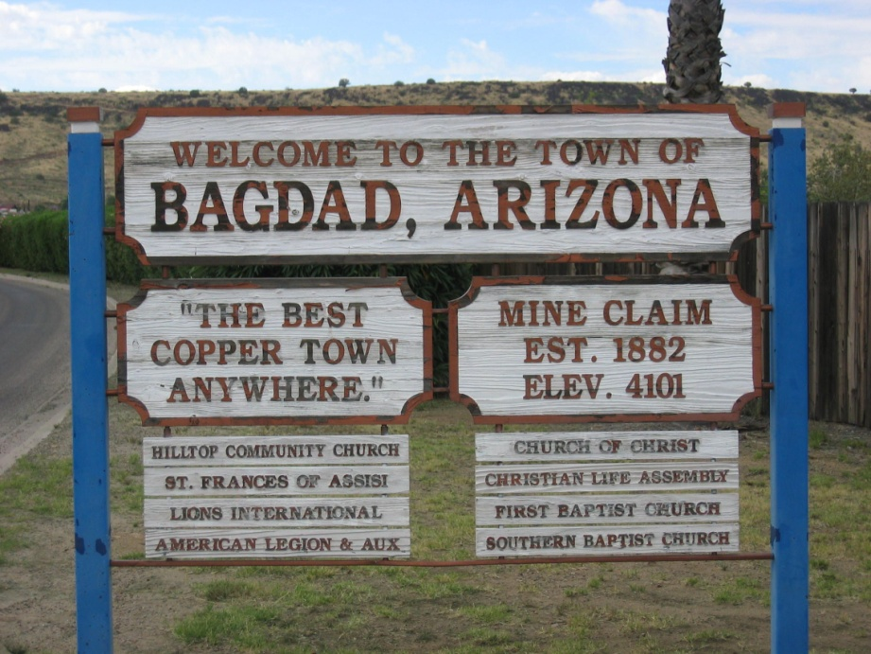
Bagdad church plant April 2018-Town had faced dark times, copper mining community, rough and tumble, don’t need church, churches dwindling, Mormon church was the largest religious group in town, apathy, that’s my church but I haven’t been in over 20 years. After preaching at a local Southern Baptist Church for 2 years, God opened the door to launch a church plant. Prayed, asked God for a space to meet and He provided! The local community center gave us an air conditioned room for free, access to the playground for children, TV, restrooms, coffee pot, chairs, they opened and locked up after us even! God was beginning something pretty cool!
- Growth comes through obedience
Illustration:
1984 Michael Jordan is drafted by the Bulls out of North Carolina. The Bulls are the laughing stock of the NBA. Bulls steadily improved over the next 4-5 years. Bulls fire their coach and promote Phil Jackson from within who wanted to incorporate the now famous “Triangle Offense”. The Bulls go on to win 6 NBA championships in the next 9 years.
Explanation:
Acts 11:22-26, 22: The report of this came to the ears of the church in Jerusalem, and they sent Barnabas to Antioch. 23 When he came and saw the grace of God, he was glad, and he (Barnabas) exhorted them all to remain faithful to the Lord with steadfast purpose, 24 for he was a good man, full of the Holy Spirit and of faith. And a great many people were added to the Lord. 25 So Barnabas went to Tarsus to look for Saul, 26 and when he had found him, he brought him to Antioch. For a whole year they met with the church and taught a great many people. And in Antioch the disciples were first called Christians.
The spread of the gospel was invigorating to the people. The church sent leaders such as Barnabas out to see and be encouraged by God’s moving. Barnabas means exhorter, comforter, so what does he do? He encourages them to be faithful and stay committed to Christ. Not only did they trust the process, they were able to teach a great number of people and build up the body of Christ.
Argument:
Although it may not always seem like it, obedience to the Lord is worth it.
Matthew 28:18-20: And Jesus came and said to them, “All authority in heaven and on earth has been given to me. 19 Go therefore and make disciples of all nations, baptizing them in the name of the Father and of the Son and of the Holy Spirit, 20 teaching them to observe all that I have commanded you. And behold, I am with you always, to the end of the age.”

Application:
Rodney-Guys from church ministered to a dear sister Paula, whom I shared about a few weeks back, she needed wood, so we brought a truck full of wood needing to still be chopped into smaller pieces. Thankfully her nephew, Rodney, came down from Oregon to assist on her off the grid property. He was excited to have a job for the next few days! Barry, Tom, and I took the opportunity to ask Rodney about Jesus. He stated he wanted to accept Christ into his heart, we prayed and promised to follow up. For the next 4-5 months Rodney was faithful in coming to Men’s Bible study, church on Sunday, and beginning to grow and ask excellent questions about God. Rodney was wanted by the law and knew he could not stay in Arizona forever so he went back home. I can only hope the prayers, teaching, Holy Spirit will break down the barriers and continue to penetrate Rodney’s heart.
We saw many people come to know Christ, rededicate their life to Christ, and even baptized 6 people that first year!
- Obedience requires participation
Explanation:
Acts 11:29: So the disciples determined, every one according to his ability, to send relief to the brothers living in Judea.
Church got together and cared for one another. This was often a key hallmark of the church to look out for the needs and interests of one another. Rather than suppose the work of the gospel was for a select few, they all gave what they could.
Argument:
For the church to flourish it takes everyone.
Ephesians 4:11-12: And he gave the apostles, the prophets, the evangelists, the shepherds and teachers, ¹² to equip the saints for the work of ministry, for building up the body of Christ,
I Corinthians 12:7, 14: To each is given the manifestation of the Spirit for the common good… For the body does not consist of one member but of many.

Application:
Bagdad Church plant continues because of participation. Youth group…check, Music ministry….check, treasurer….check, Bible study leaders…check, pastor leaves and the church needs a new pastor…check, Nate Pate picks up mantle Terra shares and 18 year old daughter of our best friend accepts Christ!
TAKEAWAY
The body of Christ needs you! The body of Christ needs the Mike’s of the world to encourage those needing appendages to remain hopeful, they need the Allison’s of the world to share their heart even when it is not easy, the body of Christ needs you as there are people only you can minister to. The body of Christ needs the Megan’s of the world, a dear sister in Christ who had an abortion as a teenager and now shares her message of redemption with young men and women.
Even when persecuted remain committed because through it comes growth. Growth happens through obedience, and through obedience we participate in God’s blessings.
What is your story?

