Multiply
Acts 9:18-31

Last week we studied the dramatic calling of Saul, resulting in his total transformation.

“He proclaimed Jesus in the synagogues… And all who heard him were amazed and said, ‘Is not this the man who made havoc in Jerusalem of those who called upon this name?’” Acts 9:20-21

The one who had been locking up and executing followers of Jesus was suddenly preaching the name of Jesus! His life was turned utterly upside down and it was shocking.

But that is what the gospel does - it changes us! When Jesus confronted Saul and Saul repented, the scales fell from his blind physical eyes at the same time that the scales fell from this spiritual eyes. Suddenly he saw the glory of Jesus - and that changed him completely.

Today we continue to follow the transformation of Saul as the disciples in Damascus care for him, train him and send him very quickly out into preaching ministry. Look at the result in verse 31.

“So the church throughout all Judea and Galilee and Samaria had peace and was being built up. And walking in the fear of the Lord and in the comfort of the Holy Spirit, it multiplied.” Acts 9:31

To this point the church in the region had been GROWING. But now it MULTIPLIED. The question is HOW? What were they doing that enabled the early church to not just grow, but to multiply? The answer is DISCIPLEMAKING. Saul is a perfect example of the process of making disciples. Look at his progression:

“He was with the disciples at Damascus. And immediately he proclaimed Jesus… His disciples took him by night…” Acts 9:19-20,25

After committing his life to Jesus, the believers in Damascus took care of him - he was with them. Very quickly they sent him out to start preaching. That word “immediately” is striking. But just five verses later, in verse 23 covering “many days,” the Jews made plans to kill him so “HIS DISCIPLES” helped him escape.

It took a few weeks, maybe a couple of months - but in that time Saul went from being a disciple to being a DISCIPLE-MAKER! Granted, he already had advanced theological education and was gifted as a leader. But this is still remarkable. He was a very young Christian, yet the believers there moved him through a process that empowered him not only to grow as a disciple but to very quickly start making disciples of his own.

Here is the four step cycle the believers brought Saul through. This is how to multiply:
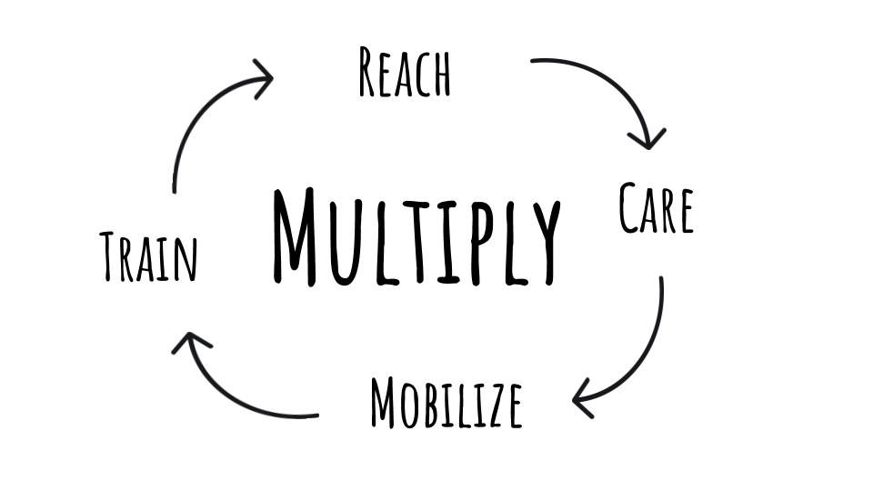
You cannot multiply without reaching out. Remember how we saw last week God called not just Saul but also Judas on Straight Street to give Saul a place to stay and Ananias to pray over Saul and provide some orientation to following Jesus. First you reach someone with the gospel, then you care for that new believer. Maybe not “immediately” but early on it’s important to get that new believer back out there to share the gospel with others. And as the young disciple learns to obey the great commission, you also provide training on everything else the Lord taught us, to help the growing believer mature. This brings the cycle back to outreach and it continues again. MULTIPLICATION. Let’s look at each of these steps, starting back in verse 18.

- Reach - Lead a Lost sinner to Jesus
“He regained his sight. Then he rose and was baptized; and taking food, he was strengthened.” Acts 9:18

This was a unique conversion - since Jesus Himself showed up directly with Saul - blinding light, knocking him off of his high horse, literally. But regular, everyday believers were involved too. Judas took the blind Saul into his home. And Ananias had to overcome his fears of Saul to visit and pray with him.

It was either Ananias or another believer there in Damascus who baptized Saul, and probably Judas was involved with providing food for his house guest. So a number of the believers were led by the Holy Spirit to reach out to this dangerous Pharisee - this persecutor of the church. They followed the Spirit, and at significant personal risk helped lead Saul to faith in Jesus.

Baptism is the public expression of private faith. Since Saul had committed his life to Jesus it was appropriate to symbolize this saving faith with public baptism. And that concluded the first step in multiplication - the believers in Damascus helped REACH Saul. And it flowed immediately into the second step.

- Care - Encourage a Newborn believer in Jesus
“For some days he was with the disciples at Damascus.” Acts 9:19

The believers took him into their homes, they gave him food; they brought Saul into their lives. He was “with them.” Consider this moment in Saul’s life. He had 3 days of blindness without food or water to rethink his whole life. This was a time when Saul needed a lot of support. He needed believers to care for him - to be with him; to process with him; to listen to him; to encourage him.

All new believers need this. The Biblical description of conversion is called being “born again,” so a new Christian is a spiritual INFANT. How much care and support does a newborn need? A lot, right? It’s been a few years since our boys were newborns but you never really forget those traumatic days, do you?

Newborns are notorious for keeping young parents up at night. That’s why you have kids when you are young yourselves. You expect to do lots of feedings, even in the middle of the night. You expect to change diapers because babies are messy. You expect a newborn to cry. If the baby doesn’t cry something is really wrong.

Why would we expect something else from new believers? They are spiritual babies! They need lots of care, support, encouragement and love.

In the summer of 1997 I did urban ministry in the city of Chicago. A young man we met was named Daniel - he was a 15 year old Puerto Rican. Just a few weeks before he had been beaten out of the Latin Kings, so the primary gang in the neighborhood did not like Daniel very much. As a former Latin King, he certainly wasn’t welcome in the territory of other rival gangs.
So when we met Daniel in the little church youth group we were helping with he was very scared. He was literally scared for his life. A couple of us shared the gospel with him and helped him look to Jesus for his security and hope. We reached out to Daniel and helped lead him to Jesus. He was so thankful to have some hope and peace in the Lord. But that was definitely not the end of our work - it was, in fact, only the beginning. Daniel needed lots of encouragement, support, teaching and care. If we had prayed with him to receive Jesus and then just said, “God bless you and good luck,” it would have been like taking a newborn and setting them out on your front porch.

We took Daniel into our community. We helped him plug in with the little church youth group. Over the next couple of years I continued to check on Daniel and brought him books to help him continue to grow in Christ. This is what the believers in Damascus did for Saul.

Step one is to reach a lost sinner. Step two is to care for a baby Christian. Now look at step three, it comes very quickly in Saul’s case.

- Mobilize - Empower a Disciple to obey Jesus
“And immediately he proclaimed Jesus in the synagogues, saying, ‘He is the Son of God.’” Acts 9:20

Now Saul had an immediate inroad to the synagogues because he was a Pharisee, an officially trained Jewish teacher. In these early days of the church, the synagogues became a natural platform for both evangelism and discipleship. In his future ministry Saul would always start in the synagogue, trying to reach Jewish worshipers and lead them to Jesus.

The synagogue was a local worshiping community that often had a building. You can visit the ruins of the synagogue in Capernaum, by the Sea of Galilee.

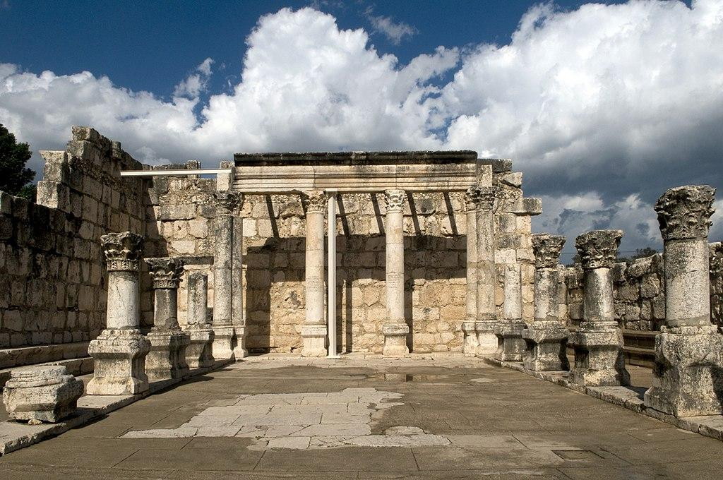

The system was similar to how we do local churches today. As a Jew, you move to a new city and the first thing you do is look for the local synagogue so you can find the other worshiping Jews. Saul was a product of this system so it was natural for him to take advantage of it.

The striking word here is “IMMEDIATELY.” Saul did not wait to start preaching Jesus. Just days before, he had been preaching against Jesus. Now that he was convinced that Jesus was the Christ, the Son of God, he immediately started preaching Jesus.
A mistake we often make with new believers is to immediately isolate them from their previous friends. In an attempt to protect them from negative, worldly influences, we end up keeping the new believer from obeying the great commission.

Jesus frequently told people, “Go and tell others all that God has done for you!” The Great Commission is a clear directive for all followers of Jesus. Our job is to share the gospel with the people around us. But by isolating new believers we actually train them NOT TO share the gospel - we train them, from their earliest days as Christ followers, NOT TO OBEY the teachings of Jesus. Look at the Great Commission itself:

- Mobilize - Empower a Disciple to obey Jesus
“Go therefore and make disciples of all nations, baptizing them… teaching them to observe all that I have commanded you.” Matthew 28:19-20

What does it look like to make disciples? Step one is to baptize them, as Saul was baptized. Going under water is a symbol of dying to your old life and coming up from the water is a sign of being born again, raised to a new life in Christ. It’s about being united with Christ, having a whole new identity in Him. Baptism is the first step of obedience for a Christian.

But teaching a new disciple to obey Jesus doesn’t end with baptism, it must go on as we teach them to obey ALL that He has commanded us. Everything. And the main command in this precise context is to MAKE DISCIPLES OF ALL NATIONS. We need to recover this principle and remind all believers that sharing the gospel is not an optional accessory to our lives - it is a central feature of the Christian life.

We spent a semester in seminary with a Japanese church. The believers were friendly and gracious with us, but they had really difficult names we couldn’t remember or tell apart so they said, “Just call me Paul,” or “Call me Joe.” Pastor Hiro (that was a name we could handle) became a good friend.

When Hiro heard the gospel in Japan and joyfully gave his life to Christ as a young adult, the man who led him to Christ took him out the NEXT DAY to hand out gospel tracts and share the good news in the train station in Tokyo. Barely 24 hours after becoming a Christian, Hiro was being taught what it meant to obey Jesus. That is simply what Christians do. Maybe not always in a massive train station - but somewhere, in some way - all of us are called to testify. Somehow we must obey the great commission and we must model this and teach this to everyone in our church - Christians must be MOBILIZED.

We are SENT ONES. We are ambassadors. We represent Jesus. We are His LIGHT, His Salt.

- Mobilize - Empower a Disciple to obey Jesus
“But Saul increased all the more in strength, and confounded the Jews who lived in Damascus by proving that Jesus was the Christ.” Acts 9:22

As he was mobilized, as he was taught IMMEDIATELY to obey Jesus, Saul was strengthened. He grew quickly through obedience and practice.
- There is no better way to learn how to pray than to PRAY.
- There is no better way to learn how to read the Bible than to read the Bible.
- There is no better way to learn how to witness than to witness.

We need to get better at just talking about Jesus. We have had tons of practice in talking about COVID-19. Most of us got pretty adept at talking about the election. The more you talk about something, the more you improve your clarity and persuasive abilities.

Start small just by getting to know a neighbor. If your interest is simply to connect with someone, to hear their story, eventually there will be a chance to hear the spiritual side of the story. Don’t stress out about forcing the gospel into the conversation in the first little chat. We need to learn to listen - to care about people enough to take the time to get to know them.

We need to re-learn the art of relational evangelism. It has gotten difficult in America and we have gotten complacent about it. But increasingly we have to GO out to connect with people in the community, they will not come to us here at church. The trends continually confirm this. How would you feel about going to a hard core biker bar? (A couple of you are like, “I was there on Friday…”) Think of a place that is usually not your scene and imagine stepping into it. You feel awkward, out of place - you don’t know anyone, you don’t know what to do. More and more these days that is how people feel about church. It’s not their scene. They don’t know anyone. They don’t know what to do - when do you stand, sit, sing, pray…? They don’t feel comfortable so they aren’t just going to stroll in. We have to go to them!

Here is the progression to multiply disciples: first, we have to reach out with the love of Jesus. Second, we have to care for new believers. Third, we need to mobilize disciples to obey the commands of Jesus. And fourth:

- Train - Equip a Maturing disciple to make a disciple
“Barnabas took him and brought him to the apostles… So he went in and out among them at Jerusalem, preaching boldly in the name of the Lord.” Acts 9:27-28

Barnabas is a great example of a disciplemaker. He came alongside Saul when others were afraid to even be with him. He saw Saul’s potential and knew he needed to be challenged to grow - so Barnabas brought him to Jerusalem, where he could play with the big dogs. There Saul was able to spend time with the apostles, to experience their preaching and teaching ministry and develop his own skills.

It seems Saul wasn’t there too long before controversy was stirred up and they sent him off to his home town of Tarsus. After all of this we come to the summary statement that started us off today.

- Train - Equip a Maturing disciple to make a disciple
“So the church throughout all Judea and Galilee and Samaria had peace and was being built up… it multiplied.” Acts 9:31

Note the fulfillment of Acts 1:8 here. Just as Jesus promised they would be witnesses in Jerusalem and in ALL Judea and Samaria, so this is now being fulfilled. The gospel is spreading with power as disciples like Barnabas invest in new believers like Saul, who quickly makes disciples of his own and expects them to go on and make disciples.

Disciplemaking is designed to multiply, not just add. We rarely see multiplication in the U.S. but it frequently happens overseas.

https://www.ywamfm.org/indigenous-disciple-making-movement-india/

YWAM tells the story of a man named Arjun [not his real name] in India, from one of the largest unreached people groups in the world. Arjun heard about Jesus and became a Christian and connected with YWAM through a training event. Hearing their approach to multiplying disciples and churches, Arjun took that strategy back to his village.

“Small teams formed combining primary health care and evangelistic Bible studies. They headed out to the villages. Physical needs were met as simple gospel stories were told in the local language. Gradually people began experiencing the love of God. The ministries of health care, signs and wonders, and God’s Word made an impact—people were being healed and delivered. Many began turning from Hindu idols to faith in Jesus.

The new believers came together to form simple churches because none existed. Meeting in a little house or under a tree, the believers committed to one another to lovingly obey Jesus’ commands. New elders ‘learn by doing’ while being trained in the background by the YWAMers.
These believers are stepping out in faith, praying for needs and sharing the gospel with their families, friends and neighbors. The sick are being healed, the demon possessed delivered and even the dead raised back to life! Hundreds of men, women, and children have been born again. The churches follow the New Testament pattern, reproducing into their own daughter churches. At last count, thirteen new churches have been established.”
Many years later, Arjun and his team have reached over 1,000 with the gospel - baptizing them and getting them into small churches that multiply rapidly.

So how can we multiply disciples?
First we need to regularly reach out to non-believers. As they hear the gospel and respond, we baptize new believers and care for them, helping them learn the basics of knowing and following Jesus. But we don’t keep them in this stage, we quickly mobilize them, teaching them to obey the commands of Jesus from the very beginning - including the command to make disciples of all nations. And as we expect this kind of obedience, we train them in what it looks like and how to be more effective at it.

Here is another way to look at it:
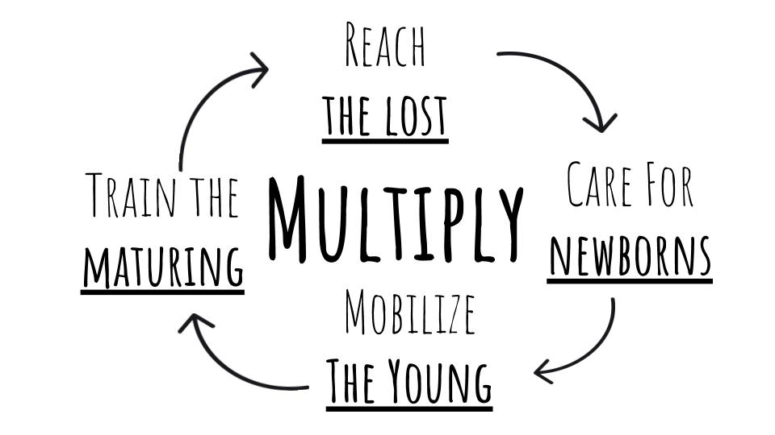

When you reach out to someone, they are lost - like Saul when he was blind. He needed someone to guide him, and so do people apart from Jesus. They need a loving friend who will patiently help them see the truth of their sin and the grace of Jesus.

When a lost person calls on the name of Jesus, they are “born again.” The new believer is a spiritual infant needing lots of care and attention.

But early in the spiritual life of a new believer, we need to urge them out of spiritual childhood into young adulthood, teaching them to obey the commands of Jesus, including His commands to reach out with the gospel. A spiritual youth is one who has gone from being spoon fed the milk of God’s Word to one who is feeding himself on Scripture and actively seeking to feed others.

But the “mature” believer is not actually mature until he or she REPRODUCES. The goal for the Christian is not spiritual adulthood but spiritual PARENTHOOD. The measure of maturity is not knowledge but reproduction. Are we making disciples? Are we multiplying?

Here is the process:
- Reach a lost person with the gospel.
- Care for a spiritual newborn.
- Mobilize a young disciple, helping them obey the commands of Jesus, including the command to make more disciples.
- Finally, train the maturing disciple in how to effectively reproduce.

That is how to multiply! May the Lord help us follow this Biblical pattern!

Let’s pray.

