Be Strong in the Lord
Ephesians 6:10-17

Imagine yourself as one of David’s mighty men - one of his 30 warriors who fought beside him through all of his campaigns. It is the night before you are going to attack Jerusalem, a fortified city with massive walls that the tribe of Judah was unable to conquer in the days of Joshua. David issues a challenge - the one to lead the attack will become the commander of my army.

You are Joab, and you immediately step forward to lead the attack, guiding other elite soldiers up a water tunnel to enter the city secretly and catch the Jebusites off guard.

Now, how did you prepare for that moment?

Can you imagine finding yourself in pajamas and flip flops, with a pool noodle in your hand? That is the stuff of nightmares, right? Leading a military assault, utterly unprepared.
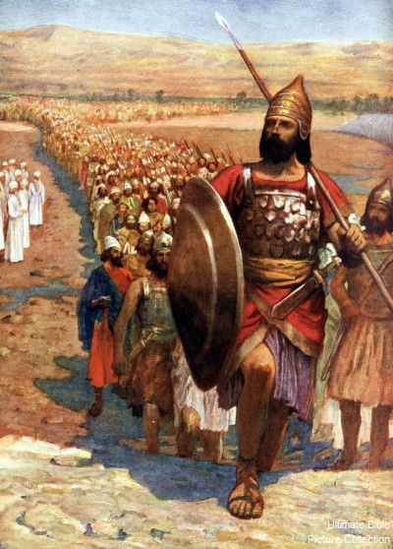
No. You would have woken up early, eaten a little breakfast, and suited up in your armor. You would have fastened on your breastplate, secured gauntlets to your forearms, strapped up your best sandals and tightened the strap on your helmet. You would be sure to pick up your shield and of you would not only have your sword but you would have spent an hour making sure the blade was razor sharp.

Before you move into battle, you gear up. You prepare. You get dressed. You make sure you are well equipped. You study the battle plan. You coordinate with your fellow soldiers. You line up together and you advance together.

Brothers and sisters, is this how we approach the spiritual battle that is constantly raging around us?
- Do we apply Ephesians 6 every day?
- Or are we like that guy in the front lines in pajamas and flip flops, boldly brandishing our pool noodles?

Hear the Word of the Lord:

“For we do not wrestle against flesh and blood, but against the rulers, against the authorities, against the cosmic powers over this present darkness, against the spiritual forces of evil in the heavenly places.” Ephesians 6:12

Could Paul have presented this any more clearly or forcefully?
- Christians are engaged in a daily battle - and it is not with Republicans or Democrats; not with human political leaders at all; it is not with a mean boss at work or with a selfish neighbor; it is not with an abusive or neglectful husband or a rebellious child - as difficult as all of those situations are.
- No. We do not wrestle against flesh and blood. Our battle is a cosmic spiritual war with demons ranging from the wimpy little private up to the terrifying four star general, and the great commander in chief, the devil himself.
- The trouble is that we don’t see these demonic hordes - what we see is flesh and blood. So we often mistake the enemy and attack each other or the people around us.

We need spiritual resources to fight a spiritual battle. You cannot win this war with your will-power, your strength, your connections, your money, your business savvy, your resources. We can only win this war if we stand firm in Christ.

Because the good news, brothers and sisters, is that Jesus ALREADY HAS won this war. The devil is a crippled enemy fighting a desperate and prolonged retreat all the way to the lake of fire. Jesus is leading His Church Victorious forward, with the banner of the gospel, and the gates of hell cannot prevail against us. (Come back in 2 weeks as we begin a new series called UNSTOPPABLE - the Church on Mission!) Here is the key exhortation of Ephesians 6:

“Finally, be strong in the Lord and in the strength of his might. Put on the whole armor of God, that you may be able to stand against the schemes of the devil.” Ephesians 6:10-11

There is a key phrase in there that we have seen over and over again in Ephesians. How can we win this spiritual battle? How can we overcome the deceptive schemes of the devil? How can we prevail against the demonic forces that outnumber us and would surely overpower us? Here is the key:

“Finally, be strong in the Lord and in the strength of his might. Put on the whole armor of God, that you may be able to stand against the schemes of the devil.” Ephesians 6:10-11

We cannot “be strong” on our own. We can only be strong and prevail in this battle IN THE LORD. What does that look like? I’m glad you asked. This is a summary of the whole message of Ephesians. Apply the gospel. The first half of Ephesians presented the truth of the gospel, the second half applied the gospel to every area of life. Here is our lesson for today:

How to be strong in the Lord:
- Know the Gospel
- Believe the Gospel
- Walk in the Gospel

It’s very simple but we must follow all three of these steps to live a victorious and fruitful Christian life. Let’s take each of them in turn. First:

- Know the Gospel
I was... | I am...

It’s no accident that the first piece of armor Paul mentions is the belt of truth. This is what holds everything together. Remove the belt, your spiritual pants fall down. Nobody wants to see that. But with a clear knowledge of the truth, your worldview and whole approach to life rests on a firm foundation.

The last piece of armor is the sword of the Spirit, which is the Word of God. So Paul begins and ends his armor listing with truth and Scripture. And of course, we know what is TRUE and good and right THROUGH the Scriptures! So the two are deliberately related.

So let’s review the book of Ephesians and the Gospel we know to be true. What does Ephesians teach us about who we WERE?

- Know the Gospel
I was... | I am...
- Dead in my sin
- Blind to the truth
- Enslaved to sin
- A child of wrath
- Separate from Christ
- Cut off from grace

Ephesians 2 vividly presents the truth. We were DEAD in our sins. All of us are sinners by nature and by choice. We were born with sinful inclinations and every one of us chose to follow those deep internal desires. As we went that way we were blind to the truth and our disobedience made us even more hardened to spiritual reality. As a result, we became addicted to sin, enslaved… following our own selfish desires - living “in the passions of our flesh.” And so we became children of wrath - deserving nothing from God but His condemnation. We were separate from Christ and all the covenant blessings promised to Israel. Paul concludes this “bad news” section in verse 12, we were “without hope and without God in the world.”

BUT GOD. Ephesians 2:4 is one of the most encouraging verses in the Bible!

“But God, being rich in mercy, because of the great love with which he loved us, even when we were dead in our trespasses, made us alive together with Christ - by grace you have been saved - and raised us up with him and seated us with him in the heavenly places in Christ Jesus.” Ephesians 2:4-6

When we were dead in our sins, God raised us to new life in Christ. He united us with Jesus as the moment we called on the Lord in faith - made us alive with Christ, raised us up WITH Christ and seated us WITH Christ. In the tomb, when Jesus’ body began to breathe, you and I were reborn. Spiritually, that is the moment each of us came to life - when Jesus rose. We have been united with Him in His death AND united with Him in His resurrection. This is the Gospel - this is the glorious truth!

- Know the Gospel
I was... | I am...
- Dead in my sin  - Blind to the truth  - Enslaved to sin  - A child of wrath  - Separate from Christ  - Cut off from grace | - Alive in Christ  - Awakened to truth  - Free from sin  - A child of God  - United with Christ  - Secure in grace

Do you KNOW this truth? Do you understand how good the good news really is? This is the first step for being strong in the Lord. You have to know the truth. The devil will attack us at each of these points:
- You are a sinner - God can’t forgive you, He won’t forgive you!
- You can’t overcome that sin, it’s too powerful for you.
- You don’t need relationship with other Christians - you are fine on your own.

The devil’s main weapon is DECEPTION. We fight him and overcome his schemes by knowing the truth. Don’t drop the Sword of the Spirit. Become skilled in wielding God’s Word - know the truth. Memorize Ephesians 2, Romans 8 and other passages that clearly present the truth of the gospel. You must KNOW the Gospel before you can go on to step two and BELIEVE the Gospel.

Many of you know the Christian rapper, Lecrae.
http://godreports.com/2016/09/rapper-lecrae-found-significance-unconditional-love-in-jesus/
Lecrae grew up in south Houston, raised by a single mom who was working all the time. His grandma took him to church a few times but he concluded it was just a place for old people. The only men in his life were active with drinking, drugs, women and gangs - so those were the men he chose to emulate. That’s what manhood was for him. He didn’t know any other truth, any other way.

In desperation, seeing her son going the wrong way, Lecrae’s mom gave him a Bible and said, “just read it. Please I don’t know what else to do.” In defiance, he ripped pages out and threw them on the ground saying, “I don’t want your Bible. I don’t want your God.”

By the age of sixteen he was getting high every day, chasing women and getting more and more involved with gangs. Looking back, he said it was a search for significance. He didn’t know where else to find purpose. He was interested in rap but the only examples he knew were TuPac and other secular rappers.

He simply didn’t know any different. When he was seventeen a friend asked him if he was “saved,” and he didn’t know what that expression meant. He figured it meant “are you like your Grandma?” and quickly said, “No. That’s not me.” He did not know the gospel so he could not go on to step two in the spiritual war to BELIEVE the gospel. That came later.

- Believe the Gospel
- In Christ, I am righteous, secure and filled with the Spirit
“Put on the breastplate of righteousness… take up the shield of faith… and take the helmet of salvation.” Ephesians 6:14-17

Why does Paul command Christians to PUT ON righteousness and salvation to take up faith as a shield? Don’t we already HAVE these things in Christ? YES! At the moment you called on Jesus in faith you were clothed forever in the righteousness of Christ and the helmet of salvation was placed securely on your head - so that NOTHING can ever snatch you from the Father’s hand and no one, no power, nor demon can ever separate you from the love of God in Christ Jesus the Lord.

That is the truth of the Gospel we know. BUT we still have to suit up every day - not in order to be saved but to exercise faith, to remember the truth and live in light of it - we need to preach the good news to ourselves and each other every day.

In Christ, I am righteous. In Christ, I am secure. In Christ, I am loved. In Christ, I am a child of God. In Christ, I am a temple of the Holy Spirit. In Christ, I have every spiritual blessing. In Christ, I am God’s workmanship - His masterpiece!

Do soldiers just go to the rifle range one time? Do they learn how to load and fire their weapon once and then their drill sargeants say, “You’re good. You’ve got this”? Of course not! They are drilled every day! They practice. They rehearse. They have more skilled, advanced trainers helping them learn the basics and then to enhance their skills.

We need to embrace this reality in the church. It’s not enough just to give someone a Bible and show them where to find the gospel of Mark. We have to help them learn to read and understand the Bible - to not just read the words but to understand, believe and apply what they read. This takes training. It takes practice! It takes time and repetition!
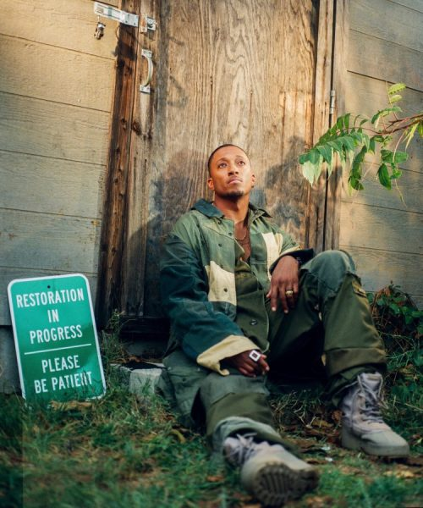
https://www.youtube.com/watch?v=_Bs6ctEFiGw (I am Second)

Fast forward in Lecrae’s life. He went to the University of North Texas and continued on with the life of drinking, drugs and chasing girls. But a friend at one point invited him to a conference. With nothing else going on he agreed, but was more interested in the girls who might be there. At this conference, for the first time in his life he met guys who used to be in gangs but who were now living for Jesus. He met girls who used to sleep around but now were in love with Jesus. He said he had never met people like this. It was all new to him.
Then he heard a preacher talk about Jesus saying, “You were bought with a price.” Suddenly all the stories he had heard about Jesus from his mom and Grandma started to make sense. THAT is why Jesus died. He died to pay for my sin! My choices, my selfishness, my drinking, my girl-chasing… Jesus took all of that on his own back to pay for it all!

At that conference Lecrae fell on his face and called on Jesus to save him. He suddenly knew the truth of the gospel. The light of truth came on. In response, he made a profession of faith. He asked Jesus to save him and forgive his sins. But there was more Lecrae still had to learn. His battle was still not over.

One more step to being strong in the Lord. It’s not enough to know and believe the gospel. Third, we have to:

- Walk in the Gospel
- In Christ, I have purpose and power to live
“And, as shoes for your feet, having put on the readiness given by the gospel of peace.” Ephesians 6:15

Can you imagine a soldier with a crisp uniform, secure helmet, complete body armor and advanced tactical assault rifle… BAREFOOT? Of course not! He or she would have solid steel-toed boots laced up tight, nicely broken in and ready to march 10 miles.

The boots for the believer are called OBEDIENCE. Actually taking steps of faith-filled ACTION. What is the test that you really believe in Jesus? You OBEY. You don’t just hear what He taught, you put it into practice. That is the wise man who built his house on the rock and built an unshakeable life - the one who HEARD, understood, believed and therefore OBEYED.

Are you wearing your gospel shoes? Or do you often find yourself barefoot and unprepared to obey? Unready to act… Do you personally know “the readiness given by the gospel of peace”?
https://www.youtube.com/watch?v=CycgRU1VEXI (Billy Graham)

Lecrae came to know about Jesus and to believe in Jesus at that conference. But it was several months later before his life was totally transformed. He fell back into old patterns of sin and found himself living a double life. He couldn’t enjoy the sin anymore, since he had this new experience called CONVICTION. So as he was driving along one day he cried out to God saying, “You have to do something! You have to change me. Do whatever it takes, just don’t kill me.”

Suddenly he was cut off in traffic and lost control of his truck. It started to roll and he felt his body tumbling in slow motion, no seatbelt to restrain him. When the world finally stood still again and he climbed out of his mangled truck, he was amazed to see just one small piece of glass in his arm - barely a scratch anywhere else. That was it.
He called his Christian friends and said, “We’ve got to make this thing happen.” He came clean about everything and surrendered his life to Jesus. In that step of radical obedience and surrender, joy flooded his heart and life - and Lecrae has never looked back. He gave Jesus control and started devoting his entire life to serving the Lord.

He got into ministry at a juvenile detention center. He started sharing his early Christian rhymes with those young people - and saw the power of the gospel as the Lord broke through to their hearts through the music and verse. He became vocal for his faith at college. Some people made fun of him, but he became radically unashamed of the gospel that had changed his life.

Do you see the progression? You first have to KNOW the Gospel. Once you know the truth you have to BELIEVE it. You have to fix your faith and confidence in the truth you have learned. You have to remember who you WERE and continually remind yourself of who you now ARE in Christ. And step 3 - as the Lord leads you, you have to OBEY - you have to walk in the Gospel you know and believe.

Hear one more time Ephesians 6:

“Finally, be strong in the Lord and in the strength of his might... Therefore take up the whole armor of God, that you may be able to withstand in the evil day, and having done all, to stand firm.” Ephesians 6:10,13

This is an exhortation from a General to his troops. The enemy is coming. The attack will be fierce and terrible. But we must not give up. Our line must not break. We must stand firm to the very end - to the last man, to the last bullet. It’s all very Gettysburg - right there on Little Round Top. Chamberlain and his 100 men from Maine were the end of the Union line. They were the far left flank. If they broke and ran, the entire Union line was exposed. So Chamberlain repeatedly told his men they could not fall back. There was no retreat. They had to stand firm.

And even when they ran out of ammunition and there was none left even to harvest from those who had fallen, they had to stand their ground. So they fixed bayonets and waited in their positions. When the Confederate charge came again, Chamberlain’s men fired their very last volley and then charged down the hill - capturing the stunned rebels and mercifully bringing an end to the action in their part of the battle field.

Suit up. Put your armor on. Sharpen you sword. Dress for battle - because we are in a battle. But the good news is that Jesus has already won the war! Little skirmishes continue, but Jesus won the decisive victory when He walked out of the tomb. We WERE dead in sin, enslaved to it, children of wrath. But God rescued us from that. He bound us to Jesus by faith, washing away our sin and filling us with His Spirit.

Our job is to KNOW this gospel truth - to BELIEVE this gospel truth and to WALK IN the truth we know. That is how to be strong in the Lord. That is how we will prevail in this ongoing spiritual battle!
Let’s pray!

