The Call to Work
1 Peter 4:7-11

How do you know you’re in the right career field?
If you’re still in school, how do you find the right career path?
What values play into your decision-making?
Here is the typical model today:
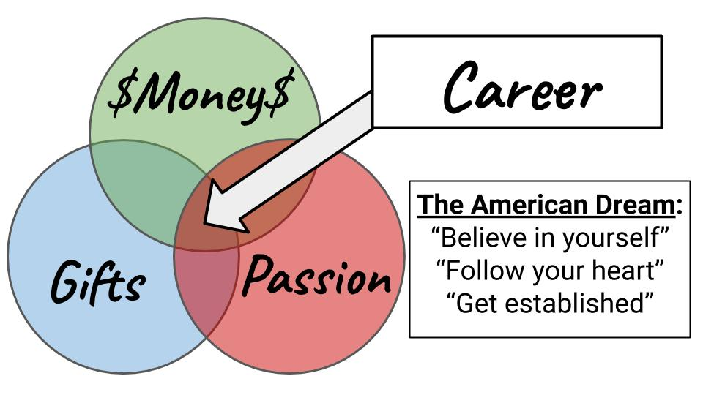
Guidance counselors work with you to help you understand your personality, temperament, abilities and interests and connect those with real jobs - opportunities to actually make money.
- You try to find a job you are good at - that uses your gifts and abilities.
- You try to find a job you enjoy - that you are at least a little passionate about.
- And, of course, you try to find a job in which you can make some money. You might order these priorities in different ways, sacrificing salary for a job you enjoy more, or the other way around - sacrificing your enjoyment to make a little more money.

And so the three primary messages of our culture related to career are:
- Believe in yourself! You have amazing gifts you just need to discover and unleash.
- Follow your heart! Whatever you are most passionate about, devote yourself to that.
- But be sure to get established. Start out sensible - work your way up. Make money, save up.

None of these are inherently bad, but there is a danger in becoming overly influenced by our culture. The objective of the world when it comes to career is clear.
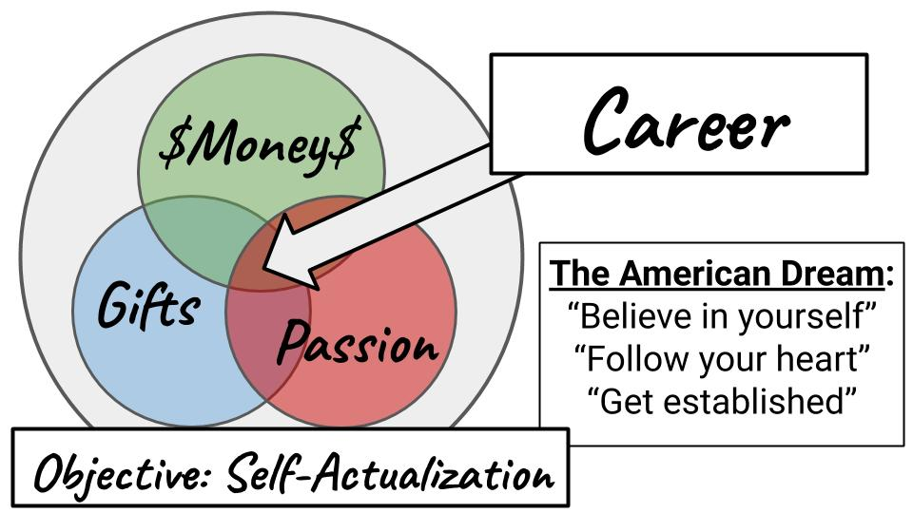
The goal is “self-actualization” - to maximize your potential; to pursue your optimum fulfillment. In essence, the objective is self-GLORIFICATION. Don’t let anyone hold you back anymore. “Let it go,” and unleash your inner glory for the world to see.

That’s the way of the world. Let’s look today at the Biblical model - not of self-glorifying career-building but of the God-glorifying pursuit of our CALLING.
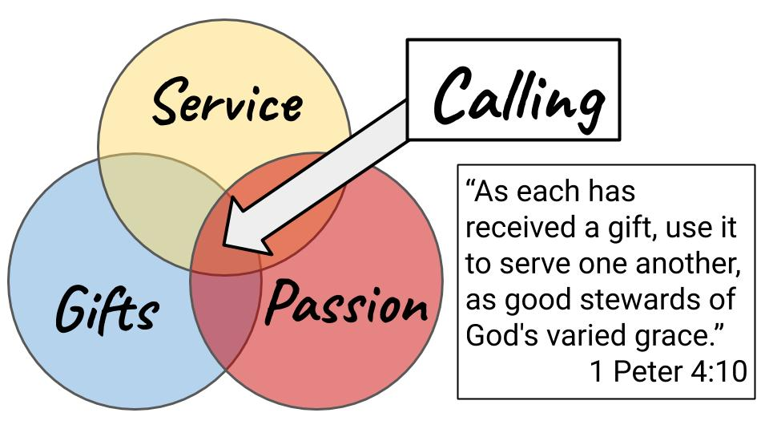
The Christian still considers the gifts and abilities God has given us. We reflect on our personality, temperament, strength and weaknesses.

We will study 1 Peter 4 today - a few key verses on knowing God’s will for your work!

In addition to our gifts, we also factor in the things we are passionate about, the issues we are most interested in. But the third category is not how to make the most money but how to serve the most people. How can you be the most USEFUL to other people? How can you most effectively SERVE others? That is how to discern your calling. And the motive could not be more different from the career-building model.

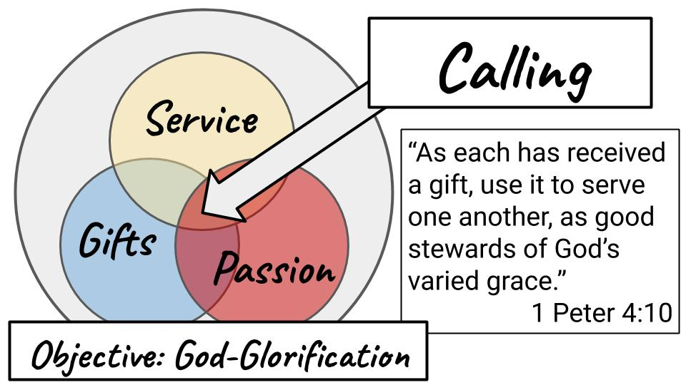
We are stewards of God’s varied grace. He has given each of us different gifts, different abilities, different experiences and opportunities. All of it is grace. All of it is a gift, preparing us for unique callings and ministry assignments. And our mission in life is not to bring glory to OURSELVES but to bring glory to the God who made us and called us to serve Him by serving others.

We need to recover the idea of VOCATION, which means calling. It is not just pastors and missionaries who are CALLED. All believers are called to work for the glory of God and the good of people and the world. We are stewards of the grace God has given us - commissioned by God to do specific tasks. So we will conclude our service today with a COMMISSIONING of EVERYONE!

Today we will explore the three INDICATORS of our calling: Gifts, Passions and Service. Think of this as your GPS, your guidance system to help you tune into the Holy Spirit’s voice as you discern your calling. First of all: GIFTS.

Gifts: use everything God has given you
“As each has received a gift, use it to serve one another, as good stewards of God’s varied grace.” 1 Peter 4:10

We are “stewards of God’s varied grace.” Isn’t that a beautiful picture? God gives grace in infinite forms. Every person is unique. Every life is custom designed to reflect God’s glory. Everything in your life is a gift from God He has given you to serve Him. Yes, even your weaknesses; even your blemishes and scars. Everything.

We are stewards of every area of our lives.

Gifts: use everything God has given you
“As each has received a gift, use it to serve one another, as good stewards of God’s varied grace.” 1 Peter 4:10
- Spiritual gifts, natural abilities, life experiences, resources, etc.

This passage is referring to spiritual gifts, to be used in the church. I preached on that this time last year, you can find that message on the church blog. But the principle applies to every part of life - spiritual gifts are just one expression of God’s varied grace to you.

Also think about your natural abilities, your personality temperament - how you are wired, how you think. Are you an introvert or an extravert? Do you prefer working with people or on tasks? Do you like science better or the arts?

That was the question that changed by direction before I went to college. I was registered pre-med like my brother, who was two years ahead of me. He studied under my Grandfather in physiology and, since I was generally a good student, everyone figured I would follow that path and become a doctor of some kind.

But the summer before I started school a youth leader asked me some great questions. When he heard my plans to study biology and become a doctor he said, “Wow, you must really love science!” You’d think that would have occurred to me before that moment. But It was a tremendously clarifying statement. Yes. If you want to spend eight years in school to become a doctor, followed by four more years of internship and residency, you better like science!

And as soon as he said that to me I started to shake my head. “No. Not really.” I got good grades in science and math but I wasn’t excited to spend the next several years studying human anatomy, organic and inorganic chemistry and advanced physiology. For some of you, that is the perfect dream.

It took me the rest of college to figure out what to do with my life. But at that point two questions hung in the air:

Guiding Questions:
- Gifts - what are you good at?
- Passion - what are you interested in?

Doing something you are good at is called “the ministry of competence” (Tim Keller). You are not honoring God or helping people by doing something you are not well-suited to do. Finding a line of work that you can excel at is a blessing to everyone and gives honor to your Creator who gave you the gifts and abilities He did.

This isn’t arrogance or self-centeredness, it is humble self-awareness. What are you good at? Later in life you want to focus in on what you are BEST at. But starting out, consider the things that come most naturally to you and get to work on them!

This quote is often attributed to Martin Luther and it turns out he didn’t say it but I couldn’t find who did. (Raynor, p. 56)

“The maid who sweeps her kitchen is doing the will of God just as much as the monk who prays - not because she may sing a Christian hymn as she sweeps but because God loves clean floors. The Christian shoemaker does his duty not by putting little crosses on shoes, but by making good shoes, because God is interested in good craftsmanship.” Jordan Raynor, Called to Create

More on Jordan Raynor in a few minutes. It is helpful to remember that doing “regular,” secular work is not less honoring to God if you do it well and do it for the glory of God. Use your gifts. Use your abilities. Find work you are GOOD AT. And don’t trust your own sense of what you are good at. Listen to other people. Listen to your boss, your co-workers, your family members. They may be giving you subtle (or not so subtle) feedback that you’re not as good as you think at certain things.

We all have strengths and weaknesses; and often strengths come with corresponding blind spots. So one of the best gifts anyone can give us is clear, direct feedback. My leadership coach told me a few months ago, “Evaluation is the breakfast of champions.”

What are you good at? And what are you interested in? This moves us to the second indicator: your passion.

Passion: follow your excitement and holy anger
“Whoever speaks, as one who speaks the oracles of God; whoever serves, as one who serves by the strength God supplies.” 1 Peter 4:11

God’s “varied grace” to you includes your gifts, abilities, experiences and passions. What fires you up? What gets you out of bed in the morning? Maybe there’s an issue that makes you angry and you can’t rest until it is addressed. That may be a “holy discontent,” God has given you as part of your calling.

This was Pete Castellani’s story. He worked as a financial analyst for IBM for over 31 years. He was laid off in 2009 and wondered what the Lord had in store for him. He and his wife, Ellen, had served off and on on the boards for several crisis pregnancy centers. So when the Lord laid it on their hearts to open one in Land O Lakes, they stepped out in faith and obedience to do so. This became Oasis Pregnancy Care Center - one of our local partner ministries.

You don’t have to spend much time with Pete to hear his passion for the unborn. His heart beats for this. He feels a deep and personal sense of urgency to protect and advocate for unborn babies in Tampa Bay - and we are right there with him.

“What is your passion?” That was the question the youth leader asked me before I started college. Once he saw it wasn’t science, he pressed the question. What are you passionate about? “What will be YOUR way to change the world for Jesus?”

Again, I didn’t have answers at that point. But the question helped guide me to ministry with PEOPLE, and eventually the local church. Discerning your calling is like coming to different cross-roads and listening to the Holy Spirit to point you one way or another. For me it was not so much science and more something to interact with people. That led me for a while into politics, but eventually I came to another crossroad, realizing I wasn’t well suited for the rat-race of politics.

1 Peter 4:11 only gives two examples of spiritual gifts: teaching and service. 1 Corinthians 12 and Romans 12 provide about a dozen more. None of those lists is meant to be exhaustive but rather to give us an idea of the kind of gifts God gives us in His “varied grace.”

The point here is - if you’re going to teach, then teach with passion and energy. If you’re going to serve, then work with all of your heart. The Apostle Paul himself is a great example of this. He had a burning passion to bring the gospel where it had never been heard. He could not rest in one place, but had to move on to new regions, new territory. He felt a holy discontent, a deep internal urgency for unreached people groups.

Passion: follow your excitement and holy anger
“I make it my ambition to preach the gospel, not where Christ has already been named.” Romans 15:20

In Acts 20:24 Paul said, “I consider my life worth nothing to me if only I may finish the race and complete the task the Lord Jesus has given to me - the task of testifying to the gospel of God’s grace.” This was Paul’s calling - to proclaim the good news where it had never been heard. Specifically, Paul was called to Gentiles. He felt a strong desire to help people who did not have his Jewish upbringing and awareness of God’s Law to come to know the holiness and grace of the Lord.

This was his ambition. His passion. What is your passion? What issue or cause or group of people has the Lord placed on your heart?

Jordan Raynor, in Called to Create, tells the story of Blake Mycoskie. A naturally wired entrepreneur, Blake started a laundry business his sophomore year of college and within a year it was making more than $1 million and employing 40 people. He went on to start several other companies, and then - along with his sister, went on the Amazing Race, and saw poverty in the world first hand. They saw droves of children who did not have shoes - and the idea was born for a shoe company that would help outfit the children of the world with shoes.

So in 2006 Mycoskie founded TOMS Shoes. For every pair of shoes sold, another pair was given to a child in need of shoes. Since 2006 the company has given away more than 60 million pairs of shoes! Blake wrote a book called Work as Worship - seeing his business as an expression of his devotion to God and to the people of the world.

This ties us in to the third indicator of calling: Service.

Service: maximize your usefulness to people
“Above all, keep loving one another earnestly… As each has received a gift, use it to serve one another.” 1 Peter 4:8-9

Again, this corrects the worldly mindset that sets our gifts and passions alongside the opportunity to make the most money for OURSELVES and says, “No, the third category needs to be how we can best be a blessing to OTHERS.”

Do you view your work this way? Do you get up each day and drive in or log in to work with that on your heart - to serve others? God has given you gifts and passions - He built you as He did for a reason - so you could bless and serve other people.

We do not own anything. Everything we have and everything we are has been entrusted to us to MANAGE. We are stewards of every minute and every resource God has given us. Will we use those minutes and resources to serve ourselves or to bless others?

Do you go in to work knowing that your mission for the day is LOVE? You are the hands and feet and mouth of God - loving people on His behalf.
- You feed people for God.
- You heal people and care for them for the Lord.
- You build and fix things for God.
- You listen to and advise people to give them wisdom from God.

Every toilet you clean, every lunch you serve, every lawn you mow, every IT issue you solve - you are the hands of God serving and blessing the people on His planet. And when we live this way, God gets all the glory, not us.

Service: maximize your usefulness to people
“In order that in everything God may be glorified through Jesus Christ.” 1 Peter 4:10

All work is a gift from God to us. We reflect His image when we create things and when we cultivate and develop this world He has entrusted to us. Work is a struggle, but God is using His people as salt and light to redeem and restore this broken world - through our prayerful, love-soaked WORK.

When our gifts, passions and service converge, people feel the love and blessing of God through us.

For this whole series on work I depended mostly on two books - one by Tim Keller, who gets plenty of press, and the other by Jordan Raynor (son of our own Tom and Lynette!).

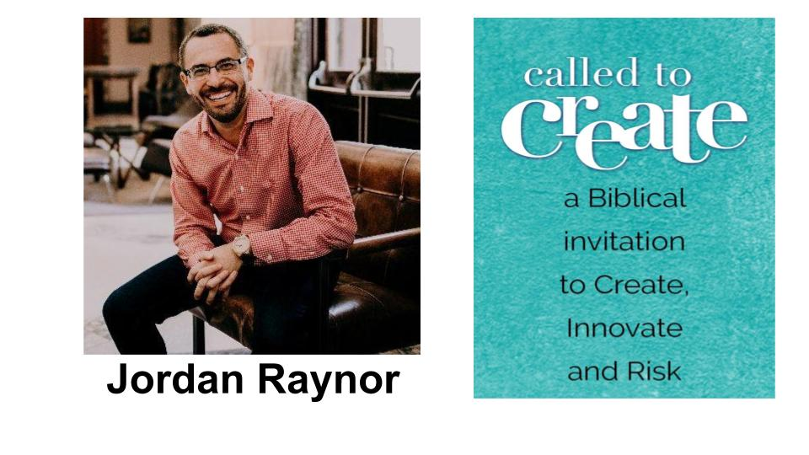
Jordan’s first book, Called to Create, is an inspiring Biblical guide to work in general and CALLING in particular. Jordan shares his own story along with 40 other stories of people and companies seeking to pursue their own callings from the Lord. I’ve already shared some of them.

It’s only appropriate that I mention Jordan in this message, since the three indicators I have presented here, I got from him. Granted, he got them from the Bible - so we share a common source. But there it is.

Finding the convergence of your gifts, passion and opportunity to serve others is a great definition of calling. When he was younger, Jordan thought the only way to really please and honor God was to be in church ministry or missions. Through college and soon after, Jordan knew he was good at starting things, so he felt that he should probably apply that entrepreneurial ability to start a CHURCH. He felt it would almost be unholy NOT to.

But some more mature, sensible people, including his father, helped him see that the call to create is not more holy in church ministry or overseas missions, nor is it less holy and God-honoring in the world of business. So Jordan set out to build a business that would help other entrepreneurs discover and fulfill THEIR call to create.

Jordan makes you earn it, but if you get 147 pages into the book he courageously shares about failure. He says the ability to admit when we fail and even celebrate what we learn through failure should be one of many things that set apart CHRISTIANS in the workplace from non-Christians. We know our identities are not tied to work, so it’s ok to fail. God will support us through mistakes and poor decisions and guide us into new opportunities - still speaking His grace and approval over us.

In the rat race of work we can be so driven by the approval of our peers and the world that nothing means more. But Jordan helpfully calls us to tune our hearts and minds first to God, as in 1 Peter 4:10.

Service: maximize your usefulness to people
“In order that in everything God may be glorified through Jesus Christ.” 1 Peter 4:10

Do we work FOR GOD, not for ourselves? Do we work to bring glory to HIS name, not to make a name for ourselves? Do we work to serve and bless others or to make as much money as we can to indulge ourselves as much as we can?

Brothers and sisters, may God be glorified through our work!

Let’s Pray.

Today we have a special closing song called Masterpiece.

“You are my masterpiece.” - God

“For we are his workmanship, created in Christ Jesus to do good works, which he prepared beforehand that we should walk in them.” Ephesians 2:10

It is based on Ephesians 2:10, which is the verse we started this whole series with three months ago. Hear the word of the Lord. When God looks at you, He says, “You are my masterpiece.”

This song is another Oakwood original. We have a gifted song-writing team and a couple of the team members have kids who have been going through difficult times. We know young people often struggle to believe they are valuable, that their lives are precious to God. And so this song was written by a Dad for his son, from the perspective of God.

God wants all of us, His children, to hear this message. “You are my masterpiece.” Even when you feel broken, even when you have failed, even when you feel useless and stuck - God does not make mistakes. He made you on purpose. He has good plans for you. God has given you gifts, passions and opportunities to serve. Hold on to that truth! Stand firm in it!

Here is the chorus of the song, written from God to each of us:

Masterpiece
I’m the Author of your story  I designed you for my glory  It was no mistake to make you  I’ll never leave you or forsake you | My love for you is endless  Unconditional, relentless  And it will never cease  You are my masterpiece

God’s love for you will never cease. No matter how you feel right now, no matter what you are going through - whether you are celebrating some amazing victories or experiencing a low point in your life, hold on to this truth: YOU are a masterpiece of God!

Twice during Jesus’ life on earth the Father spoke directly from heaven saying, “You are my beloved son, with you I am well pleased.” Because we are united with Jesus by faith, that is exactly how God feels about you and about me. Hear this song as a personal message from the Lord to you saying, “YOU are my beloved daughter, my precious son - I am so pleased with you!”

Listen to this song and may the Lord encourage all of us. Individually we are beautiful gems in God’s great palace. Together, we are a glorious work of art! WE are His masterpiece!

Masterpiece
[Please have each of the numbered items below appear one at a time]

COMMISSIONING
- Artists  - Entrepreneurs  - Finance / Business  - Healthcare  - Educators  - Government / Law  - Social Services  - Other | “For we are his workmanship, created in Christ Jesus for good works, which God prepared beforehand, that we should walk in them.” Ephesians 2:10

